# Leasehold Liberation

# Your Guide to Tackling Excessive Service Charges and Bad Management Agents in England

### **WARNING: This content was generated using Generative AI. While efforts have been made to ensure accuracy and coherence, readers should approach the material with critical thinking and verify important information from authoritative sources.**

# Table of Contents

Introduction: Understanding the Leasehold Landscape 5

The Leasehold System in England: An Overview 5

What is a leasehold property? 5

Key players: freeholders, leaseholders, and management agents 7

Common issues faced by leaseholders 11

The Legal Framework 14

Relevant legislation and regulations 14

Your rights as a leaseholder 16

Obligations of freeholders and management agents 19

Decoding Service Charges and Management Fees 23

Understanding Service Charges 23

What are service charges? 23

Typical items covered by service charges 25

Reasonableness and consultation requirements 28

Scrutinising Your Service Charge Demands 32

Reading and interpreting service charge statements 32

Red flags: identifying potentially excessive charges 34

Your right to challenge service charges 38

Management Fees: Fair Compensation or Profiteering? 41

What management fees should cover 41

Benchmarking management fees 45

Challenging unreasonable management fees 48

Challenging Excessive Charges and Unfair Terms 52

Preparing Your Case 52

Gathering evidence and documentation 52

Understanding the grounds for challenge 55

Seeking professional advice: when and how 58

Informal Resolution Strategies 62

Communicating effectively with your management agent 62

Negotiation techniques for positive outcomes 65

Using mediation services 68

Formal Dispute Resolution 72

The First-tier Tribunal (Property Chamber) 72

Preparing for a tribunal hearing 75

Alternative legal routes: county courts and the Upper Tribunal 78

Reforming Bad Management Practices 82

Identifying Poor Management 82

Common signs of mismanagement 82

Assessing communication and transparency 85

Evaluating maintenance and repair standards 88

Engaging with Your Management Agent 91

Effective complaint procedures 91

Requesting information and exercising your rights 94

Collaborating with other leaseholders for a united front 98

Changing Your Management Agent 102

Legal routes to appointing a new agent 102

The process of changing management agents 104

Selecting a reputable replacement 108

Collective Action and Empowerment 112

Forming a Residents’ Association 112

Benefits of a recognised association 112

Steps to form and register an association 115

Running an effective residents’ association 118

The Right to Manage (RTM) 121

Understanding the RTM process 121

Qualifying criteria and potential obstacles 123

Setting up and running an RTM company 126

Collective Enfranchisement 129

The benefits and challenges of buying the freehold 129

Eligibility and process overview 133

Managing your property post-enfranchisement 135

Advocacy and Reform: Shaping the Future of Leasehold 140

Current Reform Initiatives 140

Overview of proposed leasehold reforms 140

Key organisations driving change 142

How reforms may affect existing leaseholders 146

Getting Involved in Advocacy 148

Joining leasehold campaign groups 148

Engaging with your MP and local government 152

Using social media and traditional media effectively 155

The Future of Leasehold in England 159

Potential alternatives to leasehold 159

International comparisons and best practices 162

Preparing for a changing landscape 166

Conclusion: Empowered Leaseholders, Fairer Future 170

Recap of Key Strategies 170

Summary of main action points 170

Long-term outlook for tackling issues 173

Importance of ongoing education and engagement 177

Resources and Further Support 181

Useful organisations and websites 181

Recommended reading and courses 183

Templates and checklists for common procedures 186

# Introduction: Understanding the Leasehold Landscape

## The Leasehold System in England: An Overview

### What is a leasehold property?

Understanding the concept of leasehold property is fundamental to navigating the complex landscape of service charges and management issues in England. As an expert in this field, I can attest that the leasehold system, while deeply ingrained in English property law, often presents significant challenges for flat owners. This section will provide a comprehensive overview of leasehold properties, their unique characteristics, and the implications for leaseholders in the context of service charges and management.

A leasehold property is a form of property ownership where the leaseholder has the right to occupy and use the property for a fixed period, as specified in the lease agreement. Unlike freehold ownership, where the property is owned outright, leasehold ownership is time-limited, typically for a long period such as 99, 125, or even 999 years. The freeholder, also known as the landlord, retains ultimate ownership of the land and building.

Leasehold is a uniquely English form of property tenure that has evolved over centuries. It’s a system that can work well when managed properly, but it also has the potential to create significant issues for leaseholders if not understood and navigated carefully.

Key characteristics of leasehold properties include:

* Time-limited ownership: The lease has a fixed term, after which it expires unless extended.
* Ground rent: Leaseholders often pay an annual fee to the freeholder.
* Service charges: Fees for maintenance and management of communal areas and building structure.
* Restrictive covenants: Rules and restrictions on how the property can be used or altered.
* Shared responsibility: Leaseholders collectively contribute to the upkeep of the building.
* Management structure: Often involves a management company or agent appointed by the freeholder.

In the context of tackling excessive service charges and bad management agents, it’s crucial to understand that the leasehold structure inherently creates a power dynamic between freeholders and leaseholders. This dynamic can sometimes lead to conflicts, particularly around financial obligations and property management decisions.

The leasehold system’s complexity often manifests in several ways that directly impact leaseholders:

* Service charge disputes: Disagreements over the reasonableness or necessity of charges.
* Management quality issues: Concerns about the performance or integrity of appointed management agents.
* Lease extension complexities: The process and costs associated with extending a diminishing lease.
* Enfranchisement challenges: Difficulties in exercising the right to purchase the freehold collectively.
* Lack of transparency: Issues accessing information about building management and finances.
* Restrictive terms: Lease conditions that may be considered unfair or overly limiting.

It’s important to note that while leasehold properties are common for flats in England, they are relatively rare for houses. The government has recently taken steps to prohibit new-build houses from being sold as leasehold, recognising some of the inherent issues with the system.

The leasehold system, particularly for flats, creates a unique set of challenges. Leaseholders often find themselves in a position where they have significant financial obligations but limited control over decision-making. Understanding these dynamics is the first step in effectively addressing issues of excessive charges and poor management.

In recent years, there has been growing recognition of the need for leasehold reform. This has led to various government consultations and proposed changes aimed at making the system fairer for leaseholders. These include potential reforms to ground rents, service charges, and the right to manage process.

For leaseholders facing issues with service charges or management agents, understanding the fundamental nature of leasehold ownership is crucial. It provides the context necessary to navigate the legal framework, assert your rights effectively, and engage in collective action when necessary. As we delve deeper into specific strategies for tackling excessive charges and management issues in subsequent chapters, this foundational knowledge will prove invaluable.

In conclusion, while leasehold properties offer a way to own a home, particularly in multi-occupancy buildings, they come with a unique set of challenges. By understanding the nature of leasehold ownership, leaseholders can better position themselves to address issues of excessive service charges and poor management, ultimately working towards a fairer and more transparent system.

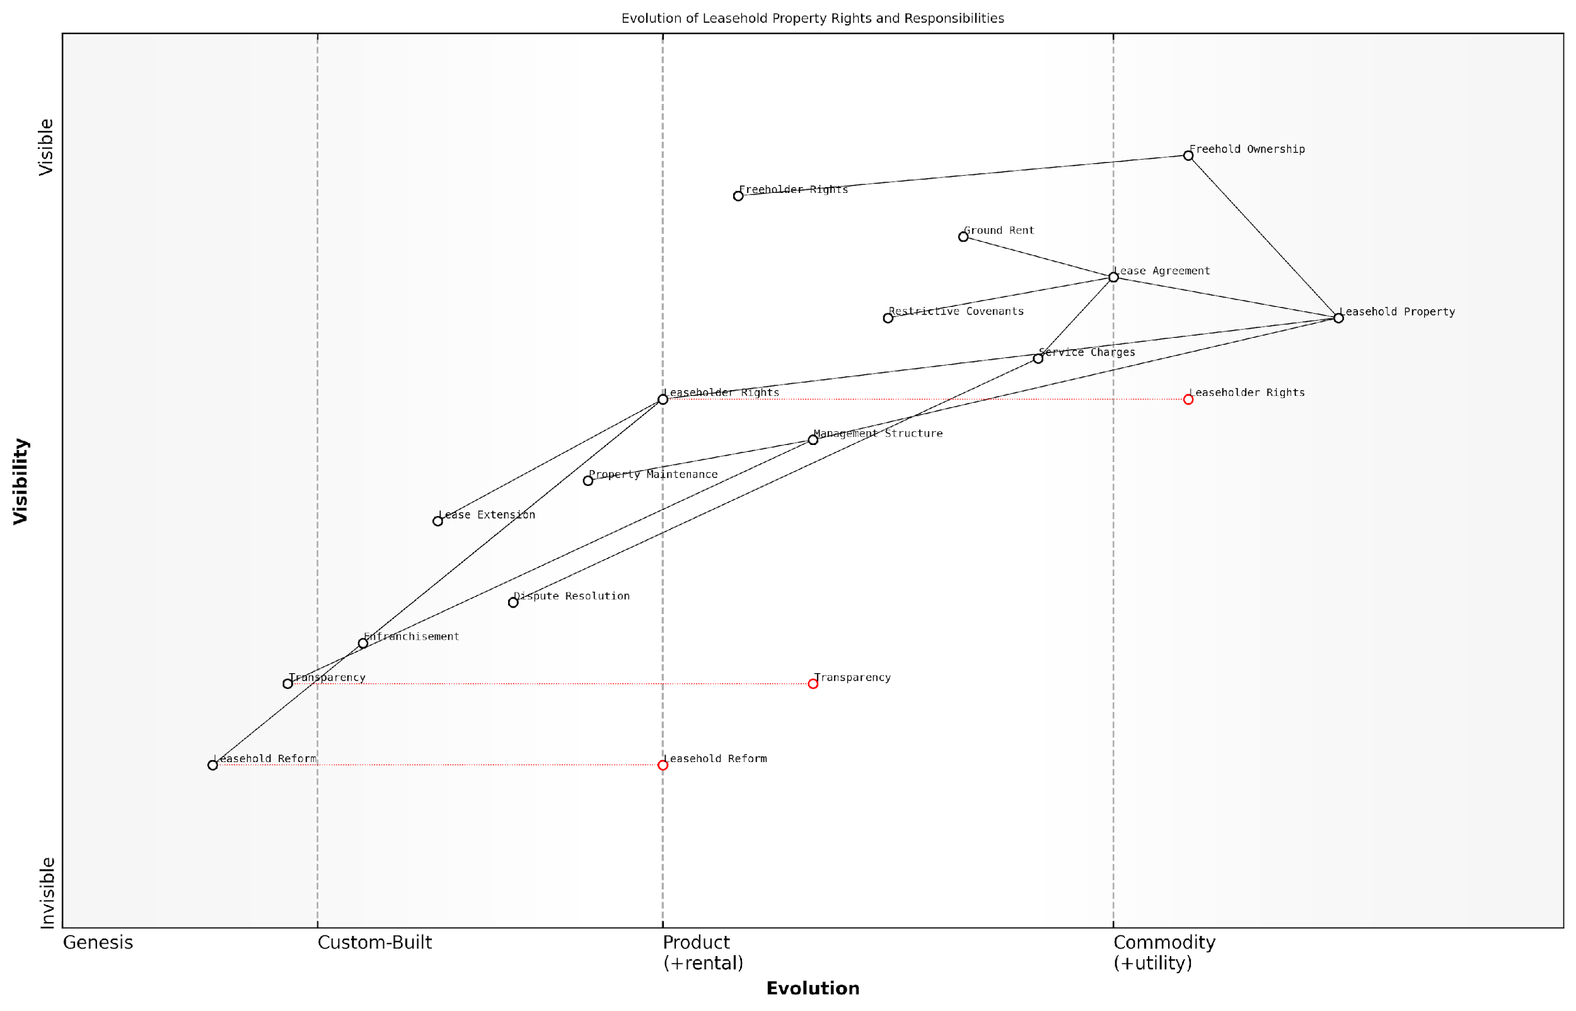

*Draft Wardley Map: [Insert Wardley Map: What is a leasehold property?]*

[Edit this draft Wardley Map](https://create.wardleymaps.ai/#clone:581721e59de2161be6)

Wardley Map Assessment

The Wardley Map reveals a leasehold property system in England that is ripe for transformation. While traditional structures remain entrenched, there is significant momentum towards reform, transparency, and rebalancing of rights. The strategic focus should be on accelerating these changes through a combination of policy reform, technological innovation, and stakeholder collaboration. The key to success lies in navigating the tension between established practices and emerging needs, with a clear focus on enhancing leaseholder rights and system transparency. This transformation presents both challenges and opportunities for all players in the ecosystem, from property owners and managers to policymakers and technology providers.

[View full Wardley Map report](https://github.com/tractorjuice/automated_wardley_reports/blob/main/markdown_wardley_map_reports/wardley_map_report_01_What_is_a_leasehold_property?.md)

### Key players: freeholders, leaseholders, and management agents

Understanding the roles and relationships between freeholders, leaseholders, and management agents is crucial for navigating the complex landscape of leasehold properties in England. These key players form the foundation of the leasehold system, each with distinct rights, responsibilities, and interests that often intersect and sometimes conflict. As we delve into this topic, we’ll explore how these relationships impact service charges, property management, and the overall experience of leasehold living.

Freeholders: The Ultimate Property Owners

Freeholders, also known as landlords, hold the freehold title to the property. This means they own both the building and the land it stands on outright. Their role in the leasehold system includes:

* Granting long-term leases to leaseholders
* Maintaining the structure and common areas of the building
* Setting and collecting ground rent
* Appointing management agents (in many cases)
* Enforcing lease terms and conditions

It’s important to note that freeholders have a legal obligation to maintain the property to a reasonable standard, but their financial interests can sometimes lead to conflicts with leaseholders over service charges and maintenance decisions.

The role of the freeholder is often misunderstood. While they have significant rights, they also bear substantial responsibilities that, if not fulfilled, can lead to legal challenges from leaseholders.

Leaseholders: The Long-Term Tenants

Leaseholders purchase the right to live in a property for a fixed period, typically between 99 and 999 years. Their position in the leasehold system includes:

* Paying ground rent to the freeholder
* Contributing to service charges for building maintenance and management
* Complying with lease terms and conditions
* Rights to challenge unreasonable charges or poor management
* Potential rights to extend their lease or purchase the freehold (under certain conditions)

Leaseholders often face the most significant challenges within the system, particularly when dealing with excessive service charges or unresponsive management. However, they also have substantial legal protections and rights that, when properly exercised, can help address these issues.

Empowered leaseholders who understand their rights and obligations are the key to a well-functioning leasehold system. Knowledge truly is power in this context.

Management Agents: The Operational Intermediaries

Management agents are typically appointed by freeholders to handle the day-to-day operations of leasehold properties. Their responsibilities often include:

* Arranging maintenance and repairs
* Collecting service charges and ground rent
* Enforcing lease conditions
* Providing financial accounts and budgets
* Communicating with leaseholders on behalf of the freeholder

The quality of management agents can vary significantly, and their performance often directly impacts leaseholders’ satisfaction and the overall value of the property. Poor management can lead to excessive service charges, substandard maintenance, and communication breakdowns.

Effective management agents act as a bridge between freeholders and leaseholders, balancing the interests of both parties. However, when this balance is not maintained, it can lead to significant discord within the leasehold community.

The Interplay Between Key Players

The relationships between these key players are complex and often fraught with potential conflicts of interest. Freeholders may prioritise maximising their return on investment, which can lead to appointing management agents who focus more on cost-cutting than service quality. Leaseholders, caught in the middle, may find themselves paying for services they feel are overpriced or inadequate.

Understanding these dynamics is crucial for leaseholders seeking to address issues of excessive service charges or poor management. By recognising the motivations and obligations of each party, leaseholders can more effectively navigate disputes and work towards fair and transparent property management.

Legal Frameworks Governing Key Players

The relationships between freeholders, leaseholders, and management agents are governed by a complex web of legislation, including the Landlord and Tenant Act 1985, the Commonhold and Leasehold Reform Act 2002, and the Leasehold Reform, Housing and Urban Development Act 1993. These laws provide important protections for leaseholders, such as:

* The right to challenge unreasonable service charges
* The right to be consulted on major works
* The right to manage (RTM) their property
* The potential right to extend their lease or purchase the freehold

However, navigating these legal frameworks can be challenging for leaseholders, often requiring professional advice or support from leaseholder associations.

The legal landscape of leasehold is constantly evolving. Staying informed about current and proposed reforms is essential for all parties involved in the leasehold system.

Conclusion: Balancing Rights and Responsibilities

The leasehold system in England relies on a delicate balance between the rights and responsibilities of freeholders, leaseholders, and management agents. While the system has its critics, understanding the roles of these key players is essential for leaseholders seeking to address issues of excessive service charges or poor management. By leveraging their legal rights, engaging proactively with freeholders and management agents, and working collectively with other leaseholders, individuals can navigate the complexities of the leasehold system more effectively.

As we progress through this book, we’ll explore in detail the strategies and tools available to leaseholders for tackling common issues, always keeping in mind the intricate relationships between these key players in the leasehold landscape.

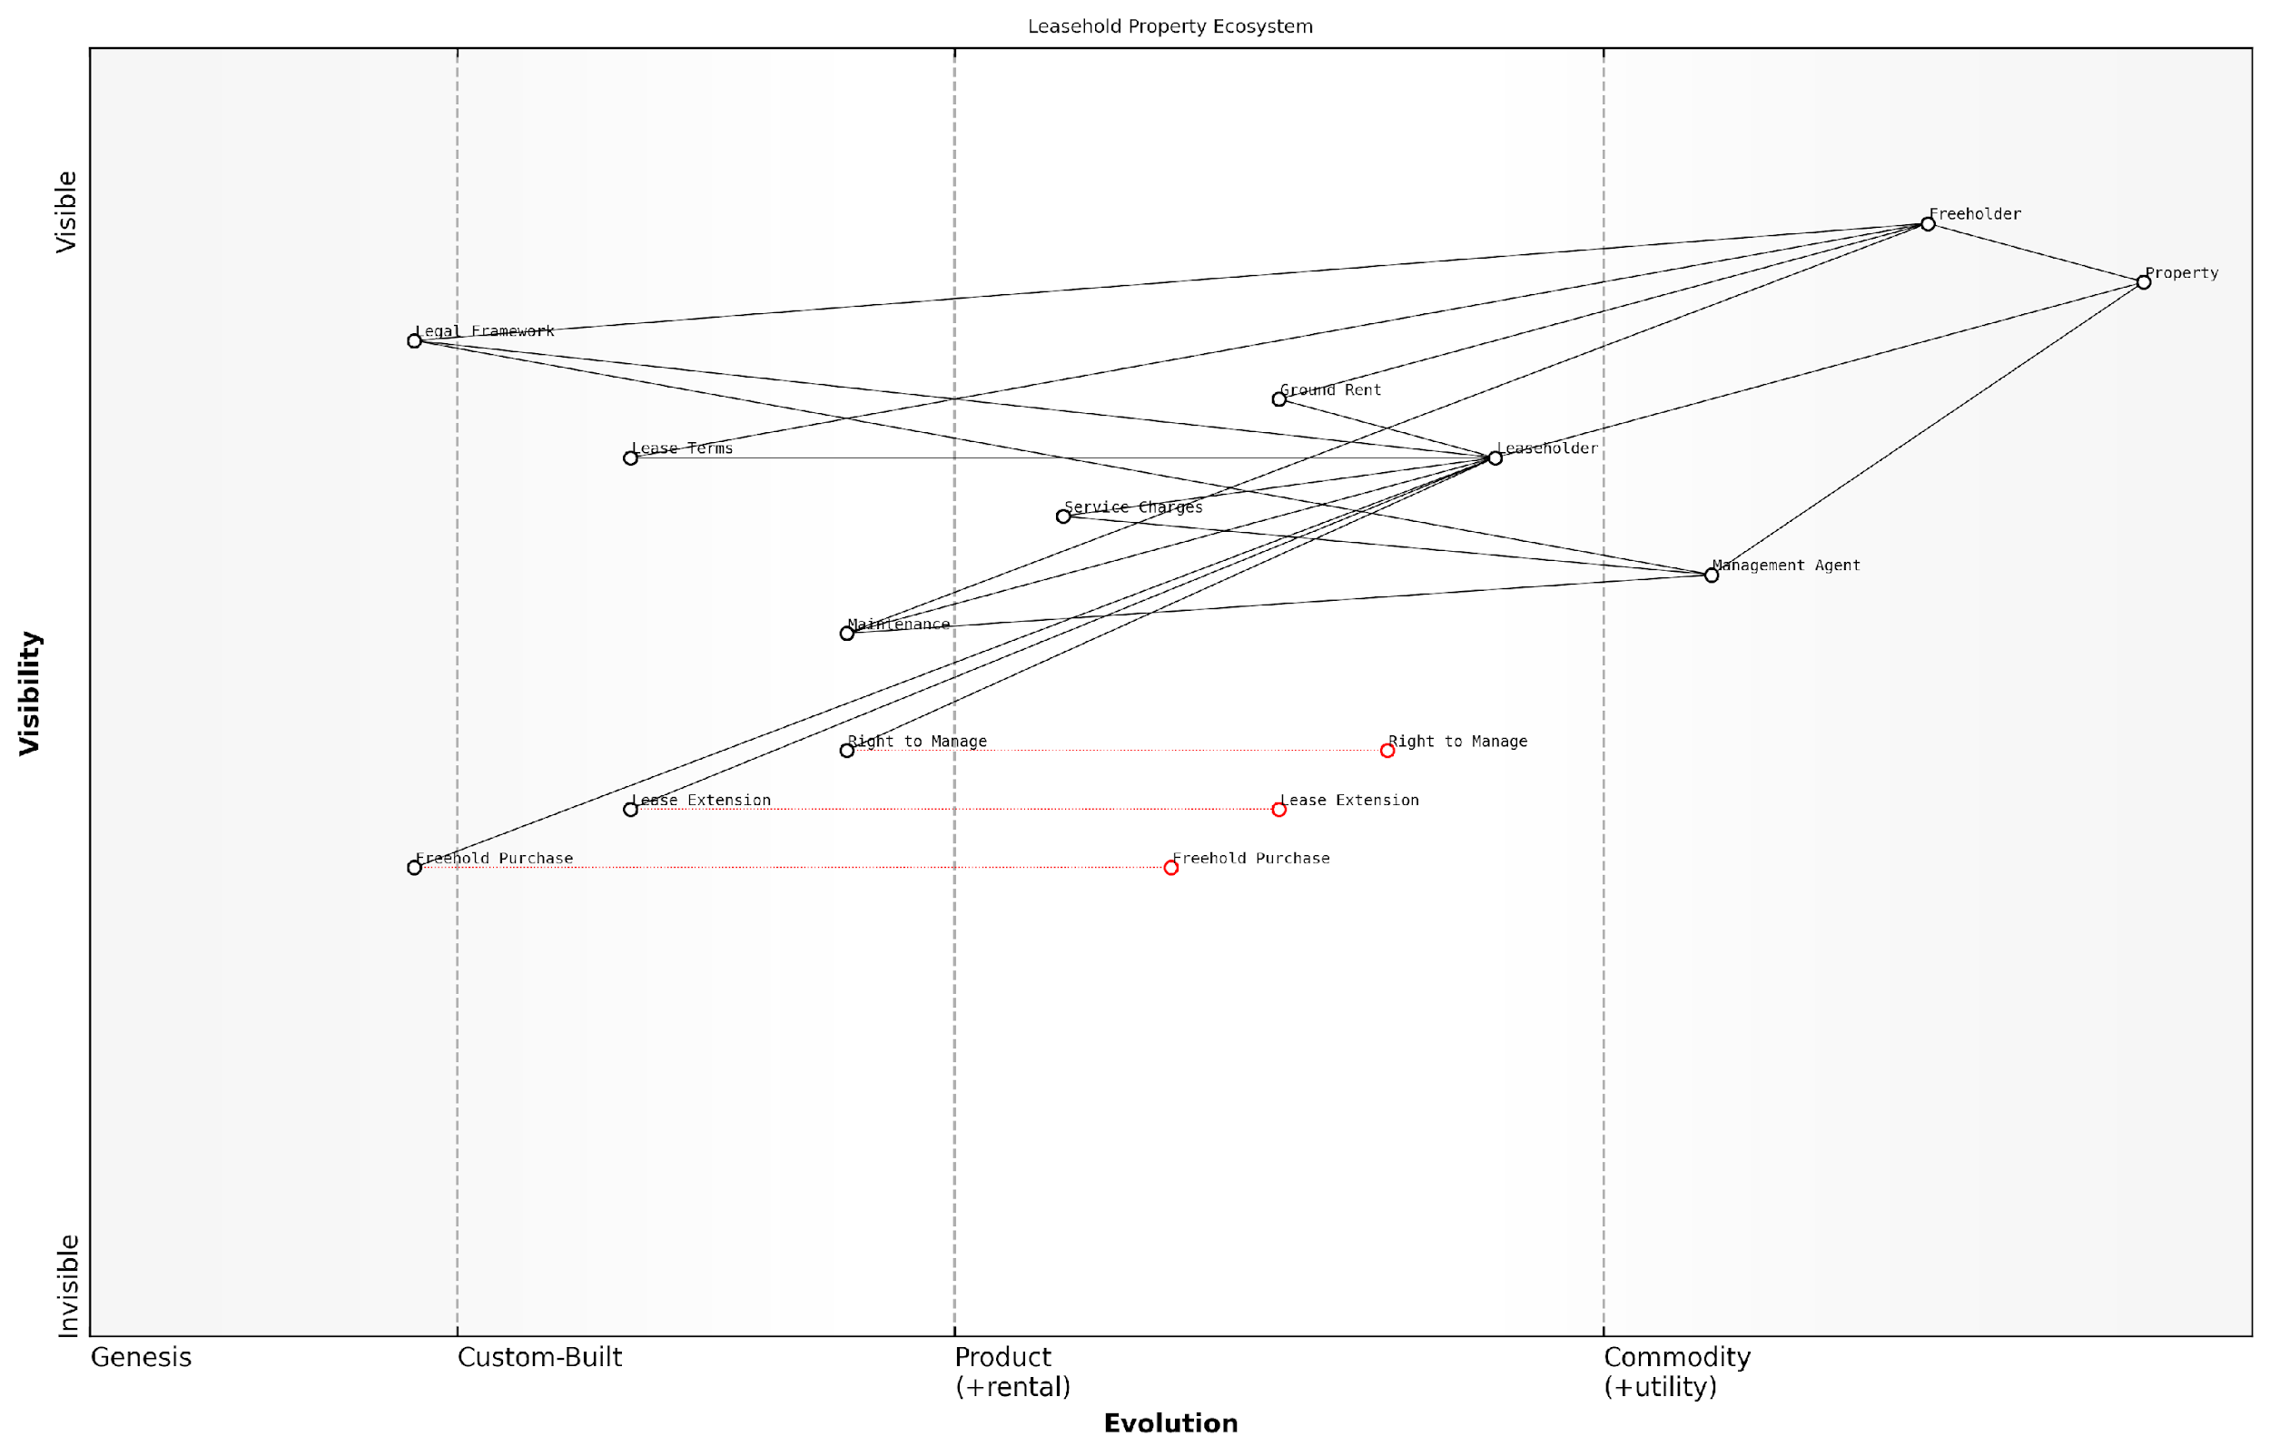

*Draft Wardley Map: [Insert Wardley Map: Key players: freeholders, leaseholders, and management agents]*

[Edit this draft Wardley Map](https://create.wardleymaps.ai/#clone:b1f3b83b03bc0746b6)

Wardley Map Assessment

The Leasehold Property Ecosystem in England is at a critical juncture, with traditional structures being challenged by evolving leaseholder rights and technological possibilities. The strategic focus should be on empowering leaseholders, increasing transparency, and leveraging technology to create a more balanced and efficient system. Key areas for innovation include digitalization of property management, simplification of legal processes, and the promotion of collaborative models between freeholders, leaseholders, and management agents. The successful evolution of this ecosystem will require a careful balance of regulatory reform, technological adoption, and stakeholder education.

[View full Wardley Map report](https://github.com/tractorjuice/automated_wardley_reports/blob/main/markdown_wardley_map_reports/wardley_map_report_02_Key_players:_freeholders,_leaseholders,_and_manage.md)

### Common issues faced by leaseholders

As an expert in leasehold property management and reform, I can attest that leaseholders in England face a myriad of challenges within the current system. These issues often stem from the inherent power imbalance between freeholders and leaseholders, as well as the complexities of leasehold law. Understanding these common problems is crucial for leaseholders to effectively navigate their rights and responsibilities, and to take appropriate action when necessary.

Let’s delve into the most prevalent issues that leaseholders encounter:

* Excessive Service Charges
* Poor Property Management
* Lack of Transparency
* Unfair Lease Terms
* Difficulties in Lease Extension
* Ground Rent Escalation
* Limited Control Over Property Decisions
* Challenges in Selling or Remortgaging

1. Excessive Service Charges: One of the most common and contentious issues faced by leaseholders is the imposition of unreasonable service charges. These charges, which cover the maintenance and repair of communal areas and the building’s structure, can often be inflated or include unnecessary works. In my experience advising government bodies on leasehold reform, I’ve encountered numerous cases where service charges have increased far beyond the rate of inflation without clear justification.

Service charges are meant to reflect the actual costs of maintaining a property, not to serve as a profit centre for freeholders or management companies. Yet, we frequently see charges that bear little relation to the services provided.

1. Poor Property Management: Many leaseholders suffer from substandard property management, which can manifest in various ways. This might include neglect of necessary repairs, poor communication, or failure to properly maintain communal areas. The impact of poor management can be significant, affecting both the quality of life for residents and the value of their properties.
2. Lack of Transparency: Freeholders and management agents often fail to provide clear, detailed breakdowns of costs and decision-making processes. This lack of transparency can make it difficult for leaseholders to understand what they’re paying for and to challenge unreasonable charges or decisions.
3. Unfair Lease Terms: Many leaseholders find themselves bound by unfair or onerous terms in their leases. These might include restrictive covenants, unreasonable fees for permissions or administrative tasks, or clauses that unduly benefit the freeholder at the leaseholder’s expense.
4. Difficulties in Lease Extension: As leases get shorter, their value decreases, and extending a lease can be a complex and expensive process. Many leaseholders struggle with the financial and legal complexities of lease extension, particularly when dealing with uncooperative freeholders.
5. Ground Rent Escalation: Some leases, particularly those created in recent decades, include ground rent terms that double periodically. This can lead to ground rents becoming unaffordable over time and can make properties unmortgageable and difficult to sell.

The issue of escalating ground rents has become so severe that it has prompted government intervention. It’s a prime example of how the leasehold system can be exploited to the detriment of homeowners.

1. Limited Control Over Property Decisions: Leaseholders often find themselves with little say in major decisions affecting their homes, such as the appointment of managing agents or the undertaking of significant works. This lack of control can be frustrating and can lead to decisions being made that are not in the leaseholders’ best interests.
2. Challenges in Selling or Remortgaging: The complexities and potential issues associated with leasehold properties can make them less attractive to buyers and mortgage lenders. This can result in difficulties when leaseholders attempt to sell their properties or secure new mortgage deals.

These issues are interconnected and often compound one another, creating a challenging environment for leaseholders. For instance, a combination of excessive service charges, poor management, and lack of transparency can significantly impact a leaseholder’s financial situation and quality of life.

It’s important to note that while these issues are common, they are not inevitable. Informed and proactive leaseholders can take steps to address many of these problems, whether through individual action, collective efforts with fellow leaseholders, or by engaging with ongoing reform initiatives.

Understanding these common issues is the first step towards addressing them. Throughout this book, we will explore strategies for tackling each of these challenges, empowering leaseholders to assert their rights and work towards a fairer, more transparent leasehold system.

Knowledge is power in the leasehold sector. By understanding the common issues and the systems that perpetuate them, leaseholders can begin to challenge unfair practices and push for meaningful change.

As we progress through subsequent chapters, we will delve deeper into each of these issues, providing practical advice, legal insights, and strategies for both individual and collective action. By addressing these common problems head-on, leaseholders can work towards creating a more equitable and transparent leasehold landscape in England.

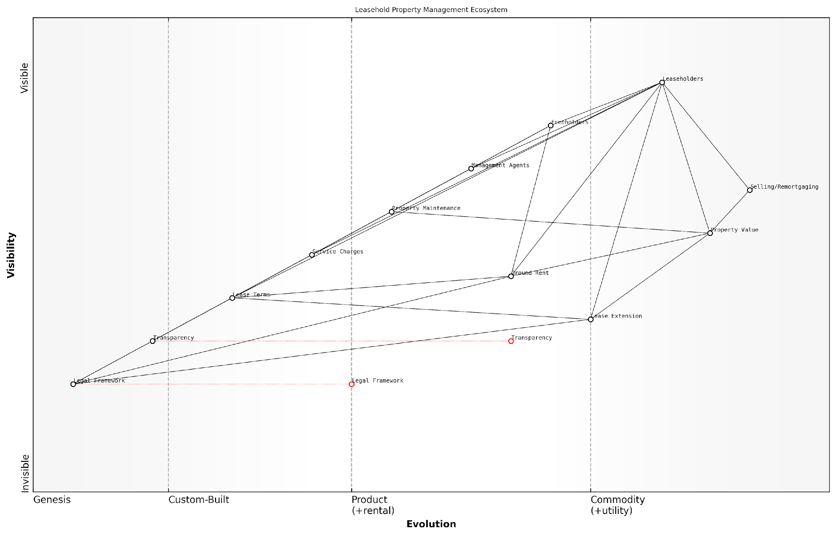

*Draft Wardley Map: [Insert Wardley Map: Common issues faced by leaseholders]*

[Edit this draft Wardley Map](https://create.wardleymaps.ai/#clone:24a90d6cae40044739)

Wardley Map Assessment

The Leasehold Property Management Ecosystem in England is at a critical juncture. While the current system is established, it faces challenges in terms of fairness, transparency, and efficiency. The strategic focus should be on evolving Transparency and the Legal Framework to create a more balanced and efficient system. This will require significant changes from all stakeholders, particularly Freeholders and Management Agents. Innovations in technology and management practices, coupled with regulatory reforms, can drive this evolution. The key to success will be in managing this transition in a way that creates value for Leaseholders while maintaining a viable business model for other stakeholders. The ecosystem is ripe for disruption, and those who can lead in transparency, fairness, and efficiency stand to gain significant competitive advantages.

[View full Wardley Map report](https://github.com/tractorjuice/automated_wardley_reports/blob/main/markdown_wardley_map_reports/wardley_map_report_03_Common_issues_faced_by_leaseholders.md)

## The Legal Framework

### Relevant legislation and regulations

The legal framework governing leasehold properties in England is complex and multifaceted, comprising a patchwork of legislation and regulations that have evolved over time. Understanding this framework is crucial for leaseholders seeking to tackle excessive service charges and address issues with bad management agents. This section provides a comprehensive overview of the key legislation and regulations that shape the rights and obligations of leaseholders, freeholders, and management agents.

The cornerstone of leasehold law in England is the Landlord and Tenant Act 1985, which establishes fundamental principles regarding service charges, consultation requirements, and the rights of leaseholders to challenge unreasonable costs. This Act has been amended and supplemented by subsequent legislation, creating a layered legal landscape that requires careful navigation.

* Landlord and Tenant Act 1985: Sets out basic rights and obligations, including the requirement for service charges to be reasonable.
* Landlord and Tenant Act 1987: Introduced the right of first refusal for leaseholders when the freeholder intends to sell the property.
* Leasehold Reform, Housing and Urban Development Act 1993: Established the right to collective enfranchisement and lease extension.
* Commonhold and Leasehold Reform Act 2002: Introduced the Right to Manage (RTM) and made significant changes to service charge regulations.
* Housing and Planning Act 2016: Strengthened leaseholder protections, including measures against retaliatory eviction.

These Acts form the backbone of leasehold law, but they are complemented by a range of regulations and statutory instruments that provide more detailed guidance on specific aspects of leasehold management. For instance, the Service Charges (Consultation Requirements) (England) Regulations 2003 set out the precise steps that landlords must follow when consulting leaseholders about major works or long-term agreements.

The complexity of leasehold legislation can be daunting, but it’s this very complexity that provides leaseholders with numerous avenues to challenge unfair practices. Understanding the law is the first step towards empowerment.

One of the most significant pieces of legislation for leaseholders dealing with excessive service charges is the Landlord and Tenant Act 1985, specifically Section 19, which stipulates that service charges must be reasonably incurred and that any work or services must be of a reasonable standard. This provision is frequently invoked in disputes before the First-tier Tribunal (Property Chamber), which has the power to determine the reasonableness of service charges.

The Commonhold and Leasehold Reform Act 2002 introduced several important changes, including:

* The Right to Manage (RTM), allowing leaseholders to take control of the management of their building without having to prove fault on the part of the landlord.
* New regulations on the form and content of service charge demands.
* The requirement for service charge funds to be held in trust.
* The ability for leaseholders to challenge administration charges.

More recently, the government has signalled its intention to reform leasehold law further, with proposals including the ban on new leasehold houses and the reduction of ground rents to zero for new leases. While these reforms are still in progress, they indicate a shifting landscape that leaseholders should be aware of when considering long-term strategies for dealing with their properties.

It’s also important to note the role of case law in shaping the interpretation and application of leasehold legislation. Decisions made by the Upper Tribunal (Lands Chamber) and higher courts can set precedents that influence how the law is applied in future cases. Staying informed about significant case law developments can provide leaseholders with valuable insights into how to approach their own disputes.

While legislation provides the framework, it’s often the interpretation of these laws in specific cases that truly defines the boundaries of leaseholder rights and landlord obligations.

In addition to primary legislation, leaseholders should be aware of various codes of practice and guidelines that, while not legally binding, can influence tribunal decisions and set standards for good practice. These include:

* The RICS Code of Practice on Service Charges in Commercial Property
* The ARHM Code of Practice for retirement housing
* The LEASE (Leasehold Advisory Service) guides and factsheets

Understanding the interplay between legislation, regulations, and best practice guidelines is essential for leaseholders seeking to challenge excessive service charges or address issues with management agents. It provides the foundation for building strong cases, whether through informal negotiations or formal dispute resolution processes.

As we navigate through the complexities of leasehold law, it becomes clear that knowledge is power. Leaseholders armed with a thorough understanding of the legal framework are better equipped to assert their rights, challenge unfair practices, and work towards a more equitable leasehold system. The subsequent sections of this chapter will delve deeper into specific rights and obligations, providing practical guidance on how to leverage this legal knowledge in real-world scenarios.

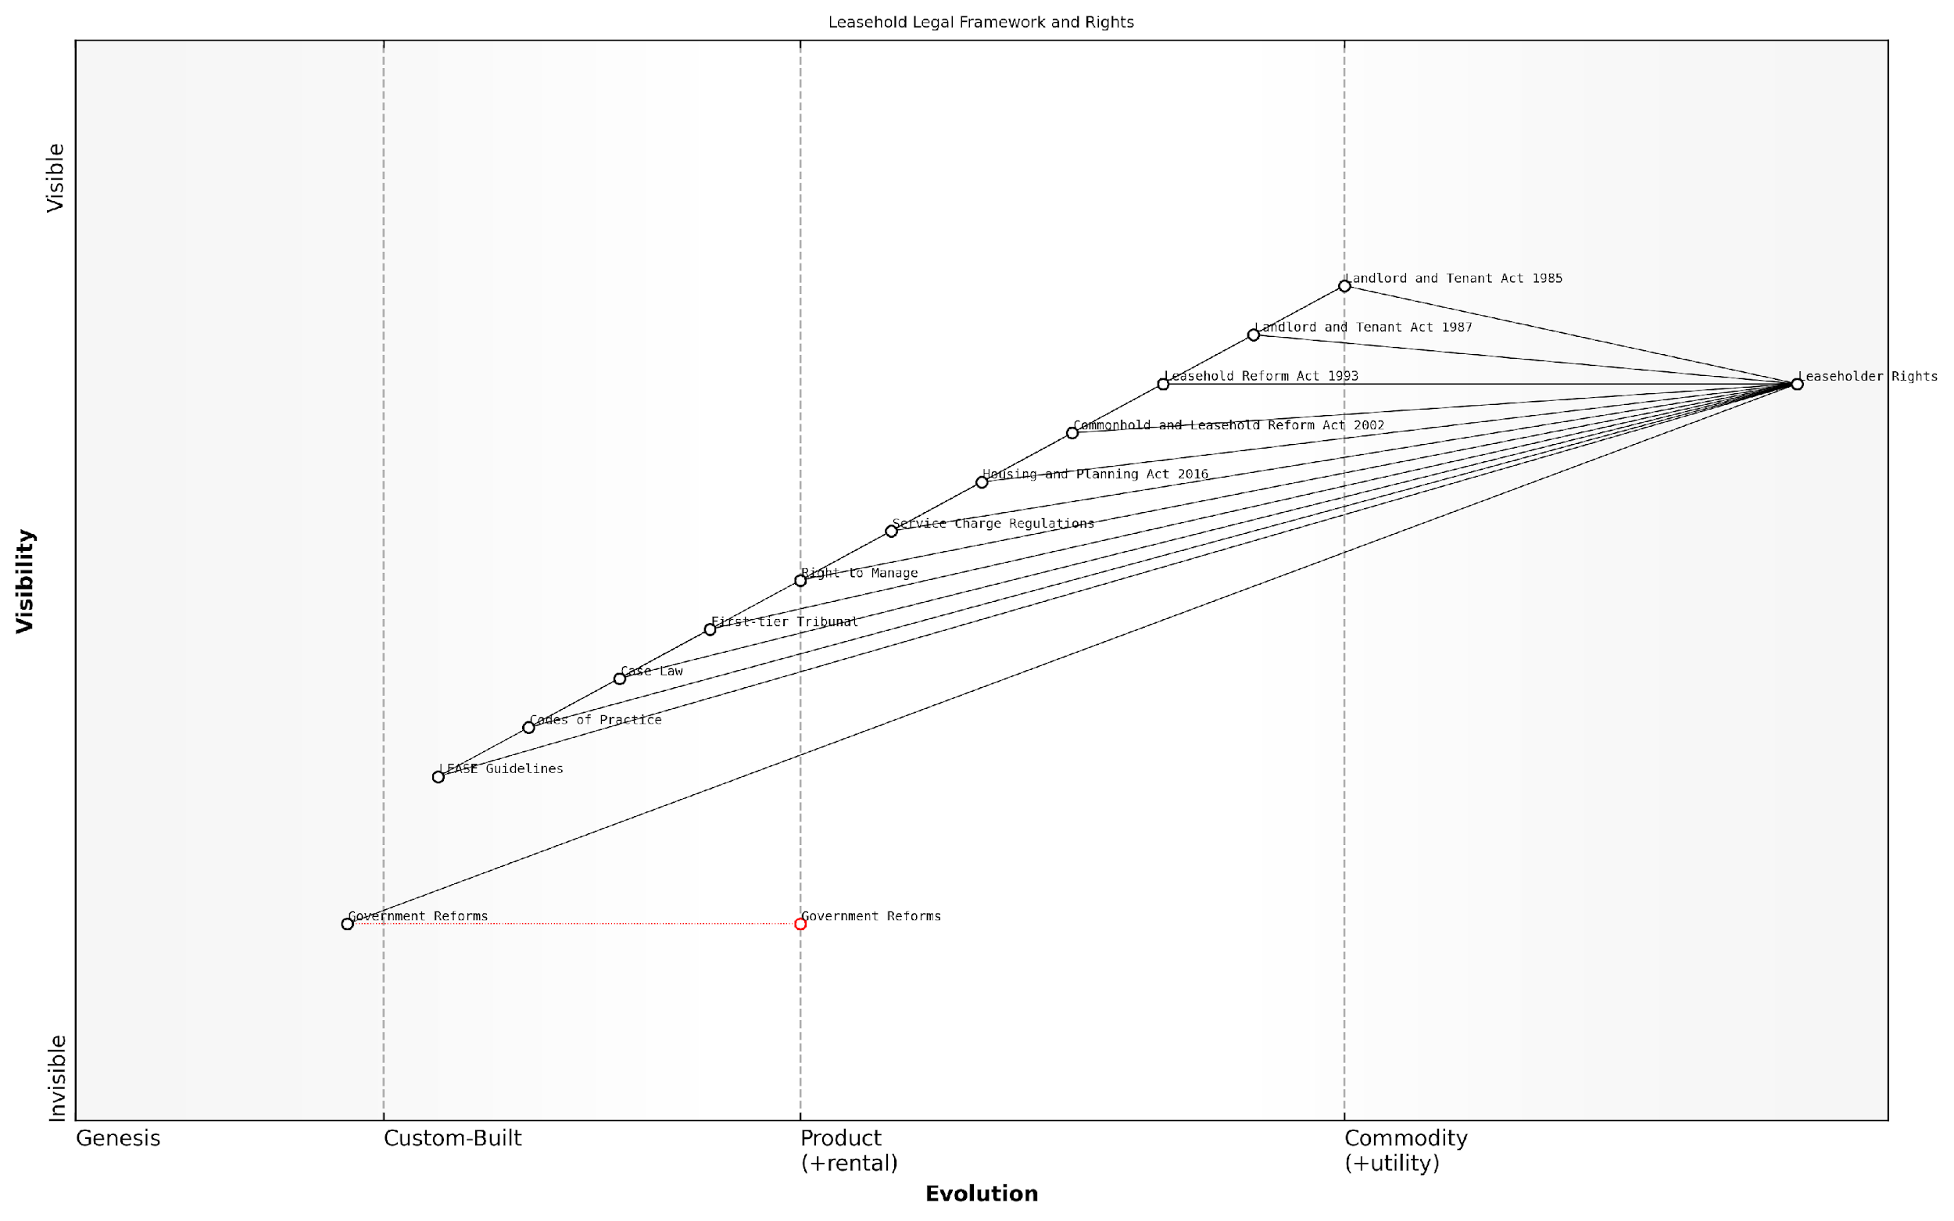

*Draft Wardley Map: [Insert Wardley Map: Relevant legislation and regulations]*

[Edit this draft Wardley Map](https://create.wardleymaps.ai/#clone:fabc5e9b05b211f301)

Wardley Map Assessment

The Leasehold Legal Framework and Rights ecosystem in England is well-established but complex, with opportunities for significant improvement through technological integration, streamlined processes, and comprehensive reforms. The strategic focus should be on simplifying the system, empowering leaseholders through better access to information and dispute resolution, and leveraging emerging technologies to create a more transparent and efficient leasehold landscape. While the current framework provides strong protections, its evolution towards a more user-friendly and technologically advanced system will be crucial for addressing current inefficiencies and future challenges in the leasehold sector.

[View full Wardley Map report](https://github.com/tractorjuice/automated_wardley_reports/blob/main/markdown_wardley_map_reports/wardley_map_report_04_Relevant_legislation_and_regulations.md)

### Your rights as a leaseholder

Understanding your rights as a leaseholder is crucial in the complex landscape of leasehold property ownership in England. These rights form the foundation for tackling excessive service charges and addressing issues with bad management agents. As an expert in this field, I can attest that a thorough grasp of these rights empowers leaseholders to effectively navigate challenges and protect their interests.

The legal framework governing leaseholder rights in England is primarily established by several key pieces of legislation, including the Landlord and Tenant Act 1985, the Leasehold Reform, Housing and Urban Development Act 1993, and the Commonhold and Leasehold Reform Act 2002. These acts, along with subsequent amendments and regulations, form a comprehensive set of protections and entitlements for leaseholders.

Let’s delve into the core rights that every leaseholder should be aware of:

* Right to Information: Leaseholders have the right to obtain key information about their property, including the name and address of the freeholder, details of service charges, and copies of relevant insurance policies.
* Right to Challenge Service Charges: Leaseholders can challenge unreasonable service charges through the First-tier Tribunal (Property Chamber).
* Right to be Consulted: For major works or long-term agreements exceeding a certain cost threshold, leaseholders must be consulted.
* Right to Manage: Qualifying leaseholders can take over the management of their building through the Right to Manage (RTM) process.
* Right to Extend the Lease: Most leaseholders have the statutory right to extend their lease by 90 years and reduce the ground rent to zero, subject to certain conditions.
* Right to Buy the Freehold: Leaseholders in qualifying buildings can join together to purchase the freehold of their property, a process known as collective enfranchisement.
* Right to First Refusal: In certain circumstances, leaseholders must be offered first refusal if the freeholder decides to sell the freehold.
* Right to Fair Treatment: Leaseholders are protected against forfeiture of their lease without due process and have the right to seek redress for breaches of covenant by the freeholder.

It’s important to note that these rights are not always absolute and may be subject to specific conditions or qualifications. For instance, the right to manage requires a certain proportion of leaseholders to participate, and the right to extend a lease or purchase the freehold is subject to length of ownership and other criteria.

The strength of leaseholder rights lies not just in their existence, but in leaseholders’ awareness and willingness to exercise them. Knowledge truly is power in the leasehold context.

In my experience advising leaseholders and government bodies, I’ve observed that many issues arise from a lack of awareness of these rights. For example, a case I encountered involved a group of leaseholders facing exorbitant service charges for unnecessary works. By exercising their right to challenge these charges at the Tribunal and their right to be consulted on major works, they were able to significantly reduce the financial burden and improve the management practices in their building.

It’s also crucial to understand how these rights interact with the obligations of freeholders and management agents. For instance, the requirement for transparency in service charge accounts is not just a right of leaseholders but a corresponding obligation on the part of managing agents. This interplay forms the basis for many of the strategies we’ll explore in later chapters for addressing issues with service charges and management.

Recent years have seen a growing movement towards leasehold reform in England, with proposals to strengthen leaseholder rights further. These include potential changes to make lease extensions easier and more affordable, and to phase out leasehold for new-build houses. While these reforms are still in progress, they underscore the importance of staying informed about your rights as a leaseholder, as the landscape continues to evolve.

As we progress through this book, we’ll explore practical strategies for exercising these rights effectively. We’ll delve into the nuances of challenging service charges, the process of exercising the right to manage, and how to navigate the complexities of lease extension and enfranchisement. Understanding your rights is the first step; knowing how to leverage them strategically is key to addressing issues with excessive charges and poor management in leasehold properties.

In the realm of leasehold property, rights are not just protections, but tools for positive change. Leaseholders who understand and assertively exercise their rights can transform their living situations and contribute to the broader improvement of the leasehold system.

As we conclude this section on leaseholder rights, it’s important to emphasise that while these rights provide significant protections, they also come with responsibilities. Leaseholders must comply with the terms of their lease, pay legitimate service charges, and engage constructively with freeholders and managing agents. Balancing rights and responsibilities is key to fostering a fair and functional leasehold system.

In the following sections, we’ll build on this foundation of rights to explore specific strategies for tackling excessive service charges and addressing issues with management agents. Armed with a solid understanding of your legal rights, you’ll be well-equipped to navigate the challenges of leasehold ownership and work towards a fairer, more transparent leasehold landscape.

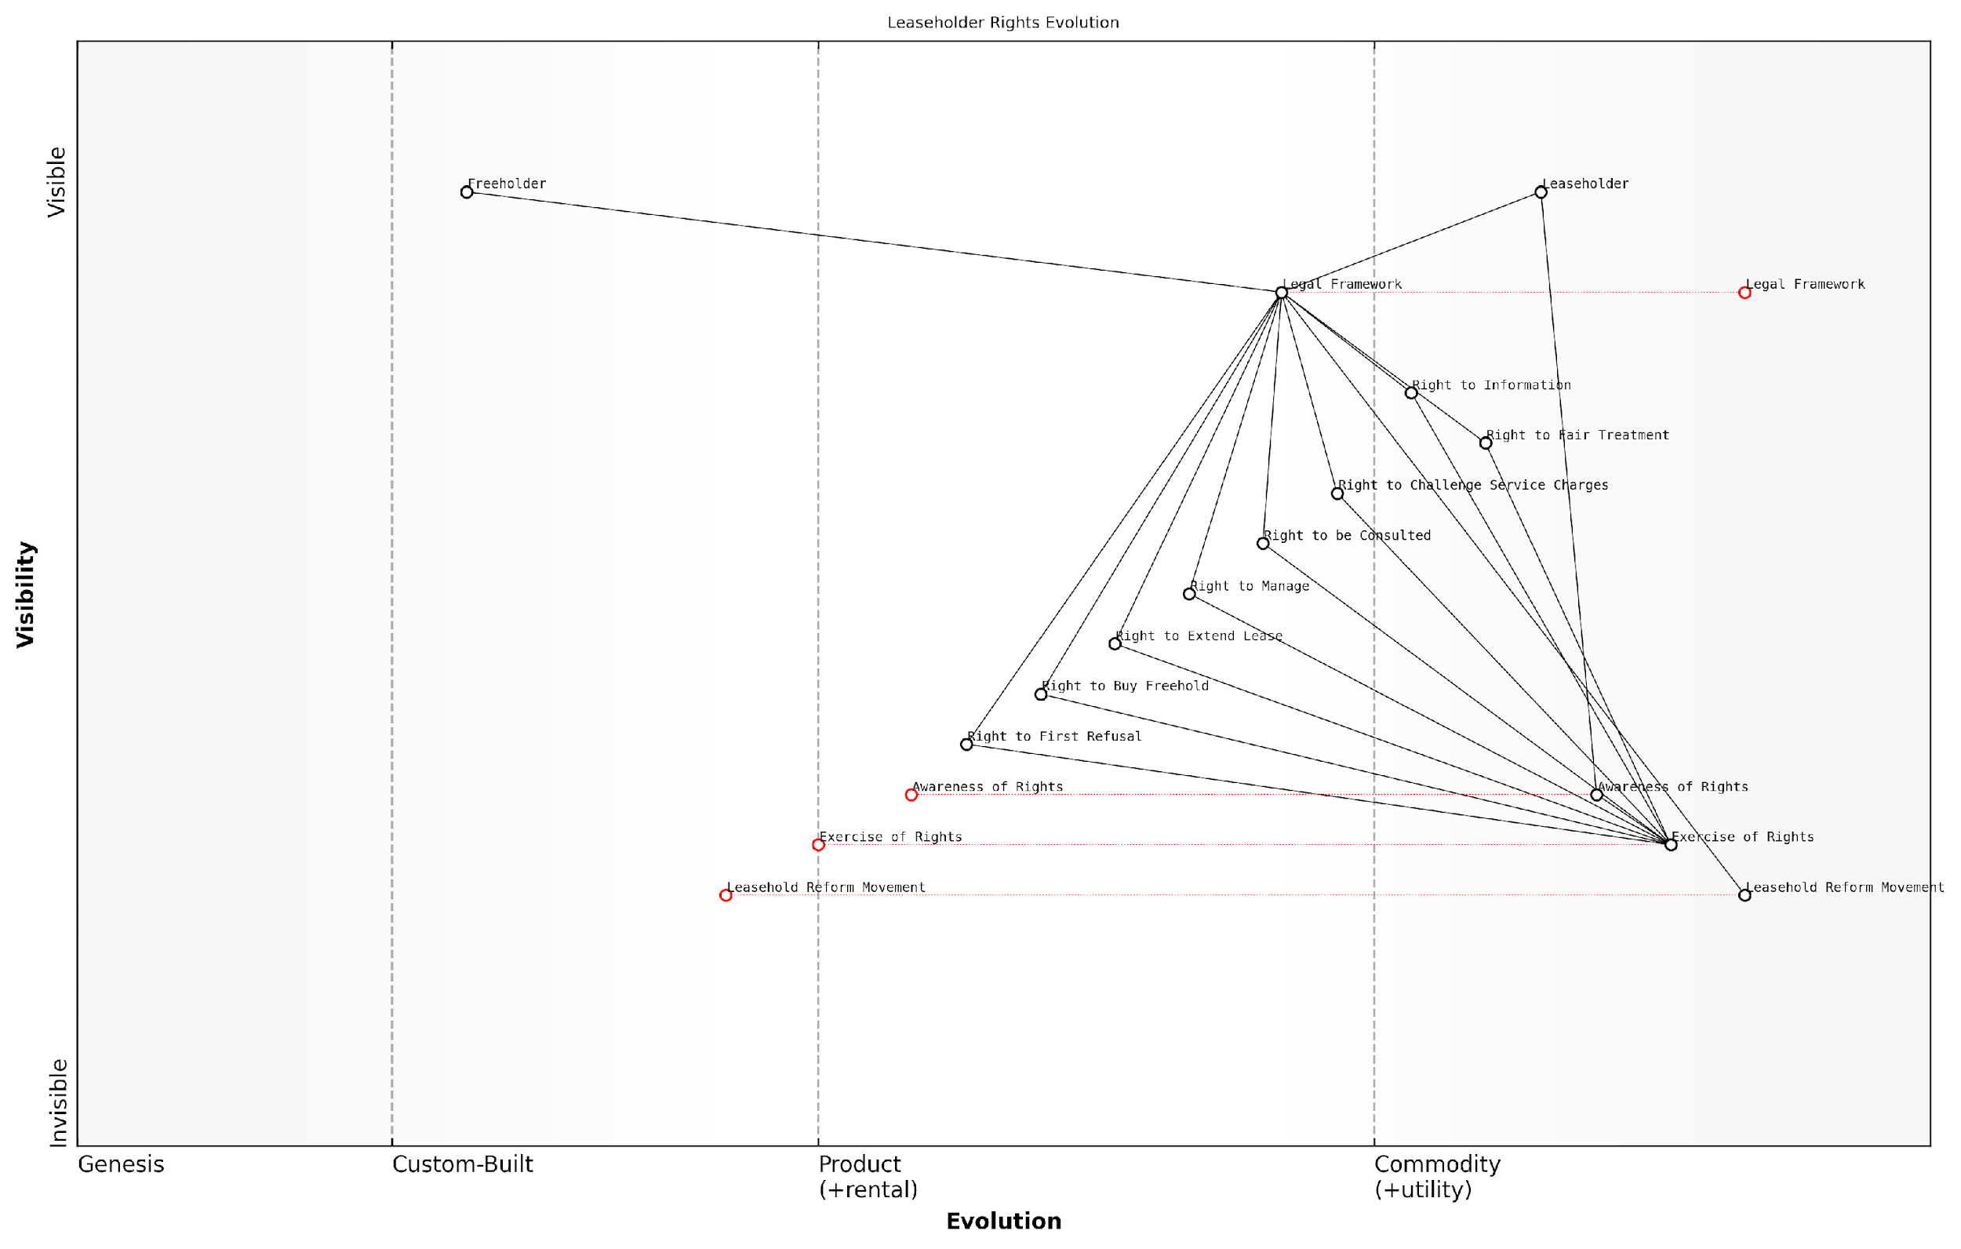

*Draft Wardley Map: [Insert Wardley Map: Your rights as a leaseholder]*

[Edit this draft Wardley Map](https://create.wardleymaps.ai/#clone:5e5d9d617bc77ba442)

Wardley Map Assessment

The Wardley Map reveals a leasehold system in transition, with well-established legal rights but lagging practical implementation. The key strategic opportunity lies in bridging the gap between the existence of rights and their awareness and exercise. By focusing on education, technology integration, and reform advocacy, there’s potential to significantly empower leaseholders and potentially transform the leasehold landscape. The emerging Leasehold Reform Movement, if properly leveraged, could be a catalyst for systemic change. The challenge will be navigating the complex ecosystem and overcoming resistance from established interests. Success will require a multi-faceted approach combining short-term practical improvements with long-term strategic reform efforts.

[View full Wardley Map report](https://github.com/tractorjuice/automated_wardley_reports/blob/main/markdown_wardley_map_reports/wardley_map_report_05_Your_rights_as_a_leaseholder.md)

### Obligations of freeholders and management agents

In the complex landscape of leasehold property management in England, understanding the obligations of freeholders and management agents is crucial for leaseholders seeking to tackle excessive service charges and poor management practices. This section delves into the legal framework that governs these obligations, providing a comprehensive overview of the responsibilities that freeholders and their appointed agents must uphold.

The obligations of freeholders and management agents are primarily derived from three key sources: statutory law, the terms of the lease, and common law principles. These obligations are designed to ensure the proper maintenance and management of leasehold properties, while also protecting the rights of leaseholders.

1. Statutory Obligations

* Compliance with the Landlord and Tenant Act 1985: This act sets out the basic framework for service charges and requires that they be reasonable and subject to consultation for major works.
* Adherence to the Commonhold and Leasehold Reform Act 2002: This legislation introduced the Right to Manage (RTM) and made significant changes to leasehold management practices.
* Observance of the Service Charges (Consultation Requirements) (England) Regulations 2003: These regulations detail the specific consultation procedures that must be followed for major works and long-term agreements.
* Compliance with the Landlord and Tenant Act 1987: This act provides leaseholders with the right of first refusal if the freeholder decides to sell the freehold.

1. Lease-Specific Obligations

The lease agreement serves as a contract between the freeholder and leaseholder, outlining specific obligations for both parties. Common obligations for freeholders and their appointed management agents include:

* Maintaining the structure and exterior of the building
* Insuring the building (but not the contents of individual flats)
* Providing and maintaining common areas and services
* Collecting service charges and ground rent
* Enforcing lease covenants
* Providing annual service charge accounts and budgets

1. Common Law Obligations

In addition to statutory and lease-specific obligations, freeholders and management agents are bound by common law principles, including:

* Duty of care: Ensuring the safety and well-being of leaseholders and visitors
* Reasonable skill and care: Managing the property with professional competence
* Fiduciary duty: Acting in the best interests of the leaseholders when managing their funds

The relationship between freeholder, management agent, and leaseholder is fundamentally one of trust and responsibility. The legal framework exists to ensure this relationship functions fairly and efficiently for all parties involved.

Key Responsibilities of Freeholders and Management Agents:

* Transparency in financial management: Providing clear, itemised service charge demands and maintaining accurate accounts
* Consultation on major works: Following the statutory consultation process for works exceeding £250 per leaseholder
* Responsiveness to leaseholder concerns: Addressing maintenance issues and complaints in a timely manner
* Compliance with health and safety regulations: Ensuring the property meets all relevant safety standards
* Fair procurement practices: Obtaining competitive quotes for works and services to ensure value for money
* Proper handling of leaseholder funds: Holding service charge monies in trust and providing annual accounts
* Maintenance of accurate records: Keeping detailed records of all property-related matters, including correspondence, accounts, and maintenance schedules

Enforcement and Recourse

When freeholders or management agents fail to meet their obligations, leaseholders have several avenues for recourse:

* First-tier Tribunal (Property Chamber): Can adjudicate on disputes related to service charges, management practices, and lease interpretations
* Right to Manage (RTM): Allows leaseholders to take over the management of their property without purchasing the freehold
* Appointment of a manager: In cases of serious mismanagement, leaseholders can apply to the tribunal for the appointment of a new manager
* Collective enfranchisement: Leaseholders can join together to purchase the freehold, giving them full control over the property’s management

Understanding and enforcing the obligations of freeholders and management agents is crucial for maintaining a fair and functional leasehold system. It empowers leaseholders to hold those responsible for their property to account and ensures the protection of their interests.

In practice, the relationship between freeholders, management agents, and leaseholders can be complex and sometimes contentious. A clear understanding of these obligations is essential for leaseholders seeking to challenge excessive service charges or poor management practices. By being well-informed about the legal framework governing these obligations, leaseholders are better equipped to assert their rights and work towards fair and effective property management.

As the leasehold landscape in England continues to evolve, with ongoing discussions about reform and alternative models of property ownership, the obligations of freeholders and management agents remain a critical area of focus. Leaseholders who are well-versed in these obligations are better positioned to navigate the challenges of leasehold ownership and contribute to the ongoing dialogue about improving the system for all stakeholders.

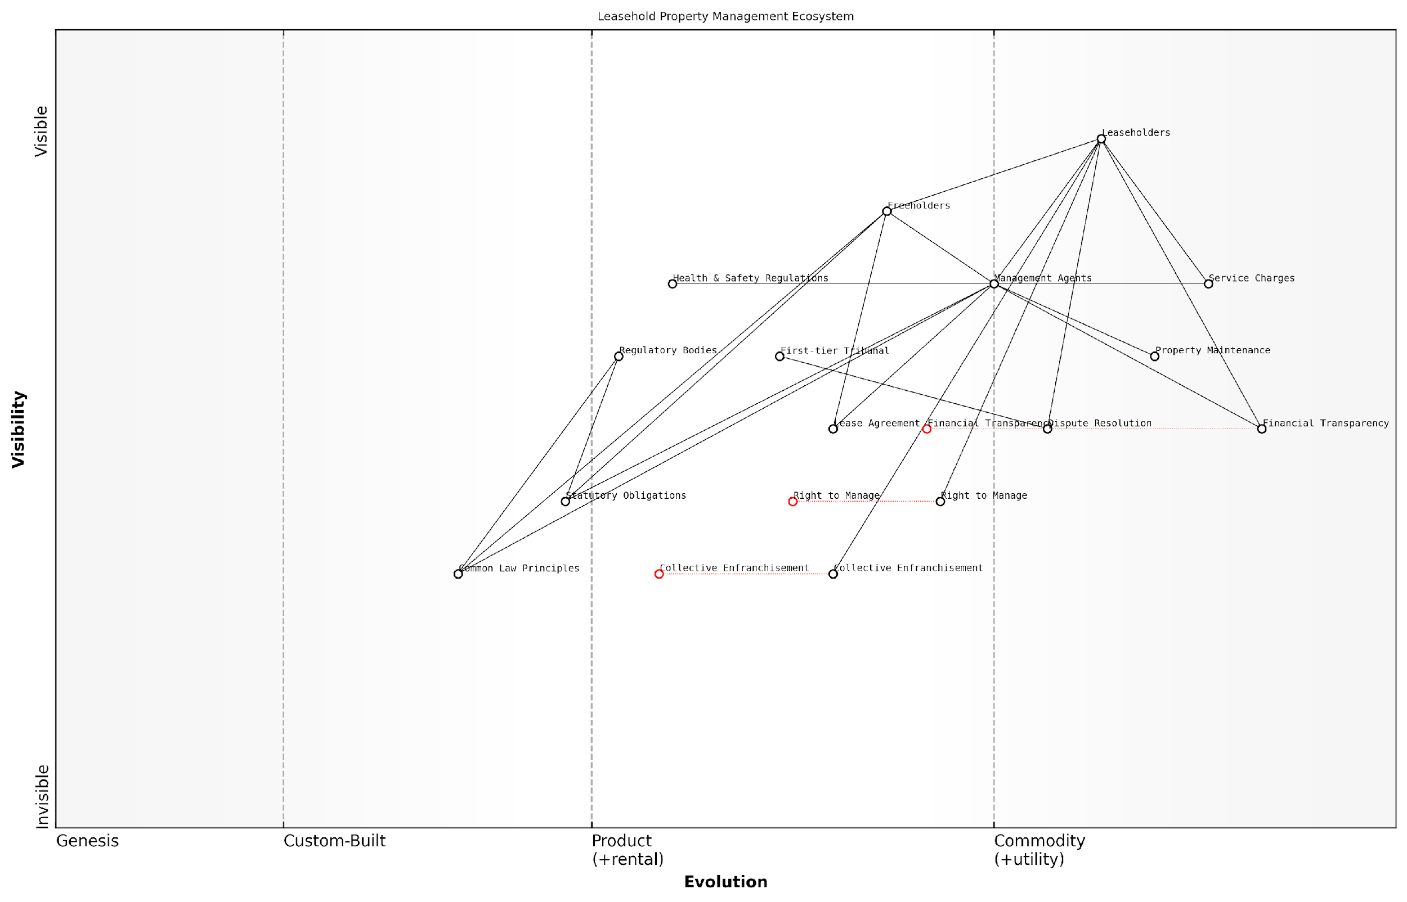

*Draft Wardley Map: [Insert Wardley Map: Obligations of freeholders and management agents]*

[Edit this draft Wardley Map](https://create.wardleymaps.ai/#clone:037f8ecc4a8bc0fd84)

Wardley Map Assessment

The Leasehold Property Management Ecosystem is at a critical juncture, balancing traditional structures with evolving leaseholder rights and technological advancements. The strategic focus should be on enhancing transparency, efficiency, and leaseholder empowerment through technology adoption and process standardization. Key areas for improvement include financial transparency, property maintenance efficiency, and dispute resolution processes. The ecosystem shows potential for significant transformation, with opportunities for innovative service providers and technology companies to disrupt traditional management models. Stakeholders should prepare for a more collaborative, transparent, and technology-driven future in leasehold property management.

[View full Wardley Map report](https://github.com/tractorjuice/automated_wardley_reports/blob/main/markdown_wardley_map_reports/wardley_map_report_06_Obligations_of_freeholders_and_management_agents.md)

# Decoding Service Charges and Management Fees

## Understanding Service Charges

### What are service charges?

Service charges are a fundamental aspect of leasehold property ownership in England, yet they often prove to be a source of confusion and contention for many leaseholders. As an expert in this field, I can attest that a clear understanding of service charges is crucial for tackling excessive fees and managing relationships with management agents effectively.

At its core, a service charge is a payment made by leaseholders to cover the costs of maintaining and managing the building and common areas of their property. These charges are typically collected by the freeholder or a management agent acting on their behalf. The concept seems straightforward, but the reality is often complex and fraught with potential issues.

Let’s delve deeper into the key aspects of service charges:

* Legal basis: Service charges are governed by the terms of the lease and relevant legislation, primarily the Landlord and Tenant Act 1985 and the Commonhold and Leasehold Reform Act 2002.
* Variable nature: Unlike ground rent, service charges can vary from year to year, depending on the actual costs incurred.
* Scope of services: These can include building insurance, cleaning, maintenance, repairs, and management fees.
* Reasonableness requirement: The law stipulates that service charges must be reasonable and for services or works carried out to an acceptable standard.
* Consultation obligations: For major works or long-term agreements, landlords must follow a statutory consultation process with leaseholders.

One of the most critical aspects of service charges is the principle of ‘reasonableness’. As a senior tribunal member once remarked, ‘The test of reasonableness is not merely what the landlord or managing agent thinks is reasonable. It is an objective test of what a reasonable person would consider a reasonable charge for the service in question.’

This principle is crucial for leaseholders to understand, as it forms the basis for challenging excessive or unjustified charges. In my experience advising government bodies on leasehold reform, I’ve observed that many disputes arise from a lack of clarity around what constitutes a ‘reasonable’ charge.

Another key consideration is the transparency of service charges. Best practice dictates that leaseholders should receive clear, itemised breakdowns of charges, allowing them to scrutinise costs effectively. As a leading expert in the field noted, ‘Transparency in service charge accounts is not just good practice; it’s essential for building trust between leaseholders and managing agents.’

It’s worth noting that service charges can be either fixed or variable. Fixed service charges are set out in the lease and do not change, regardless of actual costs incurred. Variable charges, which are more common, can fluctuate based on actual expenditure. This variability can sometimes lead to unexpected increases, causing financial strain for leaseholders.

In my years of consultancy, I’ve found that the most successful management of service charges occurs when there’s open communication between all parties. Leaseholders who understand their rights and obligations, and freeholders who prioritise transparency and fairness, are far less likely to end up in disputes.

An often overlooked aspect of service charges is the concept of ‘sinking funds’ or ‘reserve funds’. These are amounts collected in advance to cover future major works or unexpected costs. While they can help smooth out large expenditures, they can also be a source of contention if not managed properly.

Let’s consider a practical example to illustrate the complexities of service charges:

Imagine a block of 20 flats where the lift needs replacing. The cost is £100,000. The management agent proposes to split this cost equally among the leaseholders, resulting in a one-off charge of £5,000 per flat. However, this approach might not be fair or reasonable. Factors to consider include:

* Whether the lease allows for such a significant one-off charge
* If there should have been a sinking fund in place for such major works
* Whether the cost should be apportioned differently (e.g., based on floor level or flat size)
* If the statutory consultation process was followed correctly
* Whether multiple quotes were obtained to ensure value for money

This example highlights the importance of leaseholders being vigilant and informed about their service charges. It also underscores the need for management agents to act transparently and in accordance with both the lease terms and relevant legislation.

In conclusion, understanding service charges is crucial for leaseholders to effectively manage their property costs and relationships with freeholders and management agents. It forms the foundation for identifying and challenging excessive charges, and for participating in the broader movement towards leasehold reform in England.

As we move forward in this chapter, we’ll explore in more detail the specific items typically covered by service charges and delve deeper into the concepts of reasonableness and consultation requirements. This knowledge will empower leaseholders to take control of their financial obligations and ensure they’re getting fair value for their service charge payments.

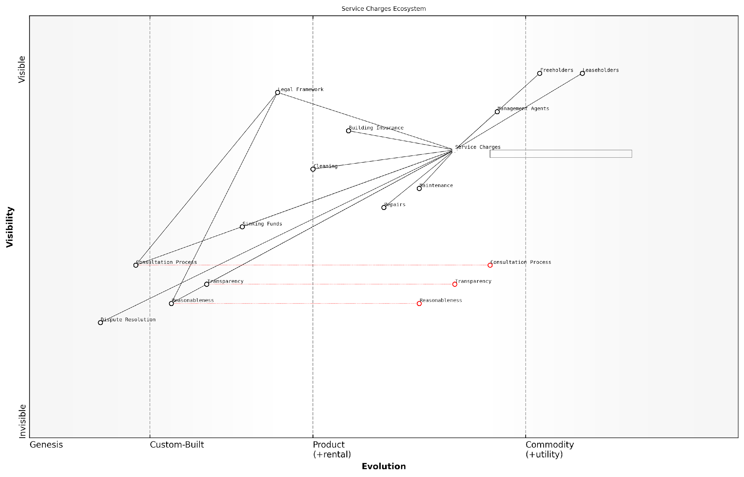

*Draft Wardley Map: [Insert Wardley Map: What are service charges?]*

[Edit this draft Wardley Map](https://create.wardleymaps.ai/#clone:3cccd148702485a85f)

Wardley Map Assessment

The Service Charges Ecosystem in Leasehold Properties is ripe for innovation and improvement. Key areas for strategic focus include enhancing Transparency, standardising Consultation Processes, and leveraging technology for more efficient and fair Service Charge management. The evolving nature of critical components suggests a system in transition, presenting opportunities for forward-thinking organisations to gain competitive advantage through innovation and improved stakeholder satisfaction. Prioritising these areas could lead to a more efficient, transparent, and equitable ecosystem for all involved parties.

[View full Wardley Map report](https://github.com/tractorjuice/automated_wardley_reports/blob/main/markdown_wardley_map_reports/wardley_map_report_07_What_are_service_charges?.md)

### Typical items covered by service charges

Understanding the typical items covered by service charges is crucial for leaseholders in England to effectively scrutinise and challenge excessive fees. Service charges are a fundamental aspect of leasehold ownership, designed to cover the costs of maintaining and managing the building and common areas. However, the lack of transparency and potential for abuse make it essential for leaseholders to be well-informed about what should and should not be included in these charges.

Let’s delve into the most common categories of expenses typically covered by service charges:

* Building Insurance: This covers the structure of the building and common areas against risks such as fire, flood, and subsidence.
* Repairs and Maintenance: Includes routine upkeep of common areas, structural repairs, and periodic redecoration.
* Cleaning and Gardening: Regular cleaning of communal areas and maintenance of any shared gardens or landscaped areas.
* Utilities: Electricity, gas, and water for common areas, including lighting for hallways and stairwells.
* Lift Maintenance: Regular servicing and repairs for buildings with lifts.
* Security Systems: Maintenance of entry systems, CCTV, and other security measures.
* Staff Costs: Salaries for on-site staff such as porters or caretakers.
* Management Fees: Charges for the services of the managing agent or landlord in administering the property.
* Reserve or Sinking Fund: Contributions towards future major works or long-term maintenance projects.

It’s important to note that while these are typical items, the specific charges can vary significantly depending on the property and the terms of the lease. Leaseholders should always refer to their lease agreement for a definitive list of permitted charges.

Service charges should reflect the actual costs incurred in maintaining and managing the property. Any attempt to profit from these charges is not only unethical but potentially unlawful.

One of the most contentious areas in service charges is the management fee. This fee should cover the cost of the managing agent’s time and resources in administering the property. However, it’s not uncommon for these fees to be inflated or for additional charges to be added for services that should be included within the basic management fee.

Another area that requires careful scrutiny is the reserve or sinking fund. While it’s prudent to set aside money for future major works, leaseholders should ensure that these contributions are reasonable and that the fund is being properly managed and invested.

It’s crucial for leaseholders to be aware that certain items should not typically be included in service charges:

* Improvements to the property (unless agreed by a majority of leaseholders)
* Costs related to the landlord’s own property or business
* Legal costs for pursuing other leaseholders for unpaid charges
* Excessive or unreasonable administration charges

Leaseholders have the right to challenge service charges they believe to be unreasonable. The Landlord and Tenant Act 1985 stipulates that service charges must be reasonable and that costs must have been reasonably incurred. This provides a legal basis for challenging excessive or unjustified charges.

Transparency is key in service charge management. Leaseholders should expect clear, itemised breakdowns of all charges and have the right to inspect invoices and other relevant documents.

To effectively scrutinise service charges, leaseholders should:

* Regularly review itemised service charge statements
* Compare charges year-on-year to identify significant increases
* Request and inspect supporting invoices and contracts
* Understand the terms of their lease regarding permitted charges
* Engage with other leaseholders to share information and concerns
* Consider forming a recognised tenants’ association for greater collective power

In my experience advising leaseholders and government bodies on these issues, I’ve found that proactive engagement and thorough understanding of service charge components are crucial in preventing and addressing excessive charges. For instance, in a case involving a large residential development in London, leaseholders successfully challenged a 30% increase in management fees by presenting evidence of industry benchmarks and negotiating collectively through their residents’ association.

As the leasehold reform agenda progresses in England, there is growing pressure for greater regulation and transparency in service charges. Proposed reforms include standardised service charge statements, clearer definitions of permissible charges, and enhanced rights for leaseholders to challenge fees. Staying informed about these developments is crucial for leaseholders seeking to protect their interests and contribute to a fairer leasehold system.

In conclusion, while service charges are a necessary aspect of leasehold ownership, they should not be a source of profiteering or exploitation. By understanding the typical items covered, being vigilant in reviewing charges, and exercising their rights to challenge unreasonable fees, leaseholders can play an active role in ensuring fair and transparent property management practices.

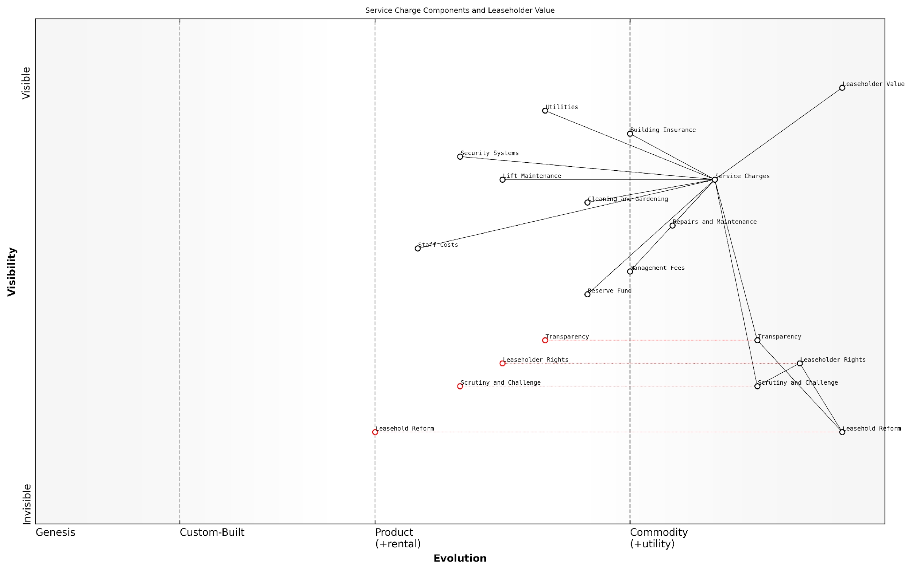

*Draft Wardley Map: [Insert Wardley Map: Typical items covered by service charges]*

[Edit this draft Wardley Map](https://create.wardleymaps.ai/#clone:3ba6af423f7f623366)

Wardley Map Assessment

This Wardley Map reveals a leasehold service charge system in transition, with significant opportunities for innovation in transparency, leaseholder empowerment, and overall reform. The strategic focus should be on rapidly evolving the less developed components like Transparency and Scrutiny, while optimising existing service provisions. There’s a clear path to competitive advantage through embracing and leading in these evolving areas, potentially reshaping the industry standard for leasehold management.

[View full Wardley Map report](https://github.com/tractorjuice/automated_wardley_reports/blob/main/markdown_wardley_map_reports/wardley_map_report_08_Typical_items_covered_by_service_charges.md)

### Reasonableness and consultation requirements

In the complex landscape of leasehold property management, understanding the concepts of reasonableness and consultation requirements is crucial for leaseholders seeking to tackle excessive service charges and poor management practices. These principles form the cornerstone of fair and transparent financial management in leasehold properties, providing essential protections for leaseholders against potential exploitation.

The concept of reasonableness in service charges is enshrined in Section 19 of the Landlord and Tenant Act 1985. This legislation stipulates that service charges must be reasonable, both in terms of the services or works provided and the costs incurred. This legal framework provides leaseholders with a powerful tool to challenge excessive or unjustified charges.

The principle of reasonableness acts as a safeguard against unscrupulous landlords or management agents who might otherwise exploit their position to extract excessive fees from leaseholders.

To determine reasonableness, several factors are typically considered:

* The necessity of the work or service
* The quality and cost of the work or service in relation to the standard expected for the particular building
* The process by which contractors were selected
* The transparency of the charging process
* The distribution of costs among leaseholders

Complementing the principle of reasonableness are the consultation requirements, primarily governed by Section 20 of the Landlord and Tenant Act 1985, as amended by the Commonhold and Leasehold Reform Act 2002. These requirements ensure that leaseholders are informed and consulted about significant expenditures that will impact their service charges.

The consultation process is triggered under two main scenarios:

* When the landlord proposes to carry out works that will cost any single leaseholder more than £250
* When the landlord intends to enter into a long-term agreement (exceeding 12 months) for the provision of services, and the cost to any leaseholder exceeds £100 per year

The consultation process typically involves three stages:

* Notice of intention: Informing leaseholders of the proposed works or agreement and inviting observations
* Notification of estimates: Providing at least two estimates for the works or services, including any submitted by leaseholders
* Notification of award of contract: Informing leaseholders of the chosen contractor and the reasons for the selection

Failure to adhere to these consultation requirements can have significant consequences for landlords or management agents. Without proper consultation, the landlord’s ability to recover costs through service charges is limited to £250 per leaseholder for works, or £100 per leaseholder per year for long-term agreements, unless they obtain dispensation from the First-tier Tribunal (Property Chamber).

The consultation requirements serve as a vital mechanism for transparency and leaseholder engagement, ensuring that those who ultimately bear the costs have a voice in significant financial decisions affecting their property.

It’s important to note that these requirements apply equally to Resident Management Companies (RMCs) and Right to Manage (RTM) companies, not just to traditional landlords. This ensures a consistent standard of transparency and fairness across different management structures.

For leaseholders, understanding these principles is crucial for several reasons:

* It empowers them to scrutinise service charge demands effectively
* It provides a basis for challenging unreasonable charges
* It ensures their right to be involved in significant financial decisions affecting their property
* It helps in identifying potential mismanagement or exploitation by landlords or managing agents

However, navigating the complexities of reasonableness and consultation requirements can be challenging. Leaseholders often face difficulties in determining what constitutes a ‘reasonable’ charge or in understanding the nuances of the consultation process. This is where seeking expert advice or joining forces with other leaseholders through a recognised residents’ association can be invaluable.

In practice, disputes over reasonableness and consultation often end up before the First-tier Tribunal (Property Chamber). The Tribunal has the power to determine whether service charges are reasonable and whether consultation requirements have been met. Their decisions provide valuable precedents and guidance for interpreting these principles in real-world scenarios.

While the legal framework provides strong protections, the practical application of reasonableness and consultation principles often requires vigilance, collective action, and sometimes legal intervention by leaseholders.

Looking ahead, ongoing leasehold reform initiatives in England may further strengthen these protections. Proposals include simplifying the consultation process, enhancing transparency in service charge accounts, and potentially introducing stricter penalties for non-compliance. Leaseholders should stay informed about these developments, as they may provide additional tools for tackling excessive charges and poor management practices.

In conclusion, the principles of reasonableness and consultation requirements form a critical line of defence for leaseholders against excessive service charges and opaque management practices. By understanding and actively engaging with these concepts, leaseholders can play a pivotal role in ensuring fair and transparent financial management of their properties, contributing to a more equitable leasehold system in England.

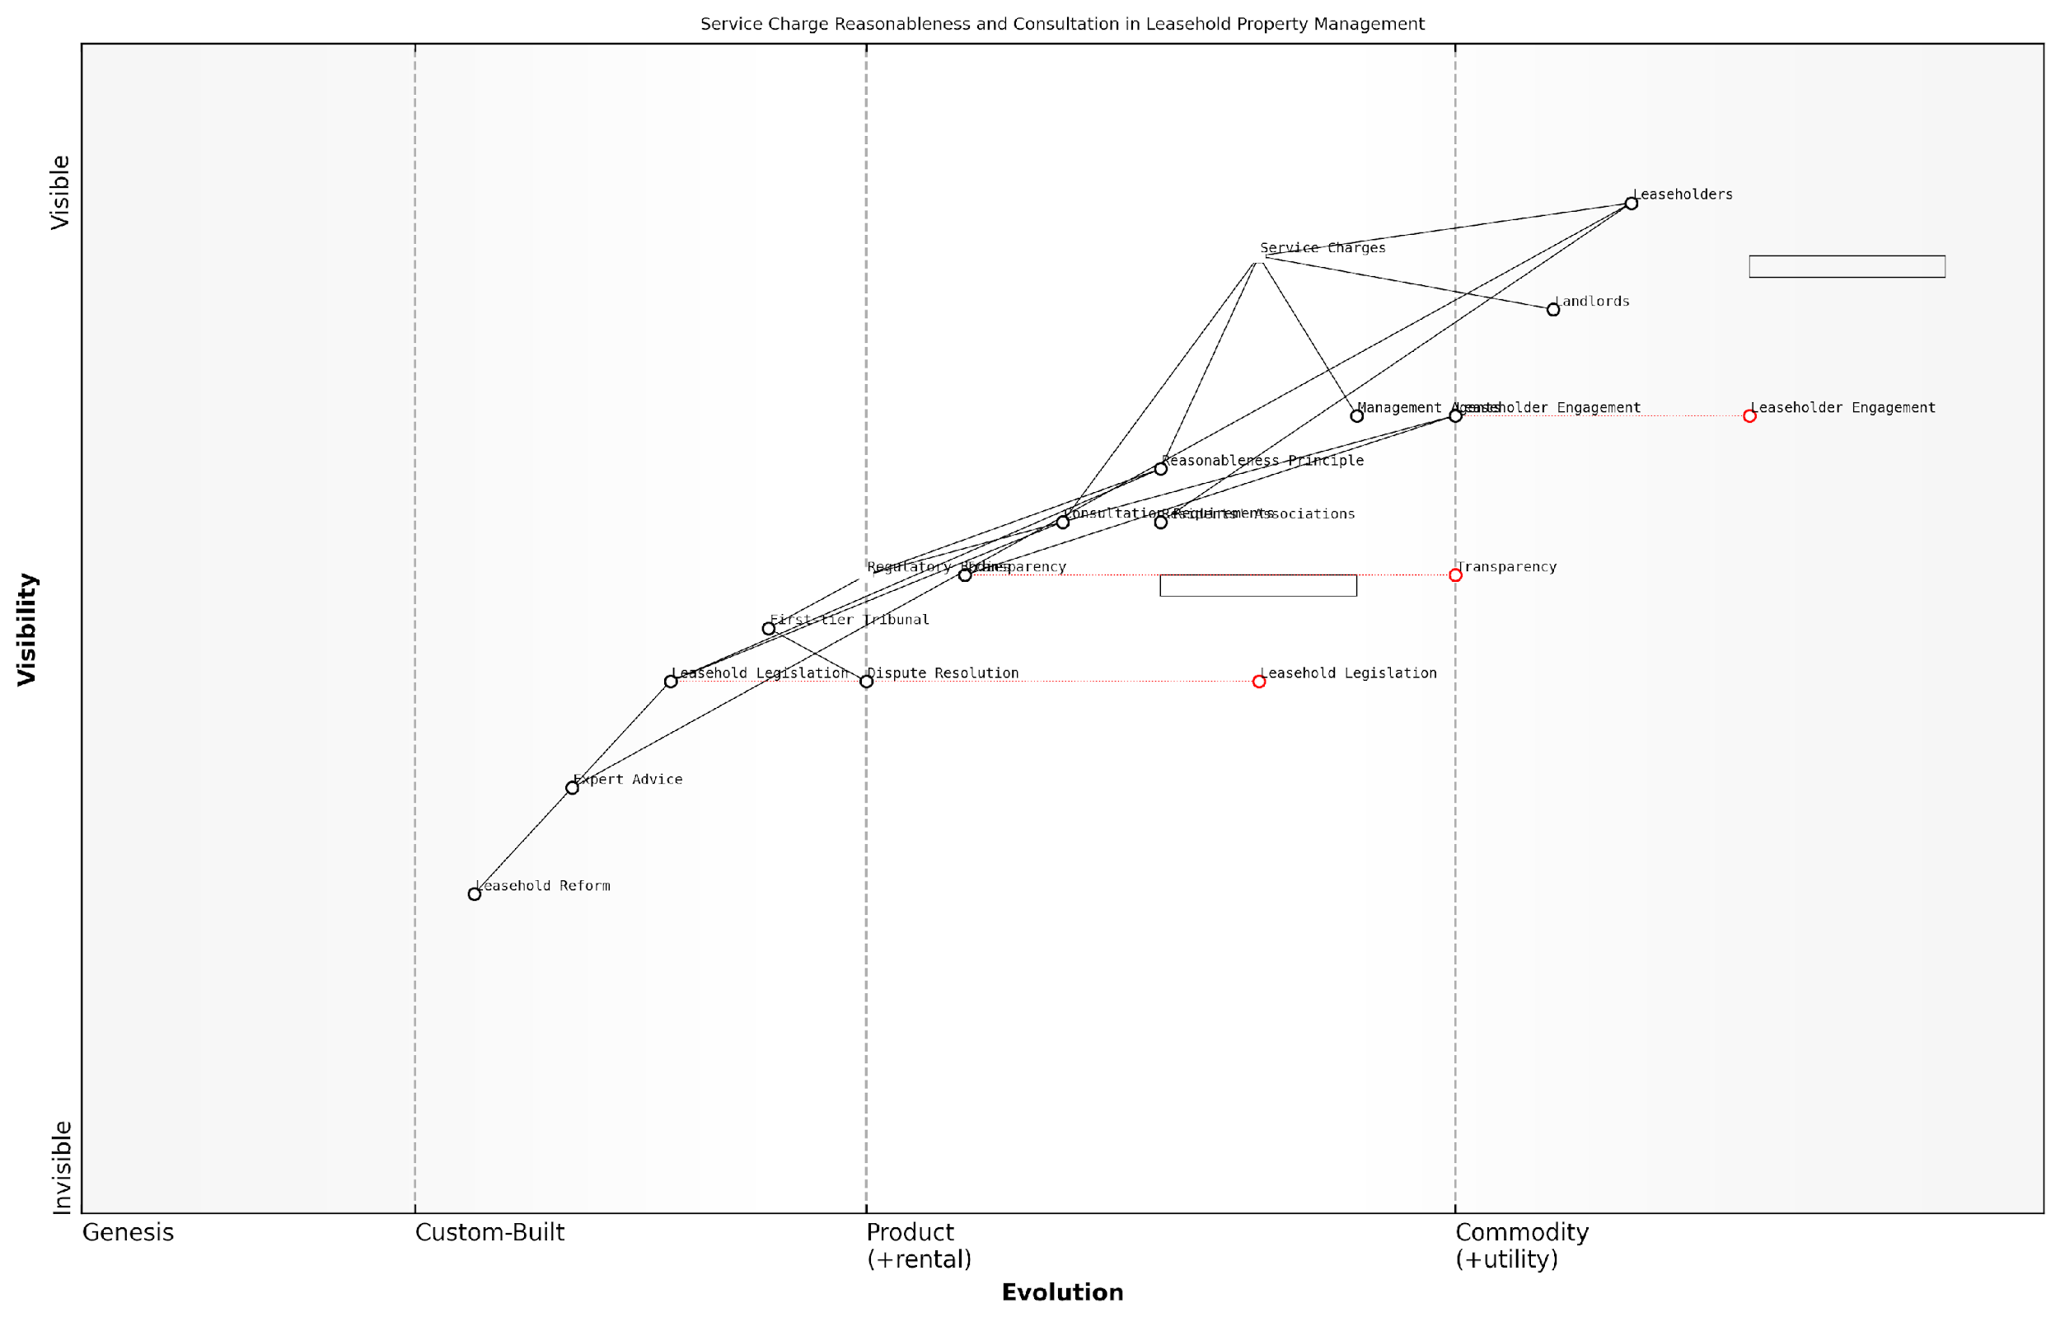

*Draft Wardley Map: [Insert Wardley Map: Reasonableness and consultation requirements]*

[Edit this draft Wardley Map](https://create.wardleymaps.ai/#clone:4f625f80a3c4db0d7b)

Wardley Map Assessment

This Wardley Map reveals a leasehold property management ecosystem in transition, with significant opportunities for innovation and improvement. The strategic focus should be on accelerating the evolution of transparency and leaseholder engagement, while simultaneously pushing for structural reforms in leasehold legislation. Key to success will be balancing the needs and resistances of various stakeholders, particularly addressing the inertia from landlords and existing legislation. By leveraging technology, standardising processes, and fostering a more collaborative ecosystem, there’s potential to significantly improve the leasehold experience for all parties involved. However, careful change management and phased implementation will be crucial to navigate the complexities and potential resistances within the system.

[View full Wardley Map report](https://github.com/tractorjuice/automated_wardley_reports/blob/main/markdown_wardley_map_reports/wardley_map_report_09_Reasonableness_and_consultation_requirements.md)

## Scrutinising Your Service Charge Demands

### Reading and interpreting service charge statements

As a leaseholder, understanding your service charge statement is crucial in identifying and challenging excessive charges. This skill forms the foundation of effective financial management and empowers you to hold your management agent accountable. Let’s delve into the intricacies of service charge statements and equip you with the knowledge to scrutinise them effectively.

Service charge statements can be complex documents, often filled with financial jargon and opaque line items. However, with the right approach, you can decode these statements and gain valuable insights into the management of your property.

Key Components of a Service Charge Statement:

* Summary of Charges: An overview of total costs for the period
* Itemised Expenditure: Breakdown of individual costs
* Income and Expenditure Account: Overall financial summary
* Balance Sheet: Financial position at year-end
* Notes to the Accounts: Additional explanations and context

When examining your service charge statement, pay close attention to the following aspects:

* Consistency: Compare current charges with previous years
* Clarity: Ensure all items are clearly described and justified
* Compliance: Check that charges align with your lease terms
* Reasonableness: Assess whether costs seem proportionate and necessary
* Supporting Documentation: Look for evidence of competitive tendering for major works

One of the most critical skills in interpreting service charge statements is the ability to identify potential red flags. These may include:

* Unexplained significant increases in costs
* Vague or ambiguous descriptions of services
* Charges for items not permitted by your lease
* Disproportionate management fees
* Lack of detail for major expenditures

A thorough understanding of your service charge statement is your first line of defence against excessive charges. It’s not just about numbers; it’s about transparency and accountability in the management of your property.

To effectively scrutinise your service charge statement, consider the following strategies:

* Create a spreadsheet to track and compare costs year-on-year
* Request a detailed breakdown of any unclear or suspicious items
* Cross-reference charges with your lease agreement
* Seek explanations for any significant variances from budgeted amounts
* Collaborate with other leaseholders to share insights and concerns

It’s important to note that under Section 21 of the Landlord and Tenant Act 1985, you have the right to request a summary of costs incurred by your landlord. This can be a valuable tool in verifying the accuracy of your service charge statement.

When reviewing your statement, be particularly vigilant about:

* Reserve Fund Contributions: Ensure these are reasonable and in line with lease terms
* Insurance Premiums: Check for any unexplained increases
* Management Fees: Assess whether these are proportionate to the services provided
* Maintenance Costs: Look for evidence of regular, planned maintenance rather than reactive repairs
* Utility Charges: Verify these against actual usage and market rates

Remember, as a leaseholder, you’re not just a passive recipient of services. You have the right to question, challenge, and seek justification for every charge on your statement.

If you identify discrepancies or have concerns about your service charge statement, it’s crucial to act promptly. Start by raising your concerns in writing with your management agent or landlord. If you’re not satisfied with their response, you may need to consider formal dispute resolution mechanisms, such as the First-tier Tribunal (Property Chamber).

Developing a keen eye for service charge statement analysis is an invaluable skill for any leaseholder. It not only helps you manage your personal finances more effectively but also contributes to the overall health and transparency of leasehold property management in England.

By mastering the art of reading and interpreting service charge statements, you’re taking a crucial step towards tackling excessive charges and holding management agents accountable. This knowledge empowers you to engage in informed discussions, challenge unfair practices, and ultimately contribute to a fairer, more transparent leasehold system.

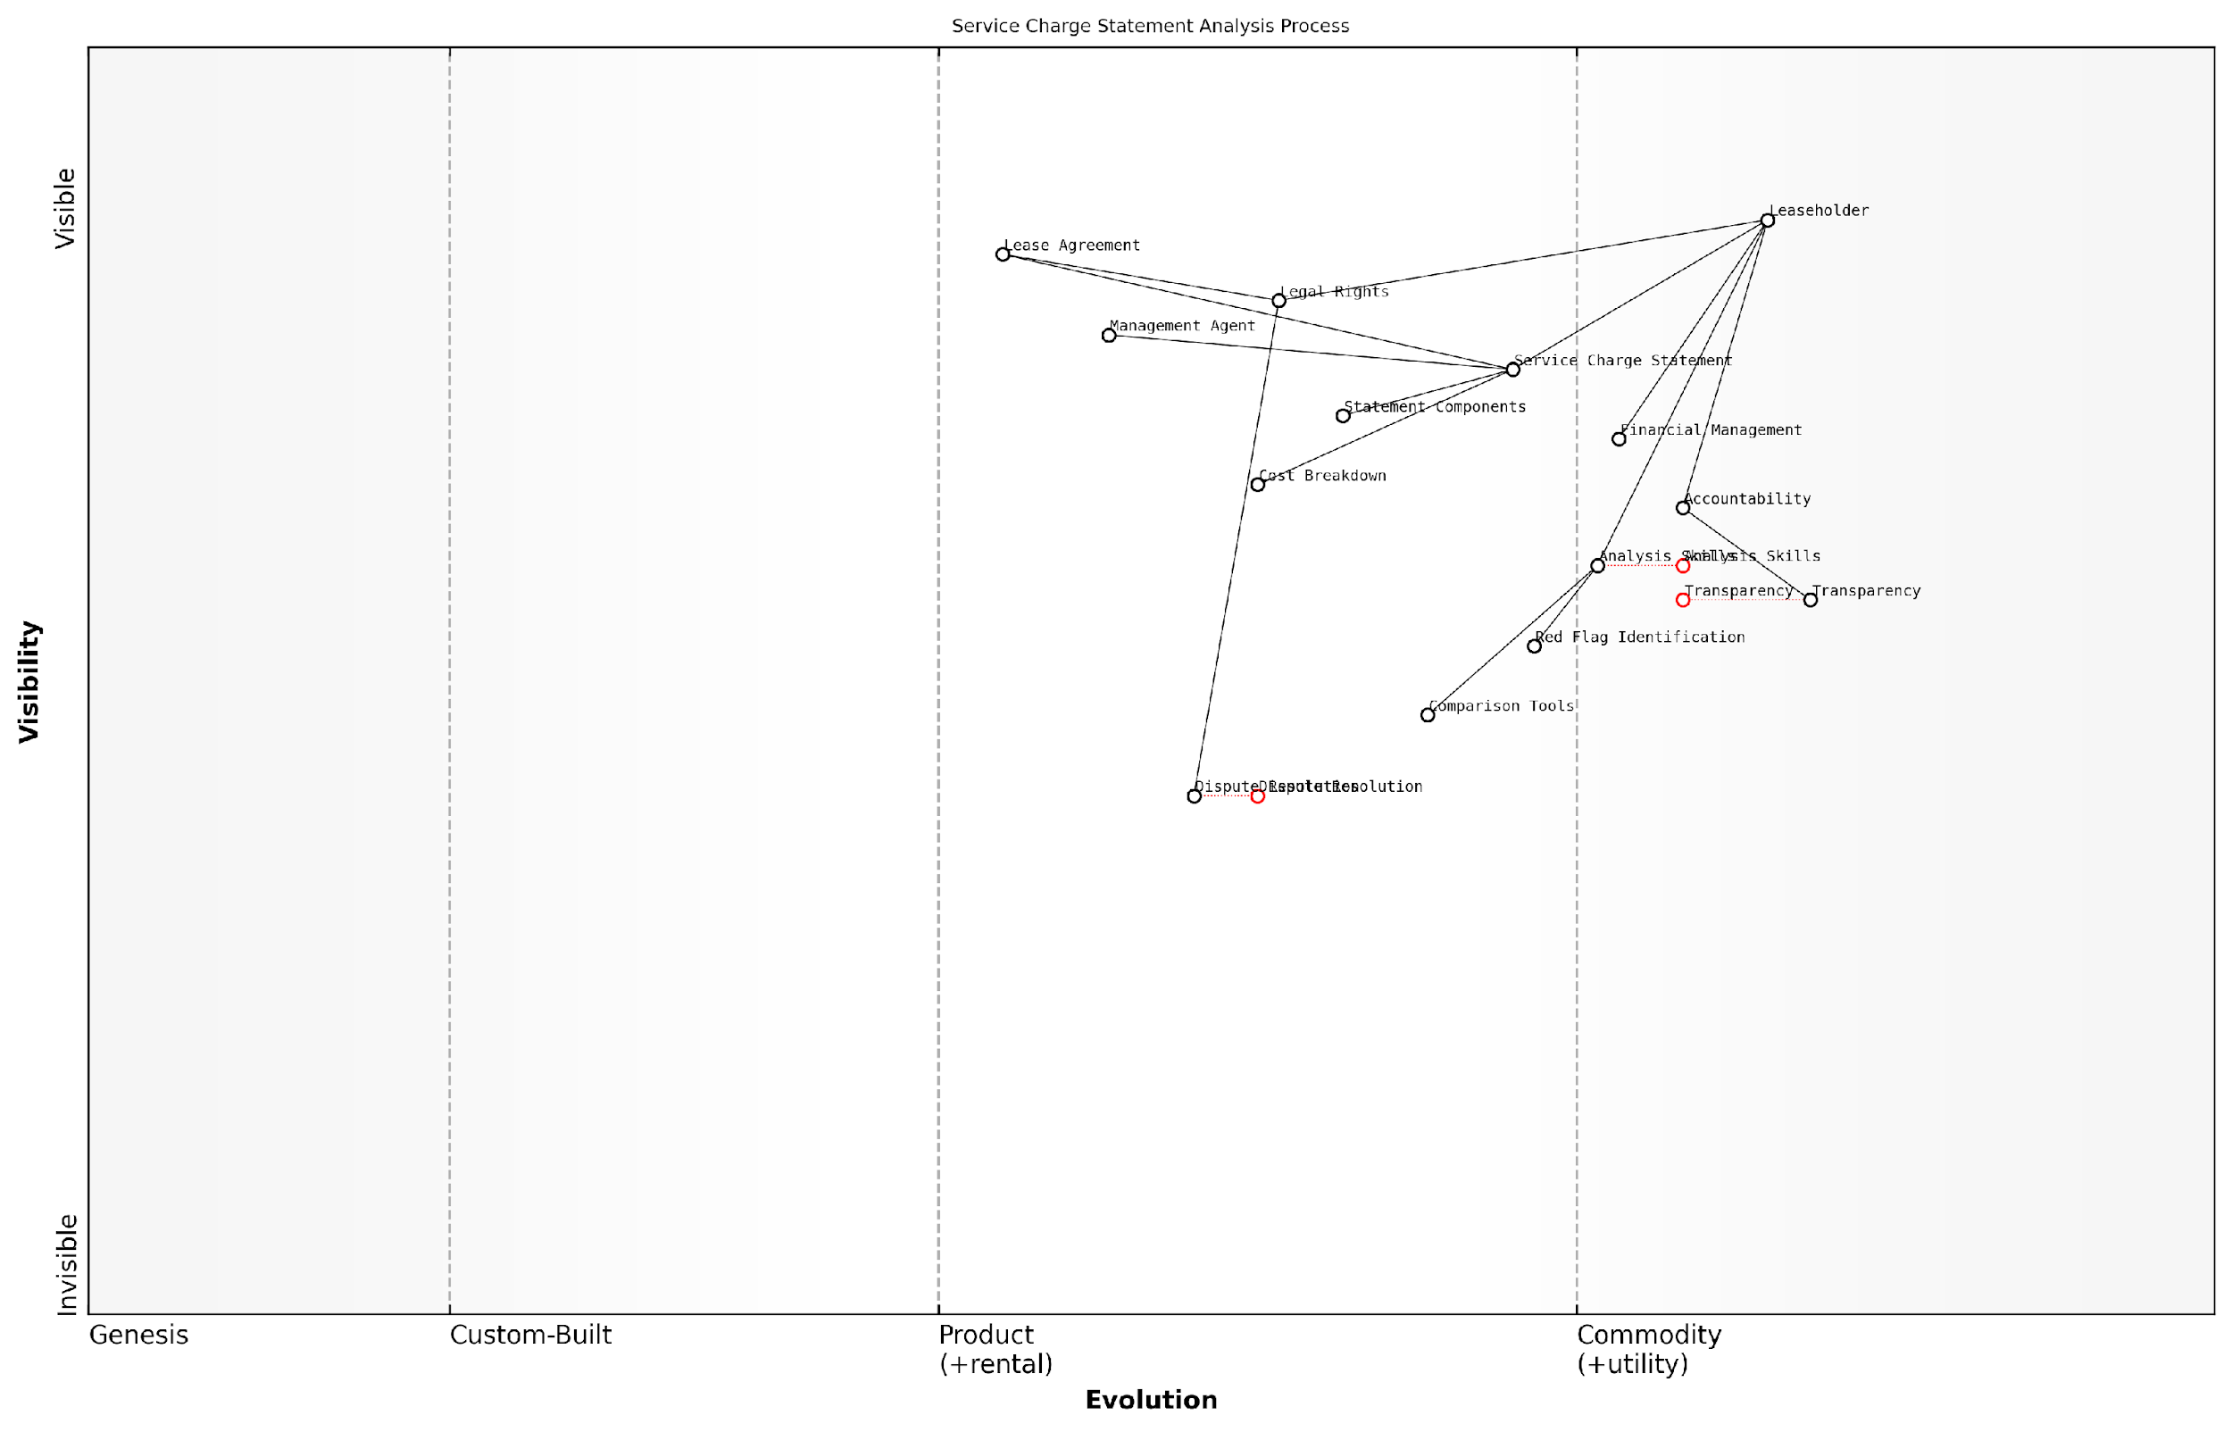

*Draft Wardley Map: [Insert Wardley Map: Reading and interpreting service charge statements]*

[Edit this draft Wardley Map](https://create.wardleymaps.ai/#clone:b8f50fd792b0acc856)

Wardley Map Assessment

This Wardley Map reveals a strategic landscape focused on empowering leaseholders in the complex area of service charge management. The current positioning emphasises the importance of transparency, analysis skills, and legal knowledge. However, there are significant opportunities for innovation, particularly in the areas of automated analysis, standardisation, and the use of emerging technologies. The evolving nature of key components suggests a dynamic environment where strategic investments in skills development and technology could yield substantial benefits. Moving forward, the focus should be on creating a more transparent, efficient, and collaborative ecosystem that balances the needs of leaseholders with the responsibilities of management agents.

[View full Wardley Map report](https://github.com/tractorjuice/automated_wardley_reports/blob/main/markdown_wardley_map_reports/wardley_map_report_10_Reading_and_interpreting_service_charge_statements.md)

### Red flags: identifying potentially excessive charges

As a leaseholder, scrutinising your service charge demands is crucial in identifying and challenging potentially excessive charges. This section will equip you with the knowledge and tools to recognise red flags that may indicate unreasonable or inflated costs, empowering you to take informed action and protect your financial interests.

Understanding what constitutes a red flag in service charge demands requires a combination of common sense, legal knowledge, and industry insight. Let’s explore the key areas to focus on when reviewing your service charge statements.

1. Unexplained or Significant Increases

One of the most obvious red flags is a sudden, substantial increase in service charges without adequate explanation. While some year-on-year variation is normal, significant jumps should be scrutinised carefully.

* Compare current charges with previous years’ statements
* Look for detailed breakdowns of increased costs
* Check if the increase aligns with the Retail Price Index (RPI) or similar inflation measures
* Be wary of increases that far outpace inflation without clear justification

A seasoned property management expert notes, ‘While costs can fluctuate, any increase exceeding 10% year-on-year should be thoroughly explained and justified by the managing agent.’

1. Vague or Ambiguous Descriptions

Service charge demands should provide clear, itemised breakdowns of costs. Vague descriptions or catch-all categories can be a sign of poor management or attempts to obscure unreasonable charges.

* Be cautious of broad terms like ‘miscellaneous expenses’ or ‘general maintenance’
* Look for specific details on work carried out, including dates and locations
* Question any recurring charges that lack clear explanations
* Ensure that descriptions align with the services outlined in your lease agreement

1. Disproportionate Management Fees

Management fees should be proportionate to the services provided and the size of the property. Excessive fees can significantly inflate your service charges.

* Compare management fees to industry benchmarks (typically 10-15% of total service charges)
* Check if fees have increased without a corresponding improvement in service quality
* Look out for additional charges for services that should be covered by the basic management fee
* Be wary of fees that seem high relative to the complexity of managing your property

1. Unexpected or Unnecessary Services

Service charges should only cover necessary maintenance and services as outlined in your lease. Be alert to charges for services that seem superfluous or unrelated to your property’s needs.

* Question any new services that haven’t been communicated or agreed upon
* Look out for services that don’t benefit all leaseholders equally
* Be cautious of charges for improvements rather than repairs or maintenance
* Check if services align with those specified in your lease agreement

1. Lack of Competitive Tendering

For significant works or ongoing contracts, managing agents should demonstrate that they’ve sought competitive bids to ensure value for money.

* Look for evidence of multiple quotes for major works or services
* Be wary of consistently using the same contractors without justification
* Check if the managing agent has adhered to the consultation requirements for major works (Section 20 consultations)
* Question any reluctance to provide information on the tendering process

A property law specialist advises, ‘Leaseholders have the right to request evidence of competitive tendering. If this information is not forthcoming, it could indicate a lack of transparency or potential conflicts of interest.’

1. Inconsistencies with Lease Terms

Your lease is the fundamental document defining what can be charged as a service charge. Any discrepancies between the charges and your lease terms are significant red flags.

* Carefully compare service charge items with the services specified in your lease
* Be alert to charges for services or areas not mentioned in the lease
* Check if the method of apportioning charges aligns with lease provisions
* Look out for attempts to recover costs that should be borne by the freeholder

1. Poor Quality of Work or Services

While not always immediately apparent from the service charge statement, consistently poor quality work or services can indicate that you’re not receiving value for money.

* Document instances of substandard work or neglected maintenance
* Compare the frequency of repairs with industry norms
* Look for patterns of recurring issues that should have been resolved
* Question charges for works that haven’t visibly improved the property’s condition

1. Lack of Transparency or Resistance to Inquiries

Managing agents have a legal obligation to provide clear, timely information about service charges. Resistance to reasonable inquiries or a lack of transparency can be a significant red flag.

* Be wary of delays or refusals to provide detailed breakdowns of charges
* Look out for reluctance to share supporting documentation, such as invoices or contracts
* Question any attempts to charge for providing information about service charges
* Be alert to dismissive or evasive responses to legitimate queries

A leading leaseholder rights advocate emphasises, ‘Transparency is not just good practice; it’s a legal requirement. Any resistance to providing clear, detailed information about service charges should be treated as a serious concern.’

By familiarising yourself with these red flags, you’ll be better equipped to identify potentially excessive charges and take appropriate action. Remember, challenging unreasonable service charges is your right as a leaseholder, and vigilance in scrutinising these demands is key to ensuring fair treatment and value for money.

In conclusion, while not all red flags necessarily indicate deliberate overcharging or mismanagement, they should prompt further investigation. By maintaining a critical eye and seeking clarification on questionable charges, you play an active role in holding managing agents accountable and ensuring the fair administration of your leasehold property.

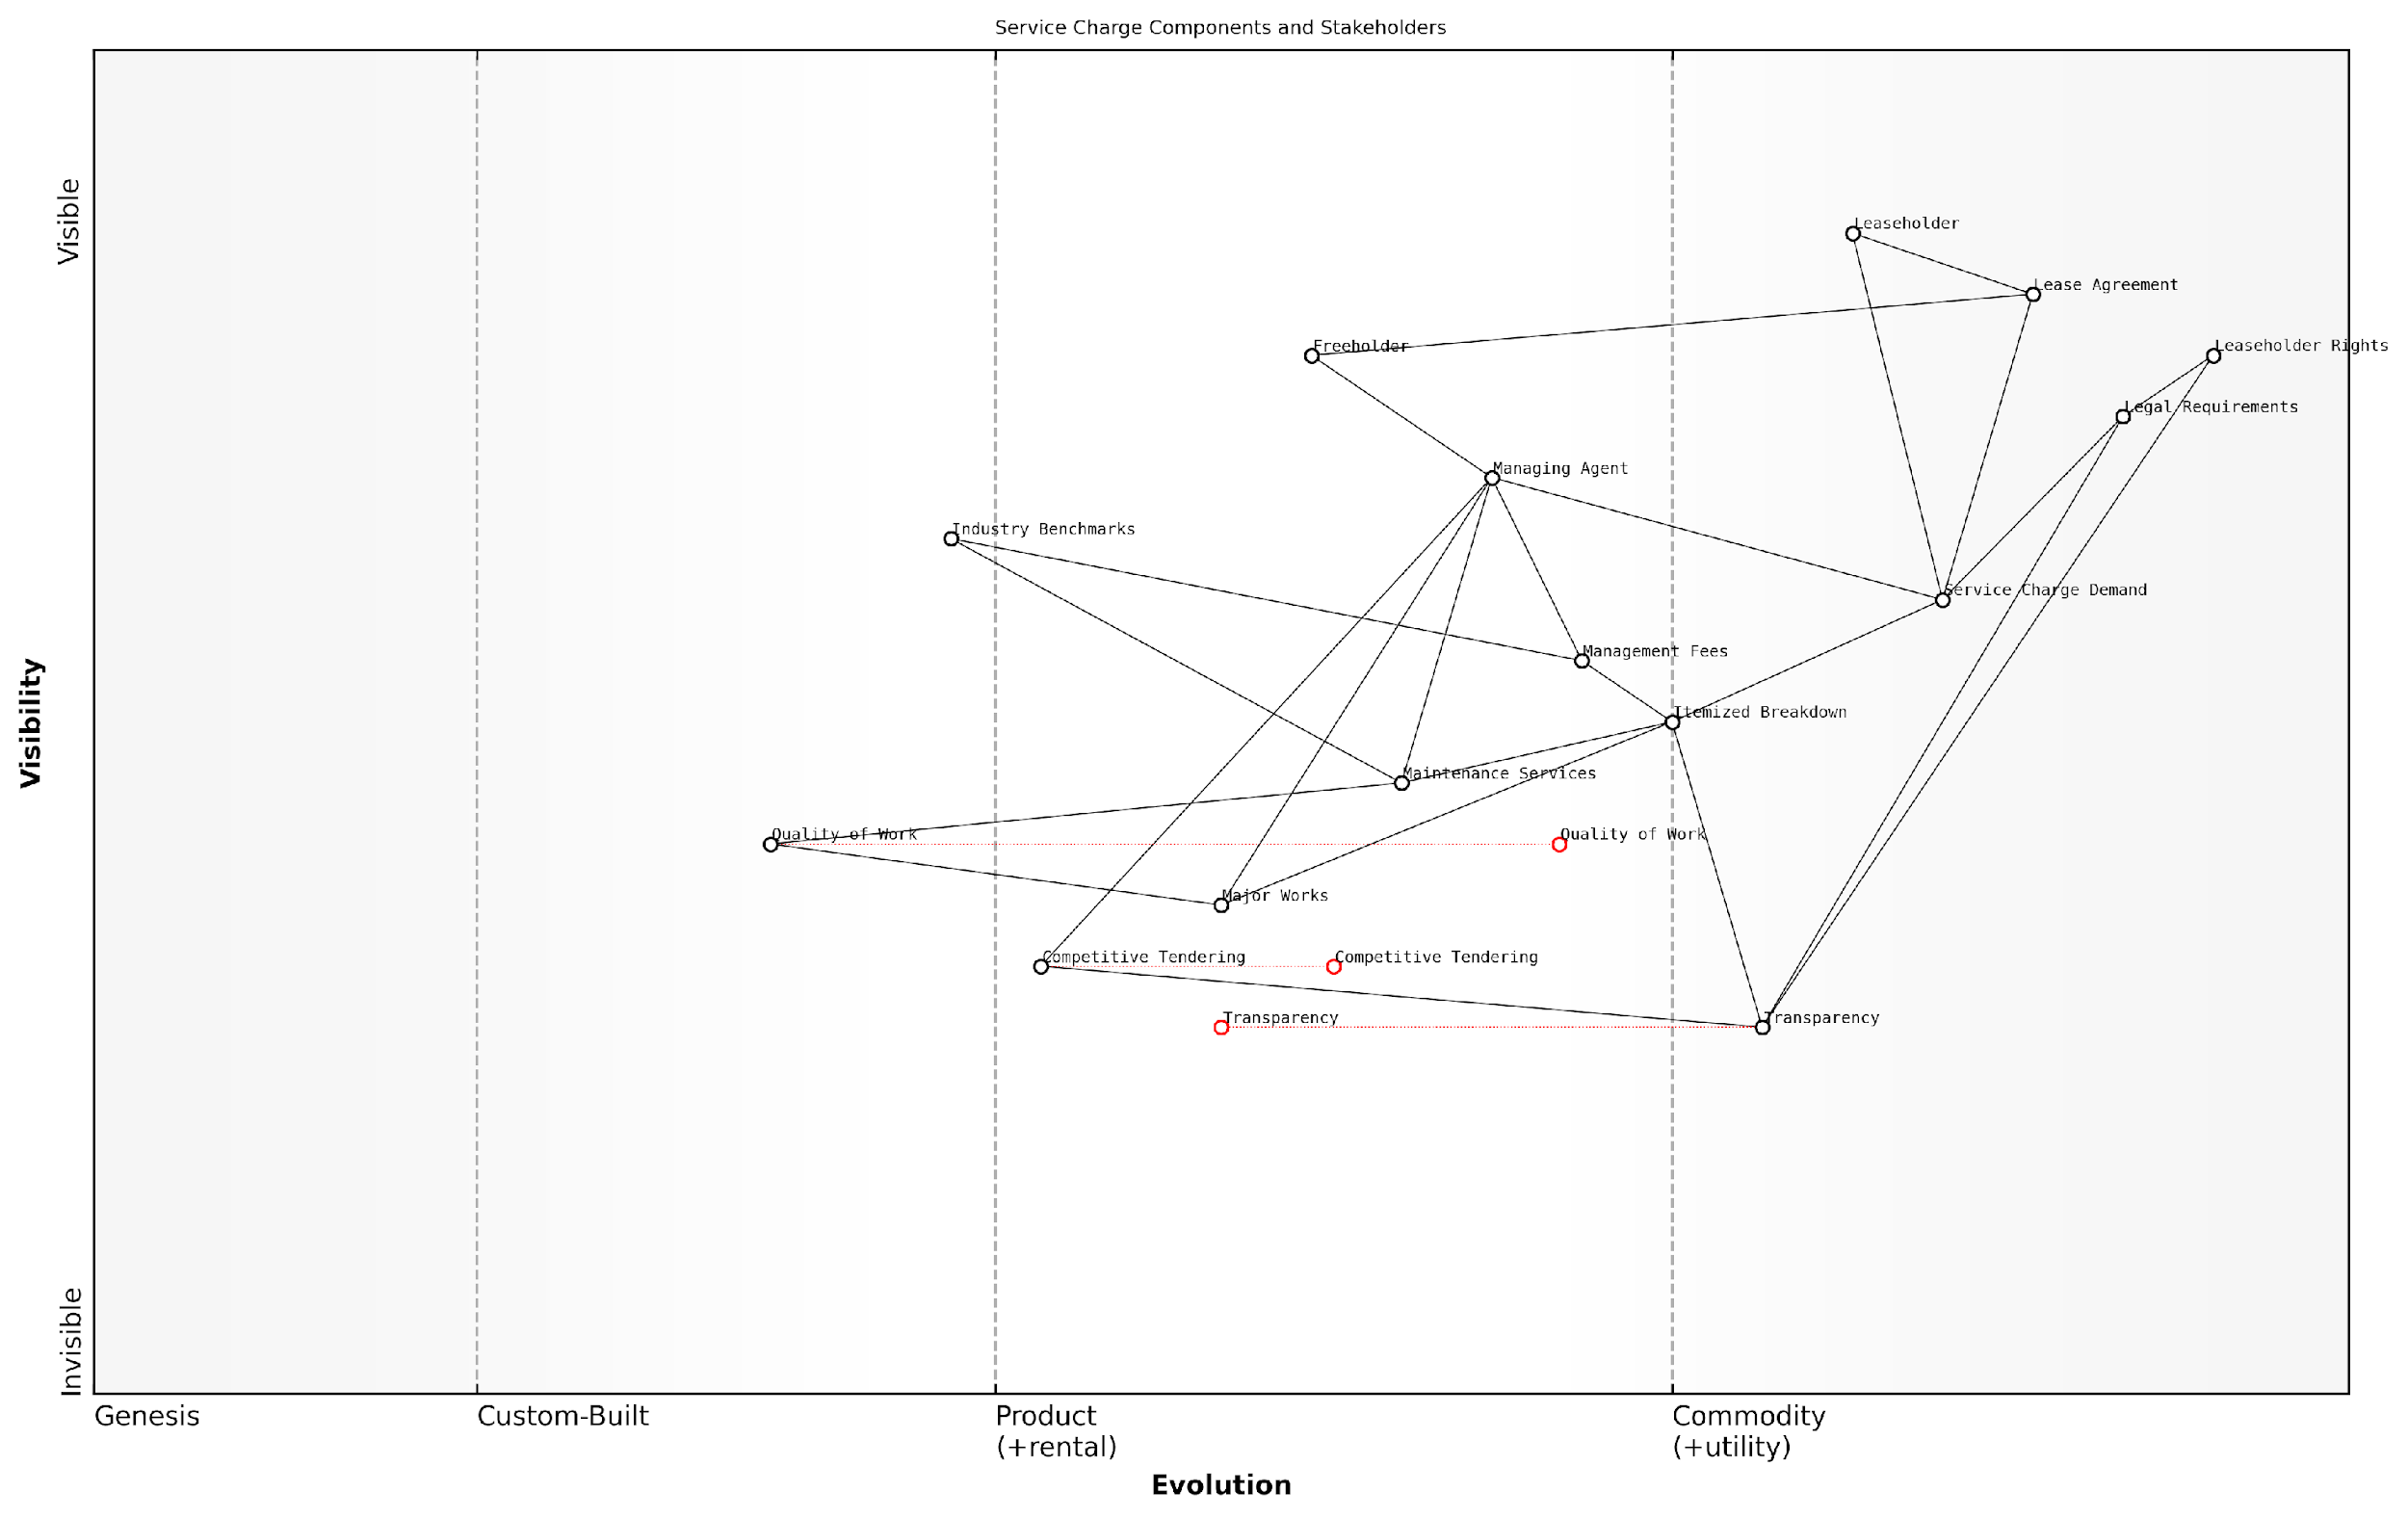

*Draft Wardley Map: [Insert Wardley Map: Red flags: identifying potentially excessive charges]*

[Edit this draft Wardley Map](https://create.wardleymaps.ai/#clone:87d145de1ba0387e6e)

Wardley Map Assessment

The Wardley Map reveals an industry in transition, with growing emphasis on transparency, fair practices, and leaseholder rights. There are significant opportunities for innovation, particularly in transparency tools, competitive tendering processes, and quality assurance. The role of managing agents may need to evolve to remain relevant in this changing landscape. Strategic priorities should focus on leveraging technology to enhance transparency and efficiency, while also improving the quality and value of services provided to leaseholders. The industry is likely to see increased standardisation and potential disruption from tech-enabled solutions, necessitating a proactive approach to adaptation and innovation from all stakeholders.

[View full Wardley Map report](https://github.com/tractorjuice/automated_wardley_reports/blob/main/markdown_wardley_map_reports/wardley_map_report_11_Red_flags:_identifying_potentially_excessive_charg.md)

### Your right to challenge service charges

As a leaseholder in England, understanding your right to challenge service charges is crucial in maintaining a fair and transparent relationship with your freeholder and management agent. This section delves into the legal framework that empowers leaseholders to scrutinise and contest potentially excessive or unreasonable charges, providing you with the knowledge and tools to protect your financial interests.

The Landlord and Tenant Act 1985, as amended by subsequent legislation, forms the cornerstone of leaseholders’ rights regarding service charges. Section 19 of this Act stipulates that service charges must be reasonable and that only reasonable costs can be recovered through these charges. This provision is your first line of defence against excessive fees.

The right to challenge service charges is not just a legal technicality; it’s a fundamental aspect of leasehold ownership that helps maintain the balance of power between leaseholders and freeholders.

Let’s break down the key aspects of your right to challenge service charges:

* Statutory Time Limits: You have 18 months from receiving the demand to challenge the reasonableness of the charge.
* Burden of Proof: The landlord must prove that the service charge is reasonable if challenged.
* Consultation Requirements: For major works exceeding £250 per leaseholder, or long-term agreements over 12 months costing more than £100 per leaseholder per year, the landlord must follow a statutory consultation process.
* Tribunal Jurisdiction: The First-tier Tribunal (Property Chamber) has the power to determine the reasonableness of service charges.

It’s important to note that your right to challenge is not limited to the overall amount of the service charge. You can also question specific aspects, such as the standard of work, the necessity of the work, or the competitiveness of the costs incurred.

When considering a challenge, start by thoroughly reviewing your lease agreement. This document outlines the services the landlord is obligated to provide and the basis on which charges can be levied. Any discrepancies between the lease terms and the charges demanded can form grounds for challenge.

A well-informed leaseholder is the best defence against unreasonable service charges. Knowledge of your rights and the confidence to exercise them can lead to significant savings and improved management practices.

To effectively exercise your right to challenge, consider the following steps:

* Request a detailed breakdown of charges from your landlord or management agent.
* Compare the charges against market rates for similar services.
* Check if the statutory consultation process was followed for major works or long-term agreements.
* Gather evidence to support your case, such as alternative quotes or expert opinions on the necessity of works.
* Engage with other leaseholders to identify common concerns and potentially share the cost of professional advice.
* Consider mediation as a first step before proceeding to a formal tribunal application.

It’s worth highlighting that the Commonhold and Leasehold Reform Act 2002 introduced additional protections, including the requirement for landlords to provide a summary of rights and obligations with every service charge demand. This summary should outline your right to challenge charges and the available dispute resolution mechanisms.

In my experience advising leaseholders and government bodies on these matters, I’ve observed that many challenges are successful when leaseholders are well-prepared and can demonstrate clear discrepancies or unreasonableness in the charges. For instance, in a recent case involving a large residential development in London, a group of leaseholders successfully challenged a £500,000 refurbishment charge by proving that the works were unnecessarily extensive and overpriced compared to market rates.

Collective action can be particularly powerful. When leaseholders unite to challenge unreasonable charges, it not only spreads the cost and effort but also sends a strong message to landlords and management agents about the need for transparency and fairness.

It’s crucial to approach challenges strategically. While you have the right to question charges, maintaining a constructive dialogue with your landlord or management agent can often lead to resolutions without the need for formal proceedings. However, don’t hesitate to escalate to the First-tier Tribunal if informal approaches prove unfruitful.

Remember, the right to challenge service charges is not just about disputing individual bills; it’s a mechanism for ensuring accountability in the leasehold system. By exercising this right responsibly and effectively, leaseholders contribute to improving standards across the sector and promoting fair practices in property management.

In conclusion, your right to challenge service charges is a powerful tool in the leaseholder’s arsenal. By understanding this right and the processes involved, you can ensure that you’re paying only for necessary and reasonably priced services. This knowledge empowers you to take an active role in the management of your property and contributes to a fairer, more transparent leasehold system.

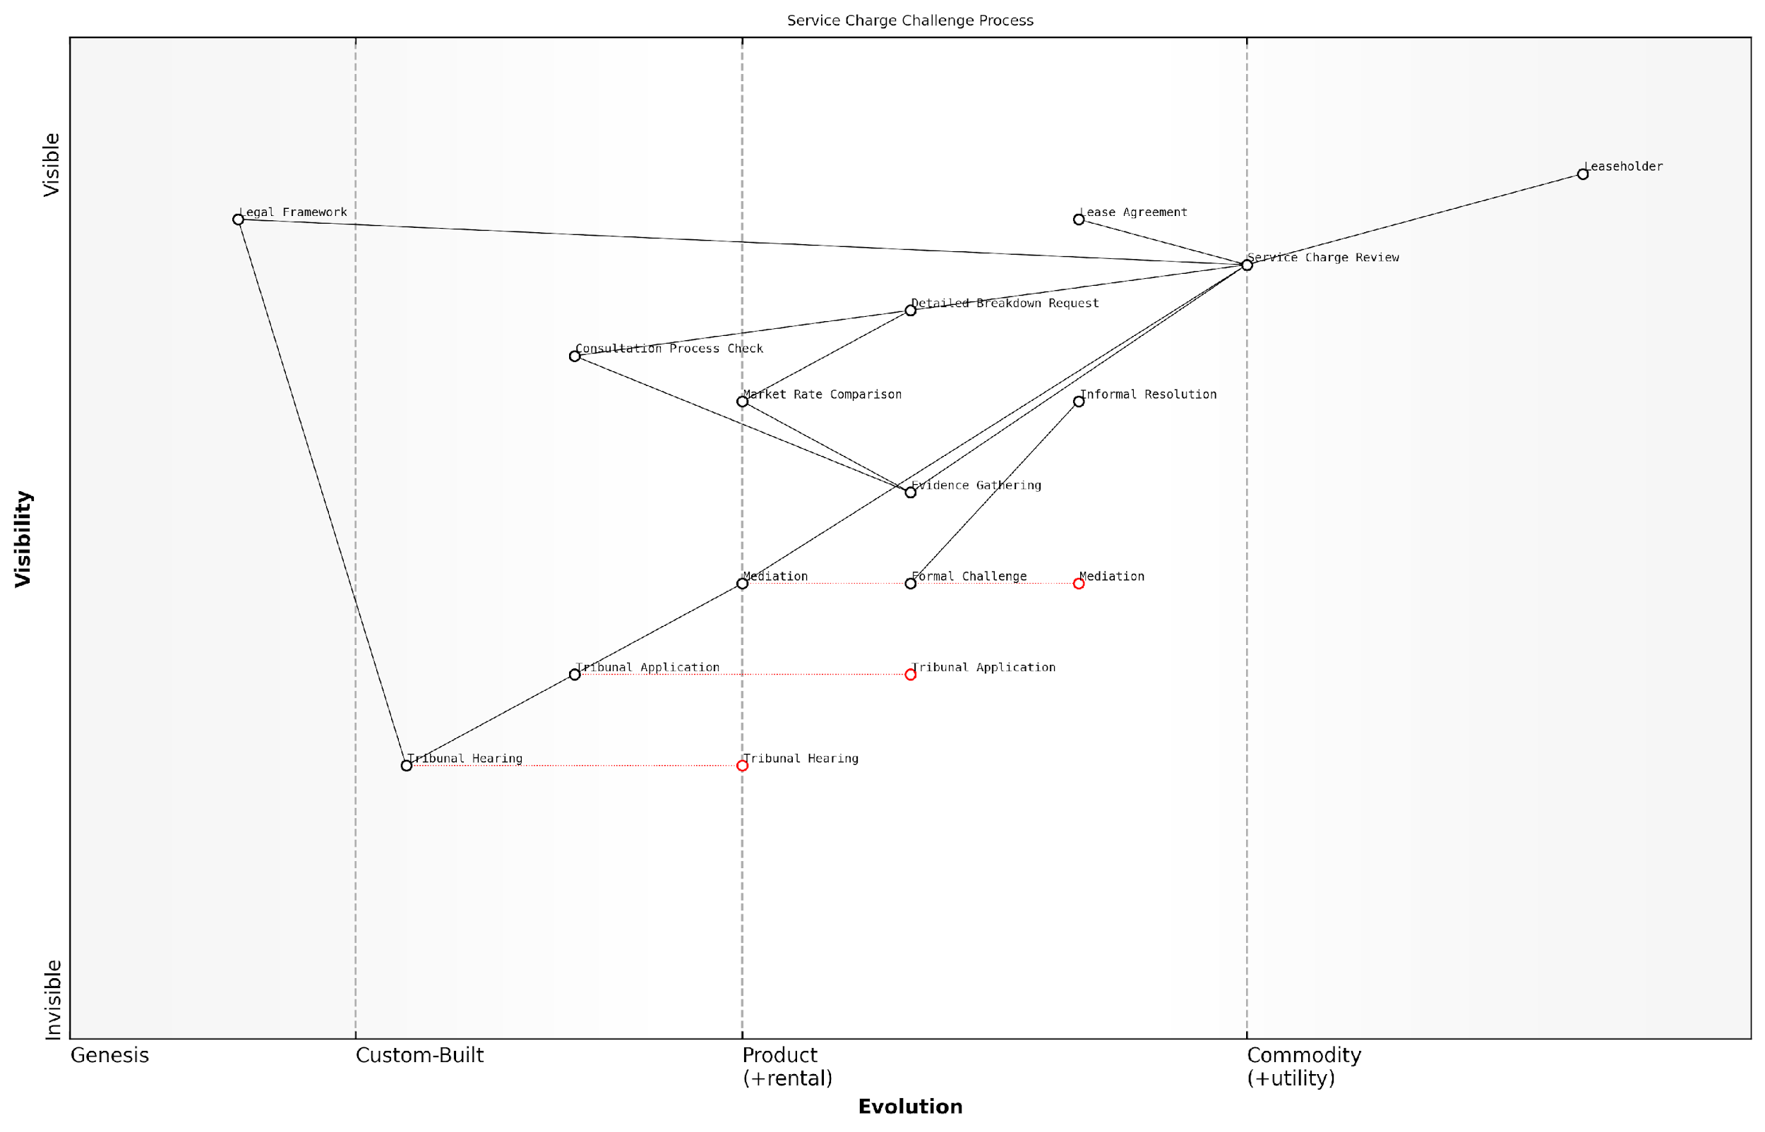

*Draft Wardley Map: [Insert Wardley Map: Your right to challenge service charges]*

[Edit this draft Wardley Map](https://create.wardleymaps.ai/#clone:476976f4876540138a)

Wardley Map Assessment

The map reveals a structured but potentially cumbersome process for service charge challenges. There are significant opportunities for innovation in the early stages of the process, particularly in evidence gathering and market rate comparison. Streamlining these areas could reduce the need for formal challenges and improve outcomes for leaseholders. The evolving nature of mediation and tribunal processes suggests a trend towards more standardised dispute resolution, which could be further enhanced through technology. Overall, the strategic focus should be on empowering leaseholders with better information and tools early in the process, while also preparing for more efficient formal challenge procedures when necessary.

[View full Wardley Map report](https://github.com/tractorjuice/automated_wardley_reports/blob/main/markdown_wardley_map_reports/wardley_map_report_12_Your_right_to_challenge_service_charges.md)

## Management Fees: Fair Compensation or Profiteering?

### What management fees should cover

In the complex landscape of leasehold property management, understanding what management fees should cover is crucial for leaseholders seeking to ensure fair treatment and value for money. This topic is of paramount importance within the broader context of tackling excessive service charges and addressing issues with management agents for leasehold flats in England. As we delve into this subject, we’ll explore the various components that should be included in management fees, the rationale behind these inclusions, and how to identify potential areas of overcharging or mismanagement.

Management fees are typically charged by managing agents or landlords to cover the cost of their services in overseeing the day-to-day operations and maintenance of leasehold properties. These fees are separate from service charges, which cover specific maintenance and repair costs. It’s essential to understand that management fees should reflect a fair compensation for the agent’s time, expertise, and resources expended in managing the property effectively.

Let’s break down the key components that should typically be covered by management fees:

* Administrative tasks and record-keeping
* Financial management and accounting
* Communication with leaseholders
* Contractor management and supervision
* Compliance with legal and regulatory requirements
* Property inspections and condition reports
* Handling of queries and complaints
* Arranging and attending meetings (e.g., AGMs)
* Preparation of service charge budgets and accounts
* Insurance administration

Administrative tasks and record-keeping form a significant portion of a management agent’s responsibilities. This includes maintaining accurate and up-to-date records of leaseholders, property details, maintenance schedules, and correspondence. Efficient record-keeping is crucial for the smooth operation of the property and ensures transparency in management practices.

Financial management and accounting are critical aspects of property management. Management fees should cover the cost of preparing annual budgets, collecting service charges and ground rent, managing bank accounts, and producing financial statements. This also includes the arrangement of annual audits or certifications of accounts as required by law.

Effective communication with leaseholders is a key responsibility of management agents. Fees should cover the cost of regular updates, newsletters, and responding to leaseholder queries and concerns. This ensures that leaseholders are kept informed about important matters affecting their property and fosters a positive relationship between the agent and residents.

Contractor management and supervision is another crucial aspect covered by management fees. This includes sourcing and appointing contractors for maintenance and repair work, overseeing their performance, and ensuring compliance with health and safety regulations. The management agent’s role in this process is vital to ensure that work is carried out to a high standard and represents value for money.

Compliance with legal and regulatory requirements is an increasingly complex area of property management. Management fees should cover the cost of ensuring the property adheres to all relevant legislation, including fire safety regulations, health and safety laws, and leasehold reform acts. This may involve arranging regular risk assessments, implementing safety measures, and staying abreast of changes in legislation.

Regular property inspections and condition reports are essential for maintaining the value and safety of the property. Management fees should include the cost of conducting these inspections, preparing reports, and recommending necessary maintenance or improvements.

Handling of queries and complaints is a time-consuming but necessary aspect of property management. Fees should cover the cost of operating a responsive and effective system for addressing leaseholder concerns and resolving disputes.

Arranging and attending meetings, such as Annual General Meetings (AGMs), is another important responsibility. Management fees should cover the time spent preparing for these meetings, including drafting agendas, circulating documents, and following up on action points.

The preparation of service charge budgets and accounts is a critical function that requires significant time and expertise. Management fees should cover the cost of producing these documents, which are essential for transparency and financial planning.

Insurance administration, including arranging building insurance and handling claims, is another key responsibility that should be covered by management fees.

A seasoned property management expert notes, ‘Transparent and comprehensive management fees are the foundation of a well-managed leasehold property. When leaseholders understand what they’re paying for, it fosters trust and reduces disputes, ultimately leading to a better living environment for all.’

It’s important to note that while management fees should cover these core responsibilities, they should not include costs for additional services that fall outside the scope of general management. For example, major project management for significant refurbishments or the cost of legal proceedings should typically be charged separately and subject to consultation with leaseholders.

Leaseholders should be vigilant in reviewing their management fee structure to ensure it aligns with industry standards and reflects the actual services provided. Any ambiguity or lack of detail in fee breakdowns should be questioned, as it may indicate potential overcharging or inefficient management practices.

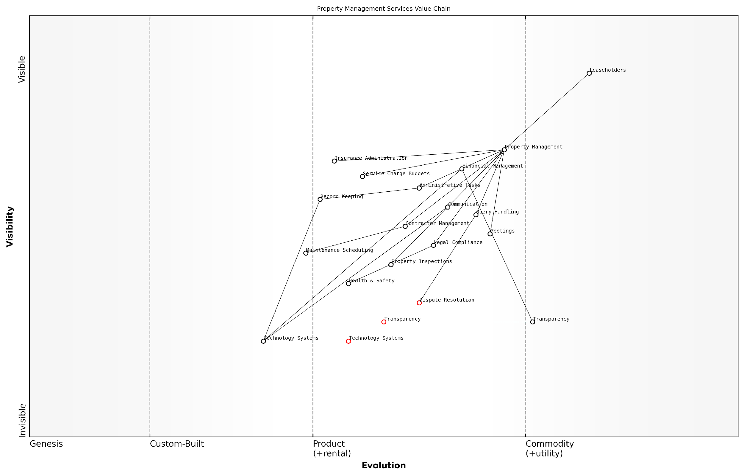

*Draft Wardley Map: [Insert Wardley Map: What management fees should cover]*

[Edit this draft Wardley Map](https://create.wardleymaps.ai/#clone:e8b272efccb91c06b2)

Wardley Map Assessment

The Property Management Services Value Chain is at a critical juncture, with traditional services well-established but facing disruption from evolving technology and increasing demands for transparency. The strategic focus should be on accelerating the development and integration of Technology Systems, enhancing Transparency across all operations, and leveraging these advancements to improve efficiency and leaseholder satisfaction. By proactively addressing these areas, property management firms can position themselves as industry leaders and create significant competitive advantages in an increasingly demanding market.

[View full Wardley Map report](https://github.com/tractorjuice/automated_wardley_reports/blob/main/markdown_wardley_map_reports/wardley_map_report_13_What_management_fees_should_cover.md)

In conclusion, understanding what management fees should cover is essential for leaseholders to ensure they are receiving fair value for their money and to identify any potential areas of excessive charging. By being informed about the components that should be included in these fees, leaseholders can more effectively challenge unreasonable charges and work towards a more transparent and equitable management structure for their properties.

### Benchmarking management fees

Benchmarking management fees is a crucial process in ensuring fair compensation for property management services while safeguarding leaseholders from excessive charges. As an expert in tackling service charge issues, I can attest to the complexity and importance of this topic within the broader context of leasehold reform in England.

To effectively benchmark management fees, it’s essential to understand the factors that influence these charges and the methods used to compare them across different properties and management agents. Let’s delve into the key aspects of this process.

Factors Influencing Management Fees:

* Property size and complexity
* Number of units
* Location
* Scope of services provided
* Frequency of on-site management
* Additional responsibilities (e.g., major works projects)

Understanding these factors is crucial when comparing management fees across different properties. A larger, more complex development in central London will naturally command higher fees than a small block of flats in a rural area.

Methods of Benchmarking:

* Percentage of service charge: Typically ranging from 10-15% of the total service charge
* Fixed fee per unit: A set amount charged per flat, often used in smaller developments
* Hybrid models: Combining percentage and fixed fee approaches
* Market comparisons: Analysing fees charged for similar properties in the same area

When benchmarking, it’s crucial to compare like with like. A senior government official once remarked, ‘The devil is in the details when it comes to management fees. What appears excessive at first glance may be justified when you consider the full scope of services provided.’

Industry Standards and Best Practices:

While there is no legally mandated cap on management fees in England, several industry bodies provide guidance on fair and reasonable charges. The Royal Institution of Chartered Surveyors (RICS) and the Association of Residential Managing Agents (ARMA) offer benchmarking services and publish guidelines that can be invaluable in assessing the reasonableness of fees.

A leading property management expert notes, ‘Transparency is key. Reputable managing agents should be able to provide a clear breakdown of their fees and justify any charges above industry averages.’

Practical Steps for Leaseholders:

* Request a detailed breakdown of management fees from your agent
* Compare fees with similar properties in your area
* Consult industry benchmarking reports and guidelines
* Engage with your residents’ association or other leaseholders
* Consider seeking professional advice if fees seem excessive

Case Study: The Importance of Scrutiny

In a recent consultation I conducted for a government housing initiative, we uncovered a case where leaseholders in a medium-sized development in Manchester were being charged management fees at 22% of their service charge. Upon investigation, it was revealed that the management agent was including costs for services that should have been separately itemised. Through careful benchmarking and negotiation, the fees were reduced to 13%, saving leaseholders thousands of pounds annually.

Challenges in Benchmarking:

* Lack of standardisation in fee structures
* Variations in service quality not reflected in fees
* Limited access to comprehensive market data
* Difficulty in assessing value for money

These challenges underscore the need for greater transparency and standardisation in the property management industry. As part of ongoing leasehold reform efforts, there are calls for more rigorous regulation of management fees and improved access to benchmarking data for leaseholders.

A senior policymaker involved in leasehold reform recently stated, ‘Empowering leaseholders with the tools and knowledge to effectively benchmark management fees is crucial in our efforts to create a fairer leasehold system.’

The Future of Management Fee Benchmarking:

As we look to the future, several developments are likely to impact the benchmarking of management fees:

* Increased use of technology and data analytics in fee comparisons
* Potential introduction of standardised fee structures through legislation
* Greater emphasis on performance-based fees linked to service quality metrics
* Enhanced disclosure requirements for management agents

These developments have the potential to significantly improve the transparency and fairness of management fees, benefiting leaseholders across England.

In conclusion, effective benchmarking of management fees is a critical tool in the leaseholder’s arsenal against excessive charges. By understanding the factors that influence these fees, utilising appropriate comparison methods, and staying informed about industry standards, leaseholders can ensure they are receiving fair value for their management services. As the leasehold landscape continues to evolve, ongoing vigilance and engagement in benchmarking practices will remain essential for protecting leaseholders’ interests.

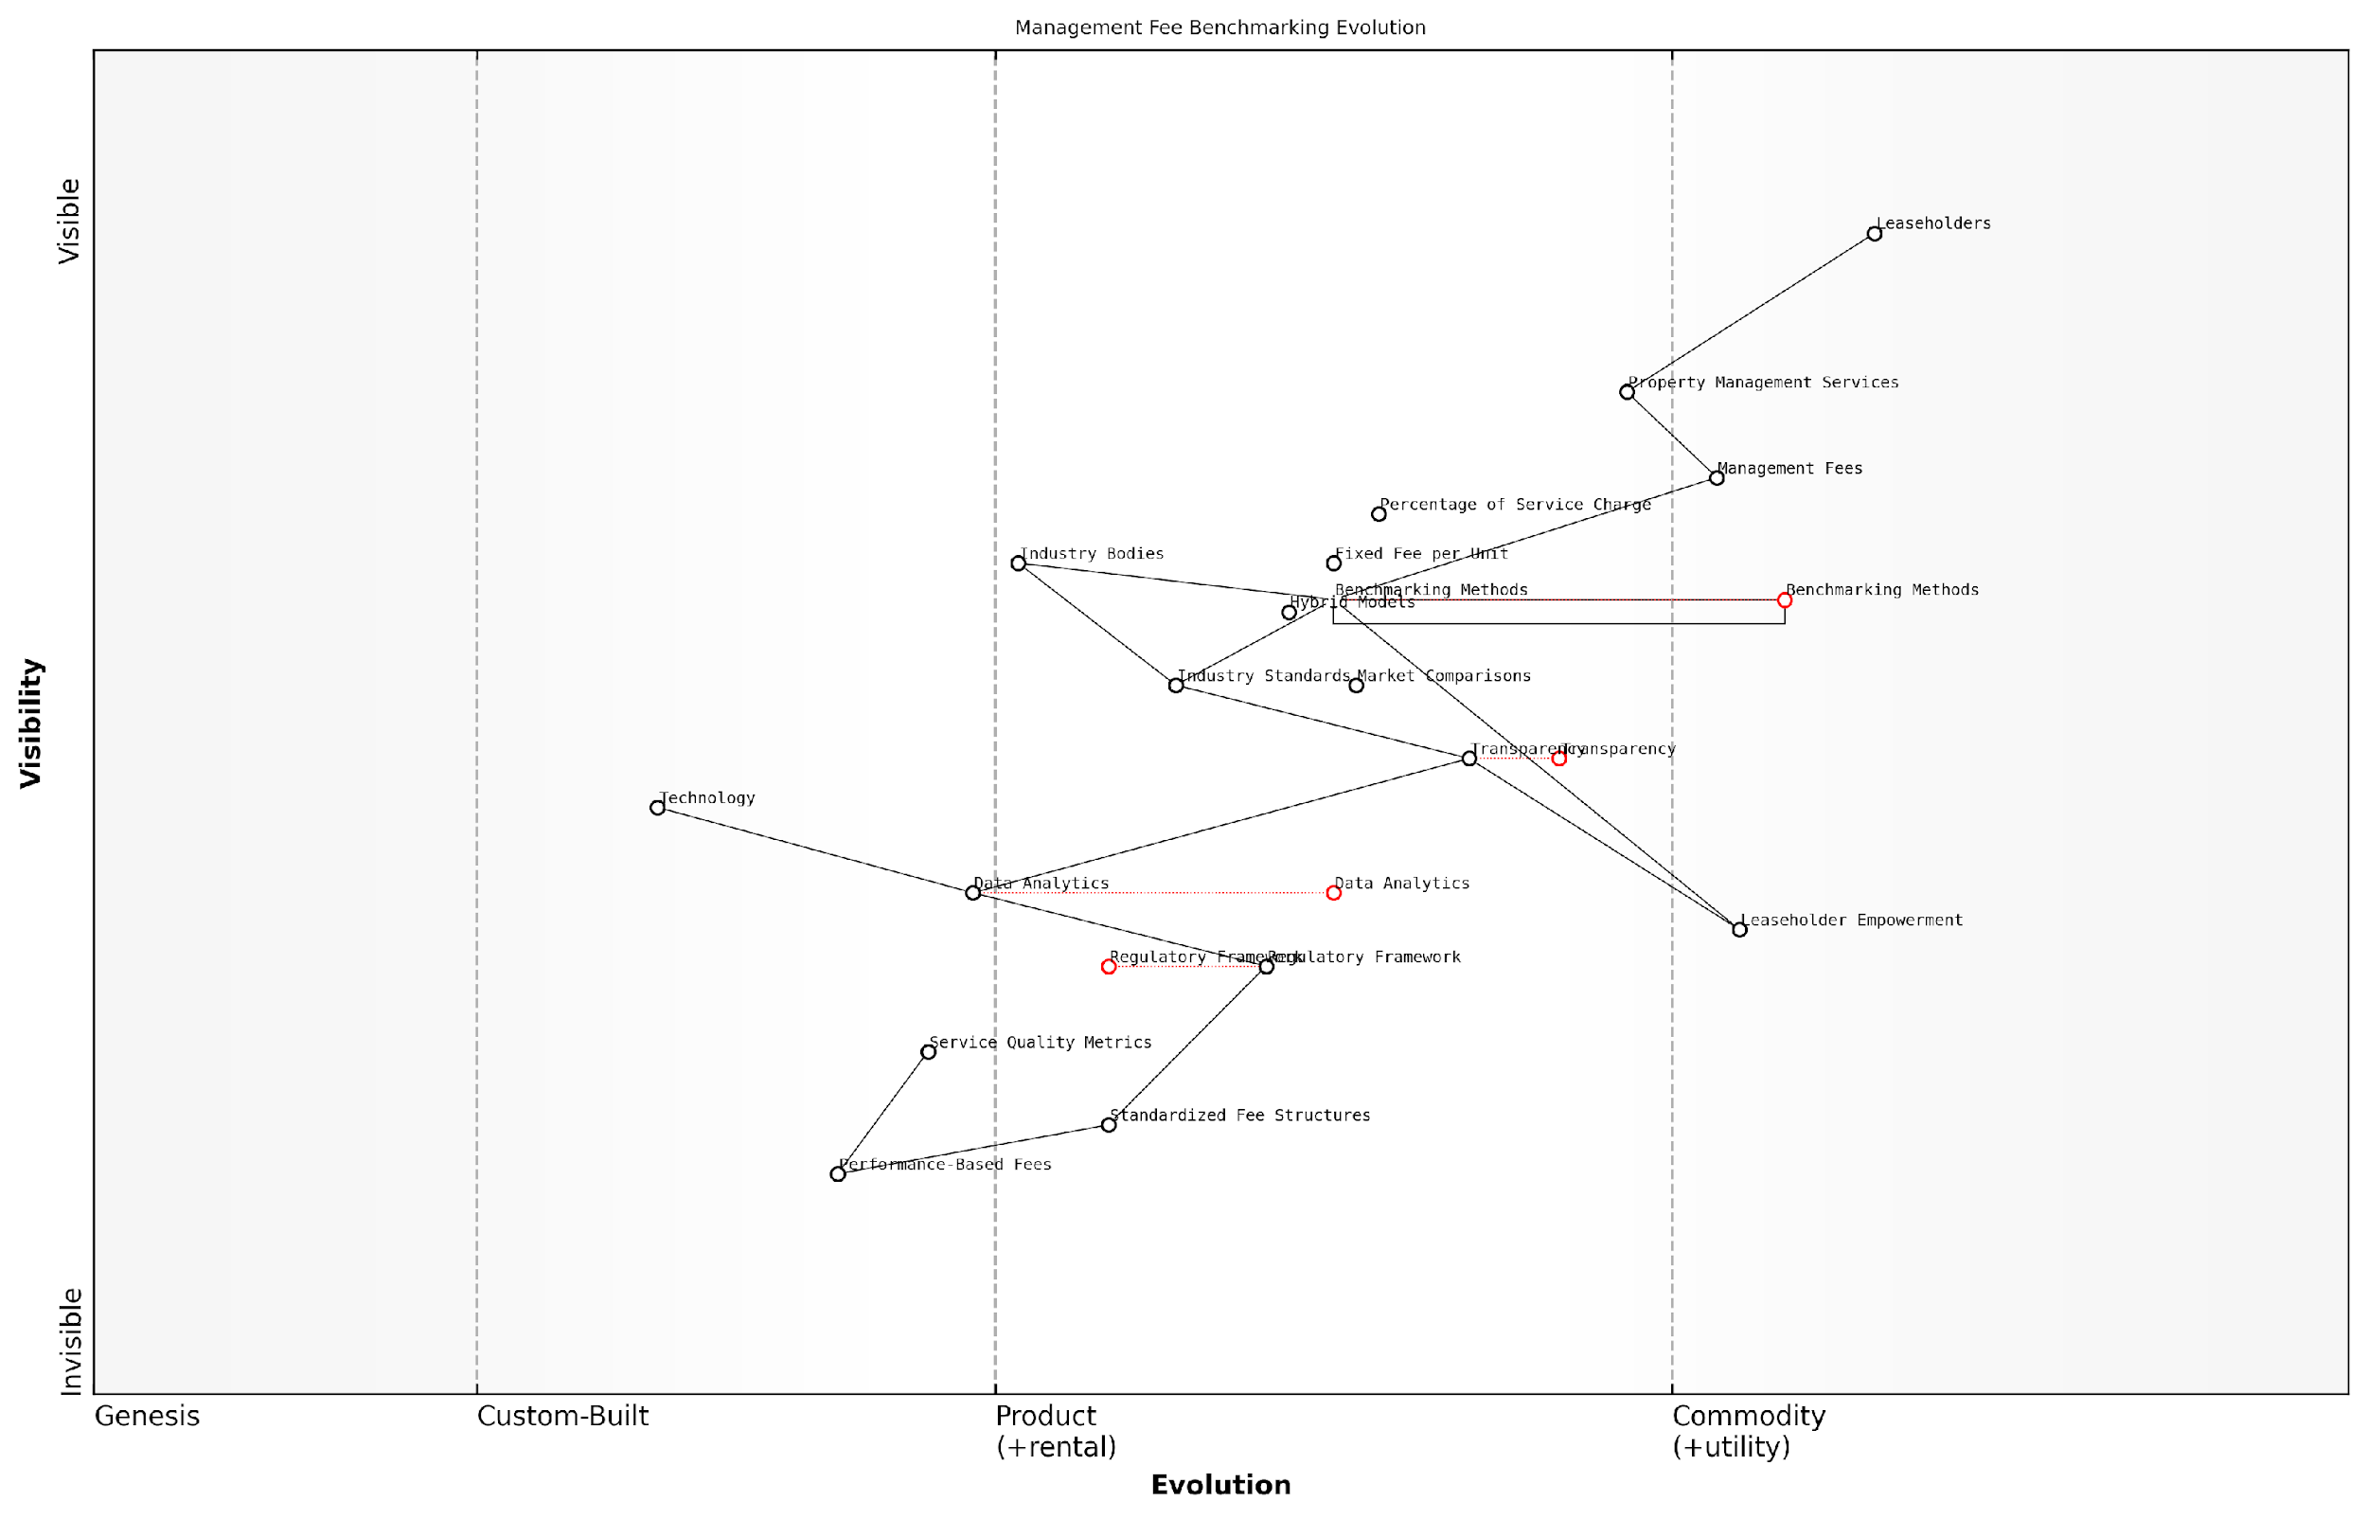

*Draft Wardley Map: [Insert Wardley Map: Benchmarking management fees]*

[Edit this draft Wardley Map](https://create.wardleymaps.ai/#clone:1ce70092a193d32453)

Wardley Map Assessment

The Wardley Map reveals an industry at a critical juncture, poised for significant transformation. The strategic focus should be on leveraging emerging technologies and data analytics to drive transparency, fairness, and efficiency in management fee structures. By proactively addressing leaseholder concerns and regulatory pressures through innovation in benchmarking and fee models, forward-thinking organisations can position themselves as leaders in a more open, performance-driven ecosystem. The key to success will be balancing the needs of all stakeholders while driving the evolution towards more sophisticated, transparent, and equitable management practices.

[View full Wardley Map report](https://github.com/tractorjuice/automated_wardley_reports/blob/main/markdown_wardley_map_reports/wardley_map_report_14_Benchmarking_management_fees.md)

### Challenging unreasonable management fees

In the complex landscape of leasehold property management, the issue of management fees often emerges as a contentious point between leaseholders and management agents. As an expert in this field, I can attest that challenging unreasonable management fees is not only a right but often a necessity for leaseholders seeking fair treatment and value for money. This section will delve into the intricacies of management fees, providing leaseholders with the knowledge and tools to effectively challenge excessive charges.

To begin, it’s crucial to understand what constitutes a reasonable management fee. Management fees typically cover the cost of the agent’s time and expertise in overseeing the property, including tasks such as arranging maintenance, collecting service charges, and ensuring compliance with relevant regulations. However, the line between fair compensation and profiteering can often become blurred.

Management fees should reflect the actual work undertaken, not serve as a profit centre for agents at the expense of leaseholders.

Let’s explore the key aspects of challenging unreasonable management fees:

* Understanding the basis of the fee
* Benchmarking against industry standards
* Gathering evidence of overcharging or poor service
* Utilising legal frameworks for challenge
* Negotiating with the management agent
* Pursuing formal dispute resolution if necessary

Understanding the basis of the fee is the first step in any challenge. Management agents should provide a clear breakdown of their fees, detailing the services covered and the basis for calculation. This could be a percentage of the service charge, a fixed fee per unit, or an hourly rate for services rendered. Leaseholders have the right to request this information under Section 22 of the Landlord and Tenant Act 1985.

Benchmarking against industry standards is crucial in determining whether a fee is reasonable. While there’s no fixed ‘correct’ amount for management fees, as they can vary based on the property’s size, location, and complexity of management, there are general guidelines. The Association of Residential Managing Agents (ARMA) and the Royal Institution of Chartered Surveyors (RICS) provide useful benchmarks.

In my experience advising government bodies on leasehold matters, I’ve found that management fees typically range from 10-15% of the annual service charge for most residential properties. Anything significantly above this warrants scrutiny.

Gathering evidence is paramount when challenging fees. This may include:

* Detailed records of services provided (or not provided)
* Comparisons with similar properties in the area
* Expert opinions on reasonable fees for the services rendered
* Documentation of any poor service or mismanagement

The legal framework for challenging management fees is primarily found in the Landlord and Tenant Act 1985 and the Commonhold and Leasehold Reform Act 2002. These acts stipulate that service charges, including management fees, must be reasonable. Section 19 of the 1985 Act specifically allows leaseholders to challenge the reasonableness of charges at the First-tier Tribunal (Property Chamber).

Before resorting to formal dispute resolution, negotiation with the management agent is often advisable. This approach can be particularly effective when multiple leaseholders act collectively, perhaps through a recognised residents’ association. Present your evidence clearly and professionally, and be prepared to discuss a fair compromise.

In my consultancy work, I’ve seen numerous cases where well-prepared leaseholders have successfully negotiated significant reductions in management fees without resorting to tribunal action.

If negotiation fails, the next step is formal dispute resolution. The First-tier Tribunal (Property Chamber) has the power to determine whether management fees are reasonable and to set a fair rate. When preparing for a tribunal:

* Compile all relevant documentation, including lease agreements, fee breakdowns, and correspondence with the management agent
* Prepare a clear, concise presentation of your case, focusing on factual evidence
* Consider seeking expert testimony to support your position
* Be prepared to demonstrate how the fees are unreasonable in relation to the services provided

It’s worth noting that the tribunal process can be time-consuming and potentially costly, so it’s important to weigh the potential benefits against the costs and stress involved. However, a successful challenge can result in significant savings and set a precedent for future fee negotiations.

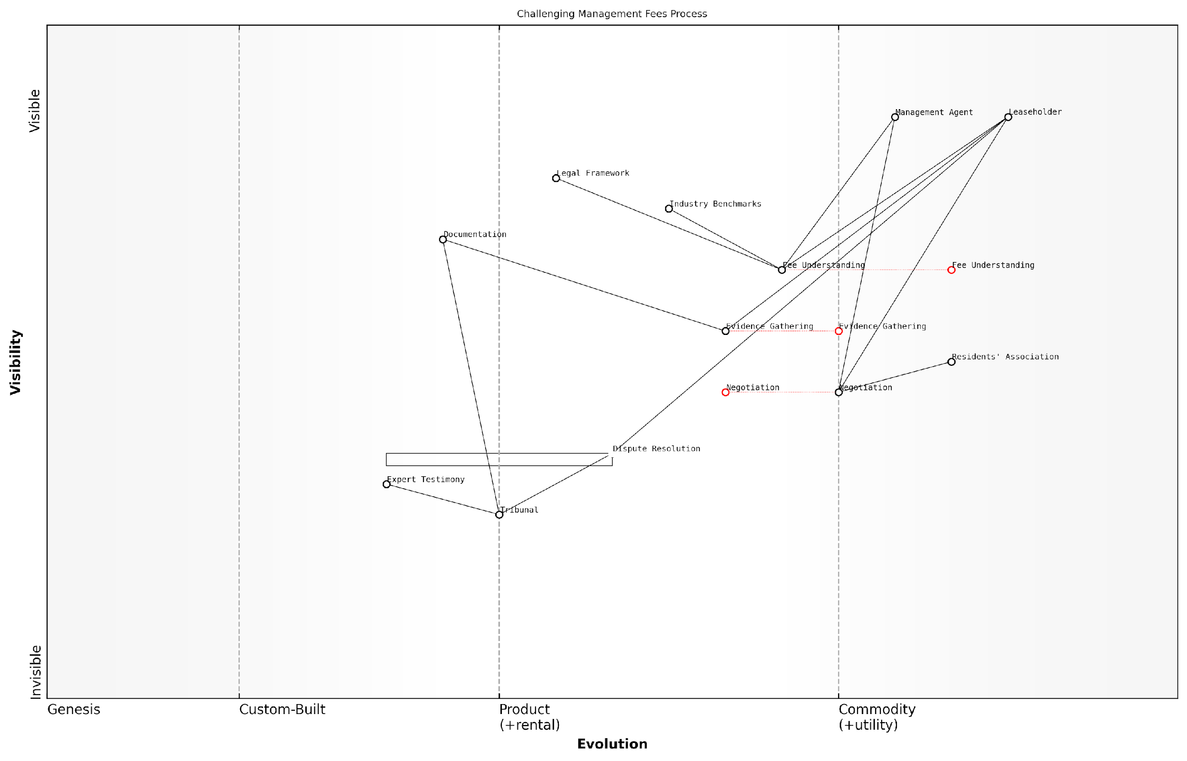

*Draft Wardley Map: [Insert Wardley Map: Challenging unreasonable management fees]*

[Edit this draft Wardley Map](https://create.wardleymaps.ai/#clone:5e324fe9a1ce9f894d)

Wardley Map Assessment

This Wardley Map reveals a maturing process for challenging management fees, with significant opportunities for innovation in fee understanding and evidence gathering. The strategic focus should be on empowering leaseholders through better information and tools, standardising processes where possible, and leveraging technology to create a more balanced and transparent ecosystem. Key areas for development include automated fee analysis, standardised evidence gathering, and AI-assisted negotiation preparation. Long-term success will likely depend on fostering industry-wide changes towards greater transparency and fairness in management fee structures.

[View full Wardley Map report](https://github.com/tractorjuice/automated_wardley_reports/blob/main/markdown_wardley_map_reports/wardley_map_report_15_Challenging_unreasonable_management_fees.md)

In conclusion, challenging unreasonable management fees is a vital tool for leaseholders in maintaining fair and transparent property management. By understanding the basis of fees, benchmarking against industry standards, gathering robust evidence, and utilising the available legal frameworks, leaseholders can effectively contest excessive charges. Whether through negotiation or formal dispute resolution, the goal is to ensure that management fees reflect fair compensation for services rendered, rather than becoming a source of unwarranted profit for management agents.

Remember, reasonable management fees are not just about cost savings; they’re about fostering a fair and sustainable leasehold system that benefits all parties involved.

# Challenging Excessive Charges and Unfair Terms

## Preparing Your Case

### Gathering evidence and documentation

In the complex landscape of leasehold disputes, the strength of your case often hinges on the quality and comprehensiveness of the evidence you gather. As an expert in tackling excessive service charges and challenging bad management agents, I cannot overstate the importance of meticulous documentation. This section will guide you through the critical process of assembling a robust evidence base, a fundamental step in preparing your case against unreasonable charges or unfair practices.

Let’s break down the evidence-gathering process into key areas:

* Financial Records and Service Charge Statements
* Correspondence and Communication Logs
* Photographic and Video Evidence
* Expert Reports and Surveys
* Witness Statements
* Comparative Data

1. Financial Records and Service Charge Statements

The cornerstone of any challenge to excessive service charges lies in the financial documentation. As a leaseholder, you have the right to request and examine detailed breakdowns of service charges. Ensure you collect:

* Annual service charge statements for at least the past three years
* Itemised bills and invoices for works carried out
* Copies of the service charge budget and actual expenditure
* Bank statements showing payments made
* Any section 20 consultation notices for major works

Remember, under the Landlord and Tenant Act 1985, you have the right to request a summary of costs incurred by the landlord. If discrepancies are found, these documents will form the basis of your challenge.

1. Correspondence and Communication Logs

Maintaining a comprehensive record of all communications with your management agent or freeholder is crucial. This includes:

* Emails and letters exchanged
* Notes from telephone conversations (including dates, times, and the name of the person you spoke with)
* Records of any in-person meetings
* Copies of formal complaints made and responses received

These records can demonstrate patterns of behaviour, responsiveness (or lack thereof), and any admissions or promises made by the management agent or freeholder.

As a seasoned tribunal member once remarked, ‘The paper trail is often what separates a successful case from an unsuccessful one. Leaseholders who meticulously document their interactions invariably present stronger arguments.’

1. Photographic and Video Evidence

Visual evidence can be compelling, particularly when challenging charges related to repairs, maintenance, or the general condition of the property. Gather:

* Dated photographs of the areas in question (before and after any works, if applicable)
* Video footage showcasing ongoing issues or the quality of completed works
* Time-stamped images that demonstrate the duration of problems

Ensure all visual evidence is clearly dated and, where possible, geographically tagged. This can be crucial in demonstrating the timeline of issues and the necessity (or lack thereof) of charged works.

1. Expert Reports and Surveys

In cases involving significant disputes or technical issues, independent expert opinions can be invaluable. Consider obtaining:

* Structural surveys from chartered surveyors
* Specialist reports (e.g., on damp issues, electrical systems, or fire safety)
* Quantity surveyor assessments on the reasonableness of costs for major works

While these reports may involve upfront costs, they can provide authoritative evidence that significantly strengthens your case, particularly in tribunal settings.

1. Witness Statements

Corroborating evidence from other leaseholders or relevant parties can add weight to your case. Collect:

* Written statements from fellow leaseholders experiencing similar issues
* Testimonies from independent contractors or service providers
* Statements from any professional advisors consulted during the dispute

Ensure all statements are signed, dated, and include the full name and contact details of the witness. These can be particularly powerful in demonstrating widespread issues or contradicting claims made by the management agent.

1. Comparative Data

To challenge the reasonableness of charges, it’s often helpful to provide context through comparative data. Gather:

* Service charge information from similar properties in the area
* Quotes from alternative service providers for comparable works or services
* Industry benchmarks for management fees and service charges

This comparative approach can be particularly effective in demonstrating that charges are out of line with market rates or industry standards.

A leading property rights advocate once noted, ‘In my experience, leaseholders who present well-researched comparative data often find tribunals more receptive to their arguments on unreasonable charges.’

Organising Your Evidence

Once you’ve gathered your evidence, organisation becomes key. Create a clear, chronological file structure, with each piece of evidence labelled and dated. Consider creating a summary document that outlines the key points of your case and references the supporting evidence.

Remember, the goal is not just to collect evidence, but to present a clear, compelling narrative that supports your case. As you organise your documentation, you’ll likely begin to see patterns and strengths in your argument that will be crucial in the next stages of your challenge.

By following this comprehensive approach to gathering and organising evidence, you’ll be well-prepared to challenge excessive service charges and confront bad management practices. Remember, in the world of leasehold disputes, thorough documentation is not just beneficial—it’s essential for success.

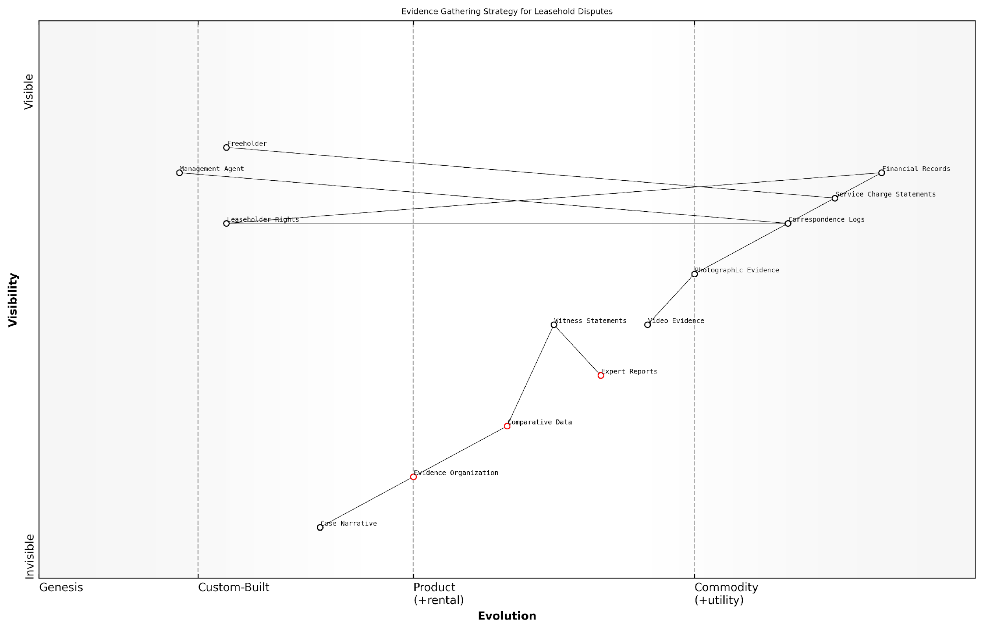

*Draft Wardley Map: [Insert Wardley Map: Gathering evidence and documentation]*

[Edit this draft Wardley Map](https://create.wardleymaps.ai/#clone:92fd7f779eaf98bb35)

Wardley Map Assessment

The map reveals a maturing field with significant opportunities for innovation in evidence organisation and presentation. By focusing on evolving components like Evidence Organization and embracing emerging technologies, organisations can gain a competitive edge in leasehold dispute resolution. The key to success lies in balancing traditional, highly evolved evidence types with newer, more customised approaches, all while maintaining a clear focus on the end goal of effective tribunal presentation.

[View full Wardley Map report](https://github.com/tractorjuice/automated_wardley_reports/blob/main/markdown_wardley_map_reports/wardley_map_report_16_Gathering_evidence_and_documentation.md)

### Understanding the grounds for challenge

In the complex landscape of leasehold property management, understanding the grounds for challenging excessive service charges and unfair terms is crucial for leaseholders seeking to protect their rights and financial interests. This section delves into the legal and practical foundations that empower leaseholders to contest unreasonable charges and practices, providing a comprehensive guide to building a robust case against unscrupulous management agents or freeholders.

The Landlord and Tenant Act 1985, as amended by subsequent legislation, forms the cornerstone of leaseholders’ rights to challenge service charges. Section 19 of this Act stipulates that service charges must be reasonable and that only reasonable costs can be recovered through these charges. This principle of reasonableness is the primary ground upon which most challenges are built.

* Lack of consultation on major works
* Failure to provide a detailed breakdown of charges
* Charges for unnecessary or substandard work
* Inflated management fees
* Charges for services not provided or not benefiting the leaseholder
* Breach of lease terms regarding service charges

One of the most common grounds for challenge is the lack of proper consultation on major works. The Commonhold and Leasehold Reform Act 2002 introduced stringent consultation requirements for works exceeding £250 per leaseholder. Failure to adhere to these requirements can result in the landlord’s ability to recover costs being limited to £250 per leaseholder, regardless of the actual cost of the works.

The consultation process is not merely a formality; it’s a fundamental right of leaseholders to have a say in significant expenditures that affect their property and finances. Landlords who bypass this process do so at their own peril.

Another crucial ground for challenge is the failure to provide a detailed breakdown of charges. The Landlord and Tenant Act 1985 requires landlords to provide a summary of rights and obligations with every demand for service charges. This summary must include an itemised breakdown of the charges, allowing leaseholders to scrutinise each element for reasonableness and necessity.

Charges for unnecessary or substandard work present a compelling case for challenge. Leaseholders have the right to expect that any work carried out is necessary for the maintenance and repair of the property, and that it is completed to a satisfactory standard. Evidence of poor workmanship, overcharging, or works that go beyond what is reasonably required can form the basis of a strong challenge.

Inflated management fees are another area ripe for scrutiny. While management agents are entitled to fair compensation for their services, fees that are disproportionate to the work carried out or significantly above market rates can be challenged. Benchmarking against industry standards and obtaining comparative quotes can provide valuable evidence in such cases.

Management fees should reflect the actual work done, not serve as a profit centre for agents at the expense of leaseholders. Transparency and justification are key when it comes to these charges.

Leaseholders may also challenge charges for services that are not provided or do not benefit them directly. This is particularly relevant in mixed-use developments or where certain services are specific to particular parts of a building. The principle here is that leaseholders should only pay for services from which they derive a benefit, either directly or indirectly through the maintenance of common areas.

Breaches of lease terms regarding service charges provide another solid ground for challenge. The lease is the fundamental contract between the leaseholder and the freeholder, and any deviation from its terms in relation to service charges can be contested. This underscores the importance of leaseholders thoroughly understanding their lease agreements and the specific provisions relating to service charges.

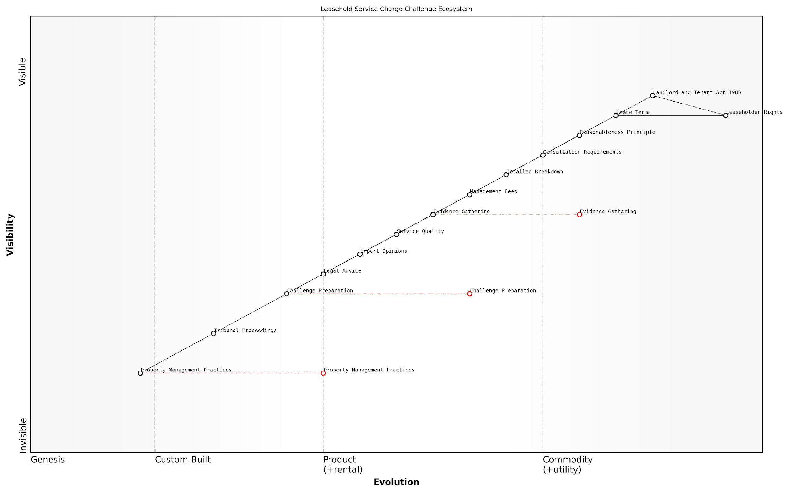

*Draft Wardley Map: [Insert Wardley Map: Understanding the grounds for challenge]*

[Edit this draft Wardley Map](https://create.wardleymaps.ai/#clone:7809a6ac8987c16531)

Wardley Map Assessment

The Leasehold Service Charge Challenge Ecosystem is at a critical juncture, with established legal frameworks and evolving practices in challenge preparation and property management. There are significant opportunities for innovation in evidence gathering and challenge preparation processes, which could lead to more efficient and effective challenges. The evolving nature of property management practices also presents an opportunity for systemic change. Organisations in this space should focus on developing standardised, technology-driven approaches to challenge preparation and evidence gathering, while also advocating for and adapting to changes in property management practices. The key to success will be balancing the need for adherence to established legal principles with the adoption of innovative approaches to increase the effectiveness of challenges and ultimately improve the overall ecosystem for leaseholders.

[View full Wardley Map report](https://github.com/tractorjuice/automated_wardley_reports/blob/main/markdown_wardley_map_reports/wardley_map_report_17_Understanding_the_grounds_for_challenge.md)

When preparing to challenge on any of these grounds, it’s crucial to gather comprehensive evidence. This may include historical service charge statements, correspondence with the management agent or freeholder, photographic evidence of substandard work, and expert opinions on the necessity and cost of works carried out.

* Collect and organise all relevant documentation
* Seek expert opinions where necessary (e.g., surveyors for assessing work quality)
* Engage with other leaseholders to strengthen your case and share costs
* Consider seeking legal advice to refine your arguments and ensure compliance with procedural requirements

It’s worth noting that the burden of proof in service charge disputes often falls on the landlord or management agent to demonstrate that charges are reasonable. However, presenting a well-documented and logically argued case significantly enhances the likelihood of a successful challenge.

In my experience advising leaseholders, the strength of a challenge often lies not just in the legal grounds, but in the meticulous preparation and presentation of evidence. A well-prepared case can often lead to resolution without the need for formal tribunal proceedings.

Understanding these grounds for challenge empowers leaseholders to take informed action against excessive service charges and unfair practices. By familiarising themselves with these principles and gathering appropriate evidence, leaseholders can effectively assert their rights and work towards fairer, more transparent property management practices.

### Seeking professional advice: when and how

In the complex landscape of leasehold disputes, knowing when and how to seek professional advice is crucial for leaseholders challenging excessive service charges or unfair terms. This section explores the pivotal role of expert guidance in preparing a robust case against management agents or freeholders, ensuring that leaseholders are well-equipped to navigate the intricacies of leasehold law and dispute resolution processes.

Recognising the Need for Professional Advice

Determining the right moment to seek professional advice is a critical decision that can significantly impact the outcome of your case. Consider consulting an expert when:

* The complexity of your case exceeds your personal knowledge or experience with leasehold law
* You’ve attempted informal resolution but have reached an impasse with the management agent or freeholder
* The financial stakes are high, with substantial sums in dispute
* You’re preparing for a First-tier Tribunal hearing or other formal legal proceedings
* There are technical aspects to your case, such as challenging the reasonableness of major works or service charge calculations
* You’re considering collective action, such as Right to Manage or enfranchisement, which requires navigating complex legal processes

Types of Professional Advice Available

When seeking professional advice, leaseholders have several options, each offering distinct benefits:

* Solicitors specialising in leasehold law: Provide comprehensive legal advice and representation
* Barristers: Offer expert opinions on complex legal matters and can represent you in tribunal hearings
* Surveyors: Assess the reasonableness of service charges, particularly for major works
* Leasehold consultants: Offer practical advice on managing disputes and navigating the leasehold system
* Accountants: Analyse service charge accounts and identify discrepancies or areas of concern

How to Choose the Right Professional

Selecting the appropriate professional is crucial for building a strong case. Consider the following steps:

* Research professionals with specific expertise in leasehold disputes
* Check for memberships in relevant professional bodies (e.g., Law Society, RICS)
* Seek recommendations from leaseholder associations or online forums
* Arrange initial consultations to assess their understanding of your case
* Discuss fees upfront and consider options for fixed-fee services or conditional fee agreements

Choosing the right professional can make all the difference in a leasehold dispute. Look for someone who not only has the technical expertise but also understands the practical realities of challenging management agents and freeholders.

Maximising the Value of Professional Advice

To ensure you get the most out of professional advice, consider the following strategies:

* Prepare a clear, chronological summary of your case before the consultation
* Gather all relevant documents, including lease agreements, service charge demands, and correspondence
* Formulate specific questions you want answered
* Be open and honest about all aspects of your case, including any potential weaknesses
* Take detailed notes during meetings and ask for clarification on any points you don’t understand
* Discuss potential outcomes and strategies, including the possibility of settlement or alternative dispute resolution

Integrating Professional Advice into Your Case Strategy

Once you’ve received professional advice, it’s essential to integrate it effectively into your overall case strategy:

* Review the advice in the context of your specific circumstances and goals
* Develop an action plan based on the professional’s recommendations
* Consider how the advice impacts your negotiation strategy with the management agent or freeholder
* Use the insights gained to strengthen your written submissions or oral arguments for tribunal hearings
* Regularly reassess your position as your case progresses, seeking follow-up advice if necessary

Professional advice should empower you to make informed decisions. It’s not about handing over control of your case, but rather gaining the knowledge and tools to advocate effectively for your rights as a leaseholder.

Cost Considerations and Funding Options

While professional advice can be invaluable, it’s important to consider the costs involved:

* Many professionals offer free initial consultations to assess your case
* Consider fixed-fee arrangements for specific services, such as document review or case assessment
* Explore group funding options if multiple leaseholders are facing similar issues
* Check if your home insurance includes legal expenses cover for property disputes
* Research pro bono services or reduced-fee schemes offered by some legal professionals
* Consider the potential cost savings of early professional intervention versus prolonged disputes

Balancing Self-Help and Professional Support

While professional advice is often crucial, it’s important to balance it with self-help strategies:

* Utilise free resources from organisations like LEASE (Leasehold Advisory Service) to build your knowledge
* Join leaseholder forums and associations to learn from others’ experiences
* Use professional advice to guide your own research and case preparation
* Consider seeking advice at key decision points rather than for every aspect of your case
* Develop a collaborative relationship with your chosen professional, where you actively participate in case strategy

The most successful outcomes often result from a combination of professional expertise and the leaseholder’s own commitment to understanding and actively participating in their case.

In conclusion, seeking professional advice at the right time and in the right way can significantly strengthen your position when challenging excessive service charges or unfair terms. By carefully selecting and effectively utilising expert guidance, leaseholders can navigate the complexities of leasehold disputes with greater confidence and increase their chances of a favourable outcome.



*Draft Wardley Map: [Insert Wardley Map: Seeking professional advice: when and how]*

[Edit this draft Wardley Map](https://create.wardleymaps.ai/#clone:a6b5ff0dd9bb834ef7)

Wardley Map Assessment

This Wardley Map reveals a leasehold dispute resolution landscape in transition, with significant opportunities for innovation and digital transformation. The strategic focus should be on enhancing self-help resources, streamlining professional selection, and integrating various services into a cohesive ecosystem. By leveraging technology and fostering collaboration between different professional roles, organisations can create more efficient, accessible, and effective solutions for leaseholders. The key to success will be balancing the value of traditional professional expertise with the efficiency and scalability of digital solutions.

[View full Wardley Map report](https://github.com/tractorjuice/automated_wardley_reports/blob/main/markdown_wardley_map_reports/wardley_map_report_18_Seeking_professional_advice:_when_and_how.md)

## Informal Resolution Strategies

### Communicating effectively with your management agent

Effective communication with your management agent is a crucial first step in addressing excessive service charges and unfair terms. As an expert in leasehold matters, I cannot overstate the importance of this approach in resolving disputes informally before escalating to more formal channels. This section will explore strategies for clear, assertive, and productive communication with your management agent, drawing from years of experience in advising leaseholders and negotiating with management companies.

Before delving into specific communication strategies, it’s essential to understand the context in which you’re operating. Management agents are bound by legal obligations and industry standards, but they also operate as businesses. Your goal is to find a balance between asserting your rights and maintaining a professional, cooperative relationship.

* Know your rights and lease terms
* Gather all relevant documentation
* Identify specific issues and desired outcomes
* Prepare a clear, concise summary of your concerns

With this groundwork laid, let’s explore key strategies for effective communication:

1. Written Communication: Always initiate and follow up on important matters in writing. This creates a paper trail and helps prevent misunderstandings. Use email or formal letters, depending on the gravity of the issue. When writing:

* Be clear, concise, and factual
* Use a professional tone, avoiding emotional language
* Reference specific clauses in your lease or relevant legislation
* Include all pertinent details, dates, and figures
* Clearly state your expectations and desired outcomes

In my experience advising leaseholders, those who maintain meticulous records of written communications are far more likely to achieve favourable outcomes in disputes with management agents.

1. Face-to-Face Meetings: While written communication is crucial, face-to-face meetings can often help build rapport and resolve issues more quickly. When arranging a meeting:

* Propose a clear agenda in advance
* Bring all relevant documentation
* Consider bringing a witness or fellow leaseholder
* Take detailed notes during the meeting
* Follow up with a written summary of what was discussed and agreed upon

1. Use of Appropriate Language and Tone: The way you communicate can significantly impact the response you receive. Aim for a tone that is:

* Firm but courteous
* Assertive without being aggressive
* Focused on facts and solutions rather than blame
* Professional, avoiding personal attacks or emotional appeals

1. Active Listening: Effective communication is a two-way street. When interacting with your management agent:

* Listen carefully to their explanations and perspective
* Ask clarifying questions to ensure understanding
* Acknowledge valid points they make
* Summarise your understanding to confirm agreement

A senior property management consultant once told me, ‘The most successful negotiations occur when both parties feel heard and respected, even if they don’t initially agree.’

1. Escalation Protocol: Establish and follow a clear escalation protocol if initial communications are unsatisfactory:

* Start with your designated property manager
* If unresolved, escalate to their supervisor or department head
* Consider contacting the company’s complaints department
* As a last resort, communicate with the managing director or CEO

1. Collaborative Approach: Where possible, adopt a collaborative rather than confrontational stance:

* Acknowledge the challenges of property management
* Offer to work together to find mutually beneficial solutions
* Suggest compromises where appropriate
* Highlight how resolving the issue benefits all parties

1. Documentation and Follow-up: After any significant communication:

* Document the key points discussed
* Confirm any agreements or action points in writing
* Set clear timelines for next steps or resolutions
* Follow up consistently if deadlines are not met

As a property law expert once remarked, ‘The difference between a resolved dispute and a protracted legal battle often comes down to the quality of communication and documentation in the early stages.’

1. Seek Support: If you’re struggling to communicate effectively:

* Consult with other leaseholders in your building
* Consider forming or joining a residents’ association
* Seek advice from organisations like LEASE (Leasehold Advisory Service)
* Consider engaging a professional mediator for complex disputes

By employing these strategies, leaseholders can significantly improve their chances of resolving issues with management agents informally. Effective communication not only addresses immediate concerns but can also foster a more positive long-term relationship, benefiting all parties involved in the leasehold arrangement.

Remember, while these strategies are often effective, there may be instances where formal dispute resolution becomes necessary. However, by establishing a foundation of clear, professional communication, you create a stronger position for yourself, regardless of the ultimate outcome of your dispute.

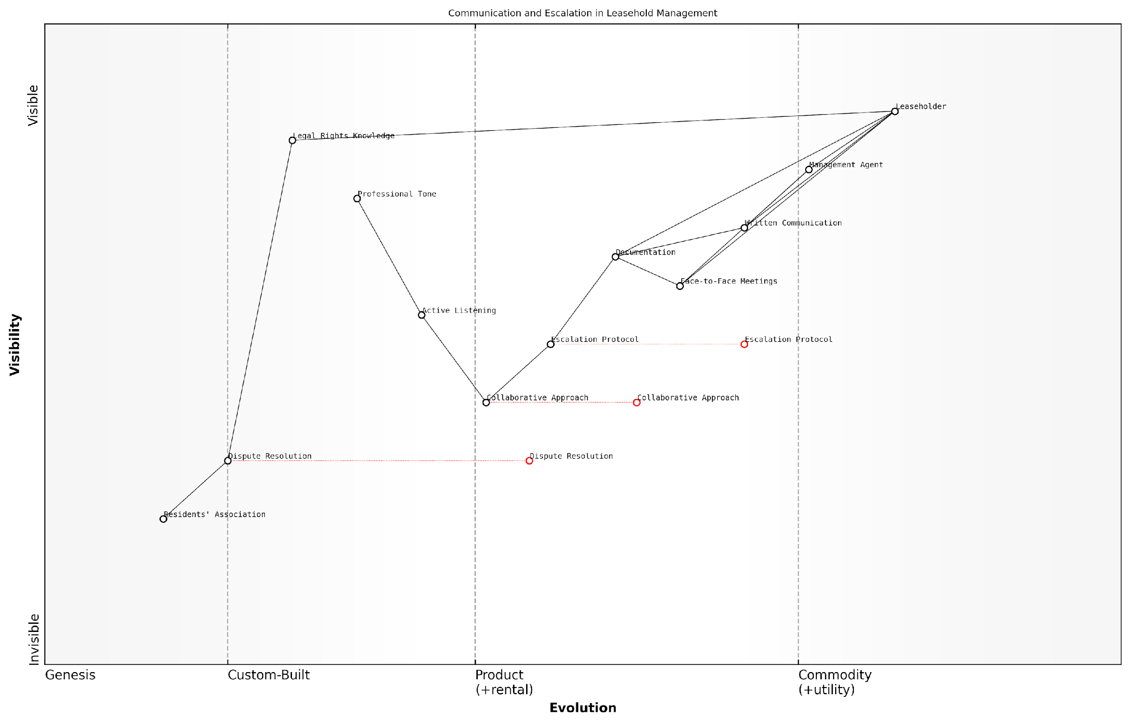

*Draft Wardley Map: [Insert Wardley Map: Communicating effectively with your management agent]*

[Edit this draft Wardley Map](https://create.wardleymaps.ai/#clone:abc5d61afd2571ca45)

Wardley Map Assessment

This Wardley Map reveals a leasehold management system that is transitioning from traditional, formal processes towards more collaborative and empowering approaches. While strong in formal communication and documentation, the system shows significant opportunities for improvement in dispute resolution, collaborative practices, and leaseholder empowerment. Strategic focus on evolving these areas, particularly through technology adoption and skill development, could lead to a more balanced, efficient, and satisfactory leasehold management ecosystem. The potential for Residents’ Associations to drive collective action represents a particularly promising avenue for system-wide improvement.

[View full Wardley Map report](https://github.com/tractorjuice/automated_wardley_reports/blob/main/markdown_wardley_map_reports/wardley_map_report_19_Communicating_effectively_with_your_management_age.md)

### Negotiation techniques for positive outcomes

In the complex landscape of leasehold property management, effective negotiation skills are paramount when addressing excessive service charges and unfair terms. This section explores proven techniques for leaseholders to engage productively with management agents, fostering positive outcomes and potentially avoiding costly formal disputes.

Preparation: The Foundation of Successful Negotiation

Before entering into any negotiation with a management agent, thorough preparation is essential. This involves:

* Gathering all relevant documentation, including service charge statements, lease agreements, and correspondence
* Researching comparable service charges in similar properties to establish a benchmark
* Identifying specific points of contention and preparing clear, factual arguments
* Setting realistic goals and determining your ‘walk away’ point

As a seasoned property rights advocate notes, ‘The most successful negotiations are those where leaseholders enter the room armed with facts, not just frustrations.’

Establishing Rapport and Open Communication

While it’s natural to feel adversarial when challenging charges, adopting a collaborative approach can yield better results. Consider these strategies:

* Initiate contact with a polite, professional tone, expressing a desire to understand and resolve issues
* Use active listening techniques to fully comprehend the management agent’s perspective
* Acknowledge any valid points made by the agent, demonstrating fairness and reasonableness
* Frame the discussion as a mutual problem-solving exercise rather than a confrontation

Effective Presentation of Your Case

When presenting your arguments against excessive charges or unfair terms, clarity and precision are key:

* Clearly articulate each point of contention, supported by relevant documentation
* Use objective criteria and industry standards to justify your position
* Present your arguments in a logical, easy-to-follow manner
* Anticipate potential counterarguments and prepare responses in advance

A prominent leasehold consultant advises, ‘In negotiations, the power of a well-structured, evidence-based argument cannot be overstated. It shifts the conversation from emotional grievances to factual discourse.’

Exploring Win-Win Solutions

The most successful negotiations often result in outcomes that benefit both parties. Consider these approaches:

* Propose alternative solutions that address both your concerns and the management agent’s obligations
* Be open to phased implementations or compromises that achieve your main objectives
* Explore options for improved transparency and communication to prevent future disputes
* Consider offering concessions on less critical issues to gain ground on more important ones

Handling Deadlocks and Difficult Conversations

When negotiations stall or become contentious, employ these strategies to maintain progress:

* Take breaks to cool down and reassess your approach if emotions run high
* Reframe the discussion by focusing on shared interests and long-term relationships
* Use ‘what if’ scenarios to explore hypothetical solutions without commitment
* Consider bringing in a neutral third party, such as a mediator, to facilitate discussions

As one experienced property tribunal member observes, ‘The most intractable disputes often thaw when parties step back and recognise their shared interest in maintaining a well-managed property.’

Documenting Outcomes and Next Steps

Once an agreement is reached, or even if negotiations are ongoing, proper documentation is crucial:

* Summarise key points of agreement or areas still under discussion in writing
* Clearly outline any actions to be taken by either party, including timelines
* Request written confirmation of any agreements from the management agent
* Set a date for follow-up to ensure agreed actions are implemented

Leveraging Collective Bargaining Power

In many cases, individual leaseholders can strengthen their negotiating position by joining forces with others:

* Coordinate with other leaseholders to present a united front
* Form or utilise an existing Residents’ Association to amplify your voice
* Pool resources to engage professional advice or representation if needed
* Use the collective knowledge and experiences of fellow leaseholders to inform your strategy

A leading leasehold reform campaigner emphasises, ‘The power of collective action in leasehold negotiations cannot be overstated. It transforms the dynamic from David versus Goliath to a more balanced dialogue.’

Knowing When to Escalate

While negotiation is often the most efficient path to resolution, it’s important to recognise when informal methods have been exhausted:

* Set clear deadlines for responses and resolution attempts
* Keep detailed records of all negotiation attempts and outcomes
* Be prepared to escalate to formal dispute resolution if negotiations fail
* Seek legal advice if you feel the management agent is acting in bad faith or breaching regulations

By mastering these negotiation techniques, leaseholders can significantly improve their chances of achieving fair outcomes when challenging excessive service charges and unfair terms. Remember, the goal is not just to win a single battle, but to foster a more transparent, equitable relationship with your management agent for the long term.

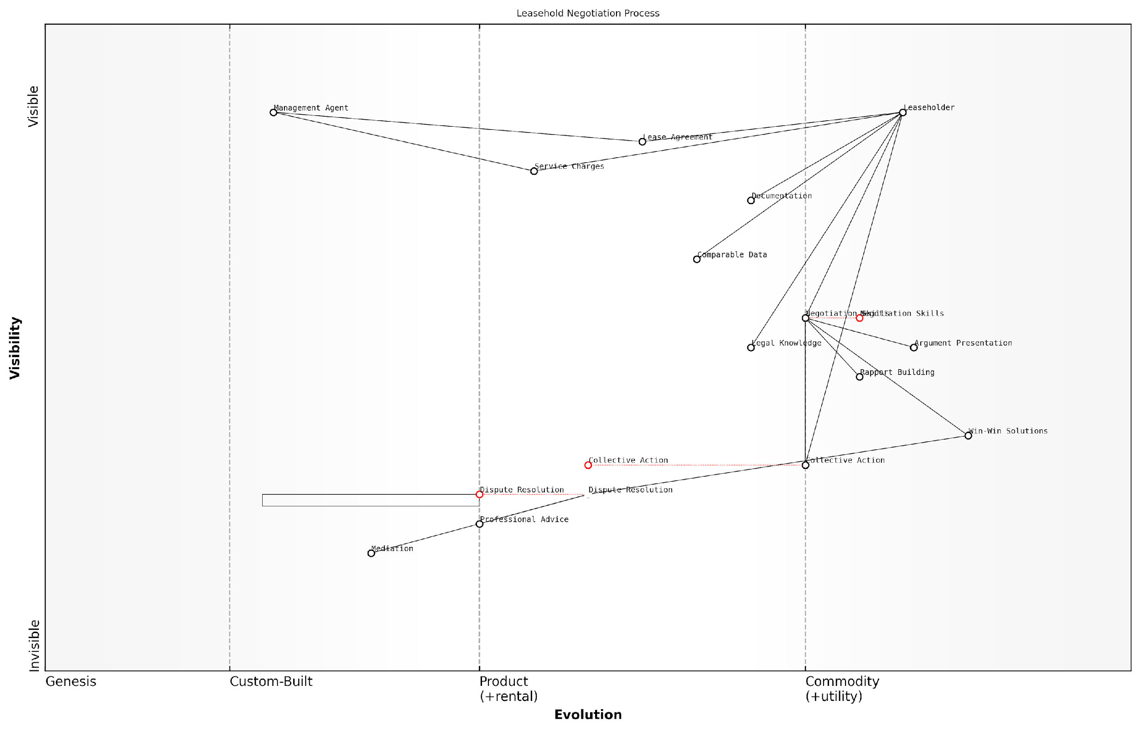

*Draft Wardley Map: [Insert Wardley Map: Negotiation techniques for positive outcomes]*

[Edit this draft Wardley Map](https://create.wardleymaps.ai/#clone:7b8b5e30c25338a3fb)

Wardley Map Assessment

The Wardley Map reveals a leasehold negotiation process that is evolving towards more sophisticated and collaborative approaches. While traditional negotiation and dispute resolution methods are well-established, there are significant opportunities for innovation, particularly in developing Win-Win Solutions and leveraging Collective Action. The strategic focus should be on enhancing Negotiation Skills, fostering Collective Action, and investing in data-driven decision-making tools. By doing so, leaseholders can strengthen their position and work towards more favourable outcomes in their interactions with Management Agents. The evolution of key components suggests a future where leasehold negotiations may become more standardised and efficient, potentially reducing conflicts and the need for formal dispute resolution.

[View full Wardley Map report](https://github.com/tractorjuice/automated_wardley_reports/blob/main/markdown_wardley_map_reports/wardley_map_report_20_Negotiation_techniques_for_positive_outcomes.md)

### Using mediation services

Mediation services play a crucial role in resolving disputes between leaseholders and management agents, offering a cost-effective and less adversarial alternative to formal legal proceedings. As an expert in tackling excessive service charges and bad management agents for leasehold flats in England, I cannot overstate the importance of understanding and utilising mediation as part of your informal resolution strategy.

Mediation is a voluntary process where an impartial third party, the mediator, facilitates communication between the disputing parties to help them reach a mutually acceptable agreement. In the context of leasehold disputes, mediation can be particularly effective for addressing issues related to service charges, maintenance responsibilities, and communication breakdowns.

Mediation offers a unique opportunity to resolve disputes in a collaborative manner, often resulting in more satisfactory and sustainable outcomes for both leaseholders and management agents.

Let’s explore the key aspects of using mediation services in the leasehold context:

* Benefits of mediation
* When to consider mediation
* Choosing a mediation service
* Preparing for mediation
* The mediation process
* Outcomes and agreements

Benefits of Mediation:

* Cost-effective: Typically less expensive than formal legal proceedings
* Time-efficient: Can resolve disputes more quickly than court or tribunal processes
* Flexible: Allows for creative solutions tailored to the specific situation
* Confidential: Discussions remain private, unlike public court hearings
* Relationship-preserving: Encourages open dialogue and can improve future interactions
* Empowering: Gives parties control over the outcome rather than leaving it to a judge or tribunal

When to Consider Mediation:

Mediation is particularly suitable when there’s a willingness on both sides to find a resolution, but direct negotiations have reached an impasse. It’s often beneficial in cases involving:

* Disputes over the reasonableness of service charges
* Disagreements about the scope or quality of maintenance work
* Conflicts arising from poor communication or misunderstandings
* Issues with transparency in financial reporting
* Disputes over the interpretation of lease terms

Choosing a Mediation Service:

When selecting a mediation service, consider the following:

* Accreditation: Look for mediators accredited by recognised bodies such as the Civil Mediation Council
* Expertise: Choose mediators with specific experience in leasehold and property disputes
* Impartiality: Ensure the service is independent and has no conflicts of interest
* Cost structure: Understand the fee structure and any potential additional costs
* Location: Consider whether in-person or online mediation is more suitable for your case

Preparing for Mediation:

Thorough preparation is key to a successful mediation. Follow these steps:

* Gather all relevant documents, including lease agreements, service charge statements, and correspondence
* Clearly define your objectives and prioritise your concerns
* Consider potential compromises and alternative solutions
* Prepare a concise summary of the dispute from your perspective
* If appropriate, seek advice from a leasehold expert or solicitor before the mediation

The Mediation Process:

While each mediation may vary slightly, the general process typically includes:

* Introduction: The mediator explains the process and sets ground rules
* Opening statements: Each party presents their perspective on the dispute
* Joint discussions: The mediator facilitates a dialogue between the parties
* Private sessions: The mediator may meet with each party separately to explore options
* Negotiation: Parties work towards finding mutually acceptable solutions
* Agreement: If successful, the terms of the resolution are documented

Outcomes and Agreements:

Successful mediations often result in a written agreement that outlines the terms of the resolution. This agreement can cover various aspects, such as:

* Adjustments to service charges or management fees
* Schedules for maintenance or repair work
* Improved communication protocols
* Clarifications on lease interpretations
* Future dispute resolution mechanisms

It’s important to note that while mediation agreements are not automatically legally binding, they can be made so if both parties consent. In many cases, the goodwill generated through the mediation process leads to voluntary compliance with the agreed terms.

Mediation is not just about resolving the immediate dispute; it’s an opportunity to establish better communication and understanding between leaseholders and management agents, potentially preventing future conflicts.

In conclusion, mediation services offer a valuable tool for leaseholders seeking to address issues with excessive service charges or poor management practices. By providing a structured yet flexible framework for dialogue, mediation can lead to more satisfactory outcomes and improved relationships between all parties involved in the leasehold arrangement.

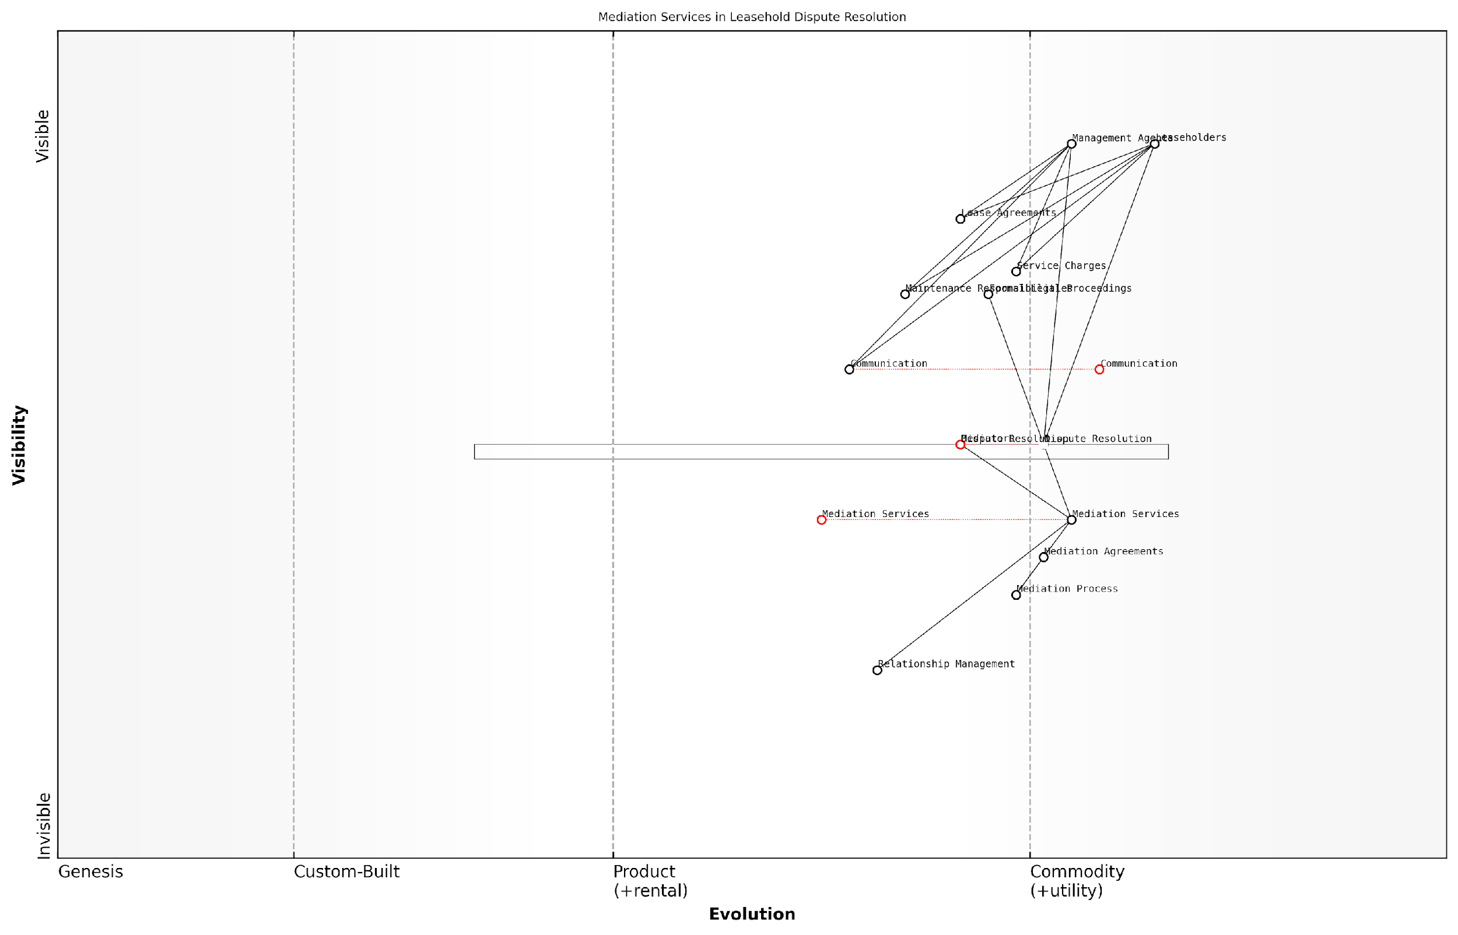

*Draft Wardley Map: [Insert Wardley Map: Using mediation services]*

[Edit this draft Wardley Map](https://create.wardleymaps.ai/#clone:5a252e4a4c0d2b42d6)

Wardley Map Assessment

This Wardley Map reveals a leasehold dispute resolution ecosystem in transition, with significant opportunities for innovation and improvement. The strategic positioning of mediation services as a more evolved alternative to traditional legal proceedings suggests a shift towards more efficient, cost-effective, and relationship-preserving methods of dispute resolution. Key areas for development include standardising communication processes, educating stakeholders about alternative dispute resolution methods, and integrating technology to streamline the entire process. By focusing on these areas, the industry can move towards a more harmonious and efficient system that better serves the needs of leaseholders while reducing the burden on formal legal systems.

[View full Wardley Map report](https://github.com/tractorjuice/automated_wardley_reports/blob/main/markdown_wardley_map_reports/wardley_map_report_21_Using_mediation_services.md)

## Formal Dispute Resolution

### The First-tier Tribunal (Property Chamber)

The First-tier Tribunal (Property Chamber) plays a pivotal role in resolving disputes between leaseholders and freeholders or management agents in England. As an expert in leasehold matters, I cannot overstate the importance of understanding this forum for leaseholders seeking to challenge excessive service charges or unfair management practices.

The tribunal serves as a more accessible and cost-effective alternative to traditional court proceedings, designed to handle a wide range of property-related disputes. Its jurisdiction covers various aspects of leasehold management, including service charge disputes, lease variations, and the appointment of managers.

The First-tier Tribunal offers a vital lifeline for leaseholders, providing a forum where their voices can be heard and their rights protected without the need for costly litigation.

Let’s delve into the key aspects of the First-tier Tribunal that leaseholders should be aware of:

* Jurisdiction and scope
* Application process
* Hearing procedures
* Evidence requirements
* Costs and potential outcomes

Jurisdiction and Scope: The tribunal’s remit is extensive, covering disputes related to service charges, administration charges, insurance, recognition of tenants’ associations, and the right to manage. It’s crucial to ensure your dispute falls within the tribunal’s jurisdiction before proceeding with an application.

Application Process: Initiating a case with the tribunal involves submitting a detailed application form, accompanied by relevant supporting documents. The process is designed to be more straightforward than court proceedings, but it’s essential to provide comprehensive information to support your case.

A well-prepared application is half the battle won. Leaseholders who present clear, concise, and well-evidenced cases stand a much better chance of success at the tribunal.

Hearing Procedures: Tribunal hearings are generally less formal than court proceedings, but they still follow a structured process. The tribunal panel typically consists of a legally qualified chair and two other members with relevant expertise. Both parties present their cases, and the tribunal may ask questions to clarify points or seek additional information.

Evidence Requirements: The burden of proof in service charge disputes often lies with the landlord or management agent to demonstrate that charges are reasonable. However, leaseholders must still present compelling evidence to support their case. This may include:

* Copies of service charge demands and statements
* Correspondence with the landlord or management agent
* Photographic evidence of maintenance issues or poor workmanship
* Expert reports on costs or building conditions
* Comparative data from similar properties or developments

Costs and Potential Outcomes: One of the most significant advantages of the tribunal is its relatively low cost compared to court proceedings. While there is an application fee, the tribunal has limited power to award costs against the losing party, reducing the financial risk for leaseholders.

Potential outcomes from a tribunal hearing can include:

* Reduction or cancellation of disputed service charges
* Determination of the reasonableness of charges or terms
* Orders for the provision of information or accounts
* Appointment of a new manager in cases of severe mismanagement

It’s important to note that while the tribunal’s decisions are binding, there is a right of appeal to the Upper Tribunal (Lands Chamber) on points of law.

In my experience advising leaseholders and resident associations, I’ve observed that the tribunal process can be a powerful tool for addressing imbalances in the leasehold system. However, success often hinges on thorough preparation and a clear understanding of the relevant laws and regulations.

The tribunal is not just a dispute resolution mechanism; it’s an opportunity for leaseholders to assert their rights and contribute to the improvement of leasehold management practices across the sector.

To maximise the chances of a favourable outcome, leaseholders should consider the following strategies:

* Seek early advice from leasehold specialists or experienced solicitors
* Gather comprehensive documentation and evidence well in advance
* Consider engaging expert witnesses for complex technical or financial matters
* Collaborate with other affected leaseholders to share costs and strengthen the case
* Prepare clear and concise written submissions to support oral arguments

It’s worth noting that the mere threat of tribunal action can sometimes prompt landlords or management agents to negotiate or reconsider their position. In many cases I’ve been involved with, disputes have been resolved without the need for a full hearing, demonstrating the tribunal’s role in promoting fair practices even beyond its direct rulings.

In conclusion, the First-tier Tribunal (Property Chamber) represents a crucial mechanism for leaseholders to challenge excessive charges and unfair practices. By understanding its processes and preparing thoroughly, leaseholders can level the playing field and contribute to the ongoing improvement of leasehold management in England.

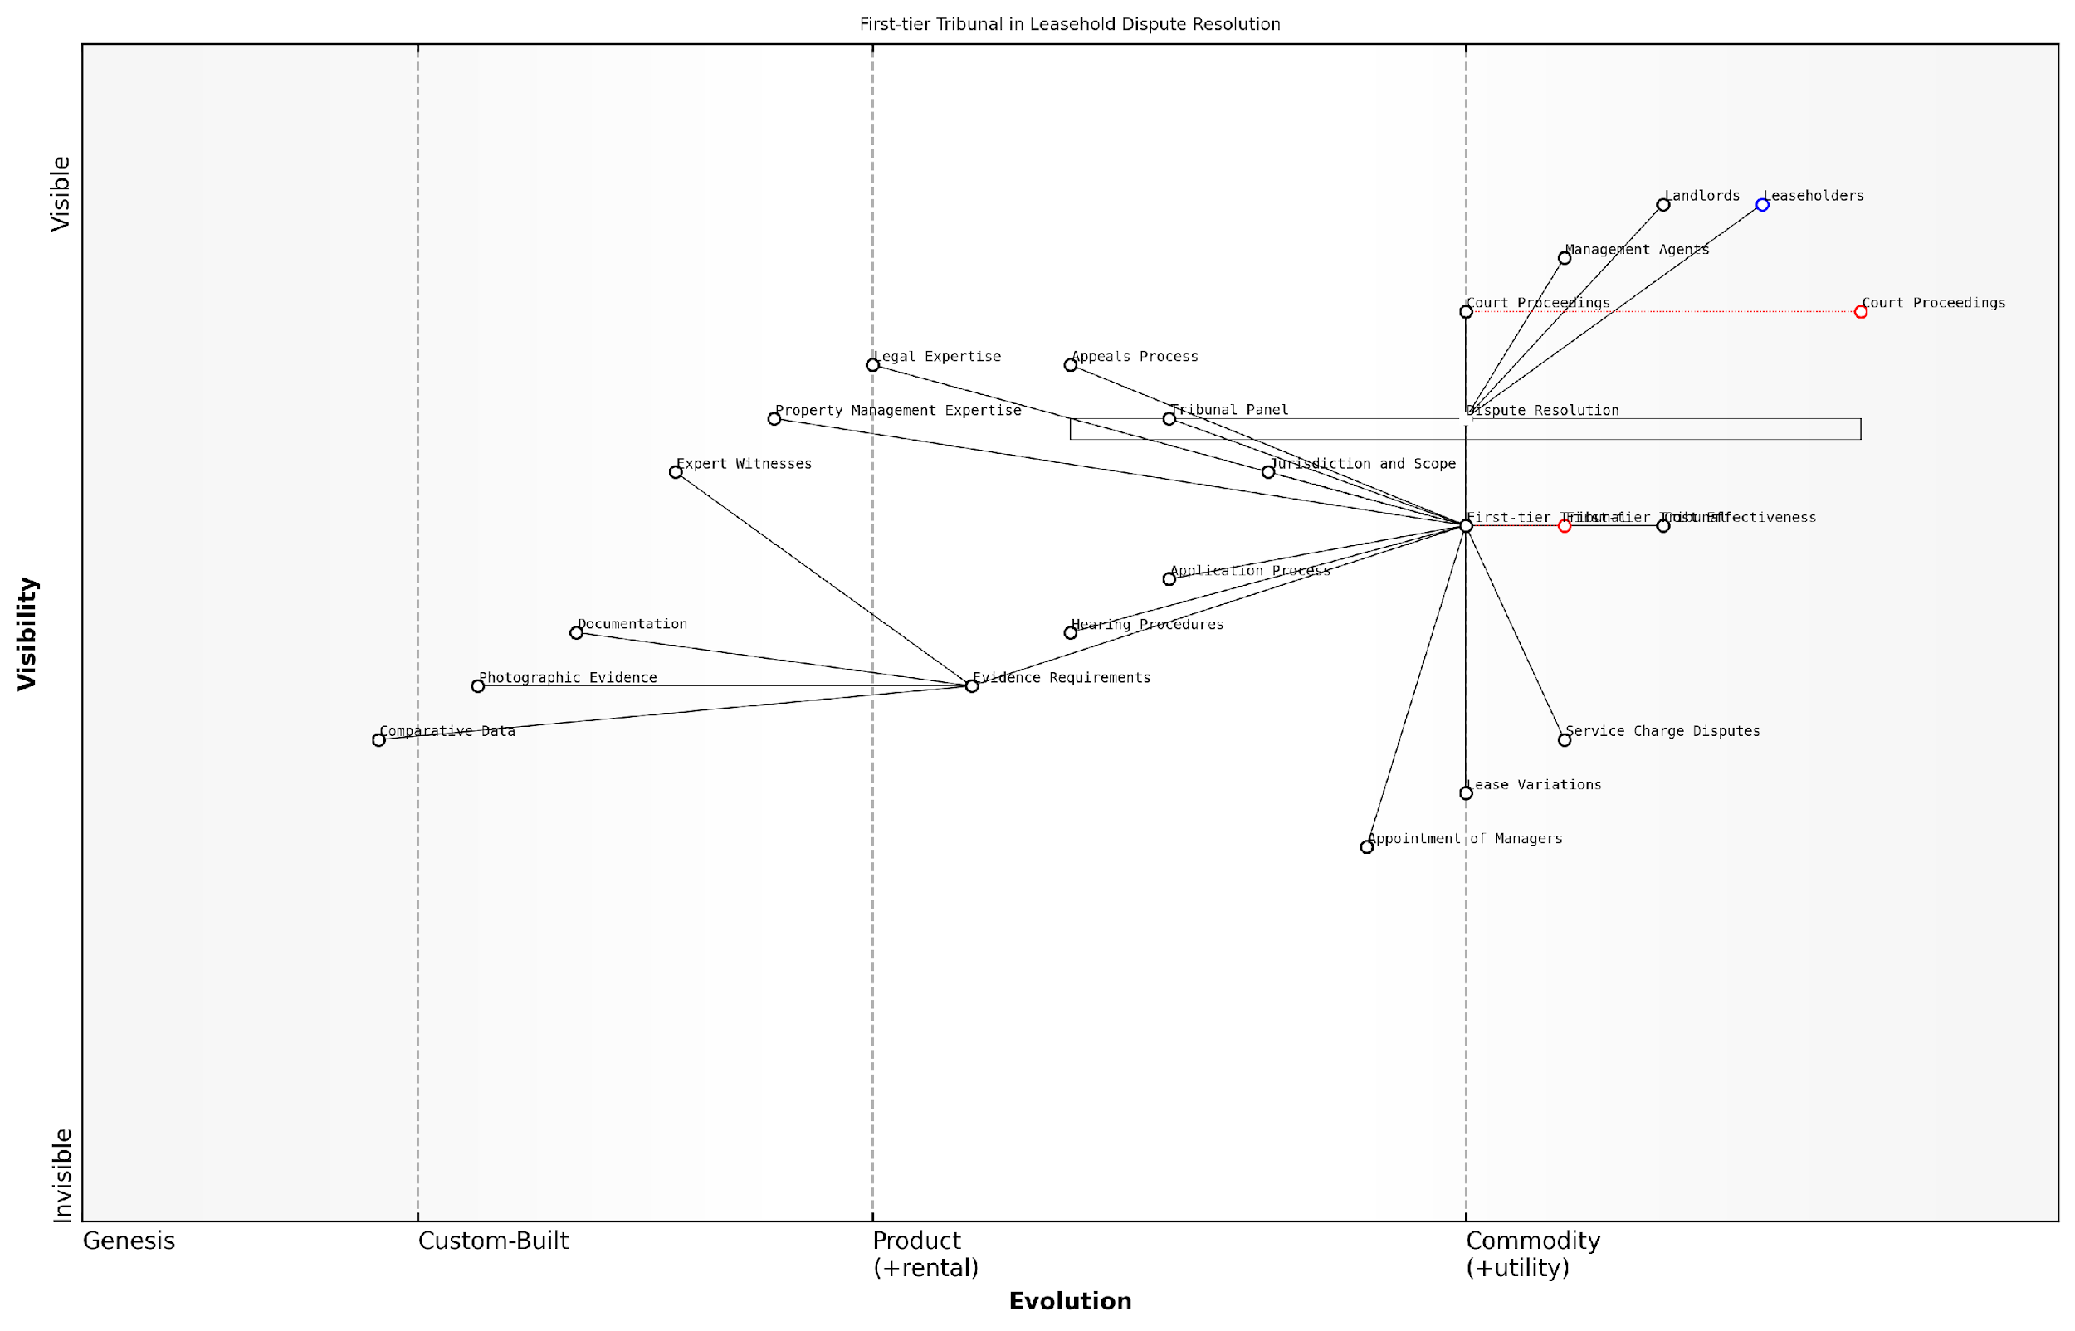

*Draft Wardley Map: [Insert Wardley Map: The First-tier Tribunal (Property Chamber)]*

[Edit this draft Wardley Map](https://create.wardleymaps.ai/#clone:90b52bfa4247ed17d3)

Wardley Map Assessment

The First-tier Tribunal (Property Chamber) is well-positioned as a specialised forum for leasehold dispute resolution, but faces challenges in modernization and efficiency. By focusing on digital transformation, standardisation of processes, and improved data utilisation, the Tribunal can enhance its effectiveness and accessibility. Key strategic moves should include digitising the application process, standardising evidence requirements, and leveraging AI and data analytics for decision support. Long-term success will depend on balancing technological advancement with the need for fair, expert-driven dispute resolution, while always keeping the needs of leaseholders at the forefront.

[View full Wardley Map report](https://github.com/tractorjuice/automated_wardley_reports/blob/main/markdown_wardley_map_reports/wardley_map_report_22_The_First-tier_Tribunal_(Property_Chamber).md)

### Preparing for a tribunal hearing

Preparing for a tribunal hearing is a critical step in the formal dispute resolution process for leaseholders challenging excessive service charges or unfair management practices. The First-tier Tribunal (Property Chamber) provides a more accessible and less formal alternative to court proceedings, but thorough preparation remains essential to present a compelling case and increase the likelihood of a favourable outcome.

As an expert in leasehold disputes, I cannot overemphasise the importance of meticulous preparation. A well-prepared case not only strengthens your position but also demonstrates to the tribunal that you have approached the matter seriously and professionally. Let’s delve into the key aspects of preparing for a tribunal hearing.

1. Gathering and Organising Evidence

The cornerstone of any successful tribunal case is robust, well-organised evidence. Leaseholders should collect and systematically arrange all relevant documents, including:

* Lease agreement and any subsequent variations
* Service charge demands and statements
* Correspondence with the landlord or management agent
* Photographic evidence of property conditions or maintenance issues
* Expert reports or surveys, if applicable
* Comparative data on service charges for similar properties in the area
* Witness statements from other leaseholders or relevant experts

It’s crucial to present this evidence in a clear, chronological order, with a comprehensive index for easy reference during the hearing. Remember, the tribunal will base its decision on the evidence presented, so ensure it is complete, accurate, and directly relevant to your case.

1. Understanding the Legal Framework

A thorough understanding of the relevant legislation and case law is vital. Key areas to focus on include:

* The Landlord and Tenant Act 1985, particularly sections 18-30 relating to service charges
* The Commonhold and Leasehold Reform Act 2002
* Relevant case law precedents that may support your position

While legal representation is not mandatory, seeking advice from a solicitor specialising in leasehold law can be invaluable in interpreting complex legal points and structuring your arguments effectively.

As a senior property tribunal judge once remarked, ‘A well-prepared leaseholder who understands the relevant law can often present a more compelling case than a poorly prepared legal representative.’

1. Crafting Your Arguments

Develop a clear, logical structure for your arguments. Focus on the specific issues in dispute and how they relate to the relevant legislation or lease terms. Key points to consider include:

* The reasonableness of the charges in question
* Whether the landlord has followed proper consultation procedures
* The quality and necessity of works or services provided
* Any breaches of the lease agreement by the landlord or management agent

Practise presenting your arguments concisely and coherently. Remember, tribunal members will appreciate a clear, fact-based presentation that directly addresses the issues at hand.

1. Familiarising Yourself with Tribunal Procedures

Understanding the tribunal’s procedures and expectations is crucial. Review the tribunal’s practice directions and guidance notes, which are available on the government’s website. Key areas to focus on include:

* Deadlines for submitting evidence and statements
* The format and structure of the hearing
* Rules on witness testimony and expert evidence
* The tribunal’s powers and limitations

Consider attending a public tribunal hearing before your own to familiarise yourself with the environment and proceedings. This can help alleviate anxiety and improve your performance on the day.

1. Preparing for Cross-Examination

Be prepared to answer questions from the tribunal members and the opposing party. Anticipate potential challenges to your evidence or arguments and prepare clear, concise responses. Practise with a friend or family member to improve your confidence and clarity.

A leading leasehold solicitor advises, ‘Remain calm and composed during questioning. If you don’t understand a question, ask for clarification. It’s better to take a moment to collect your thoughts than to give a hasty, ill-considered answer.’

1. Considering Settlement Options

While preparing for the hearing, remain open to the possibility of settlement. The tribunal may encourage parties to consider mediation or negotiation before or during the hearing process. Be prepared with a clear understanding of your minimum acceptable outcome and any areas where you might be willing to compromise.

1. Logistics and Final Preparations

In the days leading up to the hearing:

* Confirm the hearing date, time, and location
* Arrange for any witnesses to attend
* Prepare multiple copies of your evidence bundle for the tribunal and the opposing party
* Plan your journey to ensure punctual arrival
* Review your case notes and practise your opening statement

Remember, thorough preparation is key to presenting your case effectively and confidently before the tribunal. By following these steps and approaching the process with diligence and professionalism, you significantly enhance your chances of a favourable outcome in your dispute over excessive service charges or unfair management practices.

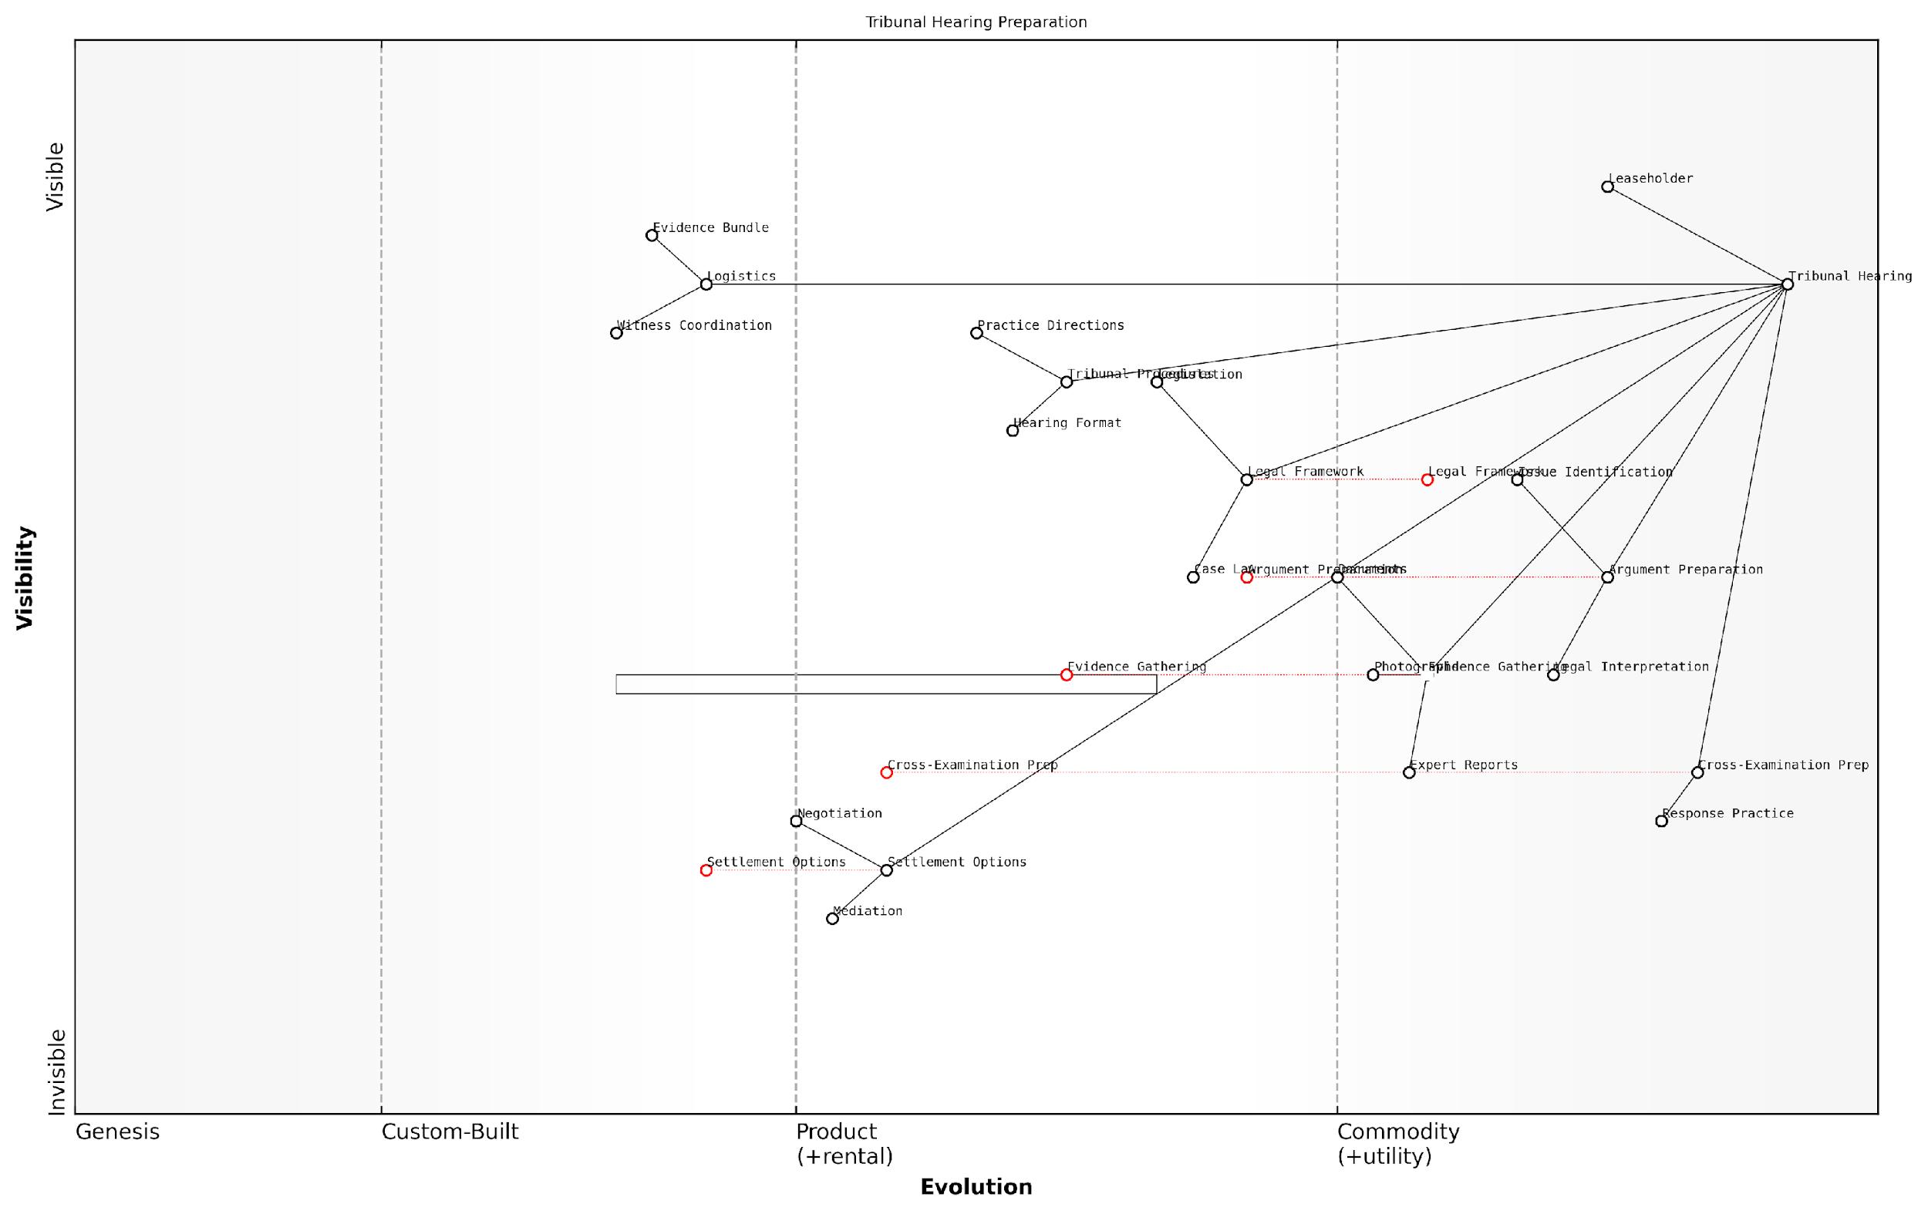

*Draft Wardley Map: [Insert Wardley Map: Preparing for a tribunal hearing]*

[Edit this draft Wardley Map](https://create.wardleymaps.ai/#clone:2e7672dc8e725a11ed)

Wardley Map Assessment

This Wardley Map reveals a system with a solid foundation in legal understanding and basic case preparation, but with significant opportunities for improvement and innovation. The key strategic focus should be on developing more advanced, standardised approaches to Cross-Examination Prep and Evidence Gathering, while also exploring the underutilised potential of Settlement Options. By addressing these areas, leaseholders can significantly enhance their preparation for tribunal hearings, potentially improving outcomes and efficiency in the dispute resolution process. The map also indicates a need for greater integration of technology and standardised processes to move custom-built components towards more evolved, product-like stages. Overall, the strategic direction should be towards creating a more systematic, technology-enabled approach to tribunal hearing preparation, while maintaining the flexibility to address the unique aspects of each case.

[View full Wardley Map report](https://github.com/tractorjuice/automated_wardley_reports/blob/main/markdown_wardley_map_reports/wardley_map_report_23_Preparing_for_a_tribunal_hearing.md)

### Alternative legal routes: county courts and the Upper Tribunal

While the First-tier Tribunal (Property Chamber) is often the primary forum for resolving leasehold disputes, it’s crucial for leaseholders to be aware of alternative legal routes available when tackling excessive service charges and bad management agents. The county courts and the Upper Tribunal (Lands Chamber) offer additional avenues for seeking justice and resolution in more complex or specific cases. Understanding these options is essential for leaseholders to navigate the legal landscape effectively and choose the most appropriate forum for their particular circumstances.

County Courts: A Broader Jurisdiction

County courts play a significant role in leasehold dispute resolution, particularly in cases that fall outside the First-tier Tribunal’s jurisdiction or involve more complex legal issues. These courts have the authority to handle a wide range of leasehold-related matters, including:

* Breach of lease covenants
* Forfeiture proceedings
* Claims for specific performance
* Disputes over lease extensions
* Enforcement of tribunal decisions

One of the key advantages of pursuing a case through the county court is its power to award costs to the successful party, which is not typically available in the First-tier Tribunal. This can be a significant factor for leaseholders considering legal action, as it may provide an opportunity to recover legal expenses if successful.

The county court’s ability to award costs can be a game-changer for leaseholders. It adds an extra layer of consideration for freeholders and management agents, potentially encouraging more reasonable behaviour and settlement offers.

However, it’s important to note that county court proceedings can be more formal and potentially more expensive than tribunal hearings. Leaseholders should carefully consider the nature of their dispute and seek legal advice to determine whether the county court is the most appropriate forum for their case.

The Upper Tribunal (Lands Chamber): Appeals and Complex Cases

The Upper Tribunal (Lands Chamber) serves as both an appellate body for decisions made by the First-tier Tribunal and a forum for more complex leasehold disputes. Its role in the leasehold dispute resolution process includes:

* Hearing appeals on points of law from First-tier Tribunal decisions
* Dealing with complex valuation disputes
* Handling cases involving substantial financial claims
* Addressing novel or contentious legal issues in leasehold matters

The Upper Tribunal’s expertise in property law and its ability to set precedents make it a crucial forum for shaping leasehold law and practice. Decisions made by the Upper Tribunal can have far-reaching implications for leaseholders across England, potentially influencing future cases and even legislative reforms.

The Upper Tribunal plays a vital role in developing leasehold law. Its decisions can provide clarity on complex issues and set standards that ripple through the entire leasehold sector.

However, pursuing a case in the Upper Tribunal can be a complex and costly process. Leaseholders should be prepared for more formal proceedings and may require specialist legal representation. The potential for significant legal costs also means that the financial implications of proceeding to the Upper Tribunal should be carefully weighed against the potential benefits.

Strategic Considerations for Leaseholders

When considering alternative legal routes, leaseholders should take into account several strategic factors:

* The nature and complexity of the dispute
* The potential financial implications, including legal costs and the possibility of cost recovery
* The desired outcome and the powers of each forum to grant specific remedies
* The potential for setting precedents or influencing wider leasehold practices
* The willingness and capacity to engage in potentially lengthy legal proceedings

It’s often advisable for leaseholders to seek early legal advice to assess the most appropriate forum for their case. This can help in developing a strategic approach that maximises the chances of a favourable outcome while managing risks and costs effectively.

Practical Steps for Leaseholders

For leaseholders considering these alternative legal routes, the following practical steps can be helpful:

* Gather comprehensive documentation related to the dispute, including lease agreements, correspondence, and financial records
* Seek initial advice from a specialist leasehold solicitor or a reputable leaseholder advisory service
* Consider the potential for alternative dispute resolution methods before committing to court or tribunal proceedings
* If proceeding, ensure you understand the procedural requirements and timelines for the chosen forum
* Be prepared for the possibility of appeals or further legal action, depending on the outcome

By understanding these alternative legal routes and approaching them strategically, leaseholders can enhance their ability to challenge excessive service charges and address issues with bad management agents effectively. While these processes can be complex, they offer important avenues for seeking justice and contributing to the ongoing improvement of leasehold practices in England.

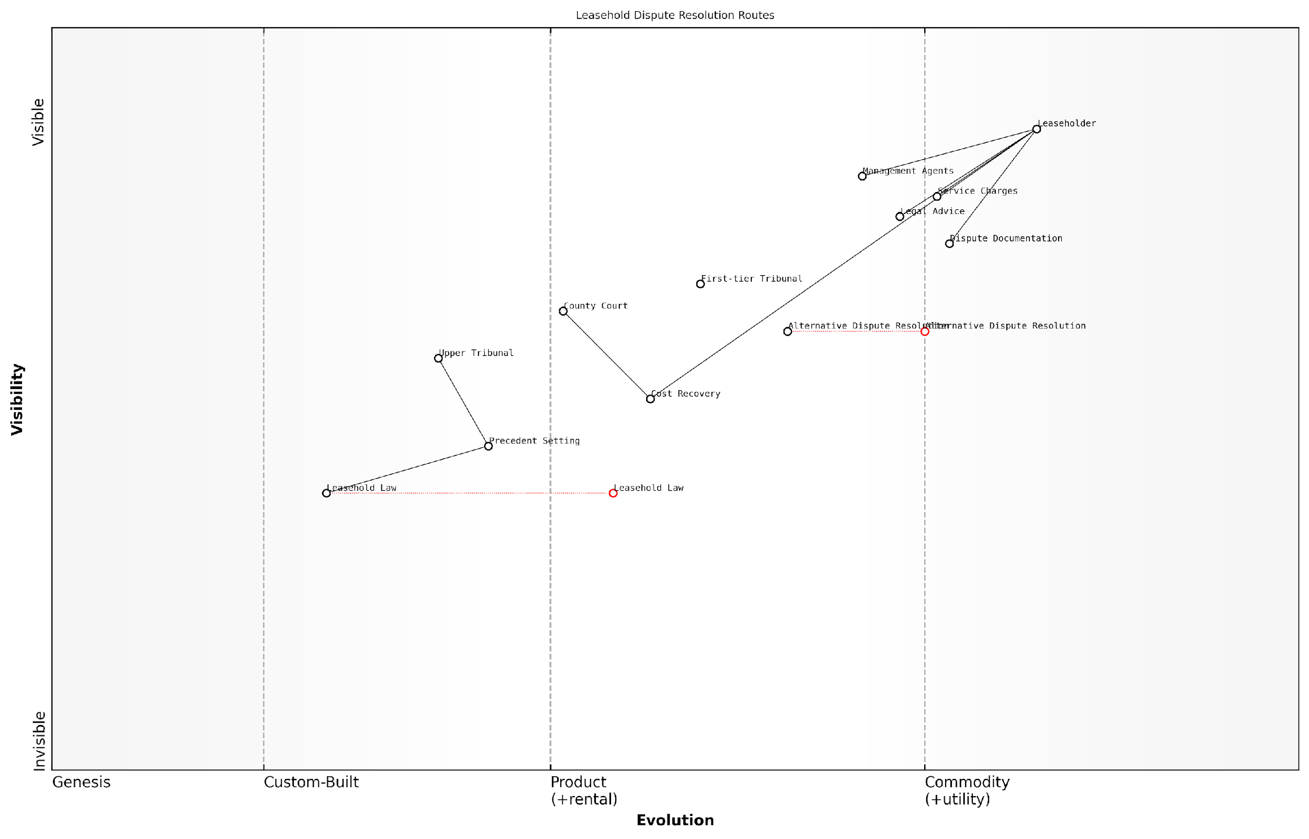

*Draft Wardley Map: [Insert Wardley Map: Alternative legal routes: county courts and the Upper Tribunal]*

[Edit this draft Wardley Map](https://create.wardleymaps.ai/#clone:9c38a32f12b324030f)

Wardley Map Assessment

The Wardley Map reveals a leasehold dispute resolution system in transition, balancing between traditional legal processes and evolving alternative methods. There are significant opportunities for innovation, particularly in leveraging technology and Alternative Dispute Resolution to create a more efficient, accessible, and cost-effective system for leaseholders. Strategic focus should be on enhancing integration between different components, promoting alternative resolution methods, and simplifying the overall process for leaseholders. Long-term success will depend on the ability to adapt to changing legal landscapes and technological advancements while maintaining fair and effective dispute resolution practices.

[View full Wardley Map report](https://github.com/tractorjuice/automated_wardley_reports/blob/main/markdown_wardley_map_reports/wardley_map_report_24_Alternative_legal_routes:_county_courts_and_the_Up.md)

# Reforming Bad Management Practices

## Identifying Poor Management

### Common signs of mismanagement

Identifying poor management is a crucial step in addressing the challenges faced by leaseholders in England. As an expert in tackling excessive service charges and bad management agents, I can attest that recognising the signs of mismanagement early can save leaseholders significant time, money, and stress. This section will explore the common indicators that suggest a management agent may not be fulfilling their duties adequately or ethically.

Before delving into specific signs, it’s important to understand that management agents have a legal and ethical responsibility to act in the best interests of both the freeholder and the leaseholders. They are bound by various regulations, including the Landlord and Tenant Act 1985 and the RICS Code of Practice. When these standards are not met, it often manifests in several observable ways.

* Lack of transparency in financial reporting
* Poor communication and responsiveness
* Neglect of property maintenance
* Unexplained increases in service charges
* Failure to follow proper consultation procedures
* Conflicts of interest in contractor selection
* Inadequate record-keeping
* Disregard for leaseholder rights and complaints

Let’s examine each of these signs in detail:

1. Lack of transparency in financial reporting: A well-managed property should have clear, detailed financial statements that are readily available to leaseholders. If you find it difficult to obtain comprehensive breakdowns of service charge expenditures or if the financial reports are vague or inconsistent, this could be a red flag. As a seasoned consultant, I’ve encountered numerous cases where management agents deliberately obfuscate financial information to hide inefficiencies or even fraudulent activities.
2. Poor communication and responsiveness: Effective management agents should be easily contactable and responsive to leaseholder queries and concerns. If you consistently face delays in receiving responses, or if your inquiries are frequently ignored or dismissed, this indicates a serious problem in the management approach. In my experience, communication breakdowns often precede more severe issues and can be an early warning sign of broader mismanagement.
3. Neglect of property maintenance: One of the primary responsibilities of a management agent is to ensure the proper upkeep of the property. Signs of neglect might include persistent issues with communal areas, delayed repairs, or a general deterioration in the condition of the building. This not only affects the quality of life for residents but can also impact property values in the long term.
4. Unexplained increases in service charges: While some increase in service charges over time is normal due to inflation and rising costs, significant or unexplained hikes should be scrutinised. A competent management agent should be able to provide clear justifications for any substantial increases. In my consultancy work, I’ve often found that unjustified increases are a symptom of either incompetence or, in some cases, deliberate overcharging.
5. Failure to follow proper consultation procedures: The Landlord and Tenant Act 1985 (as amended) requires management agents to consult with leaseholders before carrying out major works or entering into long-term agreements. If you notice that significant works are being undertaken without prior consultation, this is a clear breach of regulations and a sign of poor management practices.
6. Conflicts of interest in contractor selection: Ethical management agents should select contractors based on value for money and quality of service. If you suspect that contracts are being awarded to companies with close ties to the management agent, without a transparent tendering process, this could indicate a conflict of interest. Such practices often lead to inflated costs for leaseholders and substandard work.
7. Inadequate record-keeping: Proper management requires meticulous record-keeping of all property-related matters, including maintenance schedules, contractor agreements, and leaseholder correspondence. If you find that records are incomplete, disorganised, or inaccessible upon request, this suggests a lack of professionalism and could hinder your ability to challenge decisions or charges in the future.
8. Disregard for leaseholder rights and complaints: Management agents have a duty to respect the rights of leaseholders and to address complaints in a timely and fair manner. If you observe a pattern of dismissing legitimate concerns or failing to follow proper complaints procedures, this indicates a fundamental failure in the agent’s responsibilities.

In my years of experience dealing with leasehold disputes, I’ve found that the most problematic management agents often display multiple signs of mismanagement simultaneously. It’s rare to encounter just one isolated issue.

Recognising these signs is the first step towards addressing mismanagement. Leaseholders who identify these issues should document their concerns thoroughly and consider taking collective action with other residents. In many cases, presenting a united front can be more effective in prompting change or, if necessary, pursuing formal dispute resolution channels.

It’s worth noting that the government has recognised the prevalence of these issues and has proposed reforms to the leasehold system. These include the potential introduction of a new regulatory regime for property agents, which would set minimum standards and require agents to adhere to a code of practice. While these reforms are still in development, they underscore the importance of addressing mismanagement in the current system.

In conclusion, being vigilant and informed about these common signs of mismanagement empowers leaseholders to take proactive steps in protecting their rights and interests. By recognising these red flags early, you can address issues before they escalate into more serious problems, potentially saving significant time and resources in the long run. Remember, a well-managed property not only enhances your living experience but also protects your investment in your leasehold property.

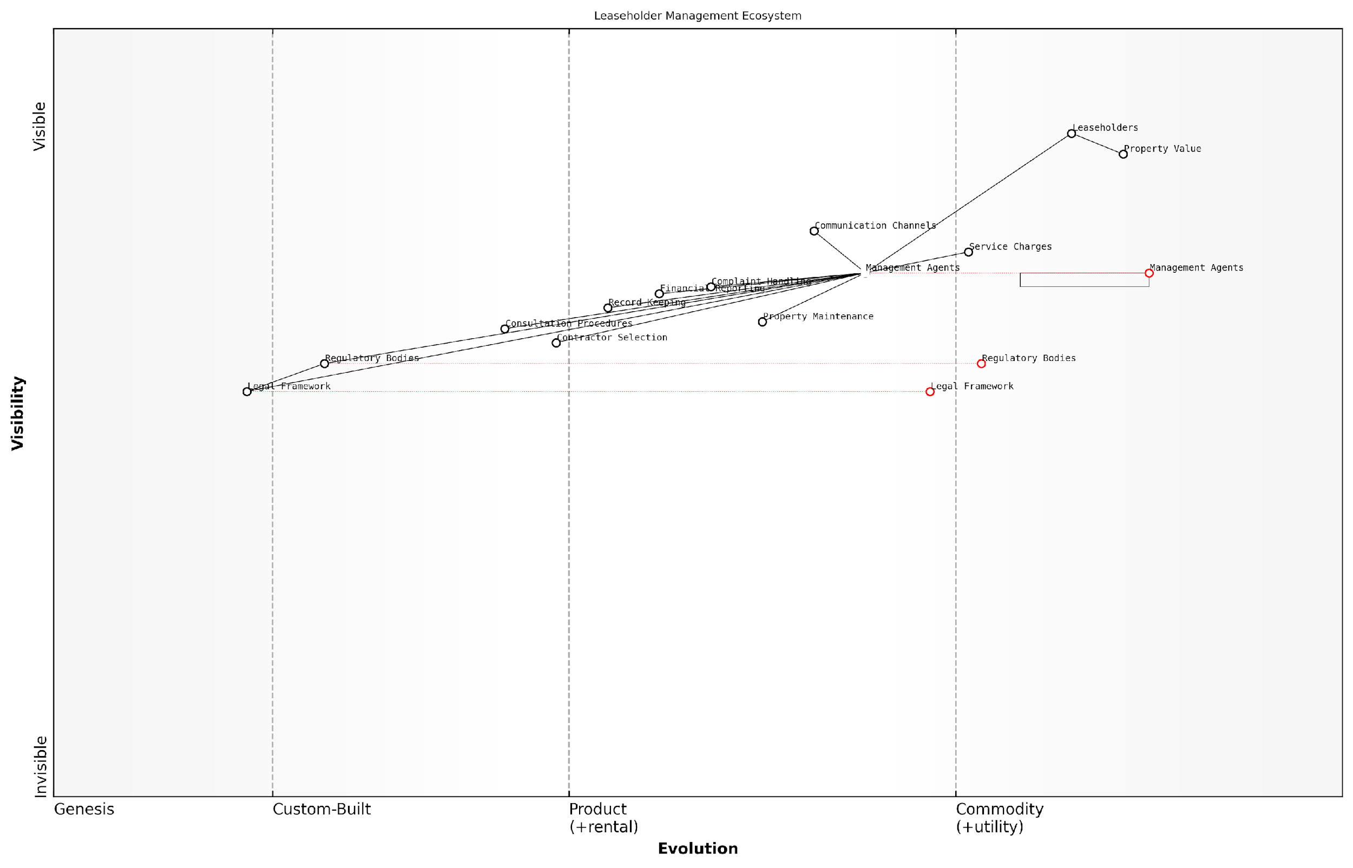

*Draft Wardley Map: [Insert Wardley Map: Common signs of mismanagement]*

[Edit this draft Wardley Map](https://create.wardleymaps.ai/#clone:7118ad7f9a50674448)

Wardley Map Assessment

The Leaseholder Management Ecosystem is at a critical juncture, with opportunities for significant improvement through digital transformation and a more leaseholder-centric approach. The evolving nature of Management Agents and Regulatory Bodies suggests an industry in flux, with potential for innovative players to gain competitive advantage. Key strategies should focus on improving communication, transparency, and efficiency through technology adoption, while preparing for a more regulated and standardised future. The ecosystem’s success will depend on balancing the needs of Leaseholders with regulatory requirements and operational efficiency.

[View full Wardley Map report](https://github.com/tractorjuice/automated_wardley_reports/blob/main/markdown_wardley_map_reports/wardley_map_report_25_Common_signs_of_mismanagement.md)

### Assessing communication and transparency

In the realm of leasehold management, effective communication and transparency are paramount to fostering a positive relationship between leaseholders and management agents. This section delves into the critical aspects of assessing these elements, providing leaseholders with the tools to identify poor management practices and take informed action.

Effective communication and transparency form the bedrock of good management practices in leasehold properties. They are essential for building trust, ensuring compliance with legal obligations, and maintaining harmonious relationships between all parties involved. When these elements are lacking, it often signals deeper issues within the management structure, potentially leading to disputes, financial irregularities, and a deterioration of the property’s condition.

Clear, timely, and comprehensive communication is not just good practice; it’s a fundamental right of leaseholders and a legal obligation for management agents.

Let’s explore the key areas to focus on when assessing communication and transparency in your leasehold management:

* Frequency and quality of communications
* Accessibility of information
* Responsiveness to queries and concerns
* Clarity of financial reporting
* Transparency in decision-making processes

1. Frequency and Quality of Communications:

A well-managed property should have regular, proactive communication from the management agent. This includes timely notifications about maintenance work, updates on ongoing projects, and clear explanations of any changes in service charges or policies. Poor management often manifests in sporadic, unclear, or reactive communication, leaving leaseholders in the dark about important matters affecting their property.

In my experience advising government bodies on leasehold issues, I’ve observed that properties with frequent, clear communications tend to have fewer disputes and higher leaseholder satisfaction.

1. Accessibility of Information:

Transparency is key in leasehold management. Leaseholders should have easy access to important documents such as the lease agreement, service charge breakdowns, planned maintenance schedules, and insurance policies. A reputable management agent will typically provide a secure online portal or regular information packs. Red flags include difficulty in obtaining these documents or receiving incomplete information when requested.

1. Responsiveness to Queries and Concerns:

The speed and quality of responses to leaseholder queries are crucial indicators of management effectiveness. Good management agents will have clear channels for communication and established response times. They will address concerns comprehensively and follow up on issues until resolution. Poor management often manifests in delayed responses, inadequate answers, or complete lack of acknowledgement of leaseholder concerns.

1. Clarity of Financial Reporting:

Financial transparency is a cornerstone of good leasehold management. Service charge statements should be detailed, clear, and provided in a timely manner. They should break down costs, explain any significant changes, and be accompanied by supporting documentation where necessary. Vague or overly complex financial reports, unexplained cost increases, or delays in providing this information are all indicators of potential mismanagement.

Transparency in financial matters is not just about compliance; it’s about building trust. When leaseholders understand where their money is going, they’re more likely to feel satisfied with the management of their property.

1. Transparency in Decision-Making Processes:

Good management agents involve leaseholders in significant decisions affecting the property. This includes consulting on major works, providing options for consideration, and explaining the rationale behind decisions. Lack of consultation, unilateral decision-making, or failure to provide justifications for choices made are signs of poor management practices.

To effectively assess these areas, leaseholders should:

* Keep a log of all communications (or lack thereof) from the management agent
* Document response times to queries and the quality of responses received
* Review financial statements critically, comparing them year-on-year and against industry benchmarks
* Engage with other leaseholders to gather a collective view of management performance
* Familiarise themselves with the requirements set out in the RICS Code of Practice for Property Management

If deficiencies are identified in these areas, it’s crucial to address them promptly. Start by raising concerns directly with the management agent, documenting all communications. If issues persist, consider escalating to the freeholder or exploring options for formal dispute resolution through the First-tier Tribunal (Property Chamber).

Remember, as a leaseholder, you have the right to transparent, effective management of your property. Don’t hesitate to assert these rights when faced with poor communication or lack of transparency.

By systematically assessing these aspects of communication and transparency, leaseholders can identify poor management practices early, take informed action, and work towards ensuring their property is managed effectively and fairly.

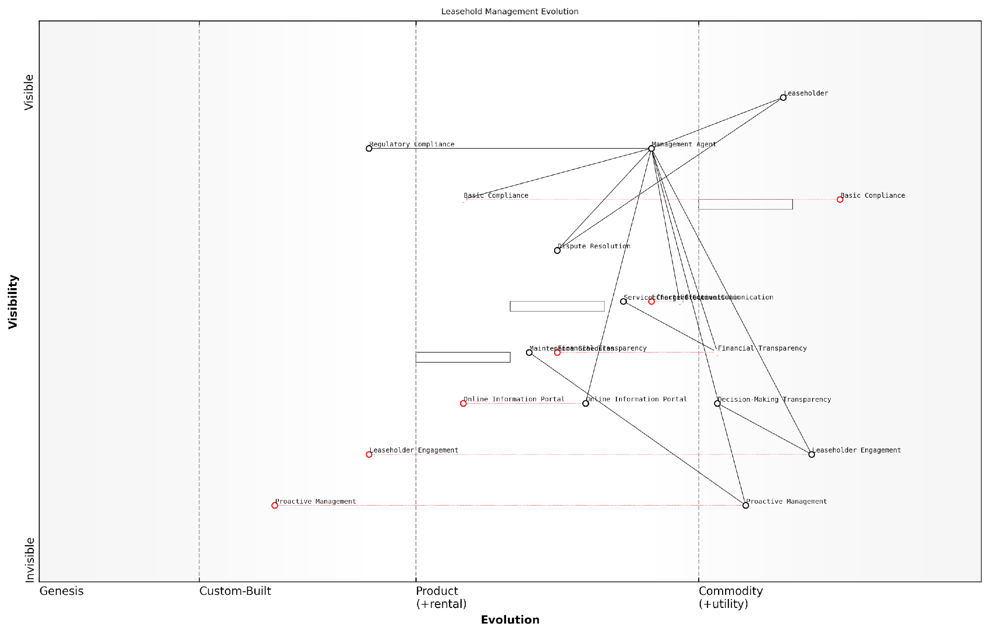

*Draft Wardley Map: [Insert Wardley Map: Assessing communication and transparency]*

[Edit this draft Wardley Map](https://create.wardleymaps.ai/#clone:f8f026763f59d31af4)

Wardley Map Assessment

The Leasehold Management Evolution map reveals an industry in transition, moving from basic compliance and reactive management towards more transparent, engaging, and proactive practices. There are significant opportunities for differentiation and value creation in the less evolved components, particularly in Leaseholder Engagement and Proactive Management. To succeed, organisations should focus on developing these capabilities while also enhancing communication and transparency. The future of leasehold management lies in creating a more integrated, transparent, and leaseholder-centric ecosystem, leveraging technology and data to provide superior service and value.

[View full Wardley Map report](https://github.com/tractorjuice/automated_wardley_reports/blob/main/markdown_wardley_map_reports/wardley_map_report_26_Assessing_communication_and_transparency.md)

### Evaluating maintenance and repair standards

In the realm of leasehold property management, evaluating maintenance and repair standards is a crucial aspect of identifying poor management practices. As an expert in tackling excessive service charges and addressing issues with bad management agents for leasehold flats in England, I can attest to the significance of this topic in ensuring fair treatment and value for leaseholders.

Proper maintenance and timely repairs are not just about preserving the aesthetic appeal of a property; they are fundamental to protecting the leaseholders’ investments and ensuring a safe, comfortable living environment. However, substandard maintenance and neglected repairs are often telltale signs of poor management, potentially leading to increased costs and decreased property values in the long run.

Let’s delve into the key aspects of evaluating maintenance and repair standards, providing you with the knowledge and tools to identify and address these issues effectively.

1. Regular Maintenance Schedules

A well-managed property should have a clear, documented maintenance schedule. This schedule should outline routine tasks such as cleaning common areas, maintaining landscaping, and servicing building systems (e.g., lifts, boilers, fire safety equipment).

* Request a copy of the maintenance schedule from your management agent
* Compare the schedule against actual maintenance activities
* Look for gaps or inconsistencies in the schedule
* Check if the schedule aligns with industry best practices and legal requirements

A senior property management consultant once remarked, ‘A comprehensive maintenance schedule is the backbone of effective property management. Its absence or poor implementation is often the first red flag of substandard management practices.’

1. Response Times to Repair Requests

The efficiency with which management agents respond to and address repair requests is a key indicator of their performance. Delays in addressing repairs can lead to more significant issues and increased costs over time.

* Keep a log of all repair requests, including dates and details
* Monitor response times and compare them to agreed-upon service levels
* Note any patterns of delayed responses or unresolved issues
* Consider surveying other leaseholders about their experiences with repair requests

1. Quality of Repairs and Maintenance Work

The standard of work carried out is just as important as the timeliness of repairs. Poor quality repairs can lead to recurring issues and unnecessary expenditure.

* Assess the durability and effectiveness of completed repairs
* Check if appropriate materials and qualified professionals are being used
* Look for evidence of ‘quick fixes’ rather than proper solutions
* Consider seeking independent expert opinions on complex or recurring issues

1. Transparency in Maintenance and Repair Costs

Good management agents should provide clear, itemised breakdowns of maintenance and repair costs. Lack of transparency can be a sign of poor management or even potential financial impropriety.

* Review service charge statements for detailed breakdowns of maintenance and repair costs
* Question any vague or unexplained charges
* Compare costs against market rates for similar services
* Look for evidence of competitive tendering for significant works

As a leading property law expert noted, ‘Transparency in maintenance and repair costs is not just good practice; it’s a legal obligation. Leaseholders have the right to question and challenge any charges they believe to be unreasonable.’

1. Proactive vs Reactive Maintenance Approach

Effective property management involves a proactive approach to maintenance, rather than merely reacting to problems as they arise. A proactive strategy can prevent minor issues from escalating into major, costly problems.

* Look for evidence of regular property inspections
* Check if there’s a long-term maintenance plan in place
* Assess how well the management agent anticipates and plans for future maintenance needs
* Consider the balance between reactive repairs and planned maintenance in the service charge expenditure

1. Compliance with Health and Safety Regulations

Ensuring compliance with health and safety regulations is a critical aspect of property management. Failure to meet these standards not only poses risks to residents but can also result in legal consequences and financial penalties.

* Check for up-to-date fire risk assessments and implementation of recommended measures
* Verify that regular safety checks are conducted on lifts, electrical systems, and gas appliances
* Ensure that asbestos surveys and management plans are in place where necessary
* Look for evidence of regular legionella risk assessments and water system maintenance

1. Communication and Reporting on Maintenance and Repairs

Effective communication about maintenance and repair activities is crucial. Good management agents should keep leaseholders informed about planned works, ongoing repairs, and any issues that may affect the property.

* Assess the frequency and quality of communications regarding maintenance and repairs
* Check if there’s a clear system for reporting and tracking maintenance issues
* Look for regular updates on the progress of ongoing works
* Evaluate the management agent’s responsiveness to queries about maintenance and repairs

A respected property management consultant once said, ‘Clear, consistent communication is the hallmark of good property management. It builds trust, reduces misunderstandings, and ultimately leads to better-maintained properties.’

By thoroughly evaluating these aspects of maintenance and repair standards, leaseholders can gain a clear picture of the quality of their property management. Poor performance in these areas is often indicative of wider management issues and may justify further action, such as formal complaints, seeking alternative management, or even pursuing the Right to Manage.

Remember, as a leaseholder, you have the right to expect high standards of maintenance and repairs. By being vigilant and proactive in assessing these standards, you can play a crucial role in ensuring your property is well-managed and your investment is protected.

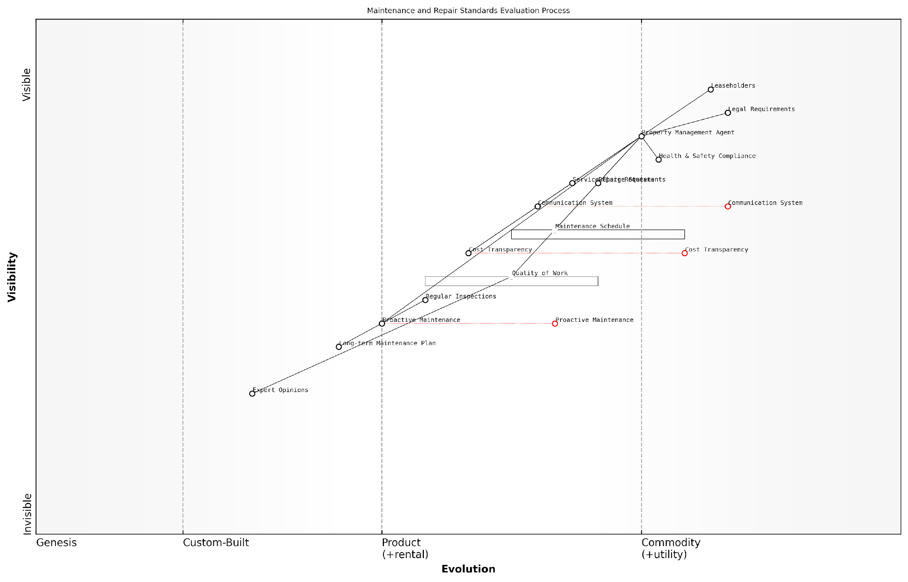

*Draft Wardley Map: [Insert Wardley Map: Evaluating maintenance and repair standards]*

[Edit this draft Wardley Map](https://create.wardleymaps.ai/#clone:9c7ec10452527ada13)

Wardley Map Assessment

The Maintenance and Repair Standards Evaluation Process is poised for significant evolution, with opportunities to leverage technology for improved efficiency, transparency, and service quality. The strategic focus should be on standardising communication, enhancing cost transparency, and developing proactive maintenance capabilities. By addressing these areas, property management agents can significantly improve their service delivery, leading to increased leaseholder satisfaction and potentially disrupting the industry standard for property management.

[View full Wardley Map report](https://github.com/tractorjuice/automated_wardley_reports/blob/main/markdown_wardley_map_reports/wardley_map_report_27_Evaluating_maintenance_and_repair_standards.md)

## Engaging with Your Management Agent

### Effective complaint procedures

In the complex landscape of leasehold property management, establishing and utilising effective complaint procedures is crucial for addressing issues with management agents and ensuring fair treatment for leaseholders. This section explores the intricacies of complaint procedures, their importance in the broader context of tackling excessive service charges and poor management practices, and provides practical guidance for leaseholders seeking to engage constructively with their management agents.

Understanding the Complaint Process

Before delving into the specifics of effective complaint procedures, it’s essential to understand the typical structure of a complaint process in the context of leasehold management. Most reputable management agents will have a formal complaints procedure in place, often consisting of multiple stages:

* Initial complaint submission
* Acknowledgement and investigation
* First-stage response
* Escalation to senior management (if necessary)
* Final response
* External redress schemes (if unresolved)

Crafting an Effective Complaint

The foundation of any successful complaint lies in its presentation. A well-crafted complaint can significantly increase the chances of a positive resolution. When formulating your complaint, consider the following best practices:

* Be clear and concise: Clearly state the issue and your desired outcome
* Provide evidence: Include relevant documentation, photographs, or correspondence
* Remain factual: Avoid emotional language and stick to the facts
* Reference relevant legislation or lease terms: Demonstrate your understanding of your rights
* Propose solutions: Offer constructive suggestions for resolving the issue
* Set reasonable deadlines: Specify when you expect a response or action

A well-structured complaint is not just about airing grievances; it’s about opening a dialogue for positive change. By presenting your case clearly and professionally, you set the stage for constructive engagement with your management agent.

Navigating the Complaint Procedure

Once you’ve submitted your complaint, it’s crucial to navigate the procedure effectively. This involves:

* Keeping detailed records of all communications
* Following up regularly if response times are not met
* Escalating the complaint through the appropriate channels if necessary
* Remaining professional and courteous throughout the process
* Being open to mediation or alternative dispute resolution methods
* Understanding your rights to escalate to external bodies if internal procedures fail

Leveraging Collective Action

In many cases, individual leaseholders may find their complaints carry more weight when presented collectively. Forming or utilising existing residents’ associations can be an effective strategy for addressing systemic issues with management agents. Collective action can:

* Demonstrate the widespread nature of concerns
* Pool resources and expertise among leaseholders
* Present a united front in negotiations
* Increase leverage when dealing with unresponsive management agents

Collective action can transform the dynamics of the leaseholder-management agent relationship. When leaseholders speak with one voice, it becomes much harder for management agents to dismiss legitimate concerns.

Utilising External Redress Schemes

In England, property management companies are required by law to be members of a government-approved redress scheme. If internal complaint procedures fail to resolve the issue satisfactorily, leaseholders have the right to escalate their complaints to these external bodies. The main redress schemes are:

* The Property Ombudsman (TPO)
* The Property Redress Scheme (PRS)

These schemes provide independent adjudication and can make binding decisions on complaints, including awarding compensation where appropriate. It’s important to exhaust the internal complaint procedure before approaching these schemes, as they typically require evidence that you’ve attempted to resolve the issue directly with the management agent first.

Continuous Improvement and Feedback

Effective complaint procedures should not only resolve individual issues but also contribute to ongoing improvement in management practices. Leaseholders can play a role in this by:

* Providing constructive feedback on the complaint process itself
* Suggesting improvements to management practices based on complaint outcomes
* Monitoring the implementation of agreed actions or changes
* Sharing positive experiences and successful resolutions with other leaseholders

A truly effective complaint procedure is one that not only resolves individual issues but also drives systemic improvements in management practices. By engaging constructively in this process, leaseholders can contribute to raising standards across the sector.

In conclusion, mastering effective complaint procedures is a crucial skill for leaseholders seeking to address issues with management agents. By understanding the process, crafting well-structured complaints, navigating procedures effectively, leveraging collective action, and utilising external redress schemes when necessary, leaseholders can significantly enhance their ability to tackle excessive service charges and poor management practices. This approach not only benefits individual leaseholders but also contributes to the broader goal of improving standards in leasehold property management across England.

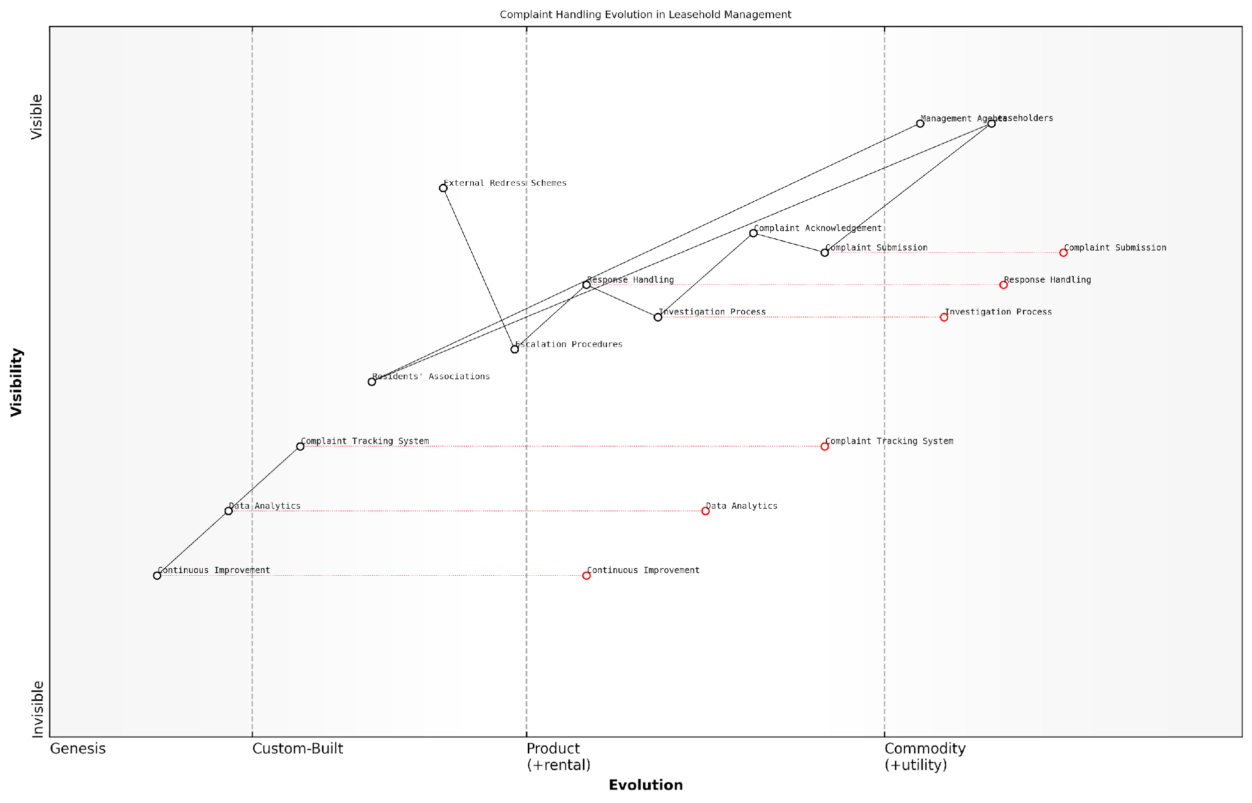

*Draft Wardley Map: [Insert Wardley Map: Effective complaint procedures]*

[Edit this draft Wardley Map](https://create.wardleymaps.ai/#clone:93096f72c335bcd84b)

Wardley Map Assessment

The Wardley Map reveals a complaint handling system in transition, with opportunities for significant improvement through technology adoption and process evolution. The strategic focus should be on developing advanced analytics capabilities, fostering a culture of continuous improvement, and creating a more integrated ecosystem approach to complaint handling. By addressing current gaps and leveraging emerging technologies, organizations can transform complaint handling from a reactive process to a proactive, value-adding function in leasehold management.

[View full Wardley Map report](https://github.com/tractorjuice/automated_wardley_reports/blob/main/markdown_wardley_map_reports/wardley_map_report_28_Effective_complaint_procedures.md)

### Requesting information and exercising your rights

In the complex landscape of leasehold property management, knowledge is power. As a leaseholder, understanding and exercising your rights to request information is a crucial step in addressing excessive service charges and reforming bad management practices. This section delves into the legal framework that empowers leaseholders, the specific types of information you’re entitled to, and strategies for effectively engaging with your management agent to obtain this vital data.

The Landlord and Tenant Act 1985 and the Commonhold and Leasehold Reform Act 2002 form the backbone of leaseholders’ rights to information. These acts provide a robust framework that obliges management agents and freeholders to be transparent about their operations, financial management, and decision-making processes.

Access to information is not just a right; it’s the cornerstone of empowered leaseholder action. Without it, challenging excessive charges or poor management becomes an uphill battle fought in the dark.

Let’s explore the key areas where leaseholders can exercise their rights to information:

* Service Charge Accounts and Supporting Documents
* Insurance Policies and Premiums
* Maintenance and Repair Records
* Management Contracts and Fees
* Long-Term Agreements
* Minutes of Residents’ Association Meetings

1. Service Charge Accounts and Supporting Documents:

Under Section 21 of the Landlord and Tenant Act 1985, leaseholders have the right to request a summary of service charge costs for the last accounting year, or for the 12-month period ending no later than the date of the request. This summary should provide a clear breakdown of expenses and be certified by a qualified accountant if the property contains more than four units.

Moreover, leaseholders can request to inspect the accounts, receipts, and other documents supporting the summary. This right extends to making copies of these documents, although you may be required to pay a reasonable fee for copying services.

1. Insurance Policies and Premiums:

Section 30A and Schedule 1 of the Landlord and Tenant Act 1985 grant leaseholders the right to request information about insurance policies affecting their property. This includes the name of the insurer, the sum for which the property is insured, and the amount of the premium paid. Management agents must provide this information within 21 days of receiving a written request.

1. Maintenance and Repair Records:

While not explicitly covered by legislation, maintenance and repair records fall under the broader category of documents supporting service charges. Leaseholders can request access to these records to verify the necessity and cost-effectiveness of works carried out on the property.

1. Management Contracts and Fees:

The Commonhold and Leasehold Reform Act 2002 introduced the right for leaseholders to be consulted on long-term agreements, including management contracts. You have the right to request information about these contracts, including the terms and associated fees.

1. Long-Term Agreements:

For any agreement lasting more than 12 months and costing over £100 per year per leaseholder, management agents must consult with leaseholders before entering into the agreement. You have the right to request information about these agreements and to be involved in the consultation process.

1. Minutes of Residents’ Association Meetings:

If your property has a recognised residents’ association, you have the right to request minutes of meetings between the association and the management agent or freeholder. These documents can provide valuable insights into ongoing issues and negotiations.

Exercising Your Rights Effectively:

While the law provides these rights, exercising them effectively requires a strategic approach:

* Always make requests in writing, keeping copies for your records.
* Be specific about the information you’re requesting and cite the relevant legislation.
* Set clear deadlines for responses, typically 21 days for most requests.
* If information is not provided, follow up with a formal complaint and consider involving the First-tier Tribunal (Property Chamber).
* Collaborate with other leaseholders or your residents’ association to make joint requests, which can be more impactful.
* Consider using a ‘Subject Access Request’ under GDPR for personal data held by the management agent.

In my experience advising leaseholders, those who systematically exercise their rights to information are far better equipped to challenge excessive charges and drive improvements in management practices.

It’s important to note that while management agents are legally obliged to provide this information, some may be reluctant or slow to respond. Persistence and knowledge of your rights are key. If you encounter resistance, consider seeking advice from organisations like the Leasehold Advisory Service (LEASE) or consulting with a specialist solicitor.

By actively engaging with your management agent and exercising your rights to information, you lay the groundwork for addressing excessive service charges and reforming bad management practices. This proactive approach not only benefits you as an individual leaseholder but contributes to a culture of transparency and accountability in leasehold property management.

Remember, the journey to reforming bad management practices often begins with a simple request for information. By understanding and confidently exercising your rights, you take a crucial step towards a fairer, more transparent leasehold system.

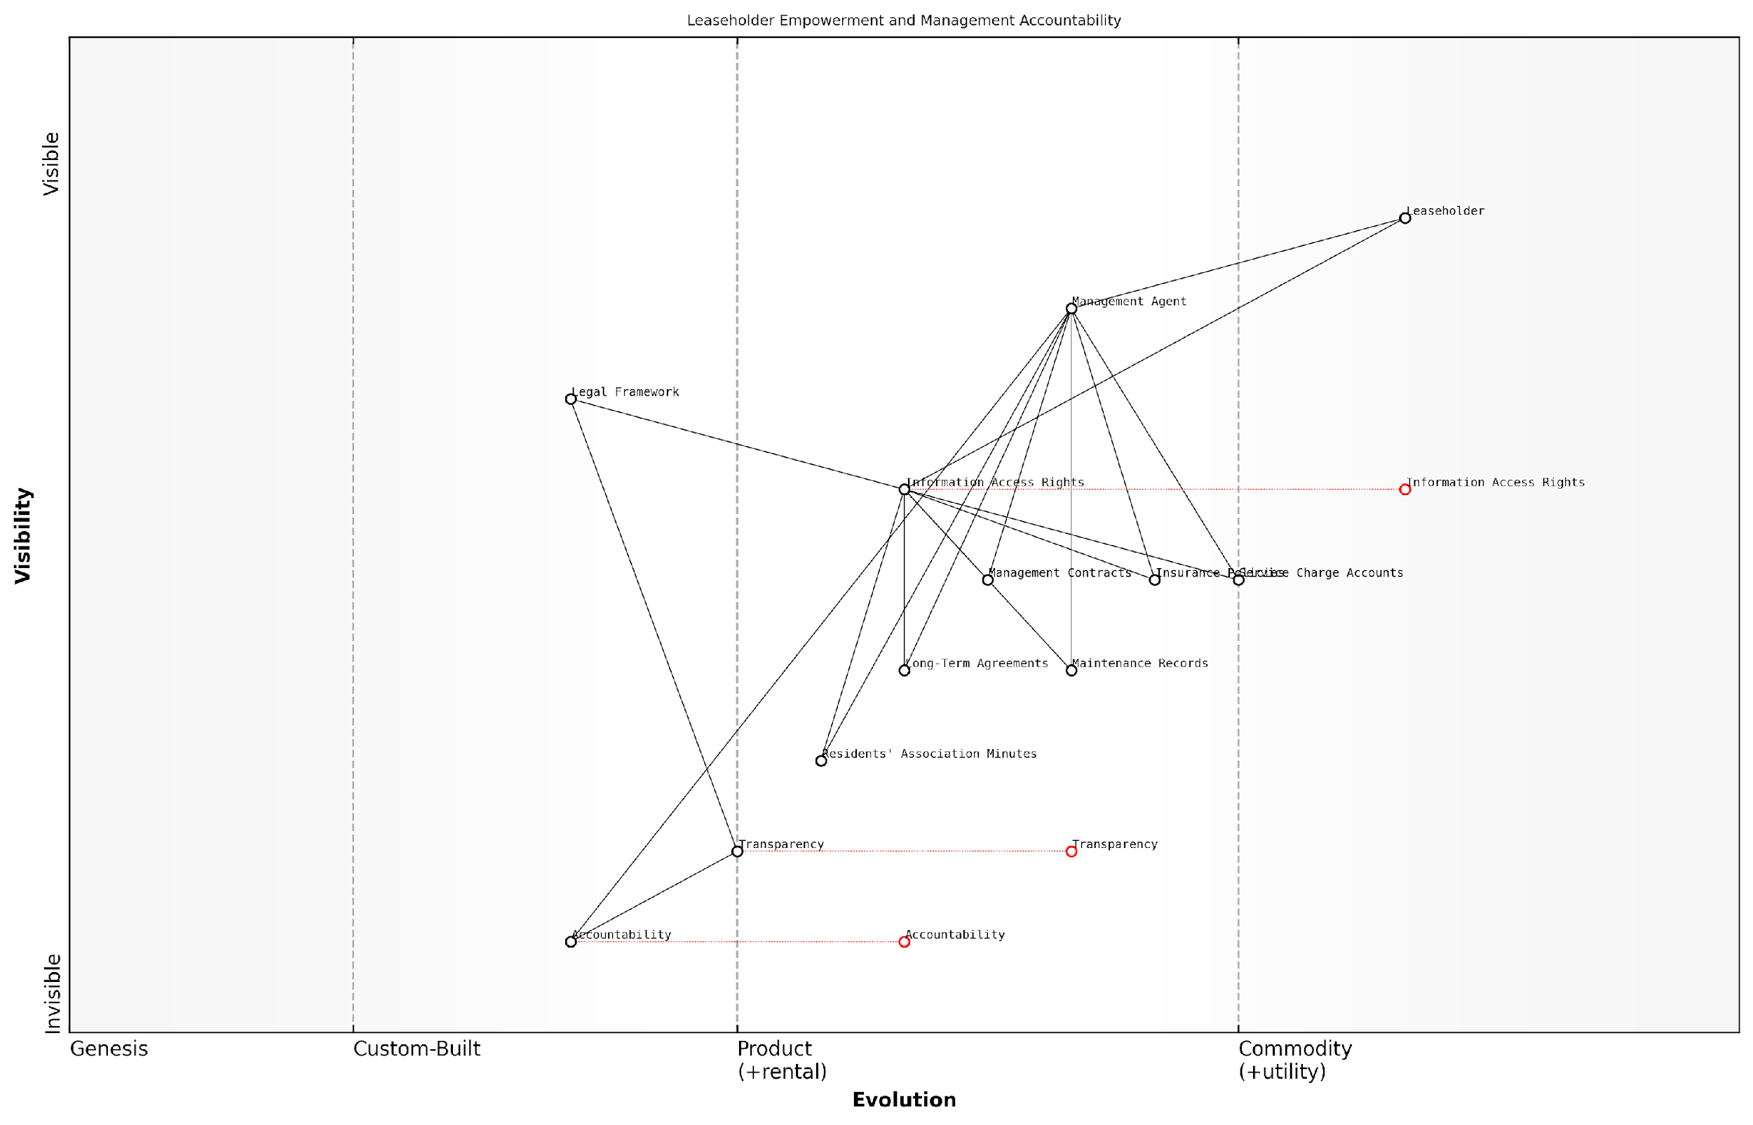

*Draft Wardley Map: [Insert Wardley Map: Requesting information and exercising your rights]*

[Edit this draft Wardley Map](https://create.wardleymaps.ai/#clone:967a09d407317b8367)

Wardley Map Assessment

This Wardley Map reveals a property management ecosystem on the cusp of significant change. The evolving nature of Transparency, Accountability, and Information Access Rights indicates a shift towards a more open, leaseholder-centric model. To thrive in this changing landscape, stakeholders must embrace innovation, particularly in digital technologies that enhance transparency and accountability. Management Agents face the greatest pressure to adapt, while Leaseholders stand to gain significant empowerment. The key to success lies in balancing the drive for openness with practical implementation, ensuring that increased transparency translates into tangible benefits for all parties involved.

[View full Wardley Map report](https://github.com/tractorjuice/automated_wardley_reports/blob/main/markdown_wardley_map_reports/wardley_map_report_29_Requesting_information_and_exercising_your_rights.md)

### Collaborating with other leaseholders for a united front

In the complex landscape of leasehold property management, the power of collective action cannot be overstated. Collaborating with fellow leaseholders to present a united front when engaging with management agents is often the most effective strategy for addressing issues and driving positive change. This approach not only amplifies individual voices but also demonstrates a shared commitment to fair and transparent management practices.

The benefits of leaseholder collaboration extend beyond mere strength in numbers. By working together, leaseholders can pool resources, share knowledge, and present a more compelling case when challenging excessive service charges or poor management practices. This united approach can significantly enhance the likelihood of achieving favourable outcomes and fostering a more balanced relationship with management agents.

In my experience advising leaseholder groups, I’ve consistently observed that management agents are far more responsive and amenable to change when faced with a well-organised collective of leaseholders rather than individual complaints.

Let’s explore the key strategies for effective leaseholder collaboration:

* Establishing a Leaseholder Communication Network
* Conducting Collaborative Research and Information Sharing
* Developing a Unified Strategy
* Presenting a Collective Case to Management Agents
* Leveraging Legal and Professional Support

1. Establishing a Leaseholder Communication Network

The foundation of effective collaboration is robust communication. Establishing a reliable network for leaseholders to connect and share information is crucial. This can take various forms, depending on the size and demographics of your leasehold community:

* Digital platforms: Create a dedicated WhatsApp group, Facebook group, or use platforms like Slack for ongoing discussions and quick updates.
* Regular meetings: Organise monthly or quarterly in-person or virtual meetings to discuss issues, share updates, and plan collective actions.
* Email lists: Maintain an up-to-date email list for distributing important information and coordinating responses to management issues.
* Notice boards: For those less comfortable with digital communication, utilise physical notice boards in communal areas to share information and meeting dates.

1. Conducting Collaborative Research and Information Sharing

Knowledge is power in leasehold disputes. Encourage leaseholders to pool their resources and conduct thorough research on relevant issues:

* Assign ‘research leads’ to investigate specific topics (e.g., legal rights, industry standards for service charges, best practices in property management).
* Create a shared digital repository (e.g., Google Drive, Dropbox) for storing and organising relevant documents, research findings, and correspondence with management agents.
* Encourage leaseholders to share their individual experiences and any responses they’ve received from management agents to identify patterns and inconsistencies.

1. Developing a Unified Strategy

With a strong communication network and shared knowledge base in place, the next step is to develop a cohesive strategy for engaging with management agents:

* Prioritise issues: Collectively decide which problems are most pressing and require immediate attention.
* Set clear objectives: Define specific, measurable goals for what you want to achieve through your engagement with management agents.
* Agree on approach: Determine whether to pursue informal negotiations, formal complaints, or legal action, ensuring all leaseholders are aligned on the chosen path.
* Designate spokespersons: Select articulate and level-headed individuals to represent the group in communications with management agents.
* Establish a timeline: Create a realistic schedule for actions and follow-ups to maintain momentum and accountability.

1. Presenting a Collective Case to Management Agents

When engaging with management agents as a united front, presentation and professionalism are key:

* Draft a comprehensive, well-researched letter outlining your concerns and proposed solutions, signed by all participating leaseholders.
* Request a formal meeting with management representatives, ensuring multiple leaseholders are present to demonstrate collective concern.
* Present evidence systematically, using data and comparisons to support your arguments against excessive charges or poor management practices.
* Maintain a constructive tone, focusing on mutual benefits and long-term improvements rather than confrontation.
* Follow up all verbal communications with written summaries to create a paper trail and ensure accountability.

A well-prepared group of leaseholders presenting a unified case can often achieve in one meeting what might take months of individual complaints to accomplish.

1. Leveraging Legal and Professional Support

While collaboration can significantly strengthen your position, there may be instances where professional support is necessary:

* Pool resources to engage a solicitor specialising in leasehold law for advice on complex issues or to review your case before presenting it to management agents.
* Consider hiring a surveyor or property management consultant to provide expert opinions on service charge reasonableness or building maintenance standards.
* Explore pro bono legal clinics or seek advice from organisations like LEASE (Leasehold Advisory Service) for initial guidance before committing to paid professional services.

By adopting these collaborative strategies, leaseholders can significantly enhance their bargaining power and effectiveness when engaging with management agents. This united approach not only increases the likelihood of resolving immediate issues but also sets the foundation for a more balanced and transparent relationship with management agents in the long term.

In the realm of leasehold management, the collective voice of informed and organised leaseholders is one of the most potent catalysts for positive change.

As we move forward in our efforts to reform bad management practices, remember that collaboration is not just a strategy—it’s a fundamental shift in how leaseholders approach their rights and responsibilities. By working together, sharing knowledge, and presenting a united front, leaseholders can navigate the complexities of property management more effectively and contribute to the ongoing evolution of fairer, more transparent leasehold practices in England.

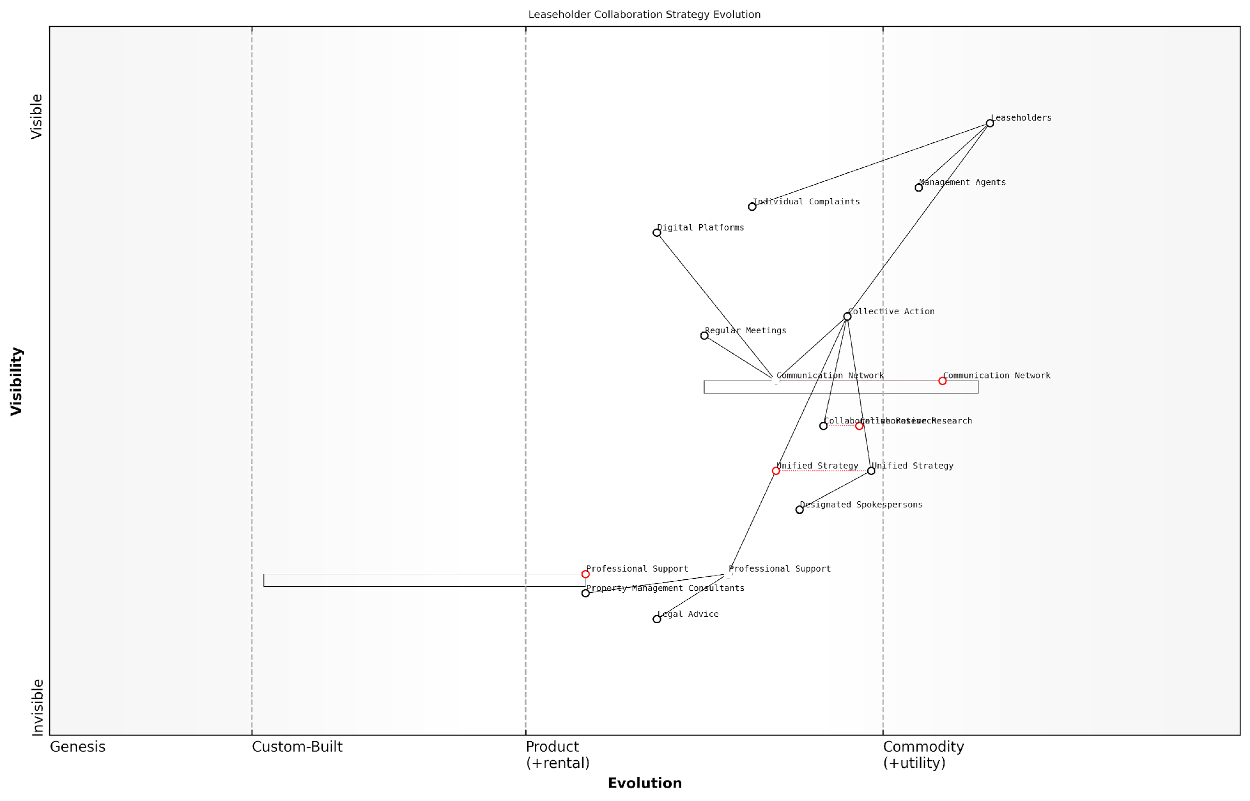

*Draft Wardley Map: [Insert Wardley Map: Collaborating with other leaseholders for a united front]*

[Edit this draft Wardley Map](https://create.wardleymaps.ai/#clone:3fd1e60ecb4595717a)

Wardley Map Assessment

This Wardley Map reveals a strategic landscape where leaseholders are evolving from individual, reactive approaches to more collective, proactive strategies in dealing with management agents. The map suggests significant opportunities for innovation in communication, collaboration, and professional support services. By focusing on developing a unified strategy, leveraging digital platforms, and integrating professional expertise, leaseholders can significantly strengthen their position. The key to success lies in the continued evolution of collective action capabilities, supported by robust communication networks and specialized professional services. As these components mature, we can expect to see a shift in the power dynamics between leaseholders and management agents, potentially leading to more favorable outcomes for leaseholders in terms of service charges and overall management practices.

[View full Wardley Map report](https://github.com/tractorjuice/automated_wardley_reports/blob/main/markdown_wardley_map_reports/wardley_map_report_30_Collaborating_with_other_leaseholders_for_a_united.md)

## Changing Your Management Agent

### Legal routes to appointing a new agent

When faced with persistent issues of excessive service charges or poor management practices, leaseholders in England have several legal avenues to appoint a new managing agent. This process, while potentially complex, can be a powerful tool in reforming bad management practices and ensuring fair treatment for leaseholders. Understanding these legal routes is crucial for leaseholders seeking to take control of their property management and improve their living conditions.

The primary legal routes available to leaseholders for appointing a new agent include:

* Right to Manage (RTM)
* Appointment of a manager by the First-tier Tribunal (Property Chamber)
* Collective enfranchisement
* Exercising rights under the lease agreement

Let’s explore each of these options in detail:

1. Right to Manage (RTM): The Right to Manage, introduced by the Commonhold and Leasehold Reform Act 2002, allows qualifying leaseholders to take over the management of their building without having to prove fault on the part of the landlord or existing managing agent. This process involves setting up an RTM company and following a prescribed statutory procedure.

A senior property law expert notes, ‘The Right to Manage has been a game-changer for many leaseholders, providing a relatively straightforward route to take control of their property management without the need for costly litigation.’

Key considerations for RTM include:

* At least 50% of qualifying tenants must participate
* The building must be self-contained and have at least two flats
* Two-thirds of the flats must be let to qualifying tenants
* No more than 25% of the building can be in non-residential use

1. Appointment of a manager by the First-tier Tribunal: If leaseholders can demonstrate that the current management is inadequate or that unreasonable service charges are being levied, they can apply to the First-tier Tribunal (Property Chamber) for the appointment of a new manager. This process is governed by Section 24 of the Landlord and Tenant Act 1987.

To succeed in this application, leaseholders must provide evidence of issues such as:

* Breach of obligations under the lease or relevant legislation
* Unreasonable service charges or administration charges
* Failure to maintain the property to an acceptable standard
* Other management failures that significantly affect leaseholders

A prominent housing barrister emphasises, ‘The tribunal route can be particularly effective when there’s clear evidence of mismanagement. It provides a formal, impartial process for addressing serious concerns about property management.’

1. Collective enfranchisement: While more complex and costly than other options, collective enfranchisement allows qualifying leaseholders to purchase the freehold of their building. This process is governed by the Leasehold Reform, Housing and Urban Development Act 1993. Once the freehold is acquired, leaseholders can appoint their own managing agent or self-manage the property.

Key points to consider for collective enfranchisement include:

* At least 50% of qualifying tenants must participate
* The building must contain at least two flats
* No more than 25% of the building can be in non-residential use
* Leaseholders must be prepared for significant upfront costs

1. Exercising rights under the lease agreement: Some lease agreements contain provisions allowing leaseholders to change the managing agent under certain circumstances. These rights may be triggered by specific events or may require a formal process, such as a vote among leaseholders.

A leading leasehold reform advocate states, ‘Always check your lease carefully. Some contain hidden gems that can provide a straightforward path to changing your managing agent without resorting to more complex legal procedures.’

When considering these legal routes, it’s crucial to weigh the pros and cons of each option carefully. Factors to consider include:

* The level of support among fellow leaseholders
* The costs involved in each process
* The time and effort required to complete the chosen route
* The potential for improving property management and reducing service charges
* The long-term implications for the property and its residents

It’s also worth noting that recent and proposed leasehold reforms in England may impact these processes in the future. Staying informed about legislative changes is crucial for leaseholders considering taking action.

In conclusion, while the process of changing a management agent through legal means can be challenging, it’s an important tool for leaseholders facing persistent issues with service charges or poor management. By understanding these legal routes and carefully considering their options, leaseholders can take significant steps towards improving their living conditions and ensuring fair treatment in the management of their properties.

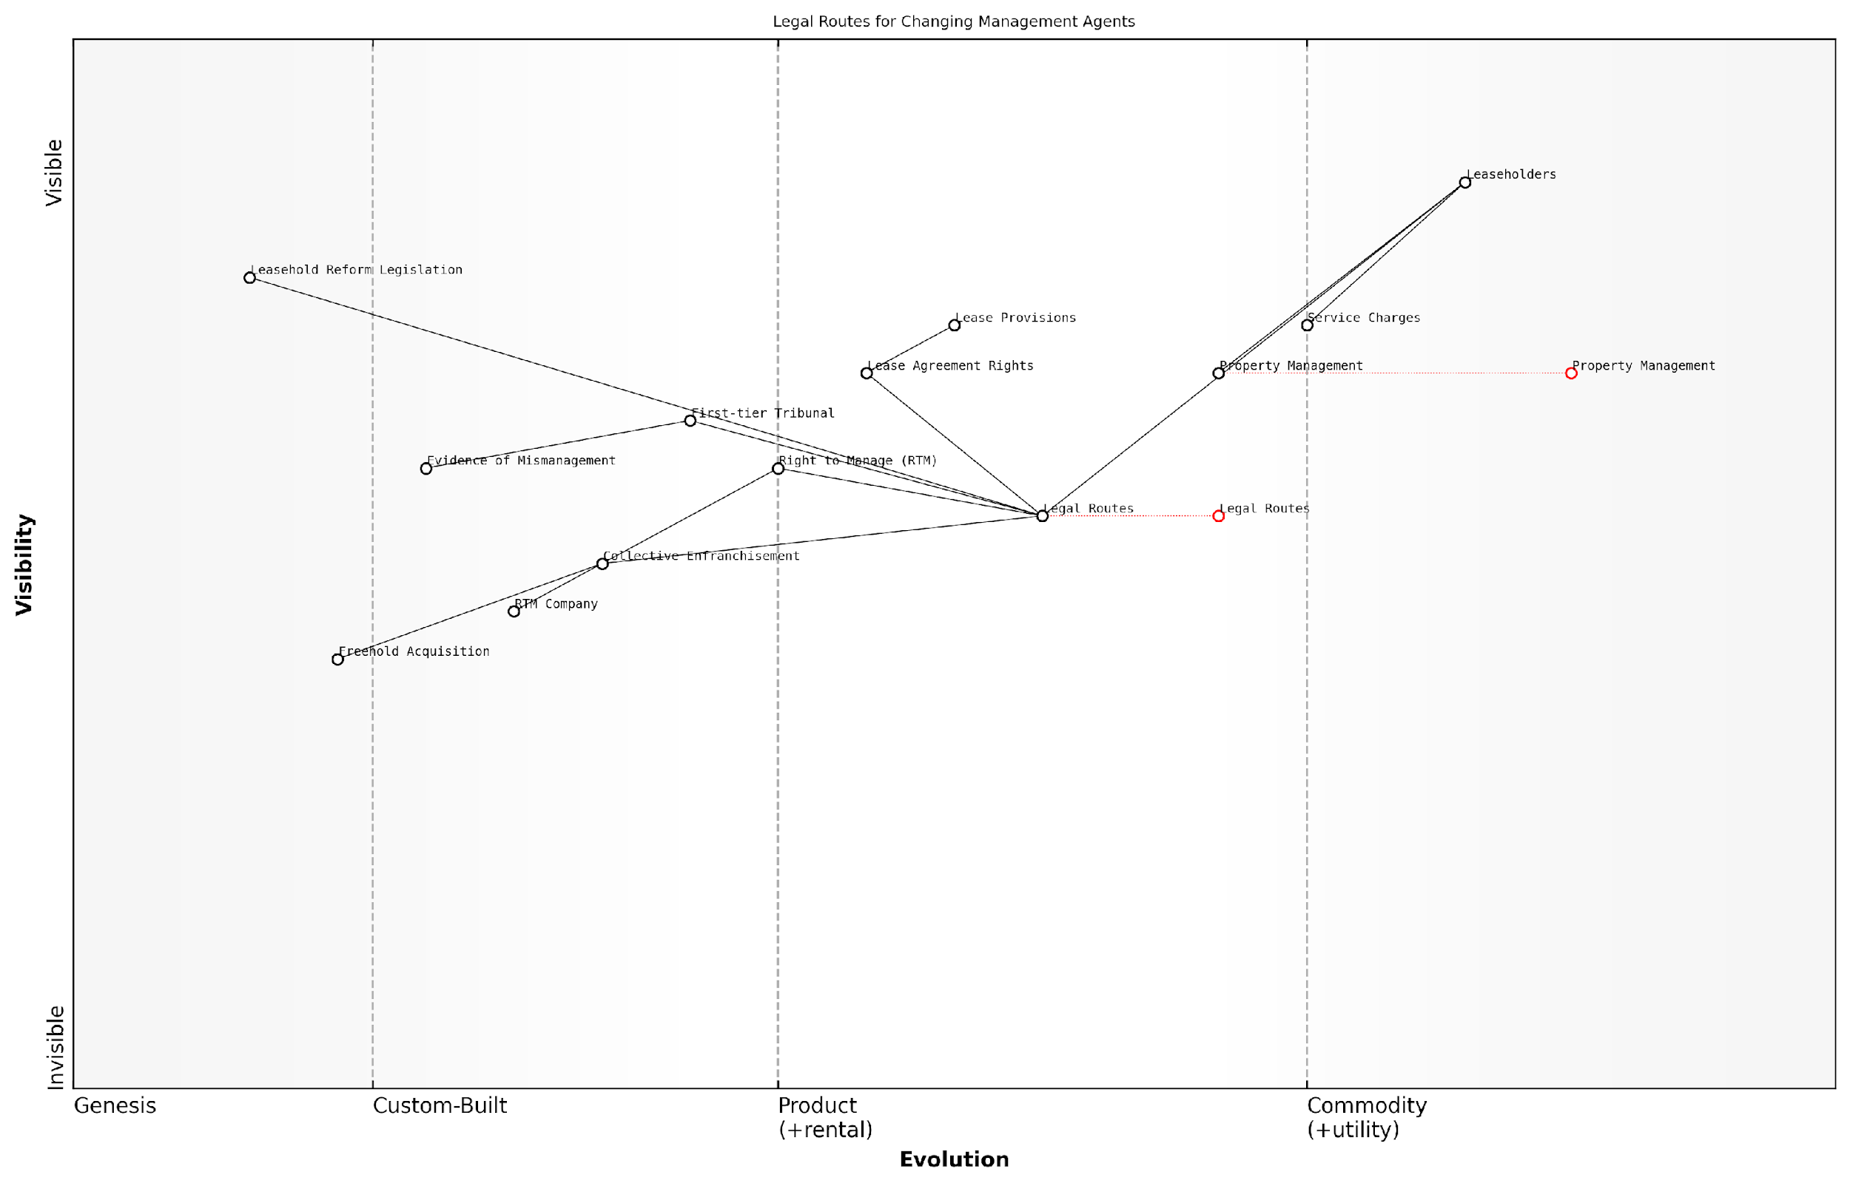

*Draft Wardley Map: [Insert Wardley Map: Legal routes to appointing a new agent]*

[Edit this draft Wardley Map](https://create.wardleymaps.ai/#clone:fa6686007d932dddfd)

Wardley Map Assessment

This Wardley Map reveals a system in transition, with significant opportunities for innovation and improvement in the process of changing management agents. The key strategic focus should be on empowering leaseholders through education, streamlined processes, and technology, while simultaneously advocating for legislative reforms to simplify the overall system. The evolving nature of Property Management and Legal Routes suggests a shifting landscape that could lead to more efficient and leaseholder-friendly practices in the future. However, the complexity of the current system and its dependence on evolving legislation present challenges that need to be carefully navigated. By focusing on the identified innovation opportunities and addressing capability gaps, stakeholders can position themselves advantageously in this changing ecosystem.

[View full Wardley Map report](https://github.com/tractorjuice/automated_wardley_reports/blob/main/markdown_wardley_map_reports/wardley_map_report_31_Legal_routes_to_appointing_a_new_agent.md)

### The process of changing management agents

Changing your management agent can be a transformative step in addressing persistent issues with service charges and poor management practices in leasehold flats. As an expert in this field, I can attest that this process, while potentially complex, can lead to significant improvements in the quality of life for leaseholders and the overall management of the property. This section will guide you through the intricacies of changing management agents, providing you with the knowledge and strategies to navigate this process effectively.

Before delving into the specifics, it’s crucial to understand that changing management agents is not a decision to be taken lightly. It requires careful consideration, planning, and often, collective action from leaseholders. However, when executed properly, it can be a powerful tool in reforming bad management practices and ensuring fair treatment for all residents.

Let’s break down the process into key stages:

* Assessing the need for change
* Legal considerations and rights
* Building consensus among leaseholders
* Formal notification and negotiation
* Appointing a new management agent
* Transition and handover

1. Assessing the need for change:

The first step in changing your management agent is to thoroughly assess the current situation. This involves documenting specific instances of poor management, excessive service charges, or breaches of contract. It’s essential to build a compelling case that demonstrates the need for change.

As a senior property management consultant once told me, ‘Changing management agents should be a data-driven decision, not an emotional one. Compile a dossier of evidence that clearly shows how the current agent is failing to meet their obligations.’

1. Legal considerations and rights:

Understanding your legal rights is crucial in this process. The Commonhold and Leasehold Reform Act 2002 provides leaseholders with the right to appoint a new management agent through a tribunal process if they can prove mismanagement. Additionally, some leases may contain specific clauses about changing management agents.

It’s advisable to seek legal counsel at this stage to ensure you’re proceeding on solid legal ground. A solicitor specialising in leasehold law can provide invaluable guidance on your specific situation and the most appropriate course of action.

1. Building consensus among leaseholders:

Changing a management agent typically requires collective action. Building consensus among your fellow leaseholders is crucial for success. This often involves forming or utilising an existing Residents’ Association to coordinate efforts and communicate effectively.

Organise meetings to discuss the issues, share evidence, and agree on a course of action. Remember, strength lies in numbers, and a united front of leaseholders is more likely to achieve the desired outcome.

1. Formal notification and negotiation:

Once you have built a strong case and gained support from other leaseholders, the next step is to formally notify the freeholder and current management agent of your intention to change agents. This should be done in writing, clearly stating your reasons and providing evidence of mismanagement or excessive charges.

In some cases, this notification may lead to negotiations. The current agent or freeholder might propose improvements or changes to address your concerns. While it’s important to consider these proposals, remain focused on your ultimate goal if the issues are systemic or long-standing.

1. Appointing a new management agent:

If negotiations are unsuccessful or not applicable, you’ll need to proceed with appointing a new management agent. This process typically involves:

* Researching potential new agents
* Requesting and reviewing proposals
* Conducting interviews
* Checking references and credentials
* Making a collective decision on the best candidate

When selecting a new agent, look for those with relevant experience, proper accreditations (such as ARMA membership), and a track record of transparent and fair management practices. Consider their communication style, fee structure, and approach to maintenance and financial management.

A leading property management expert once advised, ‘Don’t just look for an agent who promises lower fees. Seek one who demonstrates a clear understanding of your property’s unique needs and has a proactive approach to management.’

1. Transition and handover:

Once a new agent has been selected, the final stage is the transition and handover process. This can be a complex phase, involving the transfer of documents, financial records, and ongoing maintenance contracts. It’s crucial to ensure a smooth transition to minimise disruption to services and maintain clear communication with all leaseholders throughout this period.

Key aspects of a successful transition include:

* Conducting a thorough handover of all relevant documents and information
* Transferring financial accounts and reserves
* Notifying all service providers and contractors of the change
* Updating leaseholders on the new management arrangements
* Setting clear expectations and performance metrics for the new agent

In conclusion, changing your management agent can be a powerful tool in addressing issues of excessive service charges and poor management practices. While the process requires careful planning, legal consideration, and collective action, it can lead to significant improvements in the quality of life for leaseholders and the overall management of the property.

Remember, the goal is not just to change agents, but to establish a more effective, transparent, and fair management system for your leasehold property. By following this process and remaining committed to positive change, you can play a crucial role in reforming bad management practices and creating a better living environment for all leaseholders.

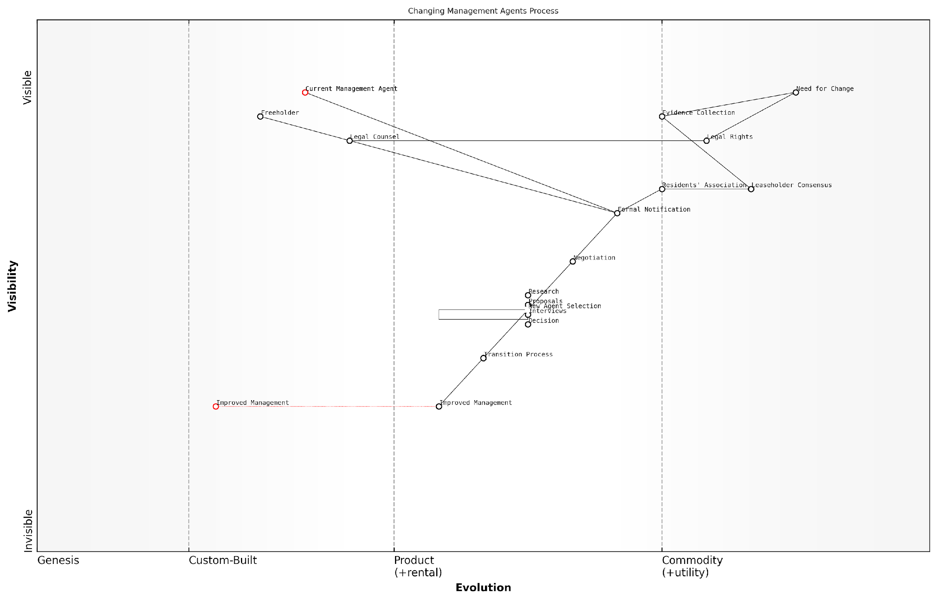

*Draft Wardley Map: [Insert Wardley Map: The process of changing management agents]*

[Edit this draft Wardley Map](https://create.wardleymaps.ai/#clone:c2278b2e23c5990456)

Wardley Map Assessment

This Wardley Map reveals a process that is maturing but still has significant room for improvement and innovation. The key strategic opportunities lie in empowering leaseholders through better organisation, evidence collection, and decision-making tools. There’s also a clear need for standardisation in several areas, particularly in the transition process and legal rights. By focusing on these areas, stakeholders can work towards a more efficient, transparent, and fair system for changing management agents in leasehold properties. The industry appears ripe for disruption through digital technologies and more collaborative models, which could significantly alter the balance of power between leaseholders, management agents, and freeholders.

[View full Wardley Map report](https://github.com/tractorjuice/automated_wardley_reports/blob/main/markdown_wardley_map_reports/wardley_map_report_32_The_process_of_changing_management_agents.md)

### Selecting a reputable replacement

When faced with the decision to change your management agent, selecting a reputable replacement is crucial for ensuring improved service and avoiding a repetition of past issues. This process requires careful consideration, thorough research, and a clear understanding of your property’s needs. As an expert in tackling excessive service charges and bad management agents for leasehold flats in England, I can attest that the right choice can significantly impact the quality of life for leaseholders and the overall value of the property.

To guide leaseholders through this critical decision-making process, we will explore key aspects of selecting a reputable replacement management agent, including qualification checks, performance evaluation, and alignment with leaseholder interests.

Qualification and Accreditation

The first step in selecting a reputable replacement is to verify the qualifications and accreditations of potential management agents. In the UK, several professional bodies oversee and accredit property management companies, providing a benchmark for quality and professionalism.

* Royal Institution of Chartered Surveyors (RICS)
* Association of Residential Managing Agents (ARMA)
* Institute of Residential Property Management (IRPM)
* Property Ombudsman Scheme

Membership in these organisations often indicates a commitment to professional standards and ongoing training. However, it’s important to note that membership alone does not guarantee excellent service. As a seasoned consultant, I advise leaseholders to use accreditation as a starting point rather than the sole criterion for selection.

Accreditation provides a foundation of trust, but it’s the management agent’s track record and approach that truly determine their suitability for your property.

Experience and Expertise

When evaluating potential management agents, consider their experience with properties similar to yours in terms of size, age, and complexity. An agent with a diverse portfolio may bring valuable insights, but specialisation in your type of property can be equally beneficial.

* Years of experience in the industry
* Specific experience with similar properties
* Knowledge of local property market and regulations
* Expertise in handling common issues faced by leaseholders

It’s crucial to delve into the agent’s track record of resolving disputes, managing major works, and maintaining transparent financial practices. Request case studies or speak with current clients to gain insights into their practical experience and problem-solving abilities.

Financial Transparency and Reporting

One of the primary concerns for leaseholders is often the lack of financial transparency from their management agents. When selecting a replacement, prioritise agents who demonstrate a commitment to clear, regular, and comprehensive financial reporting.

* Detailed breakdowns of service charges
* Regular financial statements and budgets
* Clear processes for handling reserve funds
* Transparent fee structures with no hidden costs

Ask potential agents to provide sample reports and explain their approach to financial management. A reputable agent should be able to clearly articulate how they ensure value for money and maintain financial integrity.

Transparency in financial matters is not just about providing numbers; it’s about building trust and empowering leaseholders to make informed decisions about their property.

Communication and Responsiveness

Effective communication is often the cornerstone of a positive relationship between leaseholders and management agents. When selecting a replacement, assess the agent’s communication strategies and responsiveness to queries and concerns.

* Regular updates on property matters
* Multiple channels for leaseholder communication (e.g., email, phone, online portal)
* Clear complaint handling procedures
* Proactive approach to addressing leaseholder concerns

Consider arranging face-to-face meetings with potential agents to gauge their interpersonal skills and willingness to engage with leaseholders. A reputable agent should demonstrate a genuine interest in understanding the specific needs and concerns of your property.

Technology and Innovation

In today’s digital age, the use of technology can significantly enhance property management efficiency and leaseholder satisfaction. When evaluating potential agents, consider their adoption of modern tools and innovative approaches to property management.

* Online portals for accessing documents and raising issues
* Use of property management software for streamlined operations
* Implementation of energy-efficient technologies
* Adoption of digital communication tools for swift updates

While technology should not replace personal service, it can complement it by providing leaseholders with greater access to information and more efficient processes for handling routine matters.

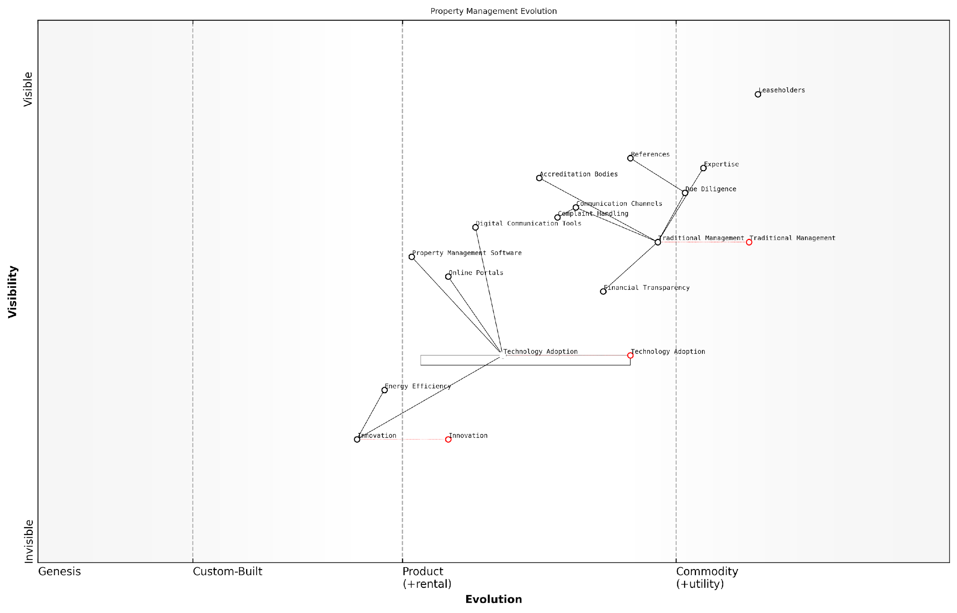

*Draft Wardley Map: [Insert Wardley Map: Selecting a reputable replacement]*

[Edit this draft Wardley Map](https://create.wardleymaps.ai/#clone:7b73752049236521ad)

Wardley Map Assessment

The Wardley Map reveals a property management industry in transition, moving from traditional practices towards a more technology-driven, innovative future. The strategic imperative is clear: embrace technological change, enhance transparency and communication, and innovate in areas like energy efficiency. Success will depend on balancing the reliability of traditional services with the opportunities presented by new technologies and changing customer expectations. Firms that can effectively navigate this transition, investing in key capabilities while maintaining strong customer relationships, will be well-positioned to lead the industry in the coming years.

[View full Wardley Map report](https://github.com/tractorjuice/automated_wardley_reports/blob/main/markdown_wardley_map_reports/wardley_map_report_33_Selecting_a_reputable_replacement.md)

References and Due Diligence

Before making a final decision, conduct thorough due diligence on your shortlisted management agents. This process should include checking references, reviewing online reviews, and potentially visiting properties they currently manage.

* Request and contact references from current clients
* Check for any complaints or disciplinary actions with relevant professional bodies
* Review the company’s financial stability and insurance coverage
* Assess their understanding of relevant legislation and best practices

Remember that while positive references are important, they should be considered alongside your own assessment of the agent’s suitability for your specific property and leaseholder community.

The most valuable insights often come from speaking directly with leaseholders who have experienced the agent’s services first-hand. Their experiences can provide a realistic picture of what to expect.

Conclusion

Selecting a reputable replacement management agent is a critical step in addressing issues of excessive service charges and poor management practices. By thoroughly evaluating potential agents based on their qualifications, experience, financial transparency, communication skills, technological capabilities, and references, leaseholders can make an informed decision that aligns with their property’s needs and their own expectations.

Remember that the goal is not just to find a new agent, but to establish a productive, long-term partnership that enhances the value and enjoyment of your leasehold property. Take the time to conduct a comprehensive selection process, and don’t hesitate to seek professional advice if needed. The effort invested in choosing the right management agent can yield significant benefits in terms of improved service, fair charges, and a more harmonious living environment for all leaseholders.

# Collective Action and Empowerment

## Forming a Residents’ Association

### Benefits of a recognised association

In the complex landscape of leasehold property management, forming a recognised residents’ association can be a powerful tool for leaseholders seeking to address excessive service charges and poor management practices. This section explores the numerous benefits that a formally recognised association can offer, providing leaseholders with a collective voice and enhanced rights in their dealings with freeholders and management agents.

A recognised residents’ association is one that has been formally acknowledged by the landlord or, in cases of dispute, by the First-tier Tribunal (Property Chamber). This official status confers several significant advantages that can greatly assist leaseholders in tackling common issues and improving their living conditions.

* Enhanced Legal Rights
* Improved Communication Channels
* Collective Bargaining Power
* Access to Information
* Representation in Consultations
* Financial Scrutiny
* Community Cohesion

Let’s delve into each of these benefits in detail:

1. Enhanced Legal Rights: A recognised association enjoys specific rights under leasehold legislation. For instance, under the Landlord and Tenant Act 1985, recognised associations have the right to appoint a surveyor to advise on service charges. This professional input can be invaluable when challenging excessive or unreasonable charges.

As a senior property law expert notes, ‘The ability to appoint a surveyor gives recognised associations a significant advantage in disputes over service charges, providing them with professional expertise to support their case.’

1. Improved Communication Channels: Recognition establishes a formal line of communication between leaseholders and the landlord or management agent. This can lead to more efficient resolution of issues and improved transparency in decision-making processes affecting the property.
2. Collective Bargaining Power: By acting as a unified entity, a recognised association can wield greater influence in negotiations with landlords and management agents. This collective strength can be particularly effective when addressing systemic issues or pushing for improvements in service delivery.
3. Access to Information: Recognised associations have the right to request and receive information about insurance policies for the building. This transparency can help ensure that appropriate coverage is in place and that premiums are reasonable.
4. Representation in Consultations: When major works or long-term agreements are proposed, landlords are required to consult with recognised associations. This gives leaseholders a formal voice in decisions that will significantly impact their property and finances.

A leading housing rights advocate emphasises, ‘The consultation rights afforded to recognised associations are crucial in ensuring that leaseholders’ interests are considered in major decisions affecting their homes and wallets.’

1. Financial Scrutiny: Recognised associations have the right to inspect accounts and receipts related to service charges. This level of scrutiny can help identify and challenge any discrepancies or excessive charges, promoting financial transparency and accountability.
2. Community Cohesion: Beyond the legal and practical benefits, a recognised association can foster a sense of community among leaseholders. This unity can be invaluable when facing shared challenges and can contribute to a more positive living environment overall.

It’s important to note that while recognition brings numerous advantages, it also comes with responsibilities. Associations must operate democratically, maintain proper records, and act in the best interests of all leaseholders. Striking this balance is crucial for maintaining credibility and effectiveness in dealings with landlords and management agents.

In practice, the benefits of a recognised association can be transformative. For instance, in a case I advised on involving a large residential complex in Manchester, the formation of a recognised association led to a 15% reduction in service charges within the first year. The association’s ability to scrutinise accounts and challenge unreasonable costs played a pivotal role in achieving this outcome.

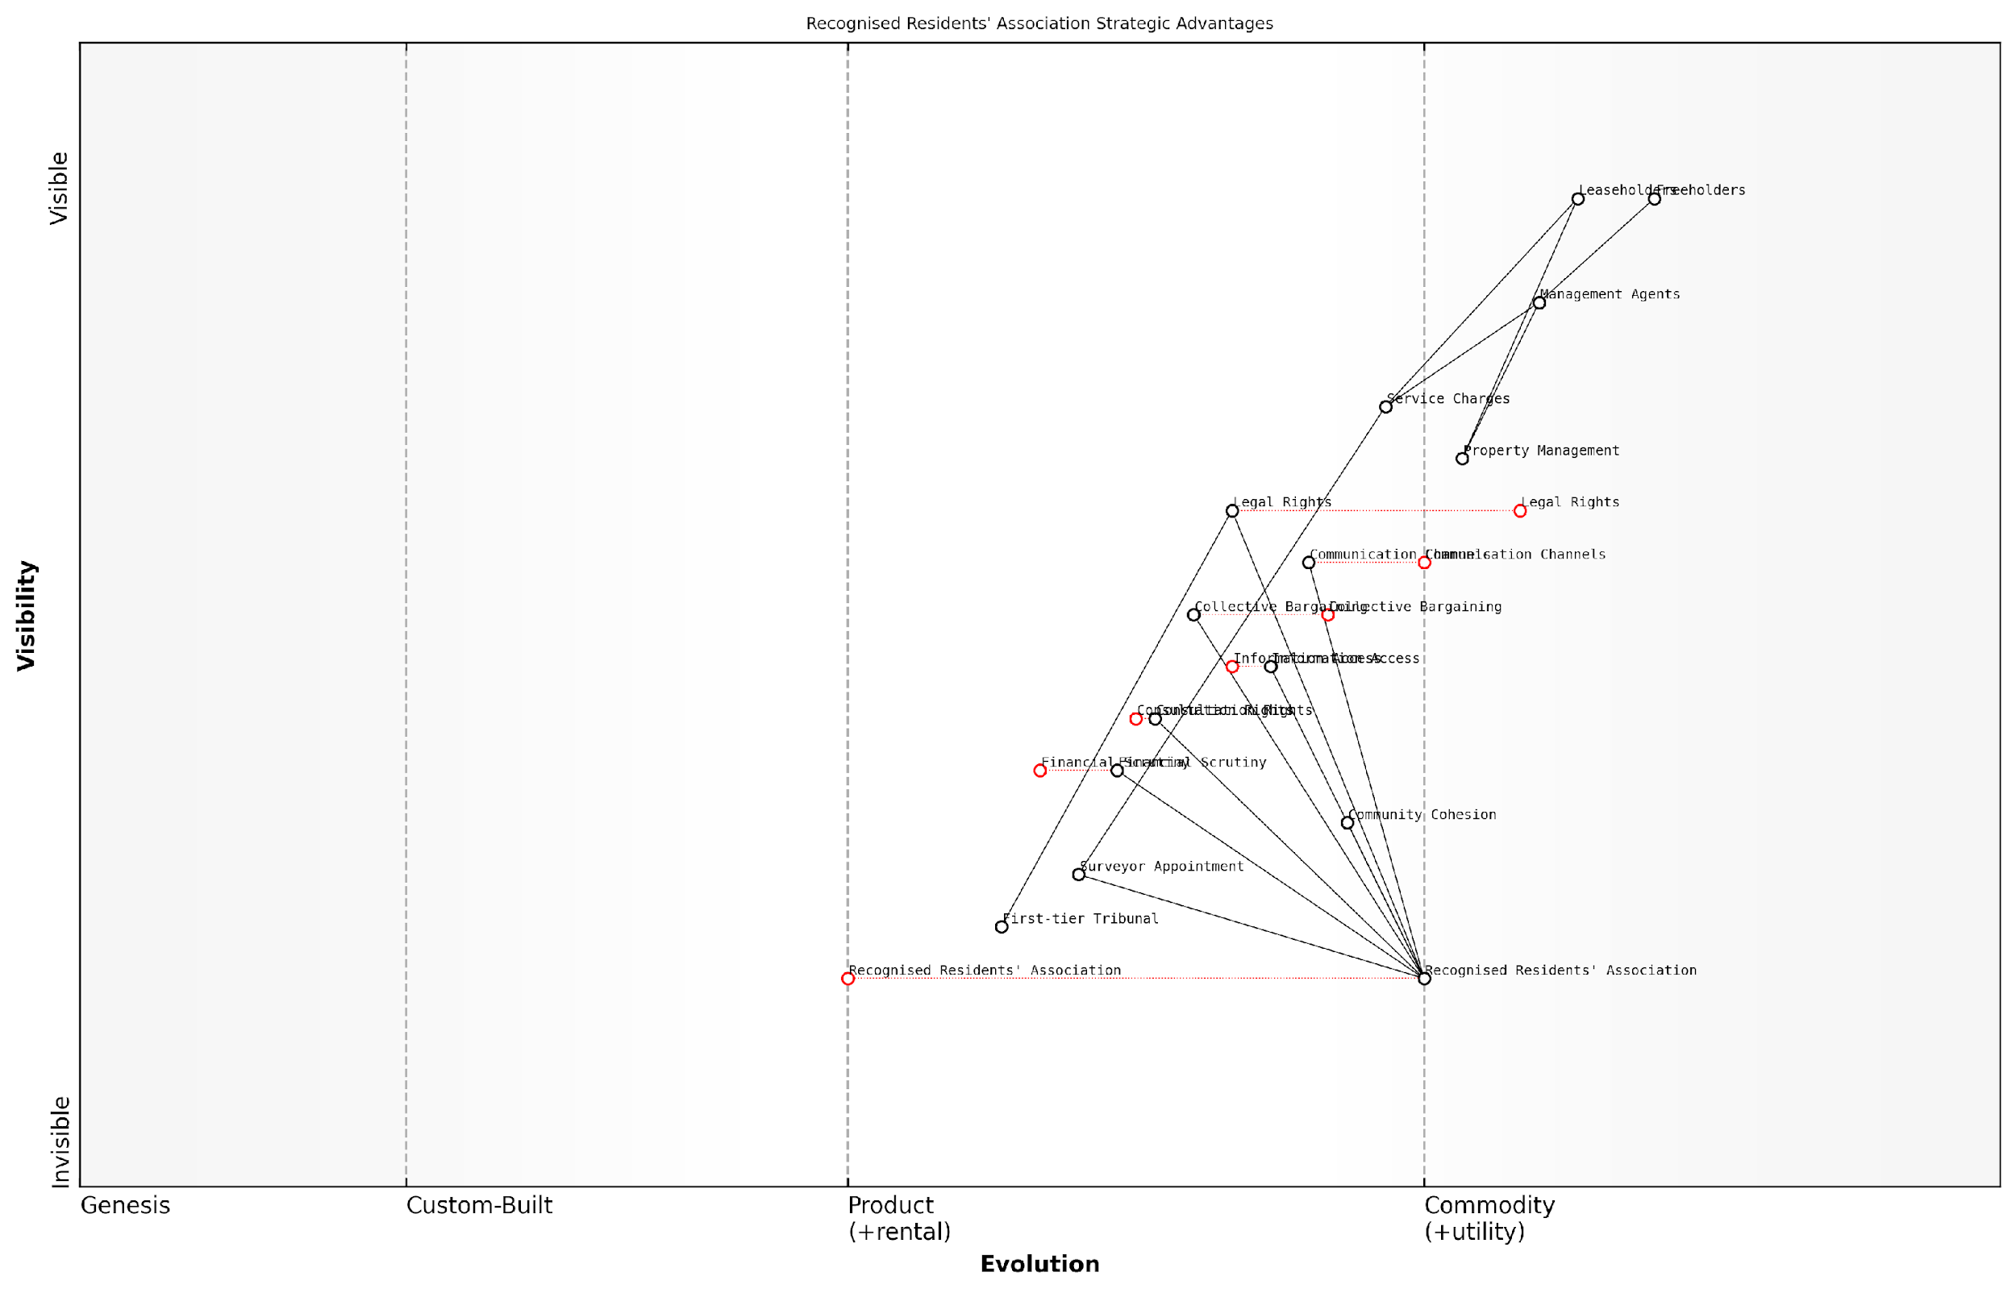

*Draft Wardley Map: [Insert Wardley Map: Benefits of a recognised association]*

[Edit this draft Wardley Map](https://create.wardleymaps.ai/#clone:4c37ce9d55e792ff4a)

Wardley Map Assessment

The Wardley Map reveals a strategic landscape where Recognised Residents’ Associations have significant potential to reshape the leasehold property management ecosystem. By leveraging their unique position and evolving key capabilities, these associations can drive innovation, improve transparency, and ultimately enhance the quality of life for leaseholders. The map suggests a path forward that balances short-term practical improvements with long-term systemic change, emphasising the need for continuous evolution and adaptation in response to both market forces and regulatory environments. Success will depend on effectively mobilising collective action, embracing technological innovation, and strategically navigating the complex relationships between various stakeholders in the property management landscape.

[View full Wardley Map report](https://github.com/tractorjuice/automated_wardley_reports/blob/main/markdown_wardley_map_reports/wardley_map_report_34_Benefits_of_a_recognised_association.md)

However, it’s crucial to acknowledge that recognition is not always straightforward. Some landlords may resist or delay the process, necessitating an application to the First-tier Tribunal. In such cases, thorough preparation and a clear demonstration of meeting the statutory criteria are essential for success.

In conclusion, the benefits of a recognised residents’ association are substantial and can significantly empower leaseholders in their efforts to tackle excessive service charges and poor management practices. By providing a formal structure for collective action, enhanced legal rights, and improved communication channels, recognised associations offer a powerful mechanism for leaseholders to protect their interests and improve their living conditions. As the leasehold landscape continues to evolve, with ongoing discussions about reform, the role of recognised associations in advocating for leaseholders’ rights remains more crucial than ever.

### Steps to form and register an association

Forming and registering a Residents’ Association is a crucial step in empowering leaseholders to collectively address issues with service charges and management agents. This process not only provides a unified voice but also grants legal recognition, enhancing the association’s ability to negotiate and challenge unfair practices. As an expert in leasehold matters, I’ve guided numerous groups through this process, and I can attest to its transformative power in tackling excessive charges and poor management.

The journey to forming a recognised Residents’ Association can be broken down into several key stages, each requiring careful consideration and execution. Let’s explore these steps in detail, drawing from best practices and legal requirements under the Landlord and Tenant Act 1985 and subsequent regulations.

* Gauge Interest and Build Support
* Hold an Initial Meeting
* Draft a Constitution
* Elect a Committee
* Apply for Recognition
* Notify the Landlord or Management Company
* Establish Communication Channels
* Register with Relevant Bodies

Let’s delve into each of these steps:

1. Gauge Interest and Build Support: The first step is to assess the level of interest among fellow leaseholders. This often involves informal discussions, distributing leaflets, or hosting a preliminary meeting. In my experience, it’s crucial to highlight the benefits of a Residents’ Association, such as increased bargaining power and the ability to challenge service charges collectively. Aim to secure interest from at least 60% of qualifying tenants, as this is typically the threshold for formal recognition.
2. Hold an Initial Meeting: Once sufficient interest is established, organise a formal meeting. This should be well-publicised, with clear objectives outlined. During this meeting, discuss the purpose of the association, potential benefits, and the steps involved in formation. It’s essential to keep minutes of this meeting as they may be required for the recognition process later.
3. Draft a Constitution: A robust constitution is the backbone of any effective Residents’ Association. It should outline the association’s objectives, membership criteria, committee structure, decision-making processes, and financial management. I’ve found that adapting template constitutions available from organisations like the Leasehold Advisory Service (LEASE) can be an excellent starting point, tailoring them to your specific circumstances.

A well-crafted constitution is not just a formality; it’s a roadmap for effective governance and a shield against potential disputes. It sets the tone for how the association will operate and interact with the landlord or management company.

1. Elect a Committee: The association should elect a committee to manage its affairs. Typically, this includes a Chair, Secretary, and Treasurer, along with other roles as deemed necessary. It’s crucial to select individuals who are committed, diplomatic, and have a good understanding of leasehold issues. In my consultancy work, I’ve observed that diverse committees with a range of skills tend to be most effective.
2. Apply for Recognition: To gain formal recognition, the association must apply to the landlord or management company. This application should include the constitution, committee details, and evidence of support from qualifying tenants. The landlord has a duty to respond within a reasonable timeframe, typically 28 days.
3. Notify the Landlord or Management Company: Once the association is formed, formally notify the landlord or management company in writing. This notification should include the names and addresses of the committee members, a copy of the constitution, and a request for recognition.
4. Establish Communication Channels: Set up effective means of communicating with members, such as email lists, social media groups, or regular newsletters. Clear and consistent communication is vital for maintaining engagement and unity among members.
5. Register with Relevant Bodies: Consider registering the association with relevant organisations such as the Federation of Private Residents’ Associations (FPRA). This can provide access to valuable resources, advice, and networking opportunities.

It’s important to note that if a landlord unreasonably refuses to recognise the association, you can apply to the First-tier Tribunal (Property Chamber) for a certificate of recognition. This process requires demonstrating that the association meets the necessary criteria and operates fairly and democratically.

In my years of advising leaseholder groups, I’ve seen time and again that a well-organised, properly registered Residents’ Association can be a game-changer in addressing service charge issues and improving property management. It transforms individual concerns into a collective voice that cannot be easily dismissed.

By following these steps diligently, leaseholders can create a powerful platform for collective action. A recognised Residents’ Association not only enhances your ability to challenge excessive service charges but also fosters a sense of community and shared purpose among leaseholders. Remember, the process of formation is just the beginning; maintaining an active and engaged association is key to long-term success in tackling leasehold issues.

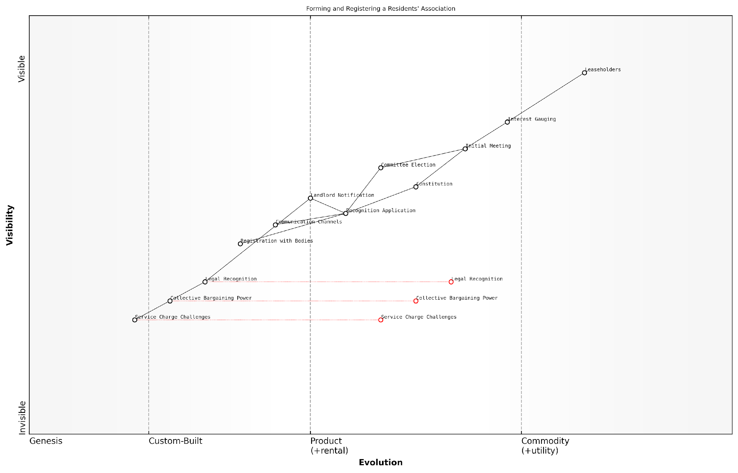

*Draft Wardley Map: [Insert Wardley Map: Steps to form and register an association]*

[Edit this draft Wardley Map](https://create.wardleymaps.ai/#clone:5fa9d433a3b1ae62e6)

Wardley Map Assessment

This map represents a well-structured approach to forming and empowering residents’ associations. The key strategic focus should be on accelerating the path to legal recognition while enhancing early-stage engagement. There’s significant potential for innovation in digital tools and data analytics to strengthen the association’s capabilities and value proposition to leaseholders. The evolution towards more commoditized service charge challenges suggests a need for associations to continually evolve their offerings and focus on broader resident empowerment strategies in the long term.

[View full Wardley Map report](https://github.com/tractorjuice/automated_wardley_reports/blob/main/markdown_wardley_map_reports/wardley_map_report_35_Steps_to_form_and_register_an_association.md)

### Running an effective residents’ association

Running an effective residents’ association is a crucial step in empowering leaseholders to tackle excessive service charges and poor management practices. As an expert in this field, I can attest that a well-organised association can be a powerful tool for collective action, negotiation, and reform within the leasehold system. This section will explore the key elements of running a successful residents’ association, drawing from years of experience in advising leaseholders and engaging with management agents across England.

To begin, it’s essential to understand the legal framework that underpins residents’ associations. The Landlord and Tenant Act 1985 provides the statutory basis for recognising residents’ associations, granting them specific rights and powers. A recognised association can request information about service charges, appoint a surveyor to advise on matters relating to service charges, and nominate contractors for major works. These legal provisions form the foundation upon which an effective association can build its influence and authority.

A well-run residents’ association can be the difference between feeling powerless in the face of unreasonable charges and having a genuine say in how your building is managed. It’s about shifting the balance of power back towards the leaseholders.

With this context in mind, let’s explore the key components of running an effective residents’ association:

* Establishing a clear governance structure
* Effective communication strategies
* Building and maintaining membership engagement
* Developing expertise and knowledge
* Negotiating with management agents and freeholders
* Leveraging legal rights and protections

Establishing a clear governance structure is fundamental to the success of any residents’ association. This typically involves creating a constitution that outlines the association’s objectives, membership criteria, committee roles, and decision-making processes. A well-crafted constitution provides legitimacy and helps prevent internal disputes that could undermine the association’s effectiveness.

Effective communication is the lifeblood of a thriving residents’ association. Regular meetings, newsletters, and digital platforms such as dedicated websites or social media groups can keep members informed and engaged. It’s crucial to strike a balance between transparency and confidentiality, particularly when dealing with sensitive negotiations or legal matters.

Building and maintaining membership engagement is an ongoing challenge for many associations. Successful strategies often include organising social events, conducting surveys to understand members’ priorities, and creating subcommittees to tackle specific issues. This approach not only distributes the workload but also helps members feel more invested in the association’s success.

The most effective residents’ associations I’ve worked with are those that foster a sense of community beyond just dealing with problems. They become a positive force in the building, which in turn strengthens their position when challenging issues do arise.

Developing expertise and knowledge within the association is crucial for effectively challenging service charges and management practices. This can involve organising training sessions on leasehold law, inviting experts to speak at meetings, or encouraging committee members to attend relevant courses. Building this knowledge base not only empowers the association but also commands respect from management agents and freeholders.

Negotiating with management agents and freeholders is often the most challenging aspect of running a residents’ association. Effective negotiation requires a combination of assertiveness, diplomacy, and a thorough understanding of leaseholders’ rights. It’s important to approach negotiations with a clear agenda, documented evidence, and a willingness to compromise where appropriate. Building a constructive relationship with the management agent can lead to more positive outcomes, even in contentious situations.

Leveraging legal rights and protections is a key strategy for effective residents’ associations. This includes exercising the right to information about service charges, challenging unreasonable fees through the First-tier Tribunal (Property Chamber), and potentially pursuing the Right to Manage or collective enfranchisement. A thorough understanding of these legal avenues can significantly strengthen the association’s position in negotiations.

Case studies from my consultancy experience highlight the transformative impact of well-run residents’ associations. For instance, a London-based association I advised successfully challenged a 30% increase in service charges by meticulously documenting discrepancies and presenting a united front to the management agent. This resulted in not only a reversal of the increase but also a comprehensive review of the building’s maintenance contracts.

Another example comes from a large development in Manchester, where the residents’ association spearheaded a campaign to replace an underperforming management agent. By gathering evidence of poor performance, conducting a thorough tender process, and leveraging their statutory rights, they successfully appointed a new agent who has since dramatically improved the quality of service and reduced overall costs.

The key to success is persistence, professionalism, and a commitment to representing all leaseholders fairly. When residents’ associations embody these principles, they become formidable advocates for positive change in the leasehold sector.

In conclusion, running an effective residents’ association requires a combination of legal knowledge, strategic thinking, and strong interpersonal skills. By focusing on clear governance, effective communication, member engagement, expertise development, skilled negotiation, and the strategic use of legal rights, associations can become powerful vehicles for tackling excessive service charges and improving management practices. As the leasehold landscape continues to evolve, well-run residents’ associations will play an increasingly important role in shaping fairer, more transparent, and more accountable management of leasehold properties across England.

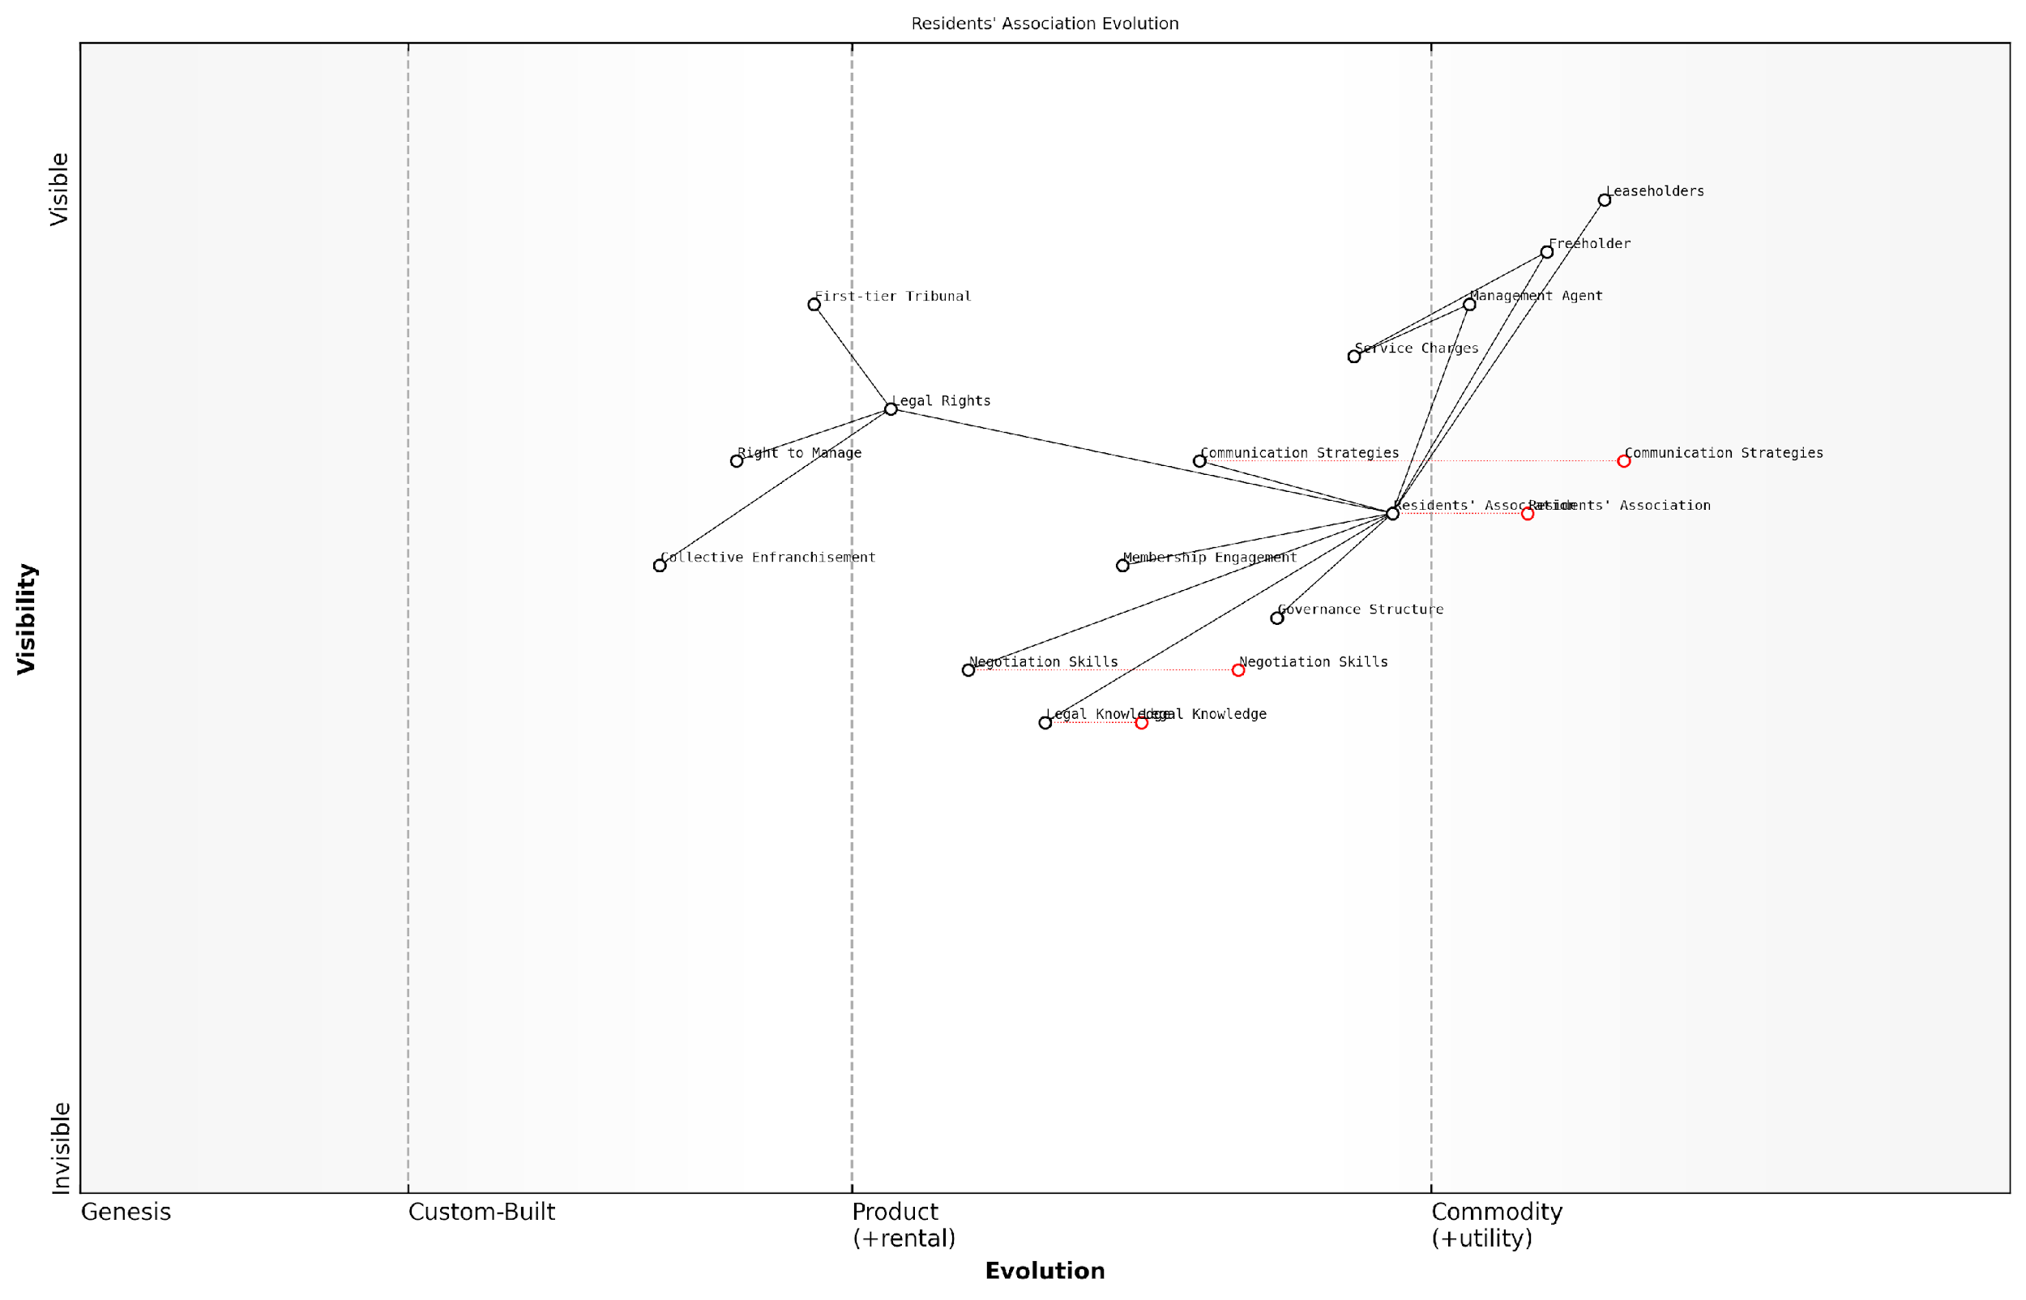

*Draft Wardley Map: [Insert Wardley Map: Running an effective residents’ association]*

[Edit this draft Wardley Map](https://create.wardleymaps.ai/#clone:d0fd244da02ca31d84)

Wardley Map Assessment

The Wardley Map reveals a residents’ association poised for significant evolution and potential disruption of traditional leasehold management. By focusing on developing legal knowledge, negotiation skills, and leveraging strong communication strategies, the association can significantly enhance its position. The map suggests a future where residents’ associations become more professionalised and influential, potentially leading to widespread adoption of right-to-manage or collective enfranchisement models. To capitalise on this potential, the association should prioritise capability development, strategic partnerships, and technological innovation, while maintaining strong member engagement. This approach could not only benefit the specific association but could also contribute to broader changes in the leasehold system.

[View full Wardley Map report](https://github.com/tractorjuice/automated_wardley_reports/blob/main/markdown_wardley_map_reports/wardley_map_report_36_Running_an_effective_residents'_association.md)

## The Right to Manage (RTM)

### Understanding the RTM process

The Right to Manage (RTM) process is a crucial tool for leaseholders seeking to take control of their property management from ineffective or unscrupulous managing agents. As an expert in leasehold reform, I cannot overstate the importance of understanding this process thoroughly. RTM empowers leaseholders to collectively manage their building, potentially leading to improved services, reduced costs, and greater transparency.

Let’s delve into the key aspects of the RTM process, breaking it down into manageable steps and highlighting critical considerations along the way.

1. Initial Assessment and Preparation

* Confirm eligibility: Ensure your building meets the criteria set out in the Commonhold and Leasehold Reform Act 2002.
* Gauge interest: Conduct informal discussions with fellow leaseholders to assess support for RTM.
* Form a steering committee: Establish a core group of committed leaseholders to drive the process forward.

1. Formation of the RTM Company

* Incorporate the company: Register a private company limited by guarantee with Companies House.
* Adopt prescribed articles: Ensure the company’s articles of association comply with RTM regulations.
* Appoint directors: Select responsible leaseholders to serve as company directors.

The formation of the RTM company is a critical step that requires meticulous attention to detail. As a senior property lawyer once told me, ‘Get this wrong, and you may have to start the entire process from scratch.’

1. Serving the Claim Notice

* Prepare the claim notice: Draft a formal notice using the prescribed form, detailing the RTM company’s intention to acquire the right to manage.
* Identify all parties: Ensure the notice is served on the landlord, any intermediate landlords, and the current managing agent.
* Serve the notice: Use a reliable method of service and keep proof of delivery.

1. Handling the Counter-Notice Period

* Wait for response: The landlord has one month to serve a counter-notice.
* Address objections: If the landlord objects, consider their grounds carefully and seek legal advice if necessary.
* Prepare for tribunal: If objections cannot be resolved, be ready to apply to the First-tier Tribunal (Property Chamber) for a determination.

1. Acquisition of Management Functions

* Set the acquisition date: This is typically three months after the claim notice date, assuming no objections.
* Request information: Formally request all necessary management information from the current managing agent.
* Prepare for handover: Establish systems and processes for taking over management responsibilities.

A seasoned RTM consultant once remarked, ‘The transition period is where the real work begins. Preparation is key to a smooth handover of management responsibilities.’

1. Post-Acquisition Management

* Implement new management structures: Set up efficient systems for handling maintenance, finances, and communications.
* Engage with leaseholders: Maintain transparent communication and involve the wider leaseholder community in decision-making.
* Review and optimise: Regularly assess the effectiveness of your management and make improvements where necessary.

Throughout the RTM process, it’s crucial to maintain meticulous records and adhere strictly to legal requirements. The process can be complex, and even small errors can lead to significant delays or failure of the RTM claim.

It’s worth noting that while RTM can be a powerful tool for leaseholders, it also comes with significant responsibilities. The RTM company directors must be prepared to take on the legal and practical obligations of managing the property effectively.

As a prominent leasehold reform advocate often says, ‘RTM is not just about taking control; it’s about being prepared to do a better job than your current managing agent.’

In my experience advising numerous RTM companies, I’ve observed that success often hinges on three key factors: thorough preparation, clear communication among leaseholders, and a realistic understanding of the responsibilities involved. Leaseholders who approach RTM with these principles in mind are far more likely to achieve positive outcomes and create a more harmonious living environment.

Understanding the RTM process is just the beginning. As we’ll explore in the next subsection, there are specific qualifying criteria and potential obstacles that leaseholders must navigate. By mastering the RTM process and being aware of these challenges, leaseholders can take a significant step towards tackling excessive service charges and poor management in their leasehold properties.

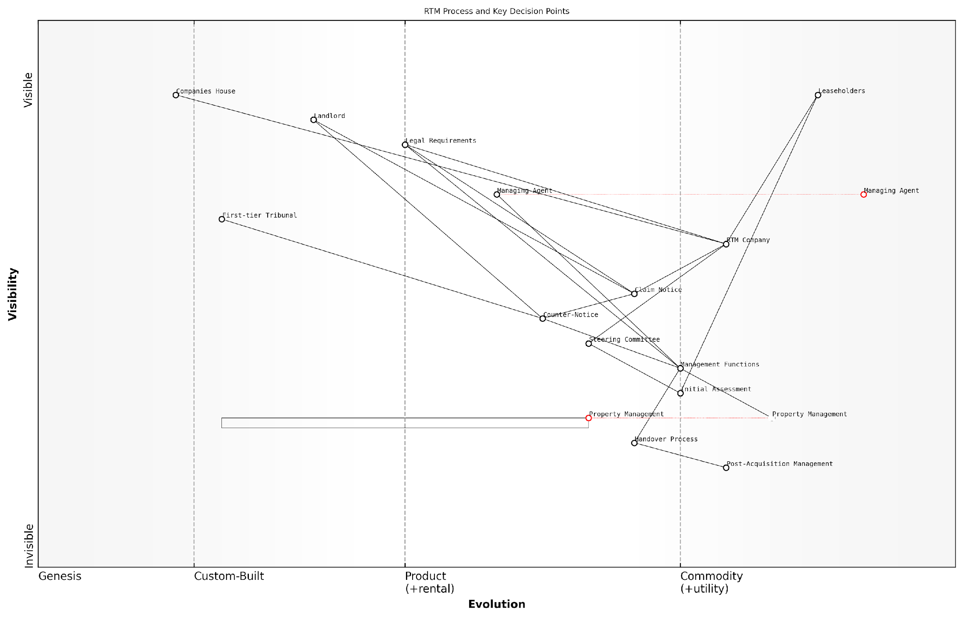

*Draft Wardley Map: [Insert Wardley Map: Understanding the RTM process]*

[Edit this draft Wardley Map](https://create.wardleymaps.ai/#clone:531c4c1e90e20088c2)

Wardley Map Assessment

The Wardley Map reveals a system in transition, with significant opportunities for innovation in property management and process streamlining. The RTM process, while complex, offers a clear path for leaseholder empowerment. Strategic focus should be on simplifying the legal and administrative processes while investing in advanced property management capabilities. The evolving nature of key components suggests that early movers in modernising RTM practices could gain significant advantages. Collaboration and technology adoption will be key to maximising the benefits for leaseholders and establishing efficient, effective RTM Companies.

[View full Wardley Map report](https://github.com/tractorjuice/automated_wardley_reports/blob/main/markdown_wardley_map_reports/wardley_map_report_37_Understanding_the_RTM_process.md)

### Qualifying criteria and potential obstacles

The Right to Manage (RTM) process offers leaseholders a powerful tool to take control of their property management, but it comes with specific qualifying criteria and potential obstacles that must be carefully navigated. As an expert in leasehold reform, I’ve guided numerous leaseholder groups through this process, and I can attest to its transformative potential when executed correctly. However, it’s crucial to understand the intricacies of RTM qualification to avoid costly missteps and ensure a successful transition.

Let’s delve into the key qualifying criteria for RTM and explore the potential obstacles that leaseholders may encounter along the way.

Qualifying Criteria:

* Building Type: The property must be a self-contained building or part of a building with or without appurtenant property.
* Residential Requirement: At least two-thirds of the flats in the building must be let to qualifying tenants.
* Commercial Space Limitation: The total internal floor area of any non-residential parts must not exceed 25% of the total internal floor area of the building.
* Qualifying Tenants: Leaseholders must have long leases (originally granted for more than 21 years).
* Participation Threshold: The RTM claim must be supported by at least 50% of the qualifying tenants in the building.

These criteria are established by the Commonhold and Leasehold Reform Act 2002, which provides the legal framework for RTM. It’s essential to conduct a thorough assessment of your building and leaseholders against these criteria before initiating the RTM process.

In my experience, the most successful RTM claims are those where leaseholders have meticulously verified their eligibility before proceeding. It’s not just about meeting the legal requirements; it’s about building a strong foundation for collective management.

Potential Obstacles:

* Complex Building Structures: Mixed-use developments or buildings with intricate layouts may struggle to meet the commercial space limitation.
* Leaseholder Apathy: Achieving the 50% participation threshold can be challenging if leaseholders are disengaged or absent.
* Freeholder Opposition: Some freeholders may contest the RTM claim, leading to tribunal proceedings.
* Incomplete or Inaccurate Information: Errors in lease details or floor area calculations can derail an RTM application.
* Management Contracts: Existing long-term management contracts may complicate the transition process.
* Financial Constraints: The costs associated with setting up an RTM company and potential legal fees can be a barrier for some leaseholder groups.

Navigating these obstacles requires a strategic approach and often benefits from professional guidance. In my consultancy work, I’ve observed that early identification of potential hurdles allows leaseholder groups to develop proactive solutions.

One senior property lawyer I’ve collaborated with aptly noted, ‘The RTM process is as much about community building as it is about legal compliance. Success often hinges on the ability to unite leaseholders behind a common vision.’

To overcome these obstacles, consider the following strategies:

* Conduct a thorough building survey and lease review to ensure all criteria are met before initiating the RTM process.
* Engage in extensive communication and education efforts to secure leaseholder participation and support.
* Seek early legal advice to anticipate and address potential challenges from the freeholder.
* Establish a clear financial plan, including provisions for professional fees and potential tribunal costs.
* Build relationships with key stakeholders, including managing agents and commercial tenants, to facilitate a smooth transition.

It’s worth noting that recent government proposals aim to reform the RTM process, potentially simplifying some of these criteria and reducing obstacles. As of my latest review, these reforms are still under consideration, but they signal a positive direction for leaseholder empowerment.

In conclusion, while the qualifying criteria and potential obstacles for RTM may seem daunting, they are not insurmountable. With careful planning, community engagement, and sometimes professional support, leaseholder groups can successfully navigate the RTM process. The rewards of taking control of your property management can be significant, often leading to improved service quality, more transparent financial management, and a stronger sense of community among leaseholders.

As one RTM company director shared with me, ‘The process was challenging, but the sense of empowerment and control we now have over our building’s management is invaluable. It’s transformed our living experience.’

By understanding and preparing for both the qualifying criteria and potential obstacles, leaseholders can approach the RTM process with confidence, setting the stage for a more responsive and efficient management structure for their homes.

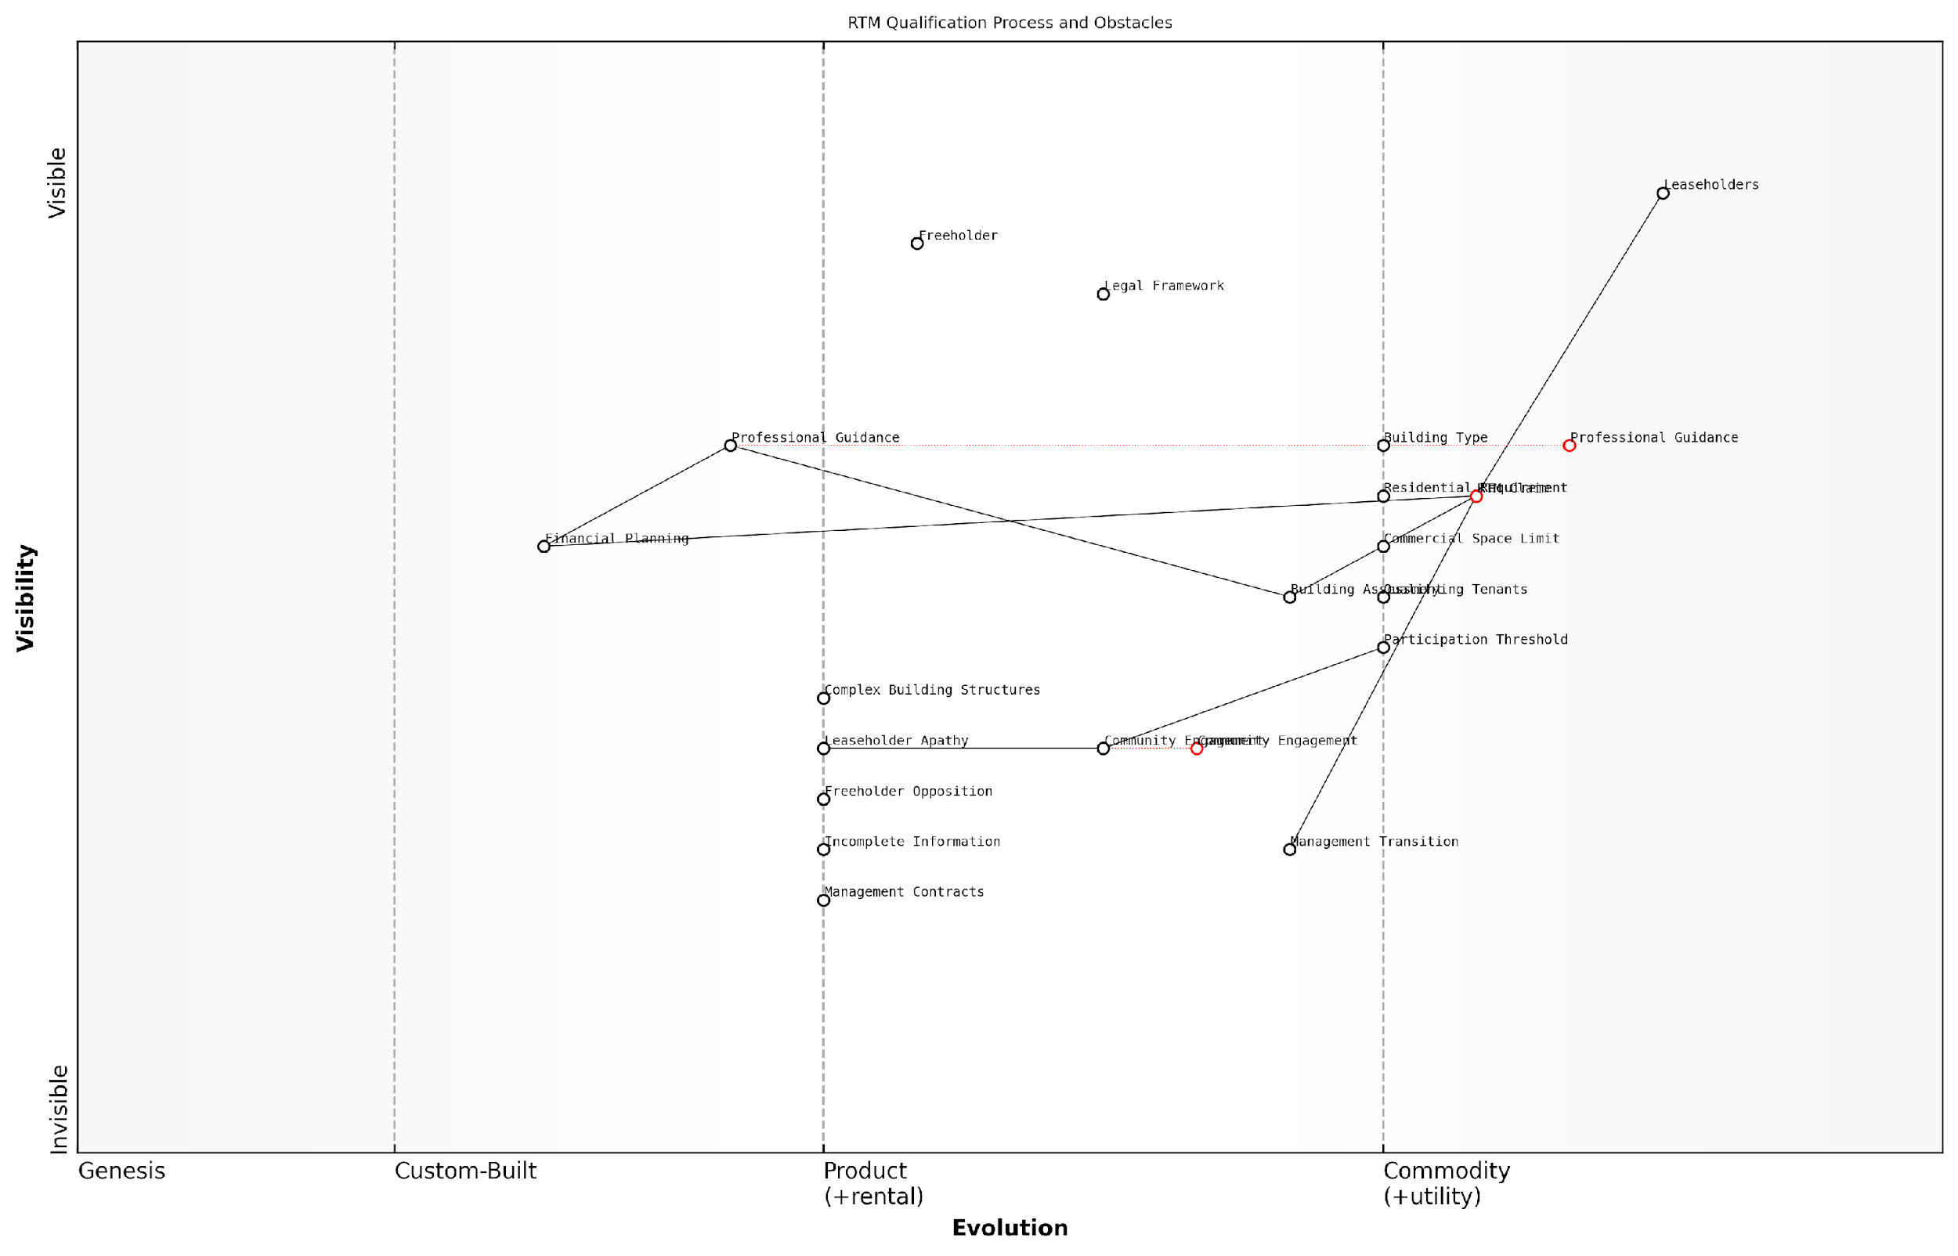

*Draft Wardley Map: [Insert Wardley Map: Qualifying criteria and potential obstacles]*

[Edit this draft Wardley Map](https://create.wardleymaps.ai/#clone:7730055e154d2cde5f)

Wardley Map Assessment

This Wardley Map reveals a RTM process that is evolving towards greater standardisation and efficiency, but still faces significant obstacles and complexities. The strategic focus should be on accelerating the evolution of key components like RTM Claim and Community Engagement, while simultaneously developing innovative solutions to address Potential Obstacles. The integration of digital technologies and data-driven approaches presents significant opportunities for improving the entire process. By prioritising these areas, stakeholders can create a more streamlined, accessible, and successful RTM implementation framework, ultimately empowering leaseholders and transforming property management practices.

[View full Wardley Map report](https://github.com/tractorjuice/automated_wardley_reports/blob/main/markdown_wardley_map_reports/wardley_map_report_38_Qualifying_criteria_and_potential_obstacles.md)

### Setting up and running an RTM company

The Right to Manage (RTM) process empowers leaseholders to take control of their property management, addressing issues of excessive service charges and poor management. Setting up and running an RTM company is a crucial step in this process, requiring careful planning, execution, and ongoing management. This section will guide you through the intricacies of establishing and operating an RTM company, drawing from best practices and real-world experiences.

Before delving into the specifics, it’s important to understand that an RTM company is a limited company with a specific purpose: to manage the building on behalf of the leaseholders. This structure provides legal protection and a framework for collective decision-making, but it also comes with responsibilities and potential challenges.

Let’s break down the process into key stages:

* Formation of the RTM company
* Serving the RTM notice
* Transition of management responsibilities
* Ongoing management and governance

1. Formation of the RTM company

The first step in setting up an RTM company is its formal incorporation. This involves:

* Choosing a company name (typically including ‘RTM Company Limited’)
* Appointing initial directors (usually from among the participating leaseholders)
* Drafting and adopting the company’s articles of association
* Registering the company with Companies House

It’s crucial to ensure that the company’s articles align with the requirements set out in the Commonhold and Leasehold Reform Act 2002. These articles should clearly define the company’s purpose, membership criteria, and decision-making processes.

A seasoned property lawyer emphasises, ‘The articles of association are the backbone of your RTM company. They must be carefully drafted to ensure compliance with legislation and to provide a robust framework for future operations.’

1. Serving the RTM notice

Once the RTM company is formed, the next step is to serve the RTM notice on the landlord and any other relevant parties. This formal notice declares the leaseholders’ intention to exercise their right to manage. Key considerations include:

* Ensuring the notice contains all required information as per the legislation
* Serving the notice in the prescribed manner
* Preparing for potential counter-notices or challenges from the landlord

1. Transition of management responsibilities

Assuming the RTM process is successful, the RTM company will need to prepare for the transition of management responsibilities. This stage involves:

* Obtaining all relevant documentation from the current managing agent
* Setting up financial systems and bank accounts
* Establishing relationships with service providers and contractors
* Communicating the change to all leaseholders and addressing any concerns

A property management expert advises, ‘The transition period is critical. Thorough preparation and clear communication can make the difference between a smooth handover and a chaotic one.’

1. Ongoing management and governance

Running an RTM company is an ongoing responsibility that requires dedication and effective governance. Key aspects include:

* Regular board meetings and annual general meetings
* Financial management, including budgeting and collection of service charges
* Property maintenance and improvement planning
* Compliance with company law and leasehold regulations
* Effective communication with all leaseholders

It’s important to note that while the RTM company takes on management responsibilities, it does not become the freeholder. The relationship with the freeholder continues, albeit in a different capacity.

One of the most significant challenges in running an RTM company is maintaining engagement and participation from leaseholders. Unlike a professional management company, an RTM company relies on the voluntary efforts of its members. Strategies to address this include:

* Regular updates and transparent communication
* Subcommittees for specific tasks or projects
* Training and support for directors and active members
* Consideration of professional support for certain aspects of management

A long-standing RTM company director shares, ‘The key to our success has been fostering a sense of community ownership. When leaseholders feel truly invested in the management of their building, they’re more likely to contribute their time and skills.’

While setting up and running an RTM company can be challenging, many leaseholders find it rewarding. It provides direct control over service charges, maintenance standards, and overall property management. However, it’s crucial to approach the process with a clear understanding of the responsibilities involved and a commitment to ongoing engagement and good governance.

In conclusion, the RTM process offers a powerful tool for leaseholders to address issues of excessive service charges and poor management. By carefully navigating the setup process and maintaining strong governance practices, an RTM company can significantly improve the living experience for all leaseholders while potentially reducing costs and improving property values.

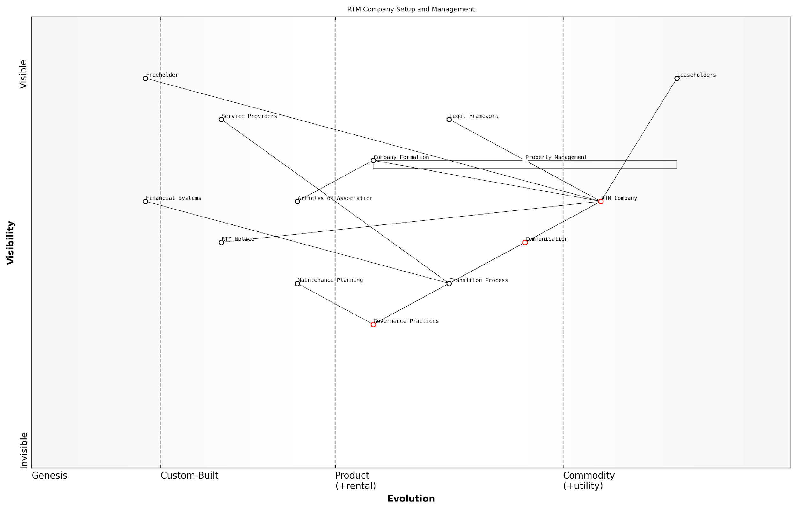

*Draft Wardley Map: [Insert Wardley Map: Setting up and running an RTM company]*

[Edit this draft Wardley Map](https://create.wardleymaps.ai/#clone:dde89195e61d206d39)

Wardley Map Assessment

The Wardley Map reveals a maturing ecosystem for RTM companies, with significant opportunities for innovation and standardization. The central position of the RTM Company component suggests a strong foundation, but there’s room for optimization in governance, financial systems, and communication. By focusing on these areas, RTM companies can enhance their efficiency, reduce costs for leaseholders, and potentially disrupt the traditional property management industry. The evolving nature of key components indicates a dynamic sector with potential for significant improvements in service delivery and leaseholder satisfaction over the coming years.

[View full Wardley Map report](https://github.com/tractorjuice/automated_wardley_reports/blob/main/markdown_wardley_map_reports/wardley_map_report_39_Setting_up_and_running_an_RTM_company.md)

## Collective Enfranchisement

### The benefits and challenges of buying the freehold

Collective enfranchisement, the process by which leaseholders come together to purchase the freehold of their building, represents a significant opportunity for empowerment and control over one’s property. This section explores the multifaceted benefits and challenges associated with this process, providing leaseholders with a comprehensive understanding of what buying the freehold entails within the context of tackling excessive service charges and poor management in England.

The decision to pursue collective enfranchisement is not one to be taken lightly, as it involves complex legal procedures, financial considerations, and collective decision-making. However, for many leaseholders, the potential benefits far outweigh the challenges, offering a path to greater autonomy and long-term financial security.

Let’s delve into the key advantages and potential hurdles of buying the freehold:

* Benefits of Collective Enfranchisement
* Challenges and Considerations
* Financial Implications
* Legal Process and Requirements
* Post-Enfranchisement Management

Benefits of Collective Enfranchisement:

* Control over service charges and management decisions
* Potential to extend lease terms or grant new 999-year leases
* Increased property value and marketability
* Ability to appoint preferred managing agents or self-manage
* Freedom to make alterations to the building (subject to planning permissions)
* Elimination of ground rent payments

One of the most significant advantages of buying the freehold is the control it affords leaseholders over service charges and management decisions. As a senior property lawyer once remarked, ‘Collective enfranchisement puts the power back into the hands of those who have the most vested interest in the property – the leaseholders themselves.’

Owning the freehold allows leaseholders to break free from the cycle of excessive service charges and subpar management, creating a more transparent and efficient system that serves their interests.

Challenges and Considerations:

* Securing agreement and participation from qualifying leaseholders
* Raising sufficient funds for the purchase and associated costs
* Navigating complex legal procedures and potential disputes
* Managing diverse opinions and expectations within the leaseholder group
* Potential resistance from the existing freeholder
* Ongoing responsibilities of freehold ownership and management

While the benefits are substantial, the challenges of collective enfranchisement should not be underestimated. A property management expert with extensive experience in leasehold enfranchisement cases noted, ‘The process requires patience, unity, and a willingness to invest time and resources. However, for those who persevere, the rewards can be transformative.’

Financial Implications:

The financial aspects of buying the freehold are multifaceted and require careful consideration. Costs typically include:

* The premium for the freehold purchase
* Legal and valuation fees
* Stamp Duty Land Tax (SDLT)
* Potential tribunal costs if disputes arise
* Ongoing maintenance and management costs post-purchase

It’s crucial to conduct a thorough cost-benefit analysis, considering both short-term expenses and long-term savings. Many leaseholders find that the initial investment is offset by the elimination of ground rent, control over service charges, and potential increase in property value.

While the upfront costs can be significant, collective enfranchisement often proves to be a sound financial decision in the long run, offering protection against escalating ground rents and excessive service charges.

Legal Process and Requirements:

The legal process of collective enfranchisement is governed by the Leasehold Reform, Housing and Urban Development Act 1993, as amended. Key requirements include:

* At least 50% of qualifying tenants must participate
* The building must contain two or more flats
* No more than 25% of the building can be in non-residential use
* Qualifying tenants must have leases originally granted for more than 21 years

The process involves serving an Initial Notice on the freeholder, followed by negotiations or, if necessary, an application to the First-tier Tribunal (Property Chamber) to determine the terms of acquisition. It’s essential to engage experienced legal professionals to navigate this complex procedure effectively.

Post-Enfranchisement Management:

Once the freehold is acquired, leaseholders must be prepared for the responsibilities of ownership. This typically involves:

* Setting up a company to own and manage the freehold
* Deciding on management structure (self-management or professional management)
* Establishing fair and transparent service charge systems
* Maintaining the building and common areas
* Ensuring compliance with relevant regulations and insurance requirements

Effective post-enfranchisement management is crucial to realising the full benefits of freehold ownership. As one property management consultant advised, ‘The key to successful freehold ownership lies in clear communication, fair decision-making processes, and a commitment to maintaining the property to high standards.’

In conclusion, while collective enfranchisement presents significant challenges, it offers a powerful solution to the issues of excessive service charges and poor management that plague many leasehold properties. By taking control of the freehold, leaseholders can create a more equitable, efficient, and responsive system of property management that serves their interests and enhances the value of their homes.

Collective enfranchisement is more than just a legal process; it’s a transformative journey that empowers leaseholders to shape the future of their living environment and investment.

As the leasehold reform movement gains momentum in England, collective enfranchisement stands as a testament to the power of collective action in addressing systemic issues within the property market. For those willing to navigate its complexities, it offers a path to greater autonomy, financial security, and a more harmonious living environment.

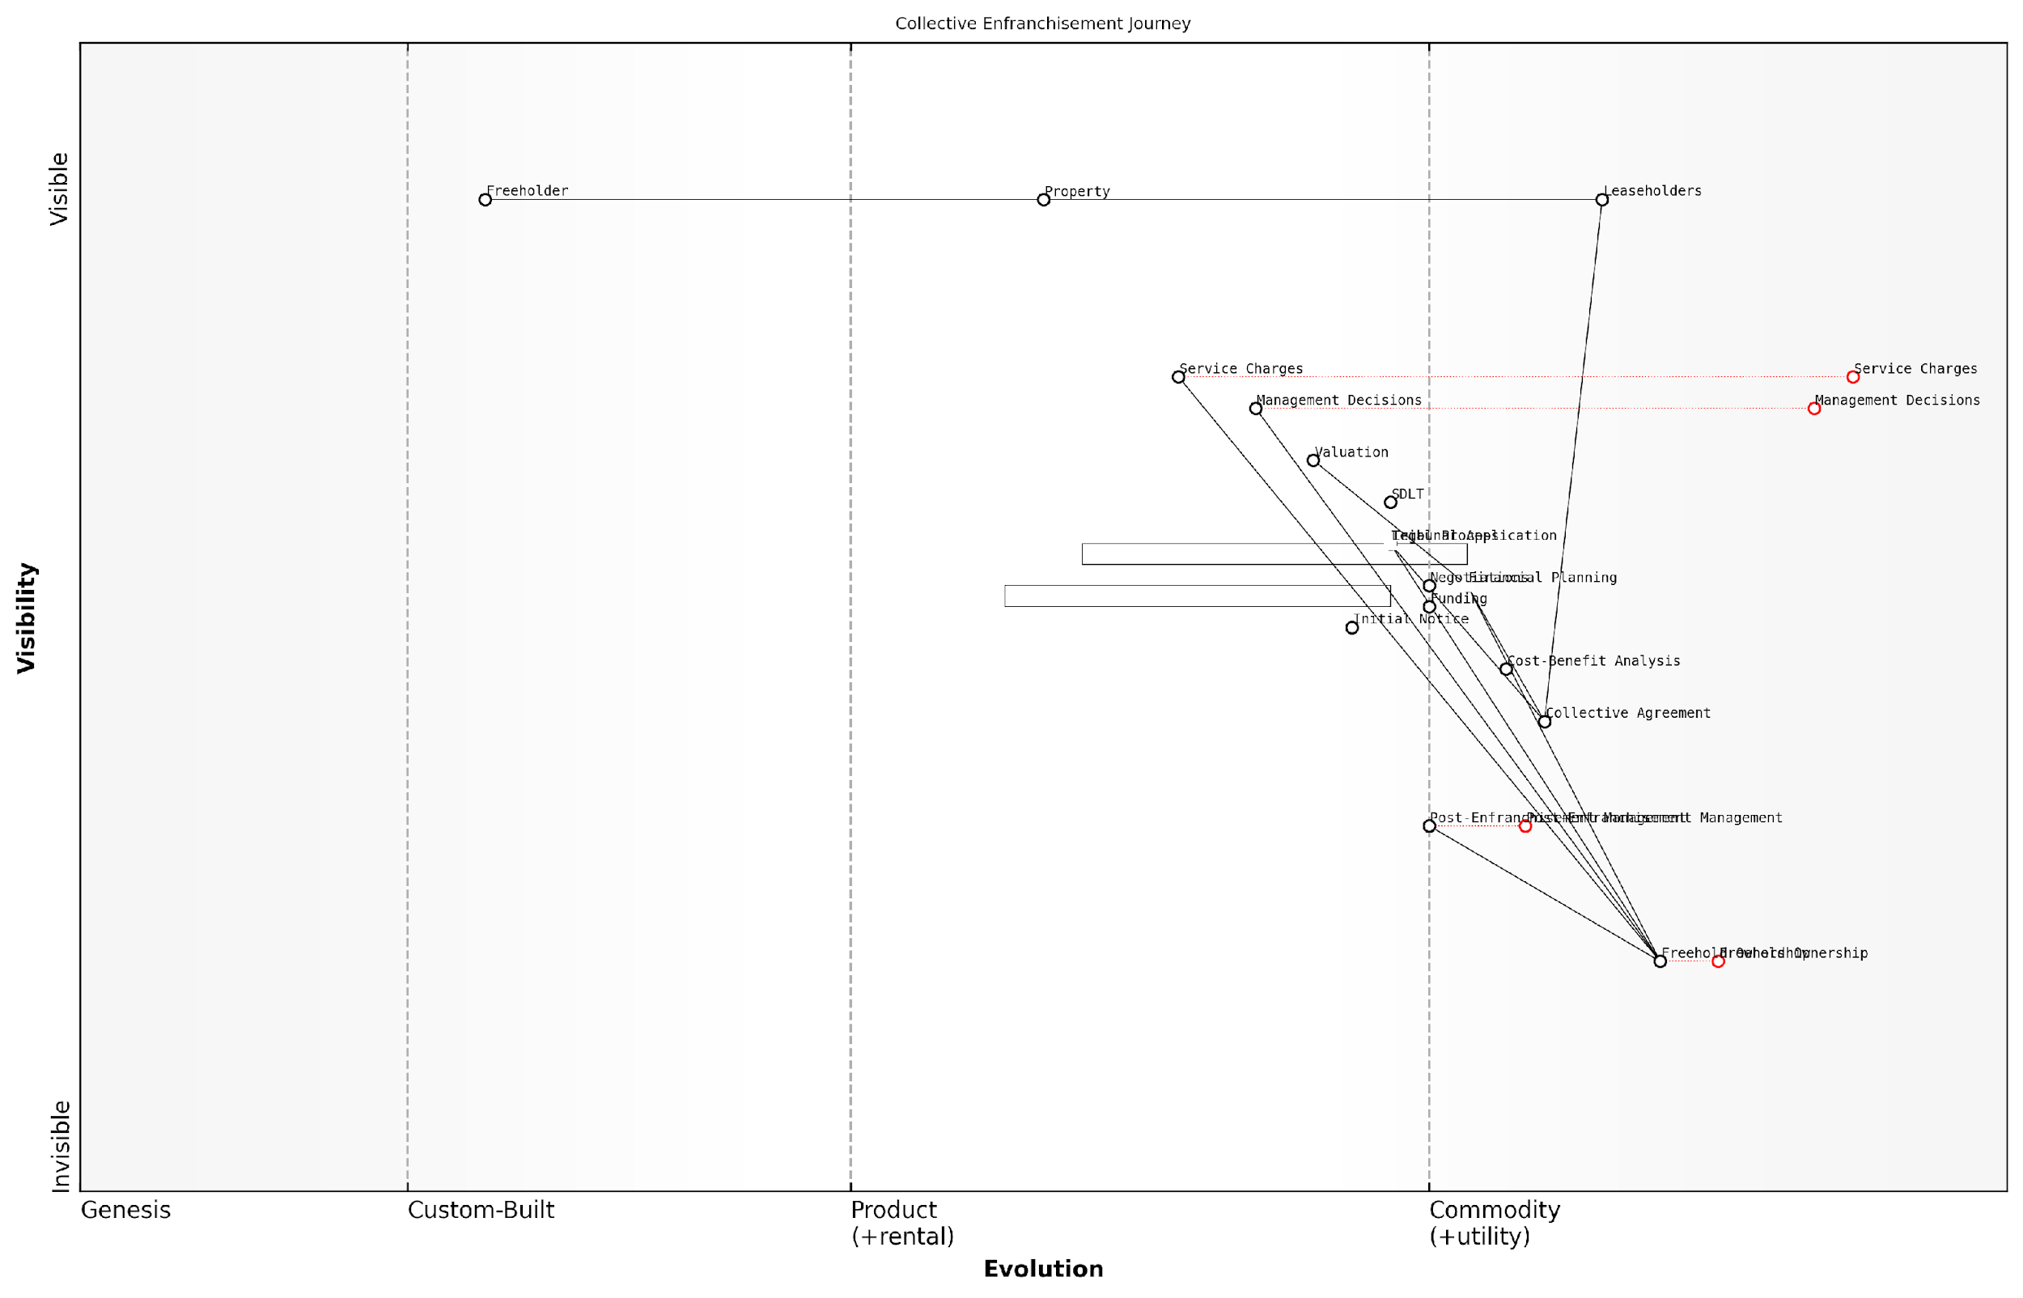

*Draft Wardley Map: [Insert Wardley Map: The benefits and challenges of buying the freehold]*

[Edit this draft Wardley Map](https://create.wardleymaps.ai/#clone:63b6cef6e3d11fdfd7)

Wardley Map Assessment

This Wardley Map reveals a well-structured but complex journey for leaseholders pursuing collective enfranchisement. The strategic position is strong, with clear value flow and evolution paths. However, there are significant opportunities for innovation, particularly in digitizing processes and improving post-enfranchisement management. The key to success lies in streamlining the critical path from Collective Agreement through Legal Process and Financial Planning to Freehold Ownership, while simultaneously preparing for the challenges of Post-Enfranchisement Management. By focusing on these areas and leveraging emerging technologies, stakeholders can significantly improve the efficiency and success rate of collective enfranchisement efforts.

[View full Wardley Map report](https://github.com/tractorjuice/automated_wardley_reports/blob/main/markdown_wardley_map_reports/wardley_map_report_40_The_benefits_and_challenges_of_buying_the_freehold.md)

### Eligibility and process overview

Collective enfranchisement is a powerful tool for leaseholders seeking to gain control over their property and tackle issues of excessive service charges and poor management. This process allows qualifying leaseholders to collectively purchase the freehold of their building, effectively becoming their own landlords. Understanding the eligibility criteria and process is crucial for leaseholders considering this option as a means to address longstanding issues with their leasehold properties.

Eligibility for Collective Enfranchisement:

* The building must contain at least two flats
* At least two-thirds of the flats must be held by qualifying tenants
* No more than 25% of the building’s floor area can be in non-residential use
* At least half of the qualifying tenants must participate in the enfranchisement

A ‘qualifying tenant’ is typically a leaseholder with a lease originally granted for more than 21 years. It’s important to note that leaseholders with multiple flats in the building can only count as qualifying tenants for up to three flats.

The Process Overview:

* Initial assessment and leaseholder agreement
* Formation of a nominee purchaser (usually a company)
* Valuation of the freehold
* Serving the Initial Notice on the freeholder
* Freeholder’s Counter-Notice
* Negotiation and possible tribunal proceedings
* Completion of the purchase

The initial assessment is crucial. Leaseholders must carefully evaluate their eligibility and the potential costs involved. This often requires professional advice from surveyors and solicitors experienced in leasehold enfranchisement. The formation of a nominee purchaser, typically a limited company, is essential to manage the process and hold the freehold post-acquisition.

Collective enfranchisement can be a complex and time-consuming process, but for many leaseholders, it’s the ultimate solution to ongoing issues with service charges and management. It puts the power back in the hands of the residents.

Valuation is a critical step. The price of the freehold is determined by a statutory formula, but can be subject to negotiation. Factors influencing the price include the property’s value, the remaining lease terms, and any potential development value. Leaseholders should be prepared for significant upfront costs, including the purchase price, professional fees, and potential tribunal costs.

The formal process begins with serving the Initial Notice on the freeholder. This document must be meticulously prepared, as errors can invalidate the claim. The freeholder then has two months to serve a Counter-Notice, either accepting the claim or proposing alternative terms. Negotiations often follow, and if agreement cannot be reached, the matter may proceed to the First-tier Tribunal (Property Chamber) for determination.

Throughout this process, clear communication and unity among participating leaseholders is paramount. Disagreements or withdrawals can jeopardise the entire claim. It’s advisable to establish a clear decision-making structure and maintain regular updates to all participants.

The key to successful collective enfranchisement lies in thorough preparation, professional guidance, and strong leaseholder cohesion. It’s not just about buying a freehold; it’s about creating a new management structure that serves the interests of all residents.

Post-enfranchisement, leaseholders face new responsibilities. The nominee purchaser company must be properly managed, complying with company law and managing the building effectively. This often involves appointing directors, setting up proper financial systems, and potentially engaging professional managing agents. While challenging, this new arrangement allows leaseholders to directly control service charges, set reserve funds, and make decisions about the building’s management and maintenance.

It’s worth noting that recent and proposed leasehold reforms may impact the collective enfranchisement process. The UK government has indicated intentions to simplify the process and potentially reduce the qualifying criteria, which could make this option available to more leaseholders in the future.

In conclusion, while collective enfranchisement presents challenges, it offers a definitive solution to issues of excessive service charges and poor management. By understanding the eligibility criteria and process, leaseholders can make informed decisions about whether this path is right for their situation. With proper planning, professional advice, and collective determination, enfranchisement can transform the leasehold experience, empowering residents to take control of their homes and investments.

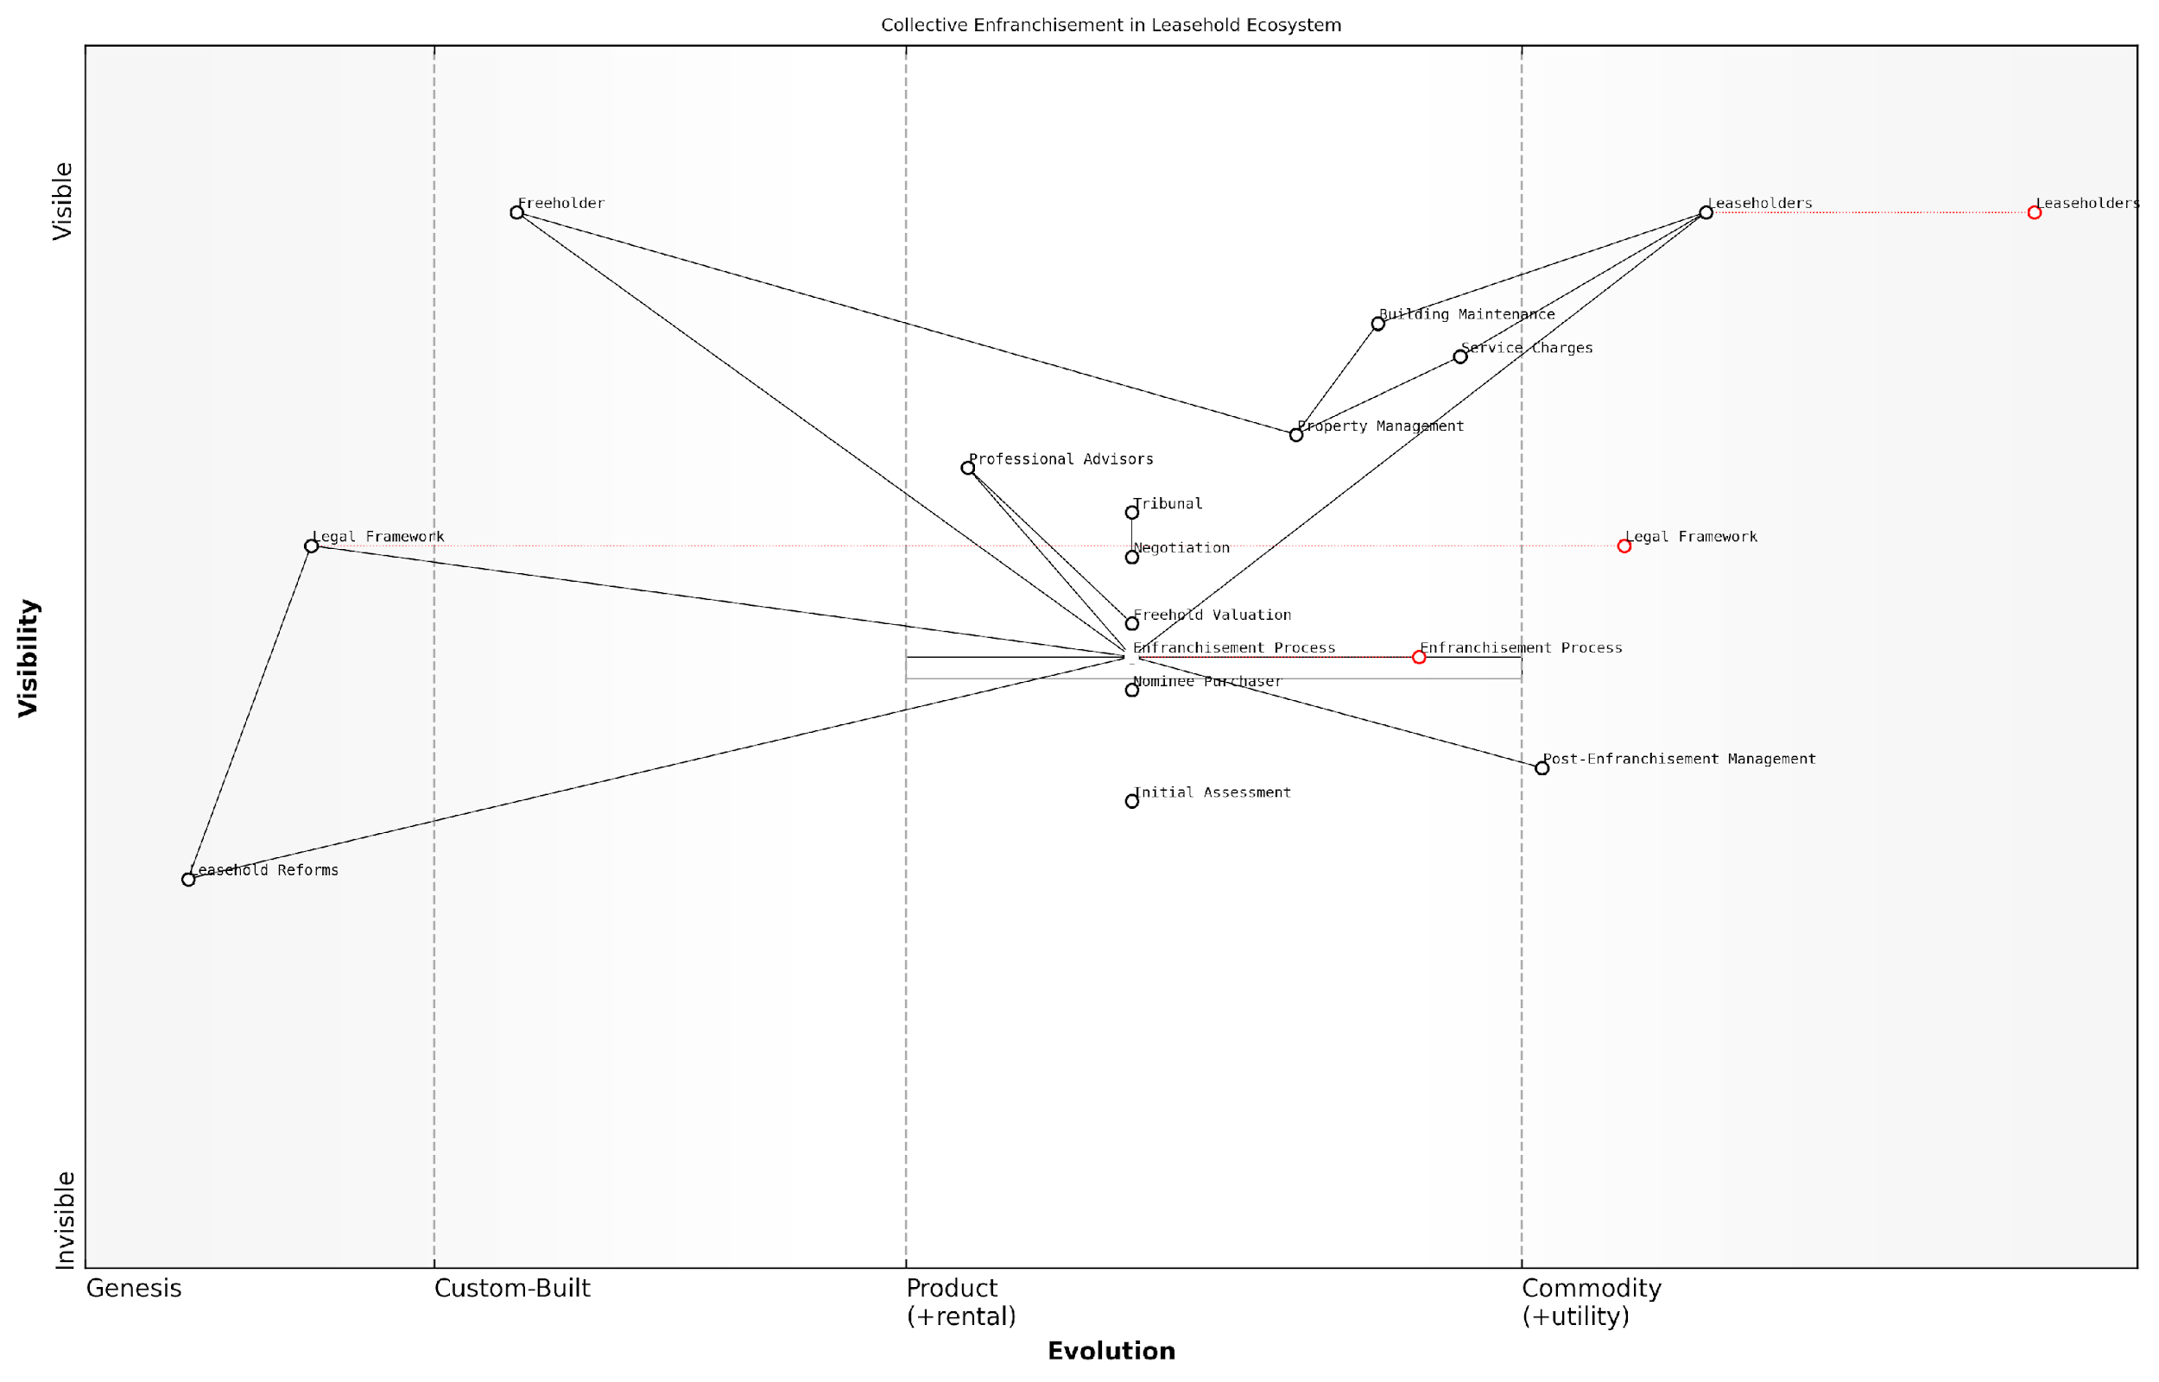

*Draft Wardley Map: [Insert Wardley Map: Eligibility and process overview]*

[Edit this draft Wardley Map](https://create.wardleymaps.ai/#clone:d455c923f52a5f2955)

Wardley Map Assessment

The Wardley Map reveals a leasehold ecosystem in transition, with significant opportunities for innovation in the Enfranchisement Process. The strategic focus should be on empowering Leaseholders, streamlining the enfranchisement journey, and preparing for potential disruptions from Leasehold Reforms. By investing in process improvements, digital tools, and stakeholder education, organisations can position themselves advantageously in this evolving landscape. The key to success will be balancing the needs of all stakeholders while driving towards a more efficient, transparent, and fair system of collective enfranchisement.

[View full Wardley Map report](https://github.com/tractorjuice/automated_wardley_reports/blob/main/markdown_wardley_map_reports/wardley_map_report_41_Eligibility_and_process_overview.md)

### Managing your property post-enfranchisement

After successfully completing the collective enfranchisement process, leaseholders find themselves in a new and empowering position as joint freeholders. This transition, while liberating, comes with its own set of responsibilities and challenges. Effective management of the property post-enfranchisement is crucial for maintaining and potentially increasing the value of the building, ensuring harmonious relations among residents, and avoiding the very issues that may have prompted the enfranchisement in the first place.

To navigate this new terrain successfully, it’s essential to understand the key aspects of post-enfranchisement property management and implement best practices. Let’s explore the critical areas that demand attention and strategic planning.

1. Establishing a Management Structure

One of the first decisions the new freeholders must make is how to structure the management of the property. There are several options available, each with its own advantages and considerations:

* Self-management by the residents
* Appointing a professional managing agent
* A hybrid approach combining resident involvement and professional support

The choice often depends on the size of the property, the skills and time availability of the residents, and the complexity of the management tasks required. For smaller properties with engaged residents, self-management can be a cost-effective option. However, larger or more complex buildings may benefit from professional management to ensure compliance with regulations and efficient handling of maintenance issues.

In my experience advising newly enfranchised leaseholders, I’ve found that a hybrid approach often yields the best results. It allows residents to maintain control while benefiting from professional expertise in areas such as legal compliance and major works planning.

1. Financial Management and Budgeting

Effective financial management is crucial for the long-term success of the enfranchised property. This involves:

* Setting realistic service charges
* Creating and maintaining a reserve fund for major works
* Implementing transparent accounting practices
* Regular financial reporting to all freeholders

It’s important to strike a balance between keeping costs manageable for residents and ensuring sufficient funds for proper maintenance and improvements. Transparency in financial matters is key to maintaining trust among the freeholders and avoiding disputes.

1. Maintenance and Improvement Planning

Post-enfranchisement, the responsibility for maintaining and improving the property lies squarely with the new freeholders. Developing a comprehensive maintenance plan is essential, including:

* Regular property inspections
* Scheduled maintenance for building systems
* Long-term planning for major works
* Energy efficiency improvements

Proactive maintenance not only preserves the property’s value but can also lead to cost savings in the long run by preventing minor issues from escalating into major problems.

A senior property manager once told me, ‘The most successful enfranchised properties are those that plan for the future, not just react to the present.’ This wisdom has proven true time and again in my consultancy work.

1. Legal Compliance and Insurance

As freeholders, the group now bears responsibility for ensuring compliance with all relevant laws and regulations. This includes:

* Health and safety regulations
* Fire safety requirements
* Asbestos management (if applicable)
* Disability access provisions
* Data protection laws

Additionally, obtaining comprehensive building insurance and public liability coverage is crucial. Regular reviews of insurance policies ensure adequate protection as the property’s value and circumstances change over time.

1. Communication and Decision-Making Processes

Effective communication among freeholders is vital for smooth property management. Establishing clear decision-making processes helps prevent conflicts and ensures that all voices are heard. Consider implementing:

* Regular meetings with formal agendas and minutes
* A system for proposing and voting on major decisions
* Clear roles and responsibilities for any management committee members
* Channels for ongoing communication (e.g., newsletters, online platforms)

1. Managing Relationships with Leaseholders

In many cases, not all flat owners will have participated in the enfranchisement process. Managing relationships with remaining leaseholders requires tact and fairness. Key considerations include:

* Ensuring equal treatment in terms of service provision
* Clear communication about changes in management practices
* Offering opportunities for leaseholders to participate in decision-making where appropriate
* Handling lease extensions or potential enfranchisement for remaining leaseholders

1. Continuous Improvement and Adaptation

The landscape of property management and leasehold law is continually evolving. Successful post-enfranchisement management requires a commitment to ongoing learning and adaptation. This might involve:

* Regular training for management committee members
* Staying informed about changes in relevant laws and regulations
* Seeking professional advice when faced with complex issues
* Regularly reviewing and updating management practices

As a consultant in this field, I always advise my clients that post-enfranchisement management is a journey, not a destination. The most successful properties are those that view their management as an ongoing process of improvement and refinement.

In conclusion, managing your property post-enfranchisement presents both opportunities and challenges. By focusing on establishing robust management structures, maintaining financial prudence, planning for maintenance and improvements, ensuring legal compliance, fostering effective communication, managing diverse stakeholder relationships, and committing to continuous improvement, newly enfranchised freeholders can create a positive living environment and protect their investment for years to come. The journey from leaseholder to freeholder is significant, and with careful management, it can lead to a more satisfying and valuable property ownership experience.

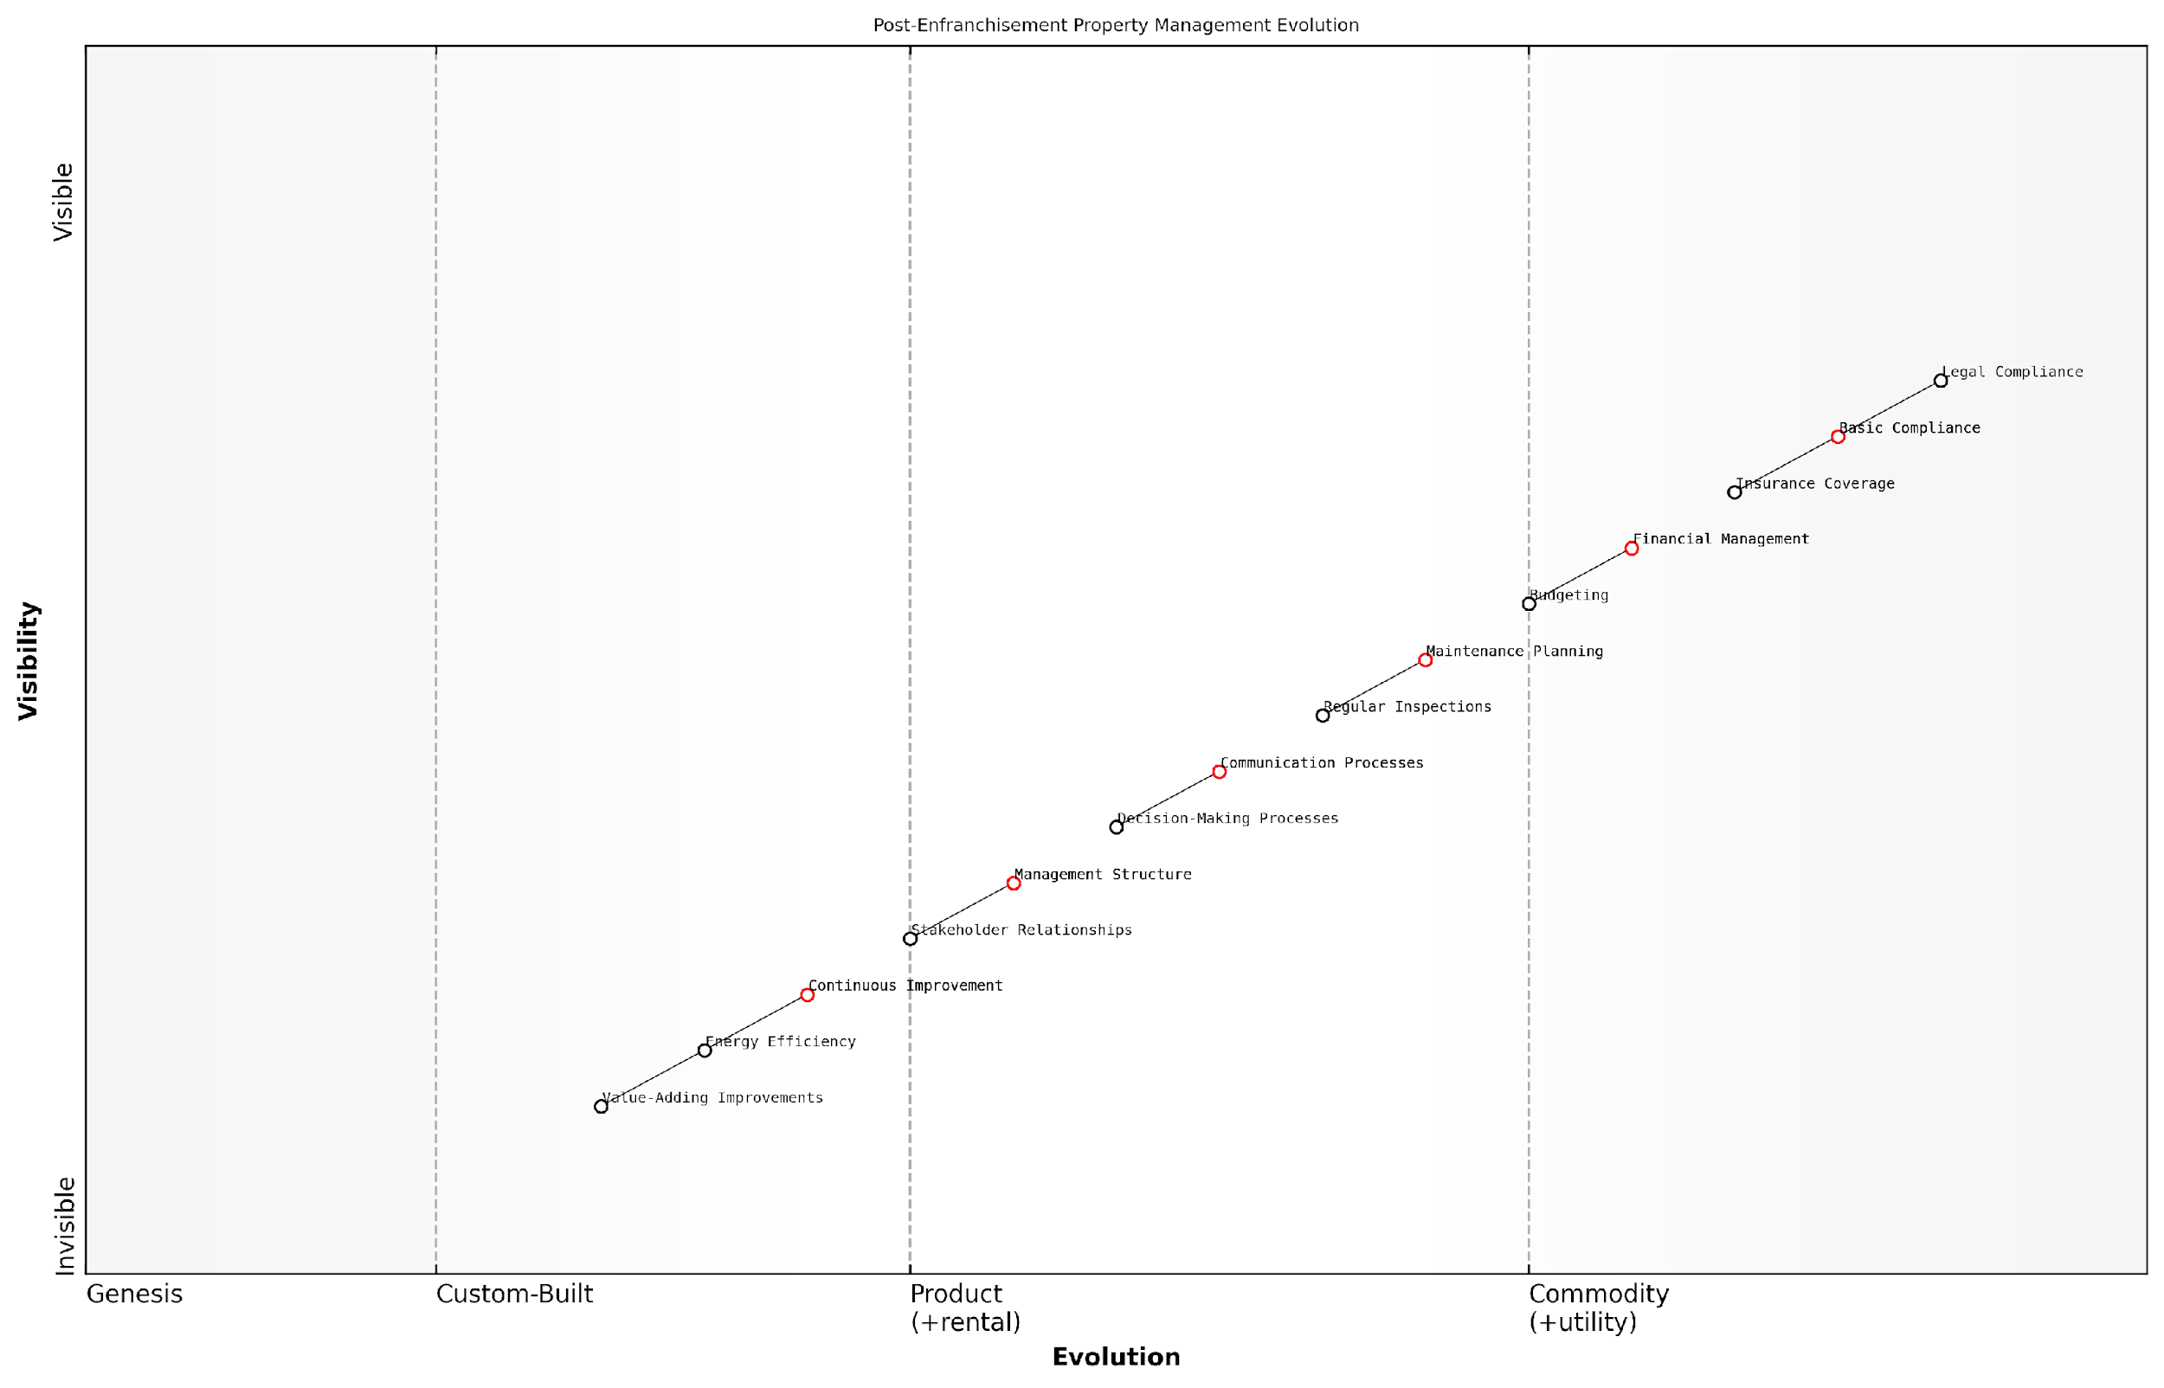

*Draft Wardley Map: [Insert Wardley Map: Managing your property post-enfranchisement]*

[Edit this draft Wardley Map](https://create.wardleymaps.ai/#clone:1af49aba2b55c040a3)

Wardley Map Assessment

This Wardley Map reveals a property management landscape in transition, moving from basic post-enfranchisement compliance to a more sophisticated, value-driven approach. The strategic focus should be on strengthening communication and decision-making processes while simultaneously developing capabilities in value-adding improvements and continuous innovation. By balancing immediate needs with long-term value creation, newly enfranchised leaseholders can transform their property management approach, potentially setting new standards in the industry.

[View full Wardley Map report](https://github.com/tractorjuice/automated_wardley_reports/blob/main/markdown_wardley_map_reports/wardley_map_report_42_Managing_your_property_post-enfranchisement.md)

# Advocacy and Reform: Shaping the Future of Leasehold

## Current Reform Initiatives

### Overview of proposed leasehold reforms

The landscape of leasehold property ownership in England is on the cusp of significant transformation. As an expert in this field, I can attest that the current reform initiatives represent the most comprehensive attempt to address long-standing issues faced by leaseholders, particularly concerning excessive service charges and poor management practices. These reforms are not merely incremental changes but rather a fundamental re-evaluation of the leasehold system itself.

The proposed reforms can be broadly categorised into several key areas, each aimed at addressing specific pain points within the current leasehold system:

* Leasehold enfranchisement and lease extension
* Ground rent abolition
* Right to Manage (RTM) improvements
* Commonhold revival
* Service charge and building safety reforms

Let’s delve into each of these areas to understand their implications for leaseholders and the broader property market.

Leasehold Enfranchisement and Lease Extension: The government has proposed significant changes to make it easier and more affordable for leaseholders to extend their leases or purchase their freehold. This includes:

* Standardising and reducing the cost of lease extensions and freehold purchases
* Extending the standard lease extension term from 90 years to 990 years
* Removing the requirement for leaseholders to have owned the property for two years before being eligible for enfranchisement

These changes aim to provide leaseholders with greater security and control over their properties, addressing the long-standing issue of diminishing lease terms and the associated costs.

Ground Rent Abolition: One of the most significant reforms is the proposed ban on ground rents for new leasehold properties. This measure, which has already been implemented for most new residential leases through the Leasehold Reform (Ground Rent) Act 2022, aims to eliminate a contentious aspect of leasehold ownership that has often been exploited by unscrupulous freeholders.

The abolition of ground rents for new leases is a watershed moment in leasehold reform. It removes a significant financial burden from future leaseholders and simplifies the leasehold structure.

Right to Manage (RTM) Improvements: The RTM process, which allows leaseholders to take over the management of their building, is set to become more accessible and effective. Proposed changes include:

* Extending RTM to leasehold houses, not just flats
* Allowing multi-building RTM on estates
* Removing the requirement for leaseholders to pay the landlord’s costs for the RTM process

These improvements aim to empower leaseholders to take control of their properties’ management, addressing issues of poor service and excessive charges more directly.

Commonhold Revival: The government has expressed a commitment to reinvigorate the commonhold system as an alternative to leasehold. This form of property ownership, which has been available since 2002 but rarely used, offers flat owners freehold ownership of their individual flats and shared ownership of common areas. Proposed measures include:

* Making commonhold the default for new-build flats
* Simplifying the process of converting existing leaseholds to commonhold
* Working with mortgage lenders to increase the availability of commonhold mortgages

The revival of commonhold represents a potential paradigm shift in flat ownership, offering a more equitable and transparent alternative to the leasehold system.

Service Charge and Building Safety Reforms: In light of the Grenfell Tower tragedy and ongoing concerns about building safety and management, several reforms are being proposed:

* Enhanced transparency and accountability in service charge management
* Stricter regulation of managing agents
* New safety obligations for building owners and managers
* A New Homes Ombudsman to address issues in newly built properties

These measures aim to address some of the most pressing concerns faced by leaseholders, particularly in terms of building safety and management quality.

The proposed reforms represent a once-in-a-generation opportunity to rebalance the relationship between leaseholders, freeholders, and managing agents. However, their success will depend on effective implementation and ongoing commitment from all stakeholders.

While these reforms offer significant promise, it’s important to note that many are still in the proposal stage and may undergo changes before becoming law. Moreover, the implementation timeline for some reforms remains uncertain, and there may be transitional challenges as the property market adapts to these new paradigms.

As an expert in this field, I believe that these reforms, if implemented effectively, have the potential to address many of the systemic issues that have plagued the leasehold system. However, leaseholders must remain vigilant and engaged throughout the reform process to ensure that their interests are adequately protected and that the spirit of these reforms is fully realised in practice.

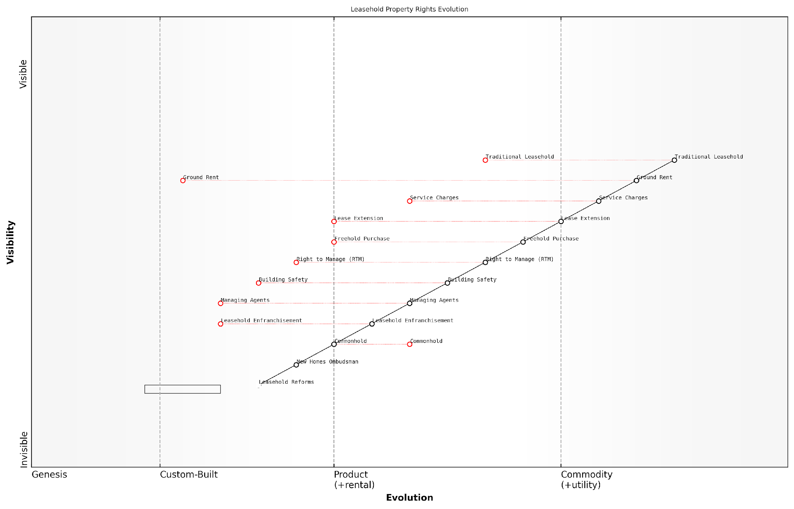

*Draft Wardley Map: [Insert Wardley Map: Overview of proposed leasehold reforms]*

[Edit this draft Wardley Map](https://create.wardleymaps.ai/#clone:c5d9aa8cc7222cfb5c)

Wardley Map Assessment

The Wardley Map reveals a leasehold property rights system in transition, with significant opportunities for reform and innovation. The strategic focus should be on accelerating the evolution of key components like Commonhold and Building Safety, while carefully managing the transition away from Traditional Leasehold structures. Success will require a balanced approach that addresses the needs of Property Owners while navigating the complexities of systemic change in a well-established industry.

[View full Wardley Map report](https://github.com/tractorjuice/automated_wardley_reports/blob/main/markdown_wardley_map_reports/wardley_map_report_43_Overview_of_proposed_leasehold_reforms.md)

### Key organisations driving change

In the complex landscape of leasehold reform in England, several key organisations are at the forefront of driving significant change. These entities, ranging from government bodies to grassroots campaigns, are instrumental in shaping the future of leasehold ownership and addressing the long-standing issues of excessive service charges and poor management practices.

The following subsections delve into the most influential organisations, their roles, and their impact on the ongoing reform initiatives:

1. Government Bodies and Regulatory Agencies

* Ministry of Housing, Communities and Local Government (MHCLG): As the primary government department responsible for housing policy, the MHCLG has been instrumental in proposing and implementing leasehold reforms. Their initiatives include the ban on new leasehold houses and the reduction of ground rents to zero for new leases.
* Law Commission: This independent body has produced extensive reports on leasehold reform, including recommendations for simplifying the process of lease extension and freehold acquisition.
* Competition and Markets Authority (CMA): The CMA has conducted investigations into the leasehold sector, particularly focusing on unfair practices and mis-selling of leasehold properties.

1. Advocacy Groups and Campaigns

* Leasehold Knowledge Partnership (LKP): A charitable organisation that provides advice and support to leaseholders while also lobbying for reform. LKP has been instrumental in bringing leasehold issues to the forefront of public and political attention.
* National Leasehold Campaign (NLC): A grassroots movement that has gained significant traction in recent years, focusing on raising awareness about leasehold injustices and pushing for legislative changes.
* Association of Leasehold Enfranchisement Practitioners (ALEP): While not strictly a campaign group, ALEP plays a crucial role in promoting best practices and professional standards in the leasehold sector.

1. Professional Bodies and Industry Associations

* Royal Institution of Chartered Surveyors (RICS): RICS has been actively involved in developing professional standards for managing agents and providing guidance on service charge best practices.
* Association of Residential Managing Agents (ARMA): As the leading trade association for residential managing agents, ARMA has been working to improve standards within the industry and contribute to the reform dialogue.
* The Property Ombudsman (TPO): While primarily focused on dispute resolution, TPO’s work has highlighted systemic issues in the leasehold sector, contributing to the case for reform.

1. All-Party Parliamentary Group on Leasehold and Commonhold Reform

This cross-party group of MPs and peers has been instrumental in keeping leasehold reform on the political agenda. They have conducted inquiries, published reports, and lobbied for legislative changes, acting as a bridge between grassroots campaigns and government action.

The combined efforts of these organisations have created unprecedented momentum for leasehold reform. As a senior policy advisor remarked, ‘We’re seeing a perfect storm of public awareness, political will, and industry recognition that the current system is no longer fit for purpose.’

1. Academic Institutions and Think Tanks

* Cambridge Centre for Housing and Planning Research: Has conducted significant research into the leasehold sector, providing evidence-based insights to inform policy decisions.
* Resolution Foundation: This think tank has published influential reports on housing issues, including leasehold reform, contributing to the broader policy debate.

The interplay between these organisations is crucial in driving comprehensive reform. Government bodies rely on input from advocacy groups and industry associations to shape policy, while academic research provides the evidence base for proposed changes. This collaborative approach has led to significant progress, but challenges remain.

A prominent leasehold reform campaigner noted, ‘The diversity of organisations involved in this fight is our strength. Each brings a unique perspective and set of skills, creating a powerful coalition for change.’

However, it’s important to recognise that these organisations sometimes have conflicting interests. For instance, industry bodies may resist reforms that grassroots campaigns see as essential. Navigating these tensions and finding common ground is an ongoing challenge in the reform process.

For leaseholders seeking to engage with these organisations or leverage their resources:

* Stay informed about ongoing consultations and reports from government bodies and the Law Commission.
* Consider joining or supporting advocacy groups like the NLC or LKP to amplify your voice.
* Engage with your local MP and encourage them to participate in the All-Party Parliamentary Group.
* Familiarise yourself with the professional standards set by bodies like RICS and ARMA when dealing with managing agents.
* Utilise the research and reports produced by academic institutions to support your arguments in disputes or advocacy efforts.

As the landscape of leasehold reform continues to evolve, these key organisations will play pivotal roles in shaping the future of property ownership in England. By understanding their functions and leveraging their resources, leaseholders can become active participants in this transformative process, working towards a fairer and more transparent system for all.

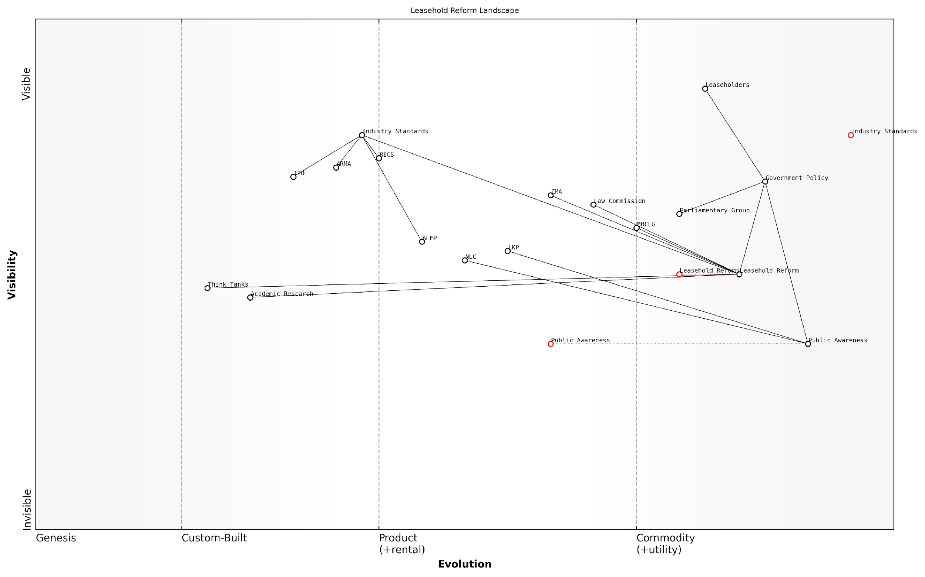

*Draft Wardley Map: [Insert Wardley Map: Key organisations driving change]*

[Edit this draft Wardley Map](https://create.wardleymaps.ai/#clone:7d0776d93c8a68477b)

Wardley Map Assessment

The Leasehold Reform Landscape map reveals a sector poised for significant change, driven by strong public demand and advocacy efforts. The strategic focus should be on maintaining reform momentum through public awareness, while simultaneously working on long-term structural changes. Key opportunities lie in leveraging technology for transparency and efficiency, fostering cross-sector collaboration, and ensuring that evolving industry standards align with reform goals. The main challenges include navigating potential industry resistance and ensuring that government policy keeps pace with public expectations. Overall, the map suggests that with coordinated effort and strategic use of evolving components, substantial positive change in the leasehold sector is achievable.

[View full Wardley Map report](https://github.com/tractorjuice/automated_wardley_reports/blob/main/markdown_wardley_map_reports/wardley_map_report_44_Key_organisations_driving_change.md)

### How reforms may affect existing leaseholders

The landscape of leasehold reform in England is rapidly evolving, with potential far-reaching implications for existing leaseholders. As an expert in this field, it’s crucial to understand that these reforms are not merely academic exercises but have the potential to fundamentally reshape the rights, obligations, and financial positions of leaseholders across the country.

The proposed reforms, primarily driven by the Law Commission’s recommendations and the government’s commitment to leasehold reform, aim to address long-standing issues within the leasehold system. These changes are likely to impact existing leaseholders in several key areas:

* Ground rent abolition
* Lease extension rights
* Commonhold conversion
* Right to Manage (RTM) improvements
* Service charge transparency and regulation

Let’s delve into each of these areas to understand their potential impact on existing leaseholders:

1. Ground Rent Abolition: The government has already legislated to set ground rents to zero for new leases. For existing leaseholders, there are ongoing discussions about retrospective application. If implemented, this could lead to significant savings for leaseholders currently paying substantial ground rents, particularly those with escalating clauses.

As a senior housing policy adviser notes, ‘The abolition of ground rents for existing leaseholders would be a game-changer, potentially saving thousands of pounds over the lifetime of a lease.’

1. Lease Extension Rights: Proposed reforms aim to simplify and standardise the lease extension process. This could include extending leases to 990 years with zero ground rent, replacing the current system of 90-year extensions. For existing leaseholders, this could provide greater security and potentially increase property values.
2. Commonhold Conversion: The government is exploring ways to reinvigorate the commonhold system as an alternative to leasehold. For existing leaseholders, this could offer a route to full property ownership and greater control over their homes. However, the transition process and its implications for existing leases remain subjects of intense debate.
3. Right to Manage (RTM) Improvements: Proposed changes aim to make the RTM process more accessible and less prone to obstruction by freeholders. For existing leaseholders, this could mean an easier path to taking control of their building’s management, potentially leading to better service and reduced costs.
4. Service Charge Transparency and Regulation: Reforms in this area could introduce stricter regulations on service charges, including clearer breakdowns of costs and potentially caps on certain types of charges. For existing leaseholders, this could lead to more predictable and potentially lower service charges, as well as greater ability to challenge unreasonable costs.

A leading leasehold reform campaigner states, ‘Increased transparency in service charges is not just about reducing costs; it’s about restoring trust in the leasehold system and empowering leaseholders to make informed decisions.’

It’s important to note that while these reforms offer significant potential benefits, they also come with challenges and uncertainties. The implementation timeline, transitional arrangements, and potential resistance from some sectors of the property industry could all affect how these changes play out in practice.

For existing leaseholders, the key considerations in light of these potential reforms include:

* Staying informed about the progress of reforms and their specific implications
* Considering the timing of lease extensions or enfranchisement claims in light of potential changes
* Engaging with residents’ associations or campaign groups to have a voice in the reform process
* Preparing for potential changes in property management structures, especially if commonhold conversion becomes more widespread
* Being aware of the potential impact on property values and marketability during the transition period

It’s also worth considering the potential for regional variations in the impact of these reforms. Urban areas with high concentrations of leasehold properties, particularly in cities like London and Manchester, may see more significant and immediate effects compared to areas where leasehold is less prevalent.

In conclusion, while the proposed reforms offer hope for a fairer and more transparent leasehold system, existing leaseholders must navigate a period of change and uncertainty. By staying informed, engaging with the reform process, and seeking expert advice when needed, leaseholders can position themselves to benefit from these changes while mitigating potential risks.

As a prominent property law expert observes, ‘The leasehold reforms represent the most significant shake-up of property ownership in generations. Existing leaseholders who educate themselves and engage proactively with these changes will be best placed to benefit from the new landscape.’

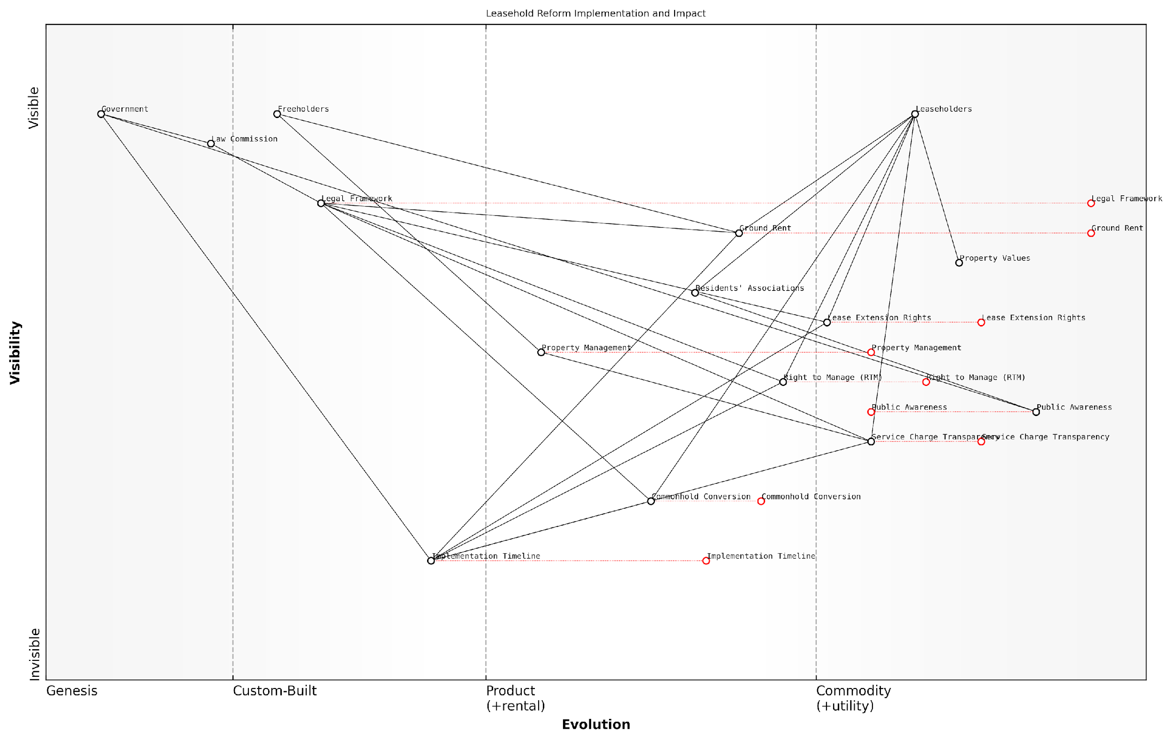

*Draft Wardley Map: [Insert Wardley Map: How reforms may affect existing leaseholders]*

[Edit this draft Wardley Map](https://create.wardleymaps.ai/#clone:f020e6c43030e27341)

Wardley Map Assessment

The Wardley Map reveals a leasehold reform landscape in transition, with significant opportunities for innovation and improvement. The strategic focus should be on accelerating the evolution of key components like Commonhold Conversion and Property Management, while ensuring effective implementation of more mature reforms like Ground Rent changes. Boosting Public Awareness and addressing the Implementation Timeline are critical for success. The shift towards more transparent, leaseholder-friendly systems presents opportunities for new market entrants and innovative solutions, particularly in Property Management and Service Charge Transparency. Long-term success will depend on effectively balancing the interests of all stakeholders while moving towards a more equitable and efficient leasehold system.

[View full Wardley Map report](https://github.com/tractorjuice/automated_wardley_reports/blob/main/markdown_wardley_map_reports/wardley_map_report_45_How_reforms_may_affect_existing_leaseholders.md)

## Getting Involved in Advocacy

### Joining leasehold campaign groups

In the complex landscape of leasehold reform, joining campaign groups is a powerful way for leaseholders to amplify their voices and effect meaningful change. These groups play a crucial role in advocating for fairer practices, influencing policy decisions, and providing support to individuals facing leasehold challenges. As an expert in this field, I cannot overstate the importance of collective action in addressing the systemic issues plaguing the leasehold sector in England.

Let’s explore the key aspects of joining and engaging with leasehold campaign groups, drawing from years of experience in advising both individual leaseholders and government bodies on leasehold reform.

1. Identifying Reputable Campaign Groups

The first step in joining a leasehold campaign group is to identify reputable organisations that align with your concerns and objectives. Some well-established groups in England include:

* The Leasehold Knowledge Partnership (LKP)
* The National Leasehold Campaign (NLC)
* The Leasehold Advisory Service (LEASE)
* The HomeOwners Alliance

These organisations have a track record of advocating for leaseholder rights and have been instrumental in pushing for legislative changes. When selecting a group to join, consider their focus areas, achievements, and methods of engagement.

As a senior policy advisor in leasehold reform once noted, ‘The collective voice of well-organised campaign groups has been pivotal in bringing leasehold issues to the forefront of political discourse and driving legislative change.’

1. Understanding the Benefits of Membership

Joining a leasehold campaign group offers numerous benefits:

* Access to expert knowledge and resources
* Networking opportunities with fellow leaseholders
* Collective bargaining power in negotiations with freeholders and management companies
* A platform to share experiences and seek advice
* Opportunities to participate in lobbying efforts and consultations
* Regular updates on legislative changes and reform progress

1. Getting Involved: Levels of Engagement

Campaign groups offer various levels of engagement to suit different capacities and interests:

* Basic membership: Receiving newsletters and updates
* Active participation: Attending meetings, webinars, and events
* Volunteer roles: Contributing skills such as legal expertise, marketing, or event organisation
* Leadership positions: Taking on committee roles or spearheading specific campaigns

It’s important to assess your available time and resources when deciding on your level of involvement. Even minimal engagement can contribute significantly to the collective effort.

1. Leveraging Social Media and Online Platforms

Many leasehold campaign groups have a strong online presence, particularly on social media platforms. Engaging with these digital channels can be an effective way to stay informed and contribute to the cause:

* Follow official accounts on Twitter, Facebook, and LinkedIn
* Participate in online discussions and forums
* Share personal experiences and case studies to support campaign narratives
* Amplify key messages and calls to action through your own social networks

A prominent leasehold campaigner once remarked, ‘The power of social media in our movement cannot be underestimated. It has allowed us to reach and mobilise thousands of leaseholders who previously felt isolated in their struggles.’

1. Contributing to Policy Consultations

One of the most impactful ways to engage through campaign groups is by contributing to government consultations on leasehold reform. These groups often coordinate responses to ensure a strong, unified message:

* Participate in workshops to formulate group responses
* Share personal testimonies to support policy arguments
* Review and comment on draft submissions
* Encourage other leaseholders to participate in consultations

1. Building Local Networks

While national campaigns are crucial, local action can be equally powerful. Many campaign groups encourage the formation of local chapters or networks:

* Organise local meetups with fellow leaseholders
* Engage with local councillors and MPs on leasehold issues
* Coordinate with residents’ associations in your area
* Share local success stories and challenges with the wider campaign

1. Supporting Legal Challenges

Some campaign groups are involved in supporting strategic legal challenges that could set important precedents for leaseholders. Ways to contribute include:

* Donating to legal funds
* Offering professional expertise if you have relevant legal or financial knowledge
* Sharing information about ongoing cases to raise awareness
* Participating in crowdfunding initiatives for legal actions

1. Measuring Impact and Celebrating Successes

It’s important to recognise the achievements of campaign groups to maintain momentum and motivation. Look out for and celebrate milestones such as:

* Legislative changes influenced by campaign efforts
* Successful legal challenges
* Increased media coverage of leasehold issues
* Growth in membership and engagement levels

As a leading expert in leasehold reform observed, ‘The cumulative effect of sustained campaigning has shifted the leasehold landscape dramatically over the past decade. Every small victory contributes to the larger goal of comprehensive reform.’

In conclusion, joining leasehold campaign groups is a vital step for leaseholders who wish to challenge excessive service charges, combat poor management practices, and contribute to broader systemic reform. By leveraging the collective power of these organisations, individuals can play a significant role in shaping the future of leasehold in England. As we continue to push for a fairer, more transparent system, the importance of organised, informed, and persistent advocacy cannot be overstated.

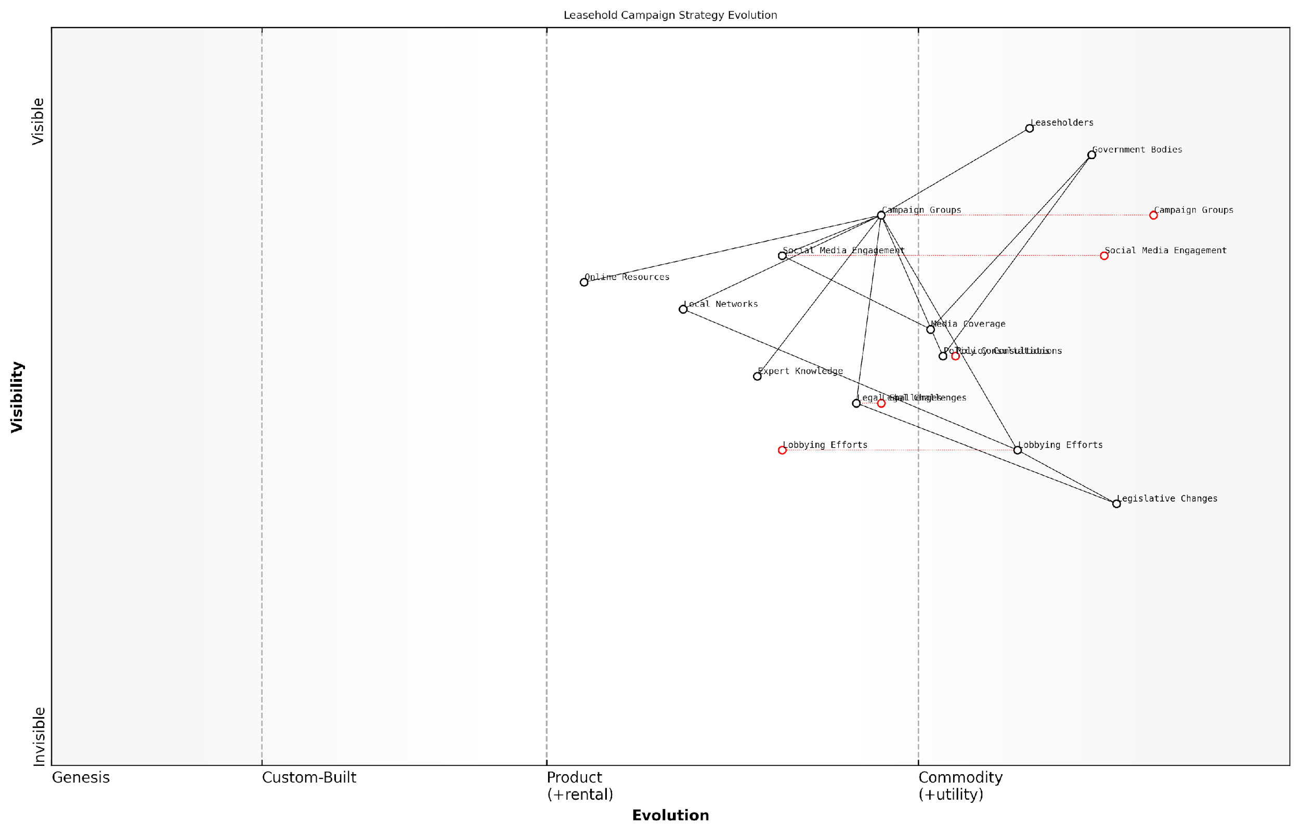

*Draft Wardley Map: [Insert Wardley Map: Joining leasehold campaign groups]*

[Edit this draft Wardley Map](https://create.wardleymaps.ai/#clone:244f11c9df4b4aee31)

Wardley Map Assessment

The Leasehold Campaign Strategy Evolution map reveals a well-structured but evolving ecosystem focused on achieving legislative change. While the campaign has strong foundations in grassroots organisation and legal expertise, there are significant opportunities to enhance its effectiveness through digital innovation, data-driven advocacy, and more direct engagement with policy-makers. The key to success lies in evolving the campaign’s capabilities in tandem with the changing landscape of policy influence, while maintaining a strong connection to the core needs of leaseholders.

[View full Wardley Map report](https://github.com/tractorjuice/automated_wardley_reports/blob/main/markdown_wardley_map_reports/wardley_map_report_46_Joining_leasehold_campaign_groups.md)

### Engaging with your MP and local government

Engaging with your Member of Parliament (MP) and local government officials is a crucial step in addressing the challenges faced by leaseholders in England. As an expert in tackling excessive service charges and bad management agents, I cannot overstate the importance of this approach in driving systemic change and securing support for individual cases.

MPs and local councillors have the power to influence policy, raise awareness of leasehold issues, and provide valuable assistance to constituents. By effectively engaging with these representatives, leaseholders can amplify their voices and contribute to the ongoing reform efforts in the leasehold sector.

Let’s explore the key strategies for engaging with your MP and local government officials to address leasehold concerns:

* Identify your representatives
* Prepare your case
* Make initial contact
* Attend surgeries and meetings
* Follow up and maintain communication
* Leverage local government resources
* Collaborate with other leaseholders

1. Identify your representatives:

The first step in engaging with your MP and local government is to identify who represents you. In the UK, you can easily find your MP by entering your postcode on the official Parliament website. For local government, visit your council’s website to find information about your ward councillors.

1. Prepare your case:

Before reaching out to your representatives, it’s crucial to prepare a clear and concise summary of your leasehold issues. Focus on specific problems, such as excessive service charges or poor management practices, and gather supporting evidence. This might include service charge statements, correspondence with management agents, and relevant legal documents.

A well-prepared case can make all the difference. As a senior adviser to leaseholder groups, I’ve seen how a concise, evidence-based presentation can capture an MP’s attention and lead to meaningful action.

1. Make initial contact:

Once you’ve prepared your case, reach out to your MP and local councillors. You can typically do this via email, letter, or through their official websites. Clearly state your concerns and request a meeting or their support in addressing the issue. Be polite, professional, and concise in your communication.

1. Attend surgeries and meetings:

Many MPs and councillors hold regular surgeries where constituents can discuss issues face-to-face. These meetings provide an excellent opportunity to present your case in person and build a rapport with your representatives. Come prepared with a summary of your issues and any relevant documentation.

1. Follow up and maintain communication:

After your initial contact or meeting, follow up with a thank-you note and any additional information requested. Keep your representatives updated on developments in your case and any broader leasehold issues affecting your community. Consistent, respectful communication can help maintain their interest and support.

1. Leverage local government resources:

Local councils often have dedicated housing departments that can provide advice and support on leasehold issues. Engage with these departments to understand local policies and initiatives that may affect leaseholders. Some councils have established leasehold forums or working groups, which can be valuable platforms for raising concerns and influencing local policy.

In my experience advising local authorities, I’ve seen how proactive engagement from leaseholders can lead to the development of more supportive policies and practices at the council level.

1. Collaborate with other leaseholders:

Engaging with your MP and local government can be more effective when done collectively. Consider forming or joining a residents’ association or action group to present a united front. This approach can demonstrate the scale of leasehold issues in your area and increase the likelihood of garnering political support.

It’s important to note that while MPs and local councillors can provide valuable support, they cannot directly intervene in legal disputes or override existing contracts. However, their influence can be instrumental in pushing for broader reforms and in some cases, facilitating dialogue with freeholders or management companies.

By effectively engaging with your MP and local government, you not only address your immediate concerns but also contribute to the wider movement for leasehold reform in England. This engagement can lead to increased awareness of leasehold issues among policymakers, potentially influencing future legislation and improving the situation for leaseholders across the country.

As a long-standing advocate for leasehold reform, I can attest to the power of grassroots engagement with political representatives. It has been a driving force behind many of the positive changes we’ve seen in recent years.

Remember, persistence and professionalism are key when engaging with your representatives. By presenting clear, evidence-based arguments and demonstrating a willingness to work constructively towards solutions, you can maximise the impact of your advocacy efforts and play a crucial role in shaping the future of leasehold in England.

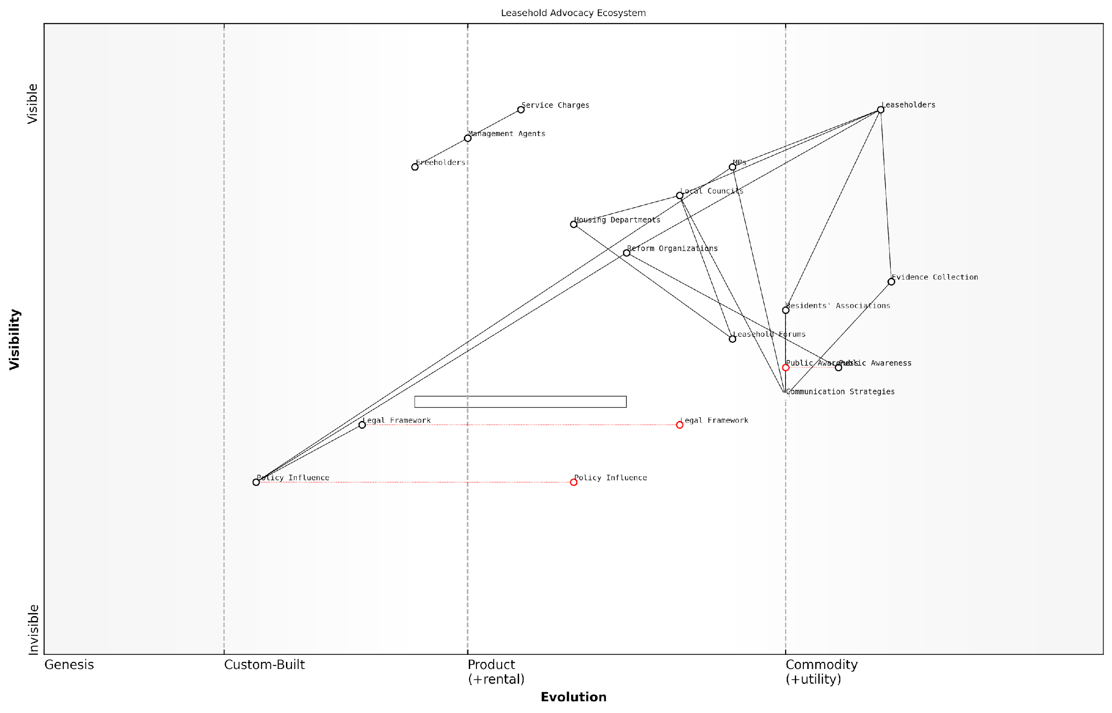

*Draft Wardley Map: [Insert Wardley Map: Engaging with your MP and local government]*

[Edit this draft Wardley Map](https://create.wardleymaps.ai/#clone:30de06bba7edfbc9b3)

Wardley Map Assessment

The Leasehold Advocacy Ecosystem map reveals a system in transition, with significant opportunities for improvement and innovation. The key to success lies in better integration of efforts, enhanced communication strategies, and a push for faster evolution of the legal and policy framework. By focusing on these areas, stakeholders can create a more effective and responsive advocacy system that better serves leaseholders’ interests and drives meaningful reform in the leasehold sector.

[View full Wardley Map report](https://github.com/tractorjuice/automated_wardley_reports/blob/main/markdown_wardley_map_reports/wardley_map_report_47_Engaging_with_your_MP_and_local_government.md)

### Using social media and traditional media effectively

In the digital age, leveraging social media and traditional media channels has become an indispensable tool for leaseholders seeking to address excessive service charges and poor management practices. This section explores how to harness these powerful platforms to amplify your voice, build community support, and effect meaningful change in the leasehold sector.

Social media platforms, in particular, have revolutionised the way leaseholders can connect, share experiences, and mobilise for action. These digital spaces offer unprecedented opportunities for rapid information dissemination, community building, and direct engagement with key stakeholders, including management agents, policymakers, and advocacy groups.

Social media has fundamentally altered the power dynamics between leaseholders and freeholders. It’s no longer about isolated individuals struggling against a system, but a connected community capable of coordinated action and amplified influence.

Let’s explore the key strategies for effectively utilising both social media and traditional media channels in your leasehold advocacy efforts:

* Building a Strong Online Presence
* Crafting Compelling Content
* Engaging with Key Stakeholders
* Leveraging Traditional Media
* Coordinating Online and Offline Efforts

1. Building a Strong Online Presence:

Establishing a robust online presence is crucial for effective advocacy. This involves creating and maintaining active profiles on key social media platforms such as Twitter, Facebook, and LinkedIn. These platforms serve different purposes and audiences, so it’s important to tailor your approach accordingly.

* Twitter: Ideal for real-time updates, engaging with policymakers, and participating in broader conversations about leasehold reform.
* Facebook: Excellent for building community groups, sharing detailed information, and organising events.
* LinkedIn: Useful for connecting with professionals in the property sector, legal experts, and policy influencers.

Consider creating a dedicated hashtag for your cause, such as #LeaseholdJustice or #FairServiceCharges, to help centralise discussions and make your content more discoverable.

1. Crafting Compelling Content:

The key to gaining traction on social media is creating content that resonates with your audience and encourages engagement. This could include:

* Personal stories highlighting the impact of excessive service charges or poor management
* Infographics explaining complex leasehold concepts or legal rights
* Live videos or webinars discussing common issues and potential solutions
* Regular updates on ongoing cases, legal changes, or reform efforts
* Polls and surveys to gather data and demonstrate the scale of leasehold issues

In the realm of social media advocacy, authenticity is your greatest asset. Real stories from real leaseholders have the power to cut through the noise and capture public attention in ways that statistics alone cannot.

1. Engaging with Key Stakeholders:

Social media provides unprecedented access to decision-makers and influencers. Use this to your advantage by:

* Directly engaging with MPs, local councillors, and government departments on platforms like Twitter
* Participating in online discussions hosted by leasehold reform organisations
* Responding to and sharing content from reputable property law firms and housing journalists
* Tagging relevant stakeholders in your posts to increase visibility and encourage response

Remember to always maintain a professional and constructive tone, even when discussing frustrating issues. This approach is more likely to elicit positive responses and meaningful engagement.

1. Leveraging Traditional Media:

While social media is powerful, traditional media still plays a crucial role in shaping public opinion and influencing policy. Here’s how to effectively engage with traditional media outlets:

* Develop relationships with local and national journalists interested in housing issues
* Write letters to the editor or opinion pieces for newspapers and online publications
* Prepare press releases for significant developments in your advocacy efforts
* Offer yourself as a case study or interviewee for relevant news stories
* Monitor news outlets for leasehold-related stories and engage in the comments sections

1. Coordinating Online and Offline Efforts:

For maximum impact, it’s crucial to coordinate your online and offline advocacy efforts. Use social media to:

* Promote offline events such as community meetings or protests
* Share outcomes and key takeaways from in-person meetings with stakeholders
* Encourage supporters to take specific actions, such as writing to their MPs or signing petitions
* Live-stream or live-tweet important events to extend their reach

The most effective advocacy campaigns seamlessly blend online and offline tactics, creating a virtuous cycle where social media amplifies real-world actions, and offline events generate content for online engagement.

By effectively leveraging both social and traditional media, leaseholders can significantly enhance their advocacy efforts. These platforms provide the tools to build communities, share knowledge, apply pressure on decision-makers, and ultimately drive the changes needed to create a fairer leasehold system in England.

As we continue to navigate the complex landscape of leasehold reform, the strategic use of media will undoubtedly play a pivotal role in shaping the future of housing policy in England. By mastering these tools, leaseholders can ensure their voices are heard and their rights are protected in the ongoing dialogue about the future of leasehold.

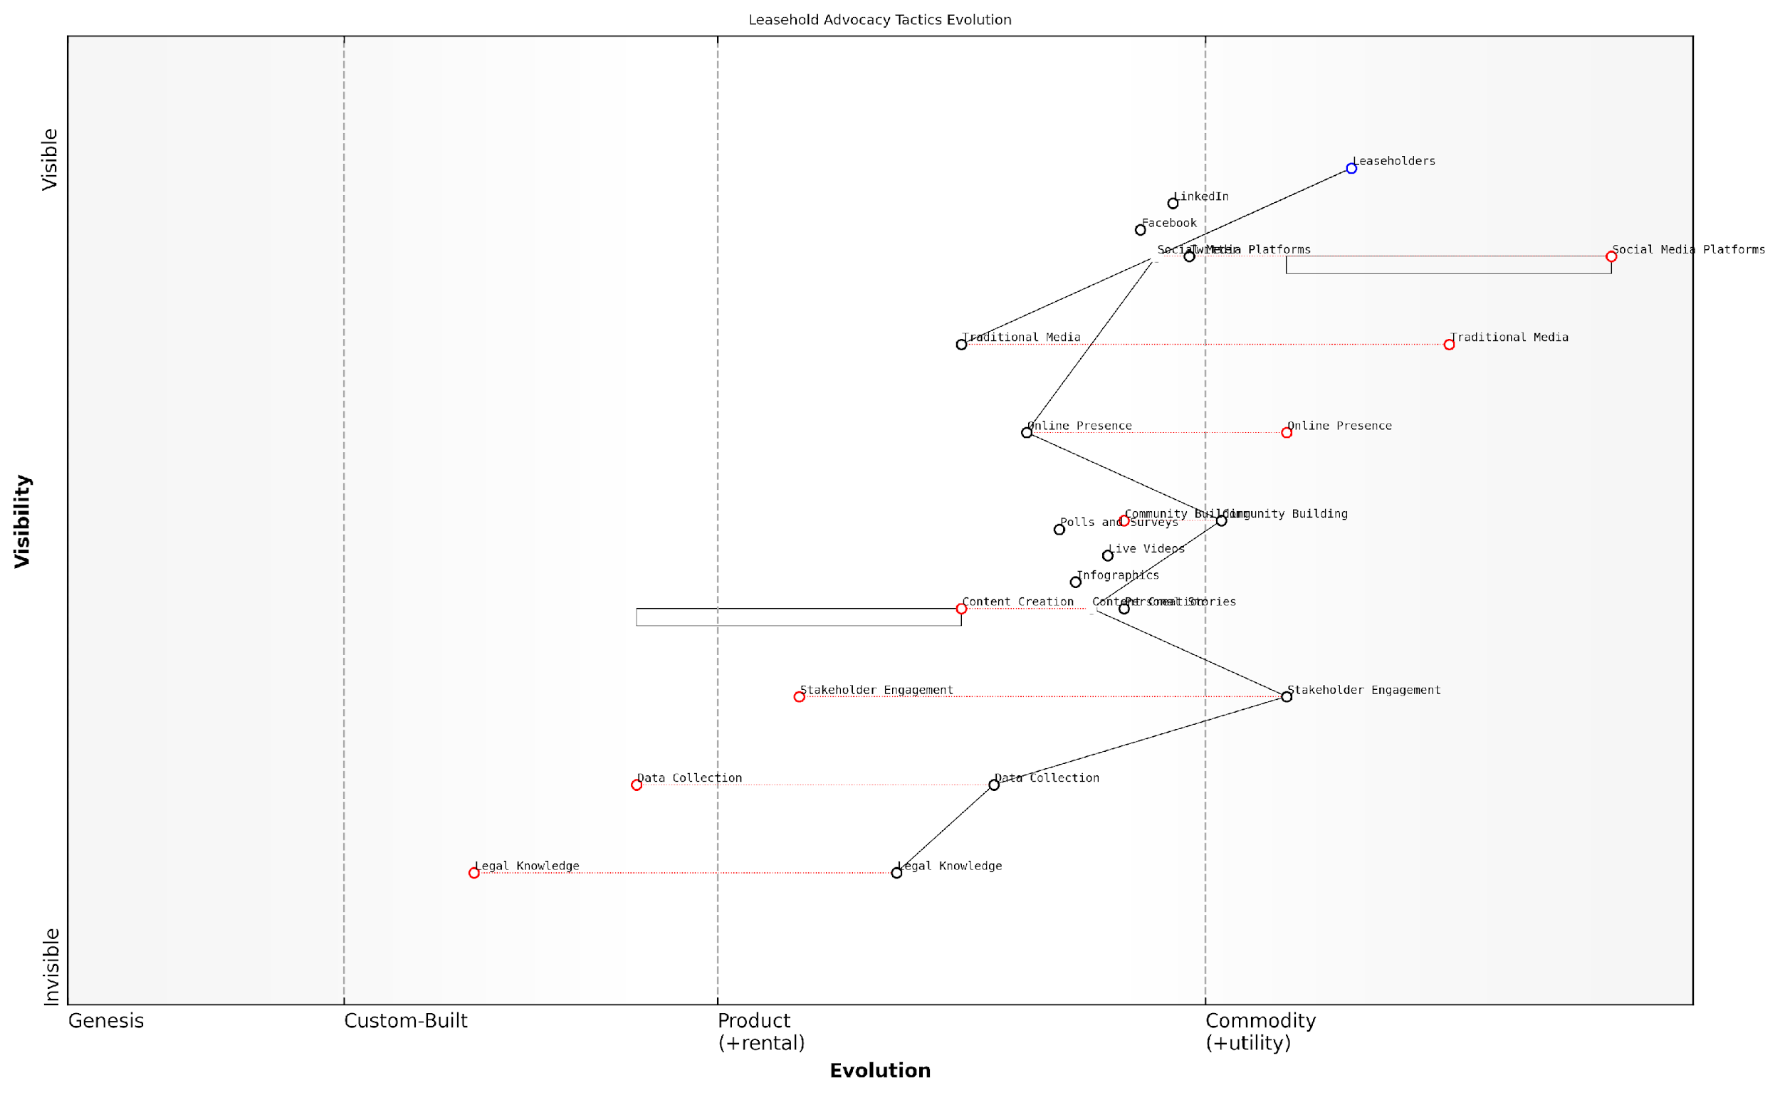

*Draft Wardley Map: [Insert Wardley Map: Using social media and traditional media effectively]*

[Edit this draft Wardley Map](https://create.wardleymaps.ai/#clone:590bb82200da07f89c)

Wardley Map Assessment

The Wardley Map reveals a strategic position that leverages digital platforms and community engagement to drive leasehold advocacy. While there’s a strong foundation in social media and content creation, there are significant opportunities to enhance data collection, legal knowledge, and stakeholder engagement. The future success of the advocacy efforts will likely depend on the ability to evolve these components while maintaining a strong connection with the leaseholder community. By focusing on data-driven insights, innovative content creation, and strategic partnerships, the advocacy efforts can become more effective and influential in shaping the future of leasehold reform.

[View full Wardley Map report](https://github.com/tractorjuice/automated_wardley_reports/blob/main/markdown_wardley_map_reports/wardley_map_report_48_Using_social_media_and_traditional_media_effective.md)

## The Future of Leasehold in England

### Potential alternatives to leasehold

As we look towards the future of property ownership in England, it’s crucial to explore potential alternatives to the leasehold system. The current leasehold structure has long been criticised for its inherent complexities, potential for exploitation, and the power imbalance between freeholders and leaseholders. This section examines several promising alternatives that could reshape the landscape of property ownership, addressing many of the issues that have plagued leaseholders for decades.

Before delving into specific alternatives, it’s important to understand the context driving this change. The push for leasehold reform has gained significant momentum in recent years, fuelled by widespread dissatisfaction with excessive service charges, unfair ground rents, and poor management practices. As a senior government adviser remarked, ‘The current leasehold system is no longer fit for purpose in a modern property market. We must explore alternatives that provide fairness, transparency, and long-term security for homeowners.’

Let’s examine some of the most promising alternatives to leasehold:

* Commonhold
* Expanded Freehold
* Scottish-style Factoring
* Community Land Trusts
* Long-term Secure Tenancies

1. Commonhold: Introduced in 2002 but rarely used, commonhold is often cited as the most viable alternative to leasehold. Under this system, flat owners have freehold ownership of their individual units and are members of a commonhold association that owns and manages the common areas. This structure eliminates the need for a separate freeholder and potentially resolves many issues associated with leasehold ownership.

Commonhold offers a more equitable and transparent form of ownership, giving flat owners true control over their properties and shared spaces. It’s a system that aligns with modern expectations of homeownership.

Despite its potential, commonhold has faced barriers to widespread adoption, including lack of awareness, resistance from developers, and challenges in converting existing leaseholds. However, recent government proposals aim to reinvigorate commonhold as a preferred alternative to leasehold.

1. Expanded Freehold: This concept involves extending freehold ownership to flats, similar to how houses are typically owned. It would require legislative changes to allow for three-dimensional property boundaries and new mechanisms for managing shared spaces and services. While complex, this approach could provide flat owners with the security and control associated with freehold ownership.
2. Scottish-style Factoring: Scotland’s approach to flat ownership offers valuable insights. In Scotland, most flats are sold as freehold properties, with shared areas managed by a ‘factor’ appointed by the owners. This system provides greater autonomy for flat owners while ensuring effective management of communal spaces.
3. Community Land Trusts (CLTs): While not a direct replacement for leasehold, CLTs offer an alternative model of land ownership and management. These non-profit, community-based organisations acquire and manage land for the benefit of the local community, potentially providing more affordable and sustainable housing solutions.
4. Long-term Secure Tenancies: Drawing inspiration from systems in other European countries, this alternative involves very long-term (e.g., 999-year) tenancies with strong protections for occupiers. While not ownership in the traditional sense, such arrangements could provide many of the benefits of ownership without some of the complexities associated with leasehold.

Implementing these alternatives would require significant legal and cultural shifts. Key considerations include:

* Legislative changes to enable and regulate new forms of ownership
* Mechanisms for converting existing leaseholds to alternative systems
* Education and awareness campaigns to inform property buyers and existing leaseholders
* Addressing resistance from stakeholders who benefit from the current system
* Ensuring robust governance structures for managing shared spaces and services

The transition to any of these alternatives would not be without challenges. As a property law expert noted, ‘Changing a system as entrenched as leasehold requires careful consideration of legal, financial, and practical implications. However, the potential benefits in terms of fairness and transparency make this a worthwhile endeavour.’

It’s important to recognise that no single alternative may be suitable for all situations. A mixed approach, allowing for different ownership models depending on the property type and local context, might be the most effective way forward.

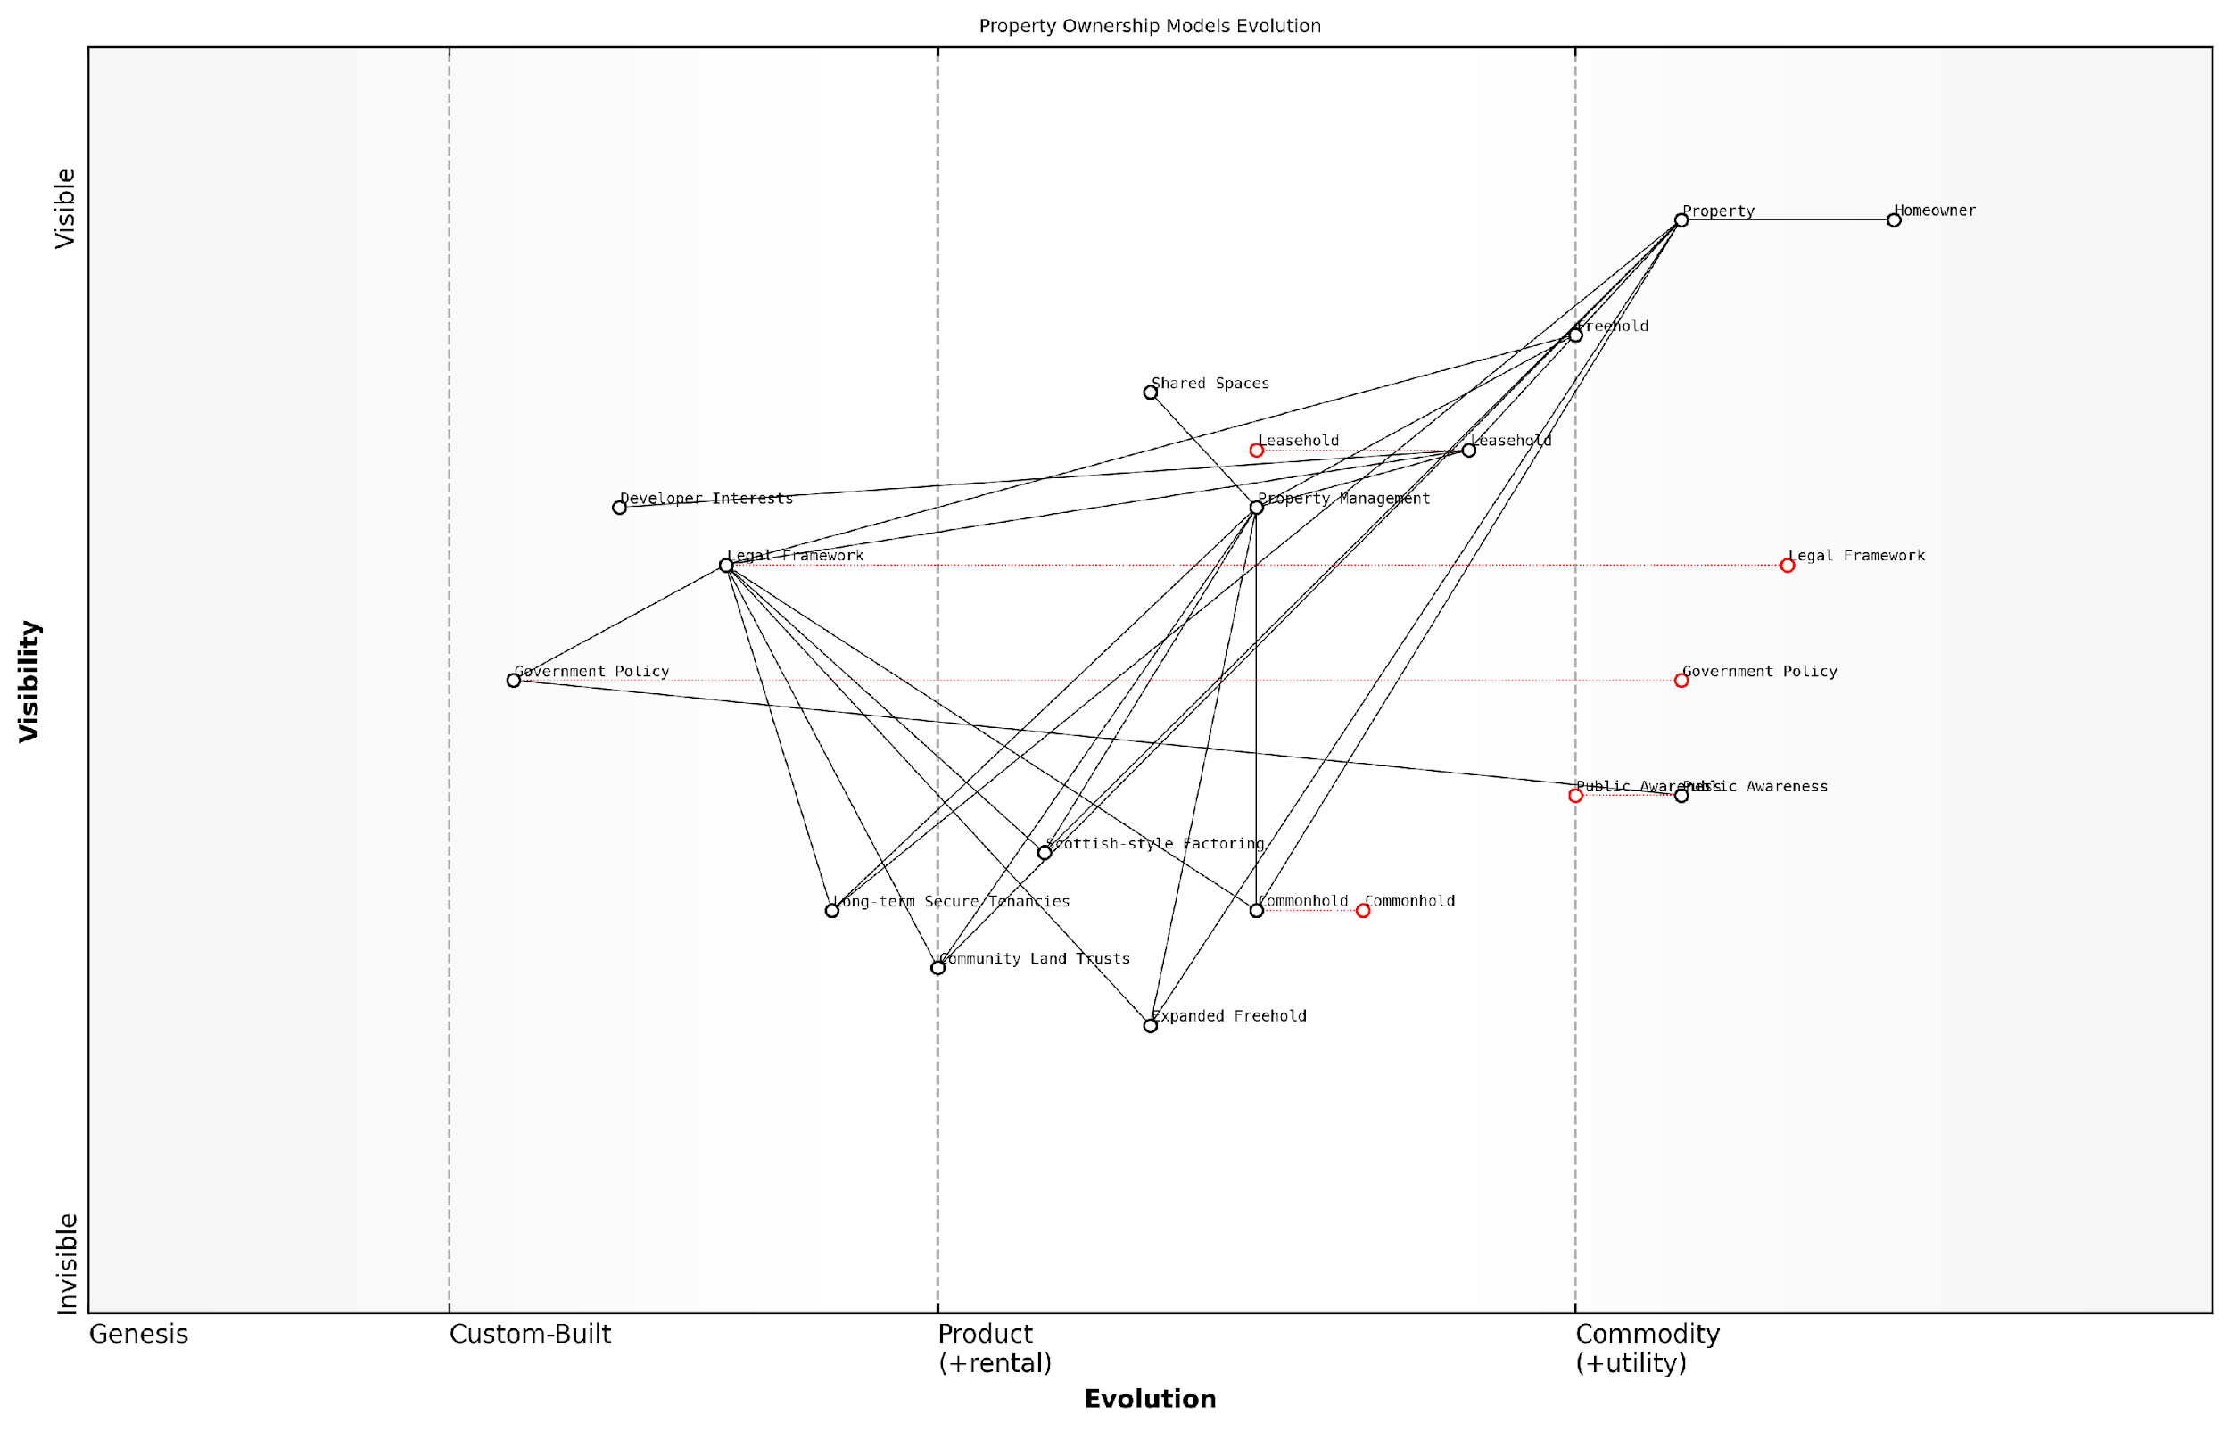

*Draft Wardley Map: [Insert Wardley Map: Potential alternatives to leasehold]*

[Edit this draft Wardley Map](https://create.wardleymaps.ai/#clone:b73e3ef8ecaab89282)

Wardley Map Assessment

This Wardley Map reveals a property ownership landscape in England that is ripe for transformation. The traditional Leasehold model, while still dominant, is under pressure from emerging alternatives like Commonhold and Community Land Trusts. The key to driving change lies in the interplay between Public Awareness, Government Policy, and the Legal Framework. By focusing on these areas, stakeholders can catalyse a shift towards more equitable and innovative property ownership models. The map suggests that the industry is at a critical juncture, with significant opportunities for those who can successfully navigate the transition to new ownership paradigms. However, challenges remain, particularly in overcoming inertia from established interests and ensuring that new models are robust and beneficial for all parties involved. Strategic action should focus on education, policy advocacy, and pilot programs to demonstrate the viability and benefits of alternative models.

[View full Wardley Map report](https://github.com/tractorjuice/automated_wardley_reports/blob/main/markdown_wardley_map_reports/wardley_map_report_49_Potential_alternatives_to_leasehold.md)

As we consider these alternatives, it’s crucial to keep the core objectives in mind: providing security of tenure, ensuring fair and transparent property management, and empowering homeowners. Any new system must address the fundamental issues that have plagued leasehold while being adaptable to the diverse needs of England’s housing market.

The exploration of these alternatives represents a significant opportunity to reshape property ownership in England, potentially resolving many of the long-standing issues associated with leasehold. As policymakers, legal experts, and property professionals continue to debate and refine these options, leaseholders and prospective homebuyers should stay informed and engaged in the process. The future of property ownership in England may look very different from its past, offering new possibilities for fairer, more transparent, and more empowering forms of homeownership.

### International comparisons and best practices

As we examine the future of leasehold in England, it is crucial to consider international comparisons and best practices. This analysis not only provides valuable insights into alternative property ownership models but also offers potential solutions to the challenges faced by English leaseholders. By exploring successful approaches from other countries, we can identify innovative strategies to address excessive service charges and poor management practices, ultimately shaping a fairer and more transparent leasehold system in England.

Let us delve into some of the most relevant international examples and the lessons they offer for the English leasehold system:

1. Scotland’s Abolition of Feudal Tenure:

Scotland’s bold move to abolish feudal tenure in 2004 through the Abolition of Feudal Tenure etc. (Scotland) Act 2000 provides a compelling case study for England. This reform effectively eliminated the Scottish equivalent of leasehold, converting most residential leaseholds into outright ownership. The Scottish model demonstrates that systemic change is possible and can be implemented successfully.

The Scottish reforms have shown that it is possible to transition from a feudal system to a more equitable form of property ownership. The process, while complex, has ultimately benefited homeowners and simplified property law.

Key lessons from the Scottish experience include:

* The importance of comprehensive legislation to address all aspects of the transition
* The need for a phased implementation to allow stakeholders to adapt
* The value of clear communication and education for all parties involved in the property market

1. Australia’s Strata Title System:

Australia’s strata title system, particularly as implemented in New South Wales, offers an alternative model for managing multi-unit developments. This system provides individual ownership of units while sharing ownership of common areas through an owners corporation (similar to a residents’ association).

Key features of the Australian strata title system that could inform English leasehold reform include:

* Transparent and regulated management structures
* Mandatory sinking funds for long-term maintenance
* Clear dispute resolution processes through specialised tribunals
* Regular reviews of strata schemes to ensure they remain fit for purpose

The strata title system in Australia has proven to be a more equitable and transparent way of managing multi-unit properties. It empowers owners and provides clear mechanisms for collective decision-making and dispute resolution.

1. Singapore’s Leasehold Renewal Programme:

Singapore’s approach to leasehold properties, particularly its Selective En bloc Redevelopment Scheme (SERS) and Voluntary Early Redevelopment Scheme (VERS), offers insights into managing the long-term sustainability of leasehold properties. These programmes provide mechanisms for renewing or redeveloping ageing leasehold properties, ensuring that the value of these assets is maintained over time.

Lessons from Singapore’s approach include:

* The importance of long-term planning for leasehold properties
* The potential for government intervention to facilitate renewal and redevelopment
* The need for fair compensation and relocation options for leaseholders
* The value of community engagement in the redevelopment process

1. New Zealand’s Unit Titles Act:

New Zealand’s Unit Titles Act 2010 provides a comprehensive framework for the management of multi-unit properties. This legislation offers valuable insights into creating a more transparent and equitable system for managing shared properties.

Key elements of the New Zealand system that could inform English leasehold reform include:

* Mandatory disclosure of information to prospective buyers
* Clear rules for body corporate governance
* Provisions for long-term maintenance plans and funds
* Streamlined dispute resolution processes

The Unit Titles Act in New Zealand has significantly improved transparency and fairness in multi-unit property management. Its focus on disclosure and long-term planning offers valuable lessons for reforming the English leasehold system.

Applying International Best Practices to England:

While each country’s property system is unique, these international examples offer valuable insights for reforming England’s leasehold system. Key principles that emerge from these comparisons include:

* Transparency in management and financial matters
* Empowerment of property owners through clear rights and responsibilities
* Effective dispute resolution mechanisms
* Long-term planning for property maintenance and renewal
* Clear and comprehensive legislation to support fair property management practices

As England considers the future of its leasehold system, policymakers and advocates should carefully examine these international best practices. By adapting successful elements from other countries and tailoring them to the English context, it is possible to create a more equitable, transparent, and sustainable property ownership model that addresses the current challenges of excessive service charges and poor management practices.

In conclusion, the future of leasehold in England can be significantly improved by learning from international experiences. By incorporating best practices from countries like Scotland, Australia, Singapore, and New Zealand, England can develop a more robust and fair system that protects leaseholders’ interests while ensuring the sustainable management of multi-unit properties. As we move forward, it is crucial to engage all stakeholders in this reform process, ensuring that the transition to a new system is smooth, equitable, and beneficial for all parties involved.

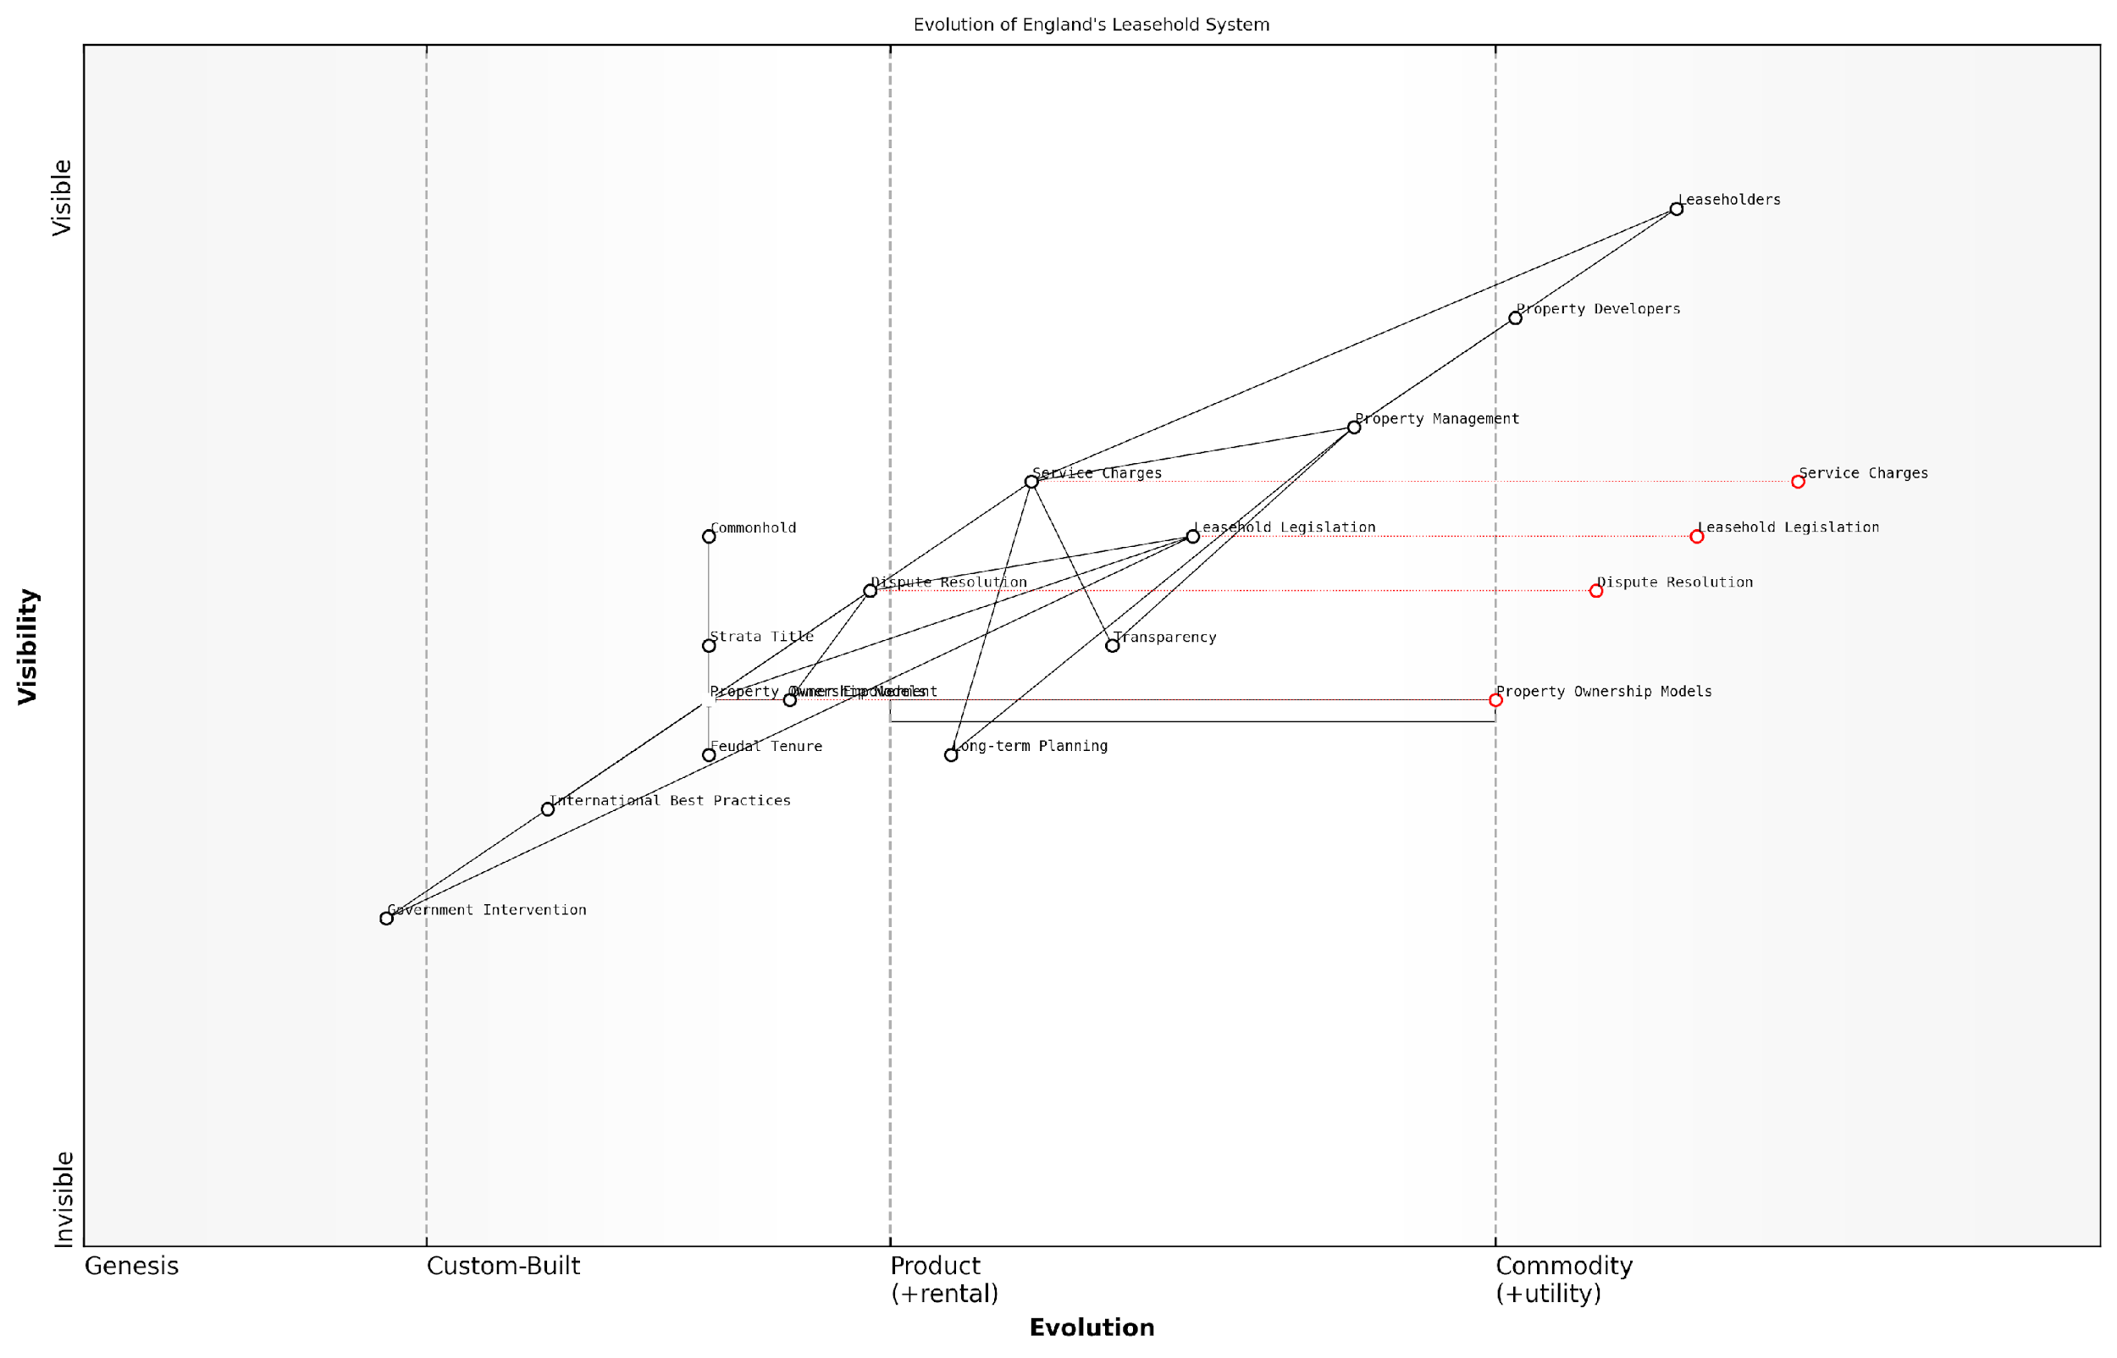

*Draft Wardley Map: [Insert Wardley Map: International comparisons and best practices]*

[Edit this draft Wardley Map](https://create.wardleymaps.ai/#clone:fd926b4c980217d10e)

Wardley Map Assessment

The Wardley Map reveals a leasehold system on the cusp of significant transformation. The strategic positioning of components suggests a strong push towards more modern, transparent, and leaseholder-friendly practices. Key opportunities lie in the evolution of Property Ownership Models, particularly the shift towards Commonhold, and in the improvement of Property Management practices through increased transparency and long-term planning. The involvement of Government Intervention and International Best Practices as driving forces indicates a favourable environment for systemic change. However, the transition presents challenges, particularly in managing the evolution of established components like Property Management and Service Charges. Success will depend on careful balancing of stakeholder interests, strategic implementation of new technologies, and a phased approach to reform that allows for adaptation and learning. The future of England’s leasehold system appears to be moving towards a more equitable, efficient, and leaseholder-centric model, with significant implications for all players in the property market.

[View full Wardley Map report](https://github.com/tractorjuice/automated_wardley_reports/blob/main/markdown_wardley_map_reports/wardley_map_report_50_International_comparisons_and_best_practices.md)

### Preparing for a changing landscape

As we stand on the cusp of significant reforms in the leasehold sector, it is crucial for leaseholders, property professionals, and policymakers to prepare for a rapidly evolving landscape. The future of leasehold in England is poised for transformation, driven by growing awareness of systemic issues, sustained advocacy efforts, and governmental recognition of the need for change. This section explores the potential shifts on the horizon and provides strategic insights for navigating the transition towards a fairer, more transparent property ownership system.

The leasehold system, deeply entrenched in English property law for centuries, is facing unprecedented scrutiny and pressure for reform. As we look towards the future, several key areas of change are emerging:

* Potential abolition or significant restriction of leasehold for new-build properties
* Introduction of standardised service charges and management fee structures
* Enhanced rights for leaseholders to challenge unfair practices
* Simplification of lease extension and freehold acquisition processes
* Greater regulation of management agents and freeholders

To effectively prepare for these changes, stakeholders must adopt a proactive and informed approach. Let’s delve into the key considerations and strategies for adapting to the evolving leasehold landscape.

1. Staying Informed and Engaged

The pace of leasehold reform can be rapid, with new proposals and legislation emerging regularly. Leaseholders and property professionals must prioritise staying abreast of these developments. This involves:

* Regularly monitoring government announcements and consultations on leasehold reform
* Engaging with reputable leasehold campaign groups and professional bodies
* Attending seminars, webinars, and conferences focused on leasehold issues and reforms
* Subscribing to newsletters and publications from legal experts specialising in property law

In my experience advising government bodies on leasehold reform, I’ve observed that those who stay informed and engaged are best positioned to influence policy and adapt quickly to changes. Knowledge truly is power in this evolving landscape.

1. Anticipating and Preparing for Legislative Changes

While the exact nature of future reforms remains uncertain, several trends are clear. Stakeholders should prepare for:

* Increased transparency in service charge calculations and management fees
* Stricter regulations on ground rent and other charges
* Enhanced rights for leaseholders to challenge unfair terms and practices
* Potential shifts towards commonhold or other alternative ownership structures

Proactive preparation might involve:

* Reviewing and potentially renegotiating existing leases to align with anticipated reforms
* Investing in training and education on new ownership models and management practices
* Developing more transparent and fair service charge systems in anticipation of stricter regulations
* Exploring alternative dispute resolution mechanisms to address leaseholder concerns efficiently

1. Embracing Technology and Innovation

The future of leasehold management is likely to be increasingly digital and data-driven. Preparing for this shift involves:

* Investing in property management software that enhances transparency and communication
* Exploring blockchain and smart contract technologies for more efficient lease management
* Implementing digital platforms for service charge calculations and dispute resolution
* Utilising data analytics to identify trends and improve management practices

A senior government official recently remarked, ‘The integration of technology in leasehold management isn’t just about efficiency; it’s about creating a more transparent, accountable, and fair system for all stakeholders.’

1. Fostering Collaboration and Community Engagement

As the leasehold landscape evolves, the importance of collaboration between leaseholders, freeholders, and management agents will grow. Strategies for fostering this collaboration include:

* Establishing regular forums for open dialogue between all stakeholders
* Encouraging the formation of residents’ associations and supporting their active involvement
* Developing collaborative approaches to property maintenance and improvement
* Creating educational programmes to ensure all parties understand their rights and responsibilities

1. Adapting Business Models and Professional Practices

For property professionals, including management agents and freeholders, adapting to the changing landscape will require significant shifts in business models and practices:

* Developing more customer-centric approaches to property management
* Exploring alternative revenue streams as traditional models face scrutiny
* Investing in professional development to align with new regulatory requirements
* Embracing transparency and ethical practices as core business principles

A leading expert in property management recently noted, ‘The future belongs to those who can adapt quickly, prioritise fairness, and build trust with leaseholders. It’s not just about compliance; it’s about creating a new paradigm of property ownership and management.’

1. Preparing for Potential Transitions to New Ownership Models

As alternatives to leasehold, such as commonhold, gain traction, stakeholders should prepare for potential transitions:

* Educating themselves and others about alternative ownership structures
* Assessing the financial and legal implications of transitioning to new models
* Developing strategies for managing communal areas and shared facilities under new structures
* Exploring case studies from other countries with successful alternatives to leasehold

In conclusion, preparing for the changing landscape of leasehold in England requires a multifaceted approach combining vigilance, adaptability, and proactive engagement. By staying informed, anticipating changes, embracing innovation, fostering collaboration, and adapting business practices, stakeholders can not only navigate the transition but also contribute to shaping a fairer, more transparent future for property ownership and management in England.

As a seasoned consultant in this field, I can attest that those who view these changes not as obstacles but as opportunities for improvement will be best positioned to thrive in the new leasehold landscape. The future may be uncertain, but with proper preparation, it holds the promise of a more equitable and efficient property system for all.

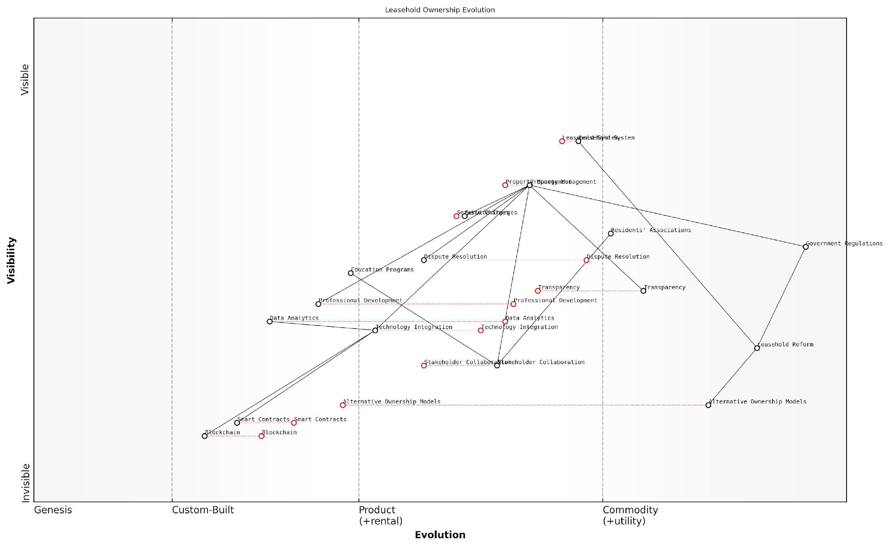

*Draft Wardley Map: [Insert Wardley Map: Preparing for a changing landscape]*

[Edit this draft Wardley Map](https://create.wardleymaps.ai/#clone:2c4da2e7d084927d24)

Wardley Map Assessment

The Leasehold Ownership Evolution map reveals a system at a critical juncture, poised for significant transformation. The traditional Leasehold System faces pressure from reform efforts, technological innovations, and changing market demands. To thrive in this evolving landscape, organizations must embrace transparency, leverage emerging technologies, and actively participate in shaping new ownership models. Success will depend on balancing short-term improvements in areas like stakeholder collaboration and dispute resolution with long-term investments in disruptive technologies and alternative ownership structures. Those who can navigate this complex transition, fostering innovation while managing regulatory changes and stakeholder expectations, will be well-positioned to lead in the future of property ownership and management.

[View full Wardley Map report](https://github.com/tractorjuice/automated_wardley_reports/blob/main/markdown_wardley_map_reports/wardley_map_report_51_Preparing_for_a_changing_landscape.md)

# Conclusion: Empowered Leaseholders, Fairer Future

## Recap of Key Strategies

### Summary of main action points

As we conclude our comprehensive exploration of tackling excessive service charges and bad management agents for leasehold flats in England, it is crucial to distil the key strategies and action points that empower leaseholders to effect positive change. This summary serves as a roadmap for leaseholders, providing a concise yet powerful set of tools to address the most pressing issues in the leasehold landscape.

The following action points represent the culmination of best practices, legal insights, and practical experiences gathered from successful cases across England. By implementing these strategies, leaseholders can navigate the complex terrain of leasehold ownership with confidence and efficacy.

* Educate yourself on leasehold rights and obligations
* Scrutinise service charge demands meticulously
* Challenge excessive charges through proper channels
* Engage proactively with management agents
* Form or join a recognised residents’ association
* Consider exercising the Right to Manage (RTM)
* Explore collective enfranchisement options
* Participate in leasehold reform advocacy

Let’s delve deeper into each of these critical action points:

1. Educate yourself on leasehold rights and obligations: Knowledge is power in the leasehold context. Familiarise yourself with the Commonhold and Leasehold Reform Act 2002, the Landlord and Tenant Act 1985, and other relevant legislation. Understanding your rights and responsibilities forms the foundation for all other actions.

A well-informed leaseholder is the freeholder’s greatest challenge and the catalyst for positive change in the leasehold system.

1. Scrutinise service charge demands meticulously: Develop a keen eye for detail when reviewing service charge statements. Look for unexplained increases, vague descriptions, or charges that seem unreasonable. Remember, the burden of proving that service charges are reasonable lies with the landlord or management agent.
2. Challenge excessive charges through proper channels: When you identify potentially excessive charges, follow the appropriate dispute resolution procedures. Start with informal communication, progress to formal complaints if necessary, and be prepared to take your case to the First-tier Tribunal (Property Chamber) if required.
3. Engage proactively with management agents: Establish open lines of communication with your management agent. Regular, constructive dialogue can prevent many issues from escalating and foster a more cooperative relationship. Document all interactions and always follow up verbal discussions in writing.
4. Form or join a recognised residents’ association: Collective action amplifies individual voices. A recognised residents’ association has statutory rights to information and consultation. It provides a unified platform for addressing common concerns and negotiating with freeholders or management agents.

United leaseholders present a formidable force for change, capable of transforming the management culture of entire developments.

1. Consider exercising the Right to Manage (RTM): For qualifying properties, RTM offers a powerful tool to take control of the management without the need to prove mismanagement or purchase the freehold. It requires careful planning and execution but can lead to significant improvements in property management and cost control.
2. Explore collective enfranchisement options: While more complex and costly than RTM, collective enfranchisement (purchasing the freehold collectively) offers the ultimate control over your property. It requires careful consideration of financial implications and long-term management responsibilities.
3. Participate in leasehold reform advocacy: Engage with organisations like the Leasehold Knowledge Partnership and the National Leasehold Campaign. Write to your MP, respond to government consultations, and share your experiences. Your voice contributes to the growing momentum for leasehold reform in England.

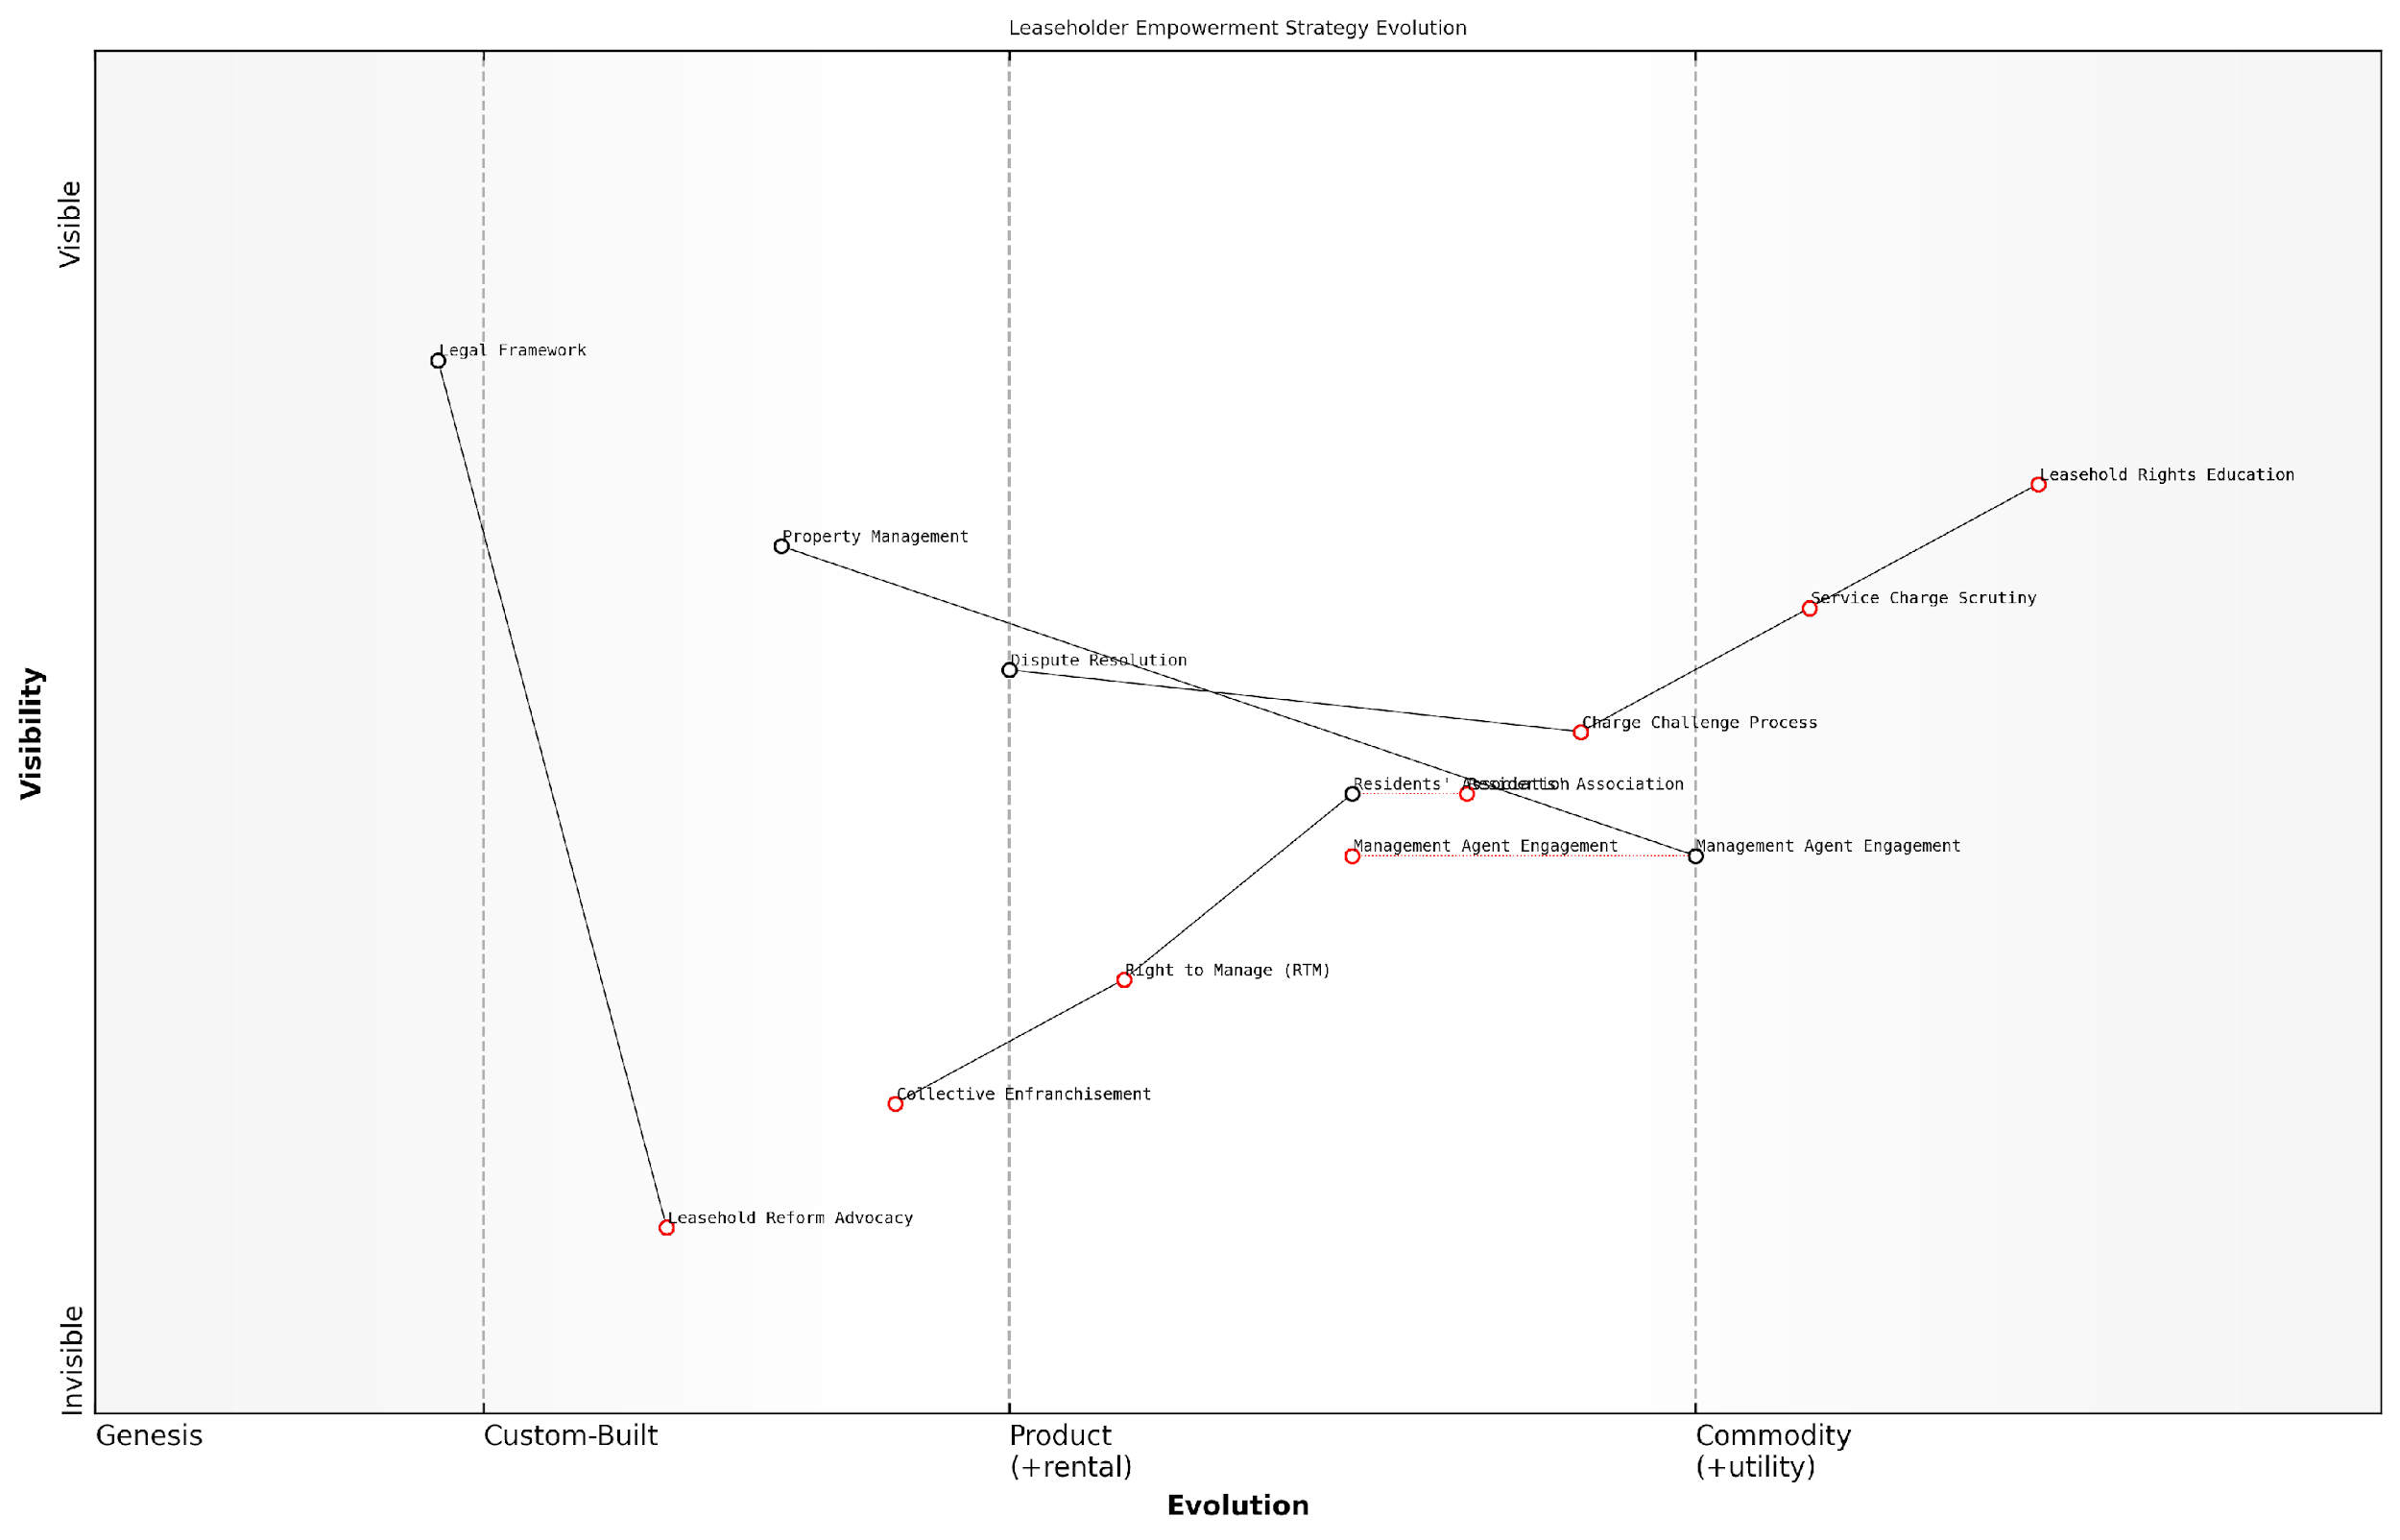

*Draft Wardley Map: [Insert Wardley Map: Summary of main action points]*

[Edit this draft Wardley Map](https://create.wardleymaps.ai/#clone:626bb20b8cffce007b)

Wardley Map Assessment

The Leaseholder Empowerment Strategy Evolution map presents a comprehensive approach to addressing leasehold issues in England. It strategically positions components from basic education to systemic reform, providing a clear pathway for empowerment. The strategy’s strength lies in its logical progression and focus on high-value, evolved components. However, there are opportunities to leverage technology and partnerships to accelerate evolution, particularly in more complex areas. The long-term success of this strategy will depend on effectively balancing immediate, practical actions with sustained efforts towards systemic change, all while navigating a complex ecosystem of stakeholders with often conflicting interests.

[View full Wardley Map report](https://github.com/tractorjuice/automated_wardley_reports/blob/main/markdown_wardley_map_reports/wardley_map_report_52_Summary_of_main_action_points.md)

Implementing these action points requires persistence, collaboration, and often, a willingness to challenge the status quo. However, the potential rewards – fairer charges, improved property management, and enhanced quality of life – make these efforts worthwhile.

It’s important to note that while these strategies have proven effective in numerous cases across England, each leasehold situation is unique. Tailor your approach to your specific circumstances, and don’t hesitate to seek professional advice when needed. Remember, the goal is not just to address immediate issues but to contribute to a more equitable and transparent leasehold system for all.

The journey to leasehold reform is a marathon, not a sprint. Every informed action taken by leaseholders today paves the way for a fairer system tomorrow.

As we move forward, it’s crucial to stay informed about ongoing reform initiatives and potential legislative changes. The leasehold landscape in England is evolving, with growing recognition of the need for systemic improvements. By remaining engaged and proactive, leaseholders can not only address their immediate concerns but also contribute to shaping a more equitable future for leasehold ownership in England.

### Long-term outlook for tackling issues

As we look towards the future of leasehold reform and management in England, it’s crucial to understand the long-term outlook for tackling the persistent issues that have plagued leaseholders for decades. This section will provide a comprehensive overview of the strategies and developments that are likely to shape the landscape of leasehold property management in the coming years, drawing from current trends, proposed reforms, and evolving best practices.

The long-term outlook for addressing excessive service charges and poor management in leasehold properties is cautiously optimistic, driven by a combination of increased awareness, legislative reforms, and collective action by leaseholders. However, it’s important to recognise that meaningful change will require sustained effort and engagement from all stakeholders involved in the leasehold sector.

The future of leasehold in England is at a crossroads. We’re seeing unprecedented momentum for reform, but the real test will be in the implementation and enforcement of new regulations to ensure they deliver tangible benefits to leaseholders.

Let’s explore the key areas that are likely to shape the long-term outlook for tackling leasehold issues:

* Legislative reforms and their implementation
* Technological advancements in property management
* Increased transparency and standardisation
* Empowerment of leaseholders through education and collective action
* Alternative models to traditional leasehold ownership

1. Legislative reforms and their implementation:

The UK government has proposed significant reforms to the leasehold system, including the potential abolition of leasehold for new-build houses and the implementation of a reformed commonhold system. These changes, if enacted and properly implemented, could fundamentally alter the landscape of property ownership and management in England.

Key aspects of proposed reforms include:

* Capping ground rents on new leases at zero
* Making it easier and cheaper for leaseholders to extend their leases or buy their freehold
* Introducing a new right for leaseholders to take over the management of their building without buying the freehold
* Standardising and regulating service charges to prevent excessive or unfair fees

The long-term success of these reforms will depend on their effective implementation and enforcement. It will be crucial for leaseholders to stay informed about these changes and understand how they can leverage new regulations to their advantage.

1. Technological advancements in property management:

The integration of technology into property management practices is set to revolutionise how leasehold properties are managed and how service charges are calculated and communicated. We can expect to see:

* Advanced building management systems that optimise maintenance schedules and reduce costs
* Blockchain-based platforms for transparent and immutable record-keeping of service charge expenditures
* AI-powered analytics to predict maintenance needs and optimise resource allocation
* Mobile apps that facilitate direct communication between leaseholders and management agents, improving transparency and responsiveness

These technological advancements have the potential to significantly reduce costs, improve efficiency, and increase transparency in leasehold management. However, it will be important for leaseholders to ensure that the benefits of these technologies are passed on to them in the form of reduced service charges and improved services.

1. Increased transparency and standardisation:

A key trend that is likely to continue and intensify is the push for greater transparency and standardisation in leasehold management practices. This includes:

* Standardised formats for service charge statements, making them easier to understand and compare
* Clear breakdowns of management fees and justifications for costs
* Regular performance reporting by management agents against agreed key performance indicators (KPIs)
* Open tendering processes for major works and long-term contracts

Transparency is the bedrock of trust between leaseholders and management agents. As we move forward, those agents who embrace openness and standardisation will thrive, while those who resist will find themselves increasingly marginalised.

1. Empowerment of leaseholders through education and collective action:

The long-term outlook for tackling leasehold issues is closely tied to the continued empowerment of leaseholders. This empowerment is likely to manifest in several ways:

* Increased availability of educational resources and training for leaseholders on their rights and responsibilities
* Growth of leaseholder associations and support networks, both online and offline
* More frequent use of collective enfranchisement and Right to Manage (RTM) processes
* Greater engagement with local and national policymakers to influence ongoing reform efforts

As leaseholders become more knowledgeable and organised, their collective bargaining power will increase, potentially leading to more favourable outcomes in disputes with freeholders and management agents.

1. Alternative models to traditional leasehold ownership:

In the long term, we may see a shift away from traditional leasehold ownership towards alternative models that address some of the inherent issues with the current system. These could include:

* Wider adoption of commonhold ownership, particularly for new developments
* Increased use of resident-managed freehold companies
* Development of hybrid models that combine elements of leasehold and freehold ownership
* Exploration of community land trusts and other cooperative ownership structures

While these alternative models may take time to gain widespread adoption, they represent potential long-term solutions to many of the issues currently faced by leaseholders.

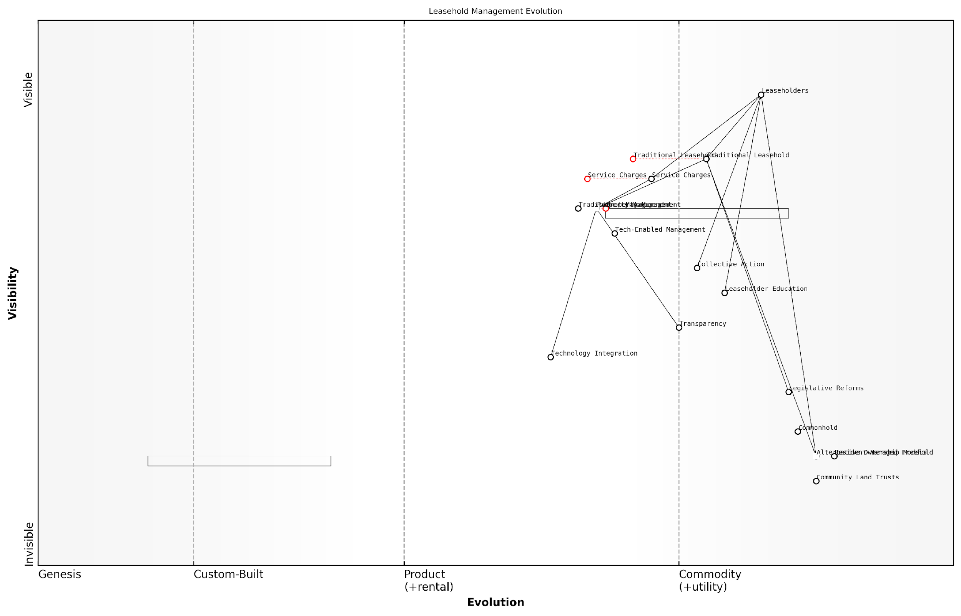

*Draft Wardley Map: [Insert Wardley Map: Long-term outlook for tackling issues]*

[Edit this draft Wardley Map](https://create.wardleymaps.ai/#clone:18db78569b01baa879)

Wardley Map Assessment

The Leasehold Management Evolution map reveals a sector on the cusp of significant transformation. The traditional leasehold model is under pressure from evolving leaseholder expectations, technological advancements, and emerging alternative ownership models. To thrive in this changing landscape, stakeholders must embrace transparency, leverage technology, and actively participate in shaping new legislative frameworks. The future lies in more equitable, efficient, and leaseholder-centric property management models, with significant opportunities for innovation and value creation. Those who can successfully navigate this transition, balancing short-term improvements with long-term structural changes, will be well-positioned to lead in the evolving property management ecosystem.

[View full Wardley Map report](https://github.com/tractorjuice/automated_wardley_reports/blob/main/markdown_wardley_map_reports/wardley_map_report_53_Long-term_outlook_for_tackling_issues.md)

In conclusion, the long-term outlook for tackling excessive service charges and poor management in leasehold properties is one of gradual but significant change. Legislative reforms, technological advancements, increased transparency, leaseholder empowerment, and the exploration of alternative ownership models all contribute to a future where the balance of power is likely to shift more favourably towards leaseholders.

However, it’s important to note that these changes will not happen automatically. Leaseholders must remain vigilant, engaged, and proactive in asserting their rights and pushing for continued improvements. By staying informed, working collectively, and leveraging the strategies outlined in this book, leaseholders can play a crucial role in shaping a fairer and more equitable future for leasehold property management in England.

The future of leasehold is not predetermined. It will be shaped by the collective actions of informed and empowered leaseholders who are willing to stand up for their rights and push for meaningful change.

### Importance of ongoing education and engagement

In the ever-evolving landscape of leasehold property management in England, the importance of ongoing education and engagement for leaseholders cannot be overstated. As we conclude our comprehensive exploration of tackling excessive service charges and bad management agents, it is crucial to emphasise that the journey towards fair and transparent leasehold practices is continuous. This final subsection will delve into why sustained learning and active participation are essential for empowered leaseholders and a fairer future in the leasehold sector.

Leasehold law and regulations in England are subject to frequent updates and reforms, reflecting the government’s recognition of longstanding issues within the system. As a seasoned expert in this field, I have witnessed numerous changes over the years, each bringing new opportunities and challenges for leaseholders. To effectively navigate this dynamic environment, leaseholders must commit to ongoing education and engagement in several key areas:

* Legislative updates and their implications
* Emerging best practices in leasehold management
* Technological advancements in property management systems
* Evolving dispute resolution mechanisms
* Trends in collective action and community organising

Let us examine each of these areas in detail, drawing upon practical insights and real-world examples to illustrate their significance.

1. Legislative Updates and Their Implications

The leasehold sector in England has been subject to significant scrutiny in recent years, resulting in a series of proposed and enacted reforms. For instance, the Leasehold Reform (Ground Rent) Act 2022 has effectively banned ground rents for most new long residential leases. Staying informed about such legislative changes is crucial for leaseholders to understand their rights and obligations.

As a senior government official recently stated, ‘The landscape of leasehold law is shifting rapidly. Leaseholders who remain informed and engaged are best positioned to benefit from these changes and protect their interests.’

To stay abreast of legislative updates, leaseholders should:

* Regularly check government websites and official publications
* Subscribe to newsletters from reputable leasehold advisory services
* Attend webinars or seminars hosted by legal experts in leasehold law
* Participate in local leaseholder forums or online communities

1. Emerging Best Practices in Leasehold Management

As the leasehold sector evolves, so too do the best practices for effective and fair management. Engaging with these emerging standards can help leaseholders benchmark their own experiences and advocate for improvements. For example, the adoption of transparent accounting practices and regular communication protocols by leading management agents has set new industry standards.

Leaseholders should actively seek out information on best practices through:

* Industry publications and reports
* Case studies of successful leasehold management reforms
* Networking with other leaseholder groups to share experiences
* Engaging with professional bodies such as ARMA (Association of Residential Managing Agents)

1. Technological Advancements in Property Management Systems

The integration of technology in property management has the potential to significantly improve transparency and efficiency in leasehold administration. From online portals for service charge statements to blockchain-based record-keeping, these advancements can revolutionise how leaseholders interact with management agents and access crucial information.

A leading expert in proptech recently observed, ‘The adoption of digital solutions in leasehold management is not just about convenience; it’s about empowering leaseholders with real-time information and enhancing accountability.’

To leverage these technological advancements, leaseholders should:

* Familiarise themselves with available property management software and platforms
* Advocate for the adoption of user-friendly technology by their management agents
* Participate in beta testing or feedback sessions for new management systems
* Stay informed about data protection and privacy implications of new technologies

1. Evolving Dispute Resolution Mechanisms

The landscape of dispute resolution in the leasehold sector is continually evolving, with an increasing emphasis on alternative dispute resolution (ADR) methods. Understanding these mechanisms and when to employ them can save leaseholders significant time and resources in addressing issues with management agents or freeholders.

Leaseholders should stay informed about:

* Updates to First-tier Tribunal (Property Chamber) procedures
* New ADR options, such as specialised leasehold mediation services
* Changes in the thresholds for legal action or tribunal applications
* Precedent-setting cases that may impact future dispute resolutions

1. Trends in Collective Action and Community Organising

The power of collective action in addressing leasehold issues cannot be underestimated. From successful Right to Manage (RTM) applications to influential advocacy campaigns, leaseholders who work together have achieved significant victories. Staying engaged with trends in community organising can provide valuable strategies and inspiration.

As noted by a prominent leasehold campaigner, ‘The most effective changes we’ve seen in the sector have come from leaseholders uniting, sharing knowledge, and speaking with one voice.’

To harness the power of collective action, leaseholders should:

* Join or form local leaseholder associations
* Engage with national leasehold campaign groups
* Utilise social media platforms to connect with other leaseholders
* Participate in consultations on leasehold reforms

In conclusion, the importance of ongoing education and engagement in the leasehold sector cannot be overstated. By staying informed, connected, and proactive, leaseholders can effectively navigate the complexities of the system, challenge unfair practices, and contribute to positive change. As we look towards a fairer future for leasehold in England, it is the informed and engaged leaseholder who will be best positioned to benefit from reforms and shape the evolving landscape of property ownership and management.

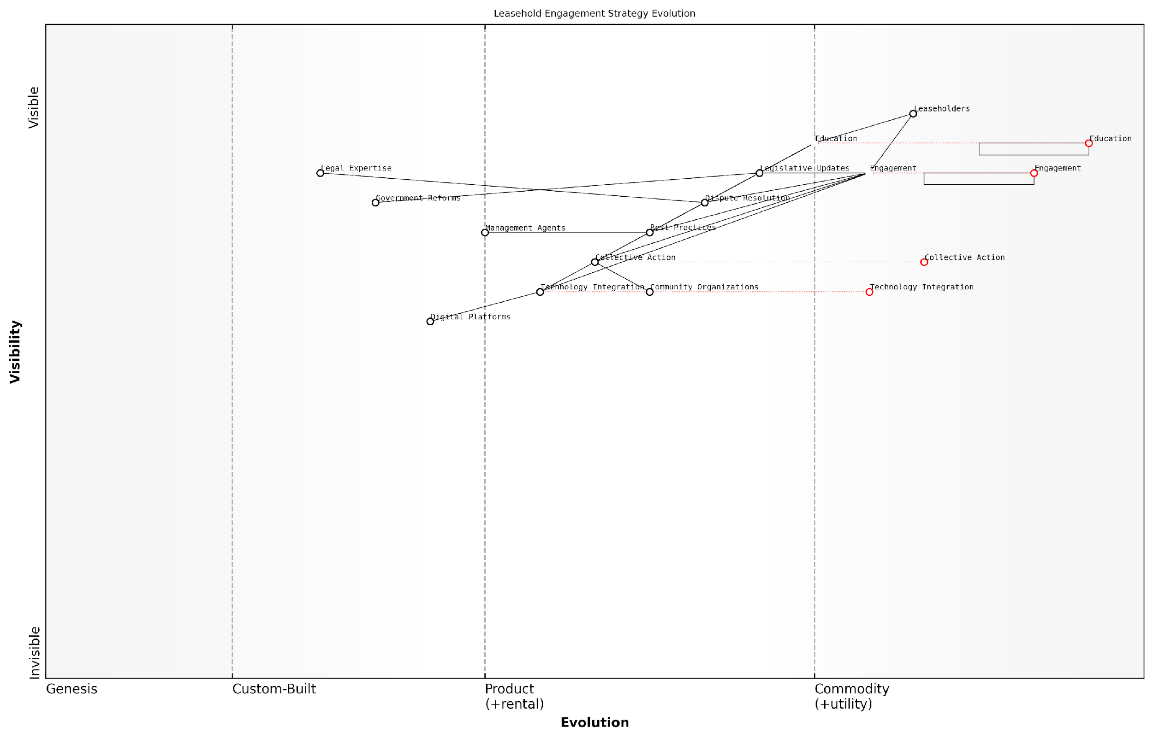

*Draft Wardley Map: [Insert Wardley Map: Importance of ongoing education and engagement]*

[Edit this draft Wardley Map](https://create.wardleymaps.ai/#clone:11e7cc1336f76841df)

Wardley Map Assessment

The Wardley Map reveals a strategic landscape focused on empowering leaseholders through education, engagement, and technological advancement. The positioning of components suggests a system in transition, with significant opportunities for innovation in digital platforms and collective action mechanisms. The key to success lies in balancing short-term empowerment strategies with long-term systemic reforms, while continuously adapting to technological advancements. The emphasis on education and engagement as evolving, high-value components is particularly noteworthy and should be leveraged for competitive advantage. However, the dependence on government reforms presents a potential vulnerability that should be mitigated through diversified strategies and ecosystem partnerships. Overall, the map indicates a promising direction for transforming leasehold management, with ample opportunities for creating value through innovation and strategic positioning.

[View full Wardley Map report](https://github.com/tractorjuice/automated_wardley_reports/blob/main/markdown_wardley_map_reports/wardley_map_report_54_Importance_of_ongoing_education_and_engagement.md)

## Resources and Further Support

### Useful organisations and websites

In the complex landscape of leasehold property management, access to reliable information and support is crucial for leaseholders seeking to address issues with excessive service charges and poor management. This section provides a comprehensive overview of key organisations and websites that offer valuable resources, guidance, and advocacy for leaseholders in England.

Government and Regulatory Bodies:

* The Leasehold Advisory Service (LEASE): A government-funded organisation providing free legal advice on leasehold law. Their website offers a wealth of information, including fact sheets, guides, and an online calculator for lease extension and enfranchisement costs.
* First-tier Tribunal (Property Chamber): The primary forum for resolving leasehold disputes. Their website provides guidance on application procedures, hearing processes, and previous decisions.
* Ministry of Housing, Communities & Local Government (MHCLG): Offers policy information and updates on leasehold reform initiatives.
* The Property Ombudsman: Provides a free, impartial dispute resolution service for consumers and property agents.

Advocacy Groups and Associations:

* Leasehold Knowledge Partnership (LKP): A charity that campaigns for leasehold reform and provides support to leaseholders. Their website offers news, case studies, and a forum for leaseholders to share experiences.
* National Leasehold Campaign (NLC): A grassroots organisation campaigning for leasehold reform, particularly focusing on issues such as ground rents and unfair lease terms.
* Association of Residential Managing Agents (ARMA): While primarily an industry body, their website offers useful guidance on best practices in property management.
* Federation of Private Residents’ Associations (FPRA): Provides advice and support for residents’ associations, including guidance on formation and management.

Access to these resources can be transformative for leaseholders. As a senior housing rights advocate notes, ‘Informed leaseholders are empowered leaseholders. These organisations provide the knowledge and tools necessary to challenge unfair practices and drive positive change in the leasehold sector.’

Professional Bodies and Legal Resources:

* Royal Institution of Chartered Surveyors (RICS): Offers professional standards for surveyors and property managers, as well as guidance on service charges and building maintenance.
* Law Society: Provides a ‘Find a Solicitor’ service to help leaseholders locate legal professionals specialising in leasehold law.
* Citizens Advice: Offers general guidance on housing issues, including leasehold matters, and can provide referrals to specialist advisors.
* Leasehold Life: An independent website offering practical advice and resources for leaseholders, including templates for letters and notices.

Online Forums and Community Resources:

* LeaseholdInfo.com: A user-driven forum where leaseholders can share experiences, seek advice, and discuss common issues.
* Reddit r/LegalAdviceUK: While not exclusively focused on leasehold issues, this subreddit can be a useful resource for general legal advice and experiences from other leaseholders.
* Flat Living: An online magazine and forum dedicated to issues affecting flat owners and residents, including leasehold matters.

Educational Resources and Courses:

* Open University: Offers free courses on land law and property rights through their OpenLearn platform.
* LEASE Webinars: Regular online seminars covering various aspects of leasehold law and management.
* ARMA Training Courses: While primarily aimed at property managers, some courses may be beneficial for leaseholders seeking to understand management practices.

A property law expert emphasises, ‘The landscape of leasehold law is constantly evolving. Regularly consulting these resources ensures leaseholders stay informed about their rights and the latest developments in reform efforts.’

When utilising these resources, it’s important for leaseholders to cross-reference information and seek professional advice where necessary. While online resources provide valuable insights, complex legal matters often require personalised guidance from qualified professionals.

Moreover, engaging with these organisations and platforms not only provides individual support but also contributes to the collective voice of leaseholders. Many of these groups play crucial roles in advocating for systemic reform, and leaseholder participation strengthens these efforts.

In conclusion, the array of organisations and websites available to leaseholders in England forms a robust support network. By leveraging these resources, leaseholders can arm themselves with knowledge, connect with others facing similar challenges, and actively participate in shaping a fairer future for leasehold property ownership.

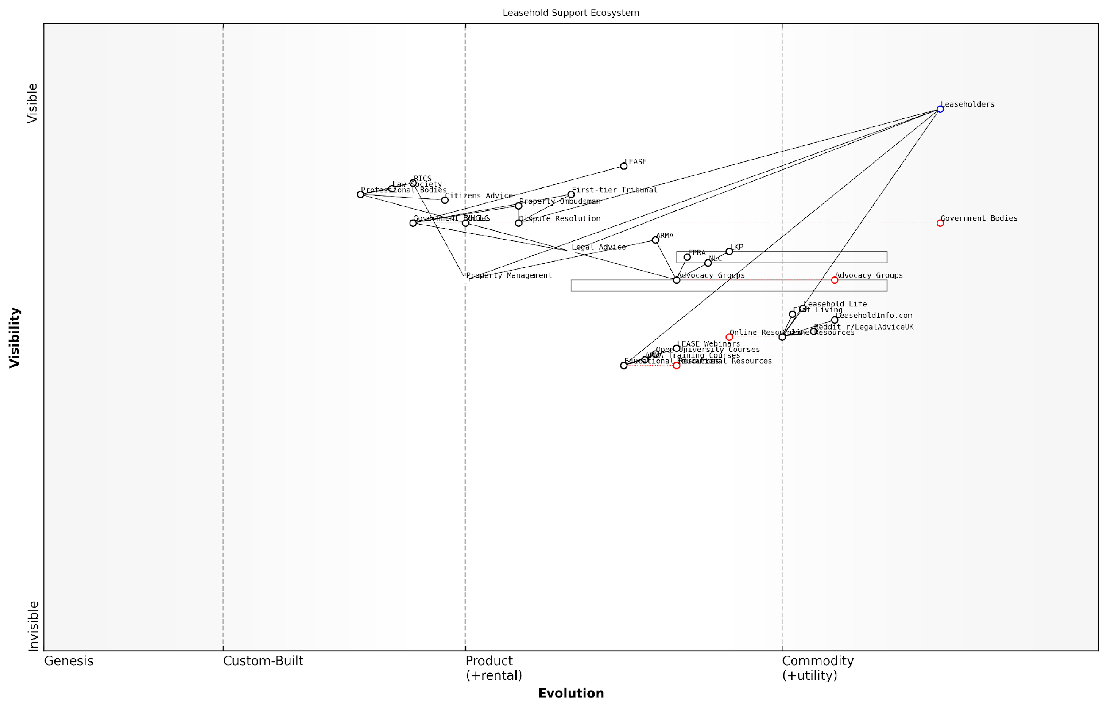

*Draft Wardley Map: [Insert Wardley Map: Useful organisations and websites]*

[Edit this draft Wardley Map](https://create.wardleymaps.ai/#clone:3add5e46b462e8ce47)

Wardley Map Assessment

The Leasehold Support Ecosystem in England is comprehensive but complex, with opportunities for greater integration and digitalization. By focusing on improving accessibility, standardising education, and leveraging emerging technologies, the ecosystem can evolve to better serve leaseholders and potentially drive significant reforms in the property market. The strong presence of advocacy groups and the emphasis on education are unique strengths that should be leveraged for future development.

[View full Wardley Map report](https://github.com/tractorjuice/automated_wardley_reports/blob/main/markdown_wardley_map_reports/wardley_map_report_55_Useful_organisations_and_websites.md)

### Recommended reading and courses

In the complex world of leasehold property management and service charge disputes, continuous learning is essential for leaseholders to stay informed and empowered. This section provides a curated list of recommended reading materials and courses that offer valuable insights and practical knowledge for tackling excessive service charges and dealing with bad management agents in England.

Books and Publications:

* ‘Leasehold: A Practical Guide’ by James Driscoll - This comprehensive guide offers an in-depth look at leasehold law and practice, covering everything from service charges to lease extension and enfranchisement.
* ‘Service Charges and Management: Law and Practice’ by Philip Freedman and Eric Shapiro - An authoritative text that delves into the intricacies of service charge legislation and case law, essential for those seeking a deeper understanding of their rights and obligations.
* ‘Flat Living: The Insider’s Guide to Managing Your Home’ by Cassandra Zanelli - A practical handbook that provides valuable tips and strategies for navigating the challenges of leasehold ownership, including dealing with management agents and service charges.
* ‘The Right to Manage: A Practitioner’s Guide’ by Tanfield Chambers - An invaluable resource for leaseholders considering the Right to Manage process, offering step-by-step guidance and legal insights.

Online Resources and Journals:

* Leasehold Advisory Service (LEASE) website - Offers a wealth of free information, factsheets, and guides on various aspects of leasehold ownership and management.
* Leasehold Knowledge Partnership (LKP) - Provides up-to-date news, analysis, and campaign information on leasehold issues.
* Property Law Journal - A professional publication that offers in-depth articles on recent legal developments and case law relevant to leasehold property management.

Courses and Training:

* LEASE Webinars and Training Sessions - Regular online seminars covering various aspects of leasehold management and dispute resolution.
* Association of Residential Managing Agents (ARMA) Courses - While primarily aimed at property managers, their courses on service charge budgeting and accounting can be invaluable for leaseholders seeking to understand the management perspective.
* Royal Institution of Chartered Surveyors (RICS) Short Courses - Offer professional-level training on topics such as service charge management and residential leasehold valuation.
* Open University ‘Understanding Leasehold Property’ - A free online course providing a solid foundation in leasehold concepts and issues.

Continuous education is the key to empowerment in the leasehold sector. The more informed leaseholders are, the better equipped they become to challenge unfair practices and drive positive change.

Professional Development and Certification:

* Institute of Residential Property Management (IRPM) qualifications - While designed for property managers, the knowledge gained from these courses can be invaluable for leaseholders, especially those involved in Right to Manage companies.
* Chartered Institute of Housing (CIH) Level 3 Certificate in Housing Practice - Offers a broader understanding of housing issues, including leasehold management.
* Law Society’s Conveyancing Quality Scheme (CQS) accredited firms - While not a course per se, seeking advice from CQS accredited solicitors ensures access to up-to-date expertise in leasehold matters.

Specialised Workshops and Seminars:

* First-tier Tribunal workshops - Occasionally offered by legal firms or housing associations, these provide practical guidance on preparing for and presenting cases at the tribunal.
* Service Charge Accounting seminars - Often organised by professional bodies like ICAEW, these offer insights into the financial aspects of service charges.
* Leasehold Reform and Management conferences - Annual events that bring together experts to discuss current issues and future trends in the sector.

It’s important to note that while these resources provide valuable knowledge, the leasehold landscape in England is constantly evolving. Recent government proposals for leasehold reform may lead to significant changes in the coming years. Therefore, it’s crucial to supplement these recommended materials with ongoing engagement with current affairs and policy developments in the leasehold sector.

Knowledge is power, but in the world of leasehold, it’s also your shield and your sword. Arm yourself with information, and you’ll be better prepared to defend your rights and challenge unfair practices.

By engaging with these recommended readings and courses, leaseholders can develop a robust understanding of their rights and obligations, the intricacies of service charge management, and effective strategies for dealing with management agents. This knowledge forms the foundation for confident and informed action, whether that involves challenging excessive charges, participating in collective management efforts, or advocating for broader leasehold reform.

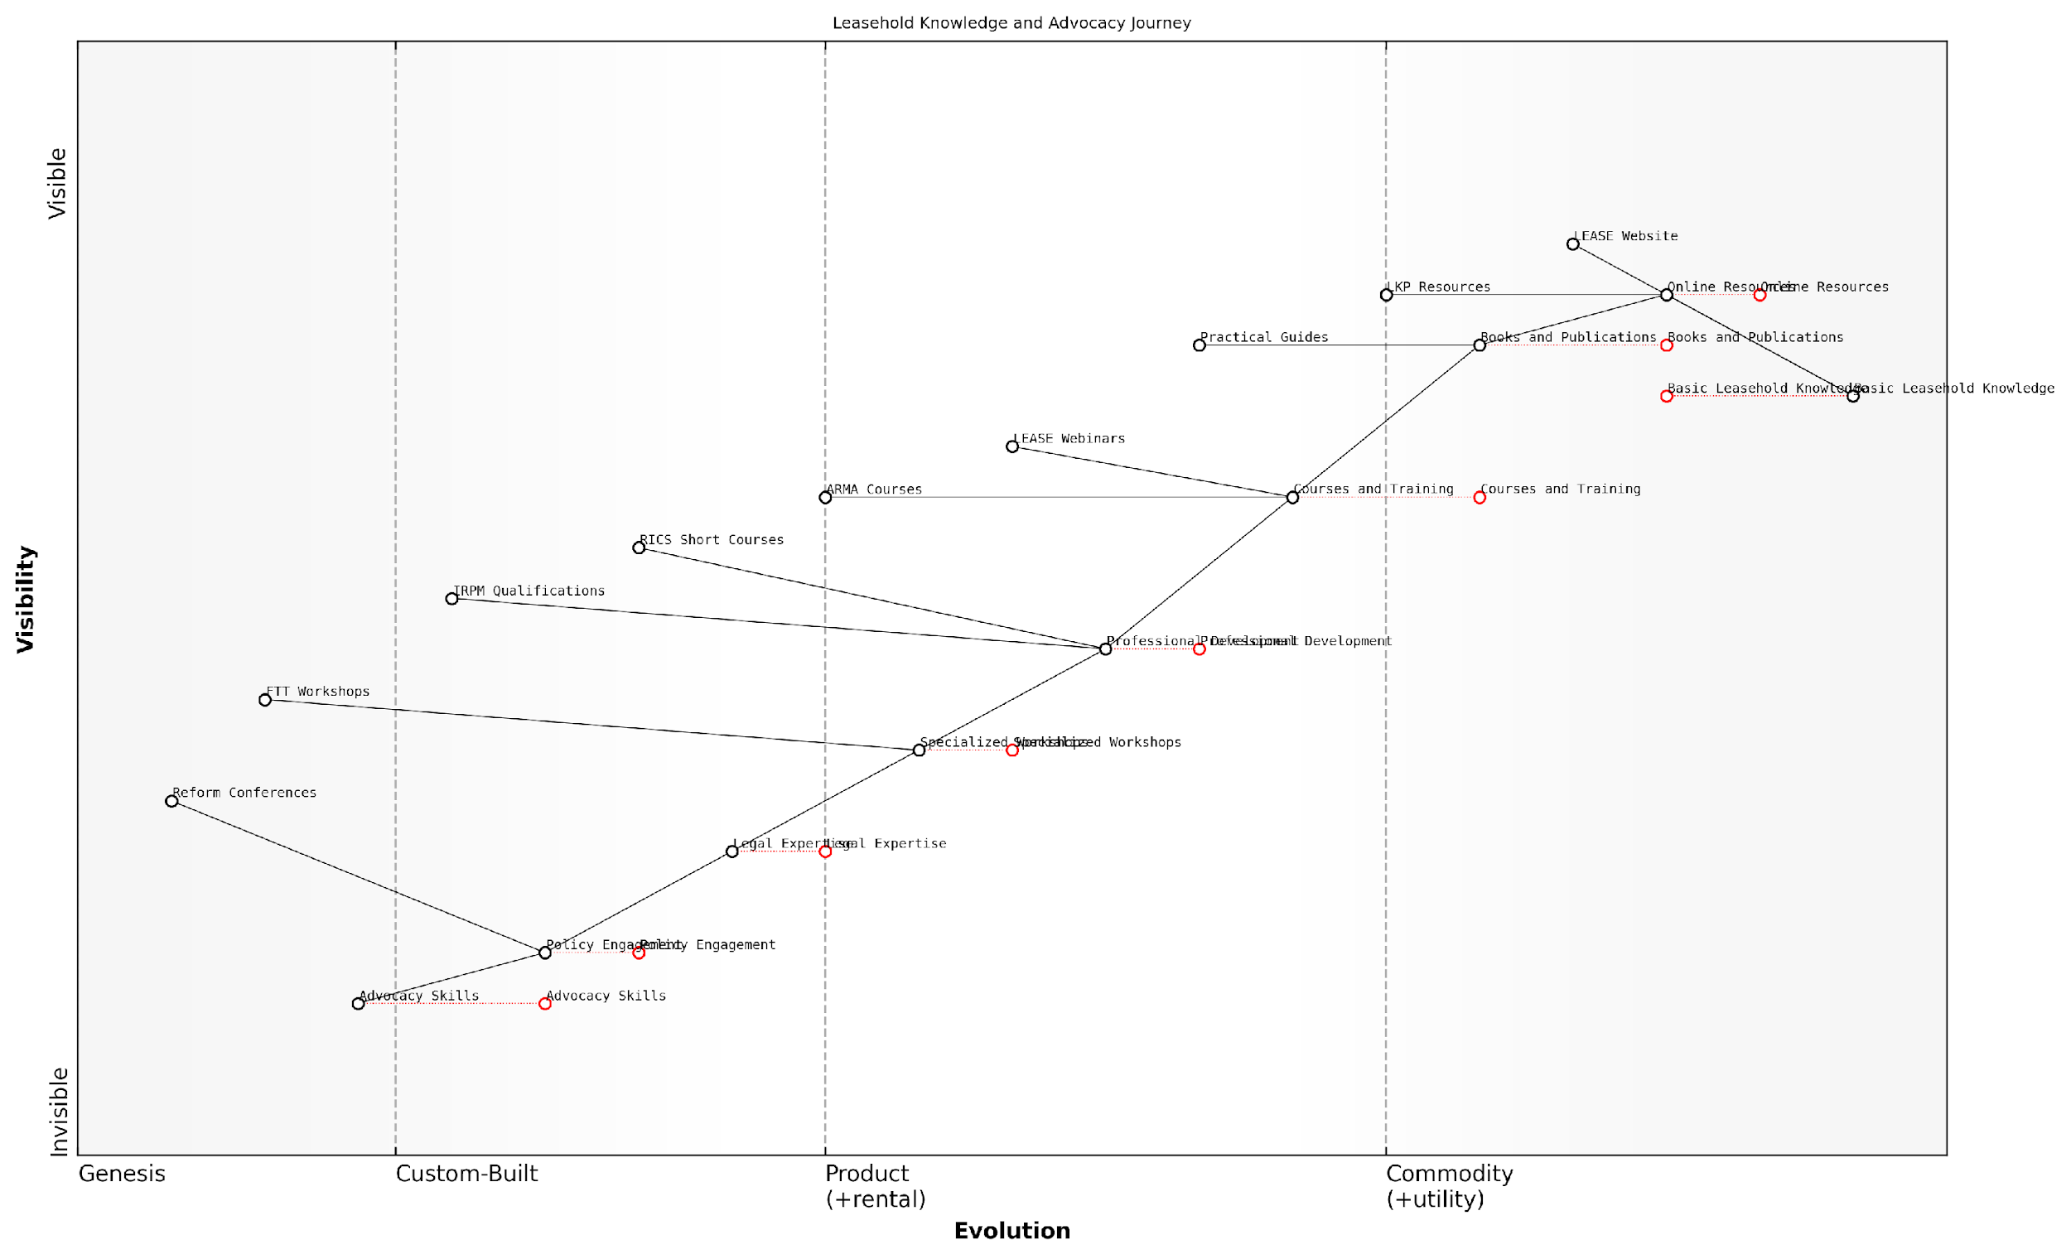

*Draft Wardley Map: [Insert Wardley Map: Recommended reading and courses]*

[Edit this draft Wardley Map](https://create.wardleymaps.ai/#clone:1efd13d414af386c83)

Wardley Map Assessment

The Leasehold Knowledge and Advocacy Journey map reveals a well-structured progression from basic understanding to advanced advocacy. Key strategic opportunities lie in enhancing the accessibility and integration of resources, particularly in bridging the gap between theoretical knowledge and practical advocacy skills. The evolving nature of online resources and training courses presents a prime area for innovation and competitive advantage. To maximise impact, focus should be placed on developing a seamless pathway from novice to expert advocate, leveraging technology and partnerships to overcome current bottlenecks in legal expertise and policy engagement. The map indicates a growing importance of advocacy and policy influence in the leasehold sector, suggesting a future where empowered leaseholders play a more significant role in shaping the industry landscape.

[View full Wardley Map report](https://github.com/tractorjuice/automated_wardley_reports/blob/main/markdown_wardley_map_reports/wardley_map_report_56_Recommended_reading_and_courses.md)

### Templates and checklists for common procedures

In the complex landscape of leasehold management, having access to well-crafted templates and comprehensive checklists can be invaluable for leaseholders seeking to navigate common procedures effectively. These resources not only streamline processes but also ensure that crucial steps are not overlooked, empowering leaseholders to tackle issues with confidence and precision.

Let’s explore some essential templates and checklists that every leaseholder should have in their toolkit:

* Service Charge Dispute Template
* Management Agent Performance Evaluation Checklist
* Right to Manage (RTM) Process Checklist
* Residents’ Association Formation Template
* Lease Extension Application Checklist
* Tribunal Hearing Preparation Checklist

1. Service Charge Dispute Template:

A well-structured template for disputing service charges is crucial for leaseholders. This template should include sections for:

* Leaseholder’s details and property information
* Specific charges being disputed
* Reasons for dispute (e.g., lack of consultation, unreasonable costs)
* Supporting evidence (e.g., comparable quotes, photographic evidence)
* Proposed resolution or request for further information
* Timeline of communications with the management agent or freeholder

A meticulously prepared service charge dispute template can significantly increase the chances of a favourable outcome. It demonstrates to the management agent or tribunal that the leaseholder has a well-reasoned case backed by evidence.

1. Management Agent Performance Evaluation Checklist:

This checklist helps leaseholders systematically assess their management agent’s performance, covering key areas such as:

* Responsiveness to communications
* Transparency in financial reporting
* Quality and timeliness of maintenance and repairs
* Compliance with legal obligations (e.g., consultation requirements)
* Value for money in service provision
* Professionalism and conduct of staff

1. Right to Manage (RTM) Process Checklist:

For leaseholders considering the RTM route, a comprehensive checklist is essential to navigate this complex process. Key elements should include:

* Verification of building eligibility for RTM
* Formation of the RTM company
* Serving of notices (including the Information Notice and Claim Notice)
* Handling of counter-notices
* Preparation for potential tribunal hearings
* Transition planning for taking over management responsibilities

The RTM process can be daunting, but a well-structured checklist ensures that leaseholders approach each stage methodically, reducing the risk of procedural errors that could derail the application.

1. Residents’ Association Formation Template:

A template for forming a recognised residents’ association should guide leaseholders through the essential steps, including:

* Drafting a constitution
* Electing committee members
* Setting membership criteria and fees
* Establishing communication channels
* Applying for formal recognition from the freeholder or tribunal

1. Lease Extension Application Checklist:

For leaseholders pursuing a lease extension, a detailed checklist should cover:

* Eligibility verification
* Valuation process
* Serving of the Tenant’s Notice
* Negotiation strategies
* Potential tribunal application
* Completion and registration of the new lease

1. Tribunal Hearing Preparation Checklist:

When facing a tribunal hearing, thorough preparation is key. A comprehensive checklist should include:

* Compilation of all relevant documents and evidence
* Preparation of witness statements
* Familiarisation with tribunal procedures
* Rehearsal of oral arguments
* Logistics planning (e.g., travel arrangements, document copies)

A senior tribunal member once remarked, ‘The most compelling cases are often those where leaseholders have clearly followed a structured approach in preparing their evidence and arguments.’

These templates and checklists serve as invaluable tools for leaseholders, providing a structured approach to common procedures and challenges. By utilising these resources, leaseholders can ensure they are well-prepared, thorough, and confident in their actions, whether disputing charges, evaluating management performance, or pursuing significant changes like RTM or lease extensions.

It’s important to note that while these templates and checklists provide a solid foundation, they should be adapted to individual circumstances and updated regularly to reflect changes in legislation or best practices. Leaseholders are encouraged to seek professional advice when dealing with complex issues, using these resources as a starting point for more tailored guidance.

As the leasehold landscape continues to evolve, so too will the tools available to leaseholders. Future iterations of these templates and checklists may incorporate advanced features such as interactive digital formats, integration with case management systems, or AI-assisted guidance. However, the core principle remains: equipping leaseholders with structured, comprehensive resources to effectively navigate the complexities of leasehold ownership and management.

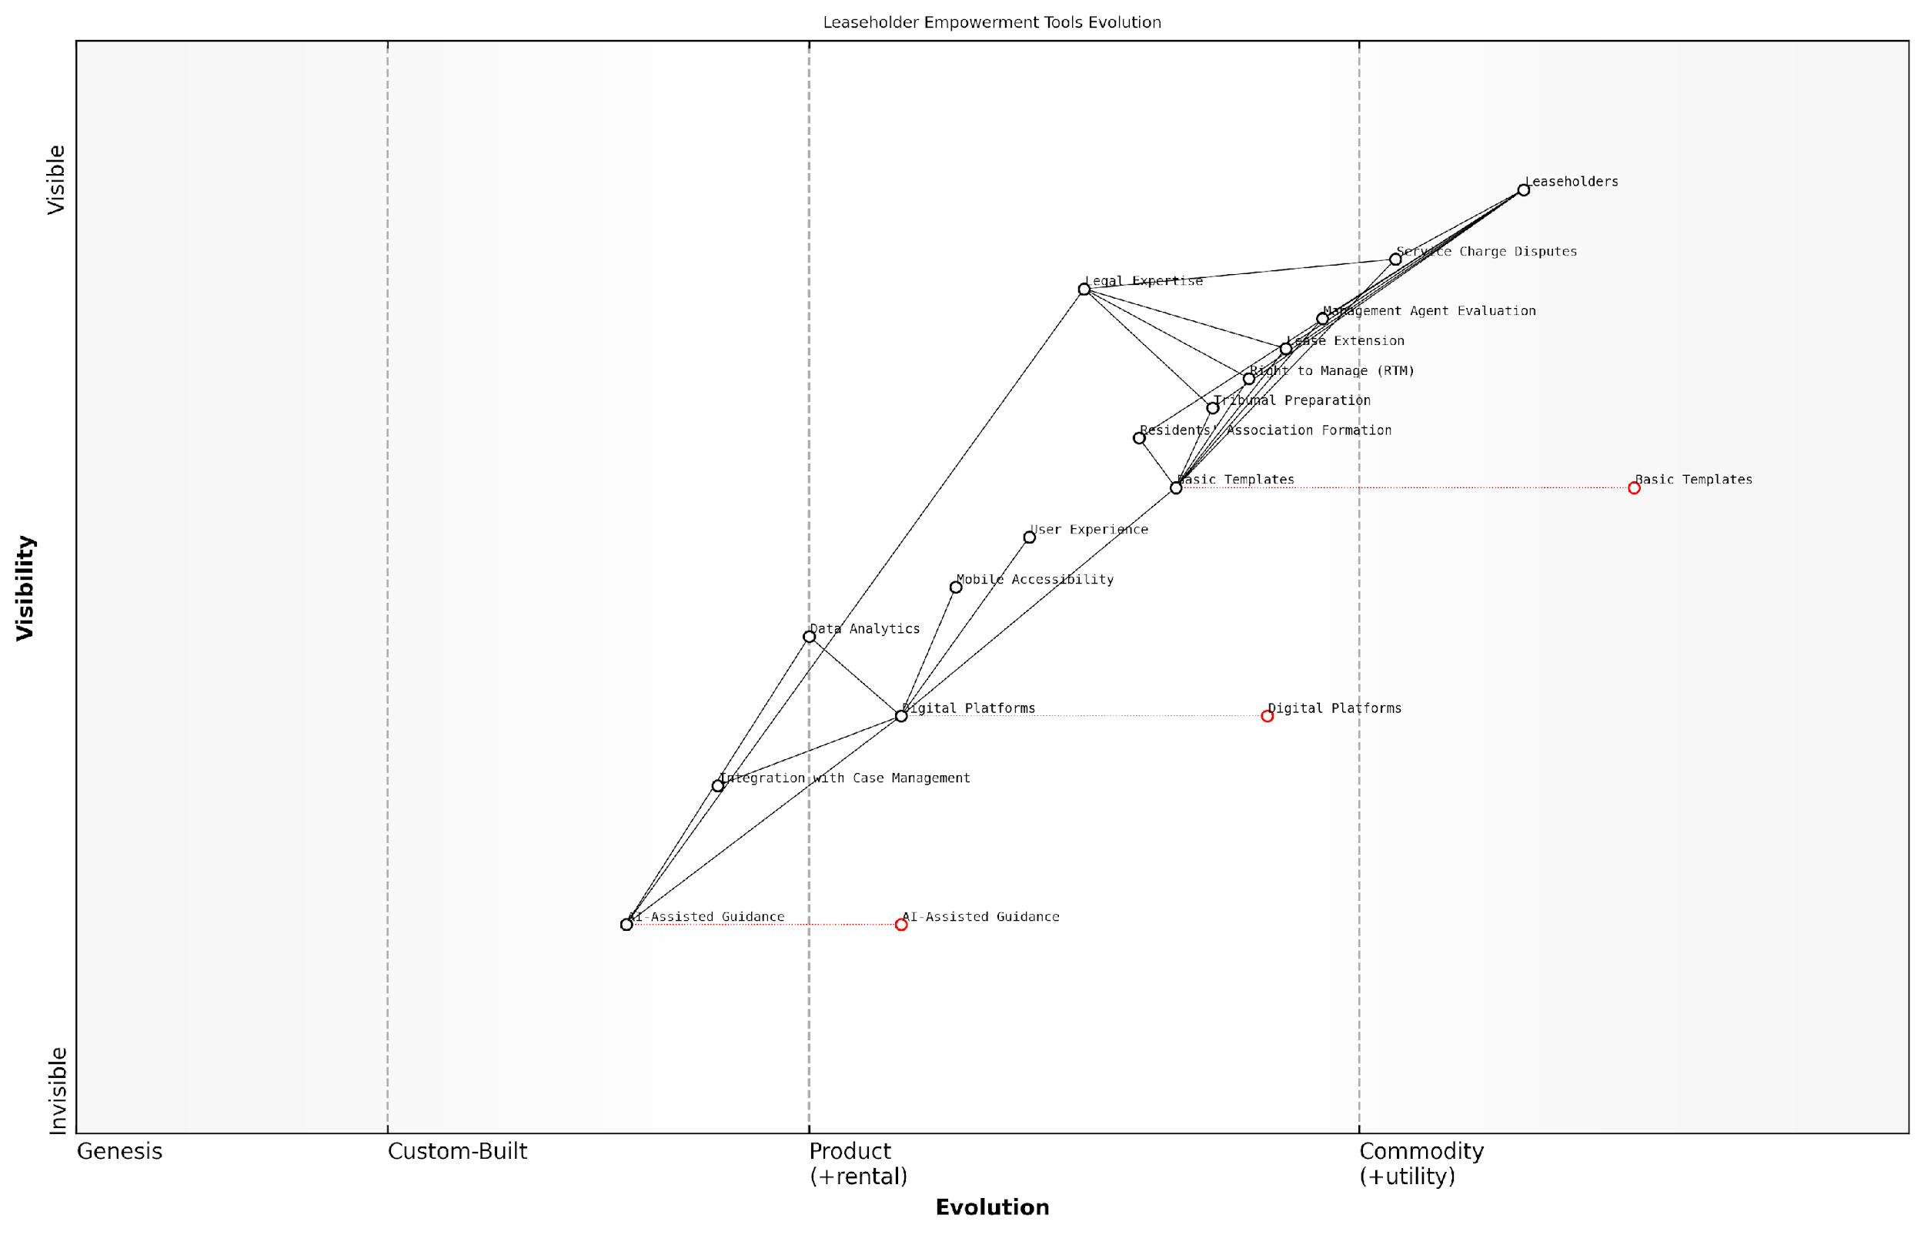

*Draft Wardley Map: [Insert Wardley Map: Templates and checklists for common procedures]*

[Edit this draft Wardley Map](https://create.wardleymaps.ai/#clone:c2983ffc9feb083fe6)

Wardley Map Assessment

The Wardley Map reveals a strategic landscape in transition, with significant opportunities for innovation in leaseholder support through AI and digital platforms. The key challenge lies in effectively integrating these emerging technologies with existing legal expertise and processes. Organizations that can successfully navigate this transition, balancing innovation with reliability and user trust, will be well-positioned to lead in empowering leaseholders and transforming the industry. The future likely holds a more democratized, efficient, and user-centric approach to leaseholder rights and dispute resolution.

[View full Wardley Map report](https://github.com/tractorjuice/automated_wardley_reports/blob/main/markdown_wardley_map_reports/wardley_map_report_57_Templates_and_checklists_for_common_procedures.md)